CS3103 PROJECT B DATABASE DESIGN

ALIASGAR KOTHARI: 3684005
VIET ANH NGUYEN: 3652375

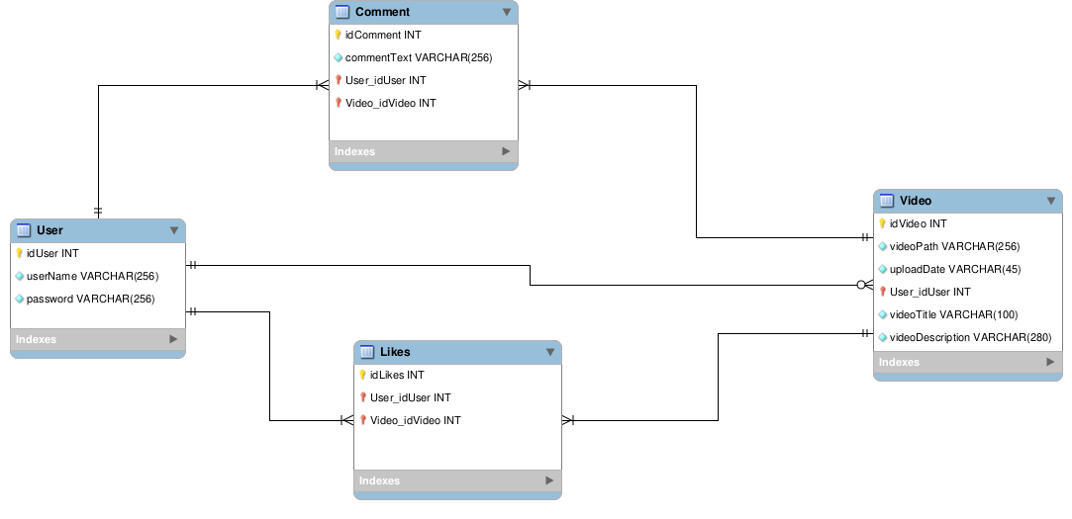

A user entity can upload zero or many videos.
A video belongs to only one user.
A user can have many likes.
A single like can only be made by one user.
A video can have many likes.
Only a single like can be made by a user on a video.
A user can make many comments.
A video can have many comments.
A comment can only belong to one user.
A comment can only be on one video.

Procedures to implement:

Procedure name | Functionality
getVideo(videoName, videoId) | Lets you get the required video from the path
getLikeCount(videoId) | Gets the number of likes on a video
getVideoList(userId) | Gets all the videos of a user
getCommentsList(videoId) | Gets all the comments on a video
getUserofVideo(videoId) | Gets the user that made the video
getLikedVideos(userId) | Gets all the videos liked by the user
getVideoDescription(videoId) | Get the description of a video
searchVideo(keywords) | Get a list of videos based on keywords
uploadVideo(userId, videoTitle, videoDescription, videoPath) | Upload a new video for a user
deleteVideo(videoId) | Delete a video
WriteComment(userId, videoId, commentText) | Write a comment
deleteComment(videoId, userId) | Delete a comment
likeVideo(videId, userId) | User likes a video
createUser(userName, password) | Create a new user
removeLike(userId, videoId) | Delete a like entry
changeVideoDescription(videoId) | Change the description on a video
changeVideoTitle(videoId) | Change the title of a video
editComment(userId, videoId) | Edit the text of a comment
changePassword(userId, userName, userPassword) | Change user’s password
changeUserName(userId, userPassword) | Change user’s username

