CIPHER LABS / QAMAR
UI/UX EXPERIENCE BIBLE
The living Orb, the constellation interface, and every launch screen
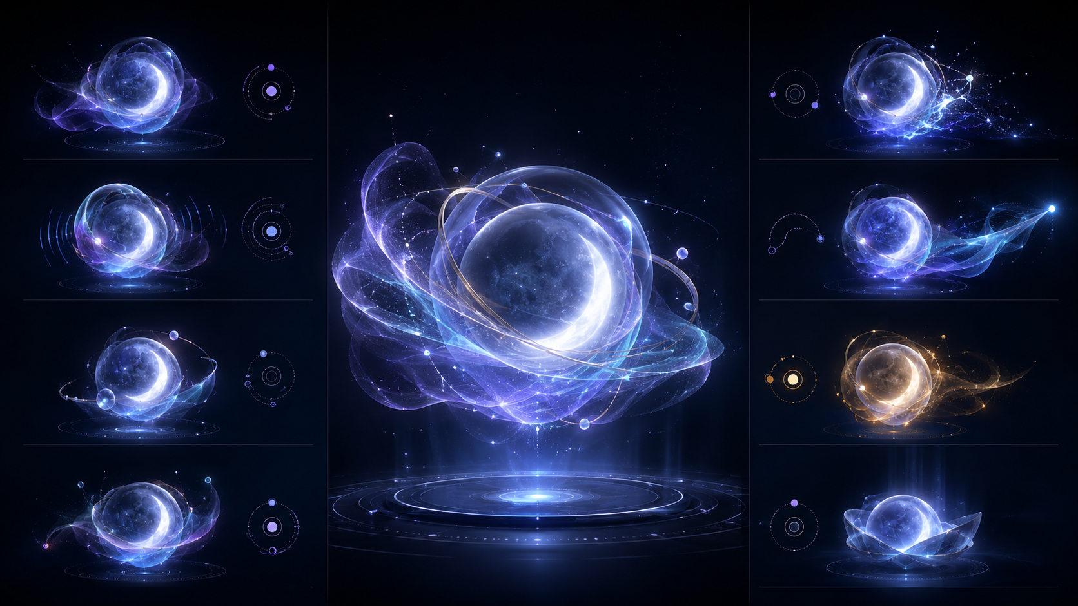
Canonical character direction: a lifelike lunar spirit, never a cartoon mascot.
EGYPT LAUNCH · ARABIC RTL · ADULTS 18+ · NUTRITION FIRST
Owner: Basel Elsakka · Version 2.0 · 13 August 2026

Document mandate
Experience thesis: Qamar is not a dashboard with an AI button. Qamar is a living lunar guide whose Orb is the interface, the companion and the sole global navigation system. Every screen should feel like a place the same intelligence has led the user to—not a separate feature tab.

Version 2.0 design canon
System | Version 2.0 decision
Living guide | The faceless lunar-spirit Orb remains the one hero, one voice and one persistent navigation portal.
Living constellation | Branches are emitted moonlight and part of the Orb's body language. They carry state, focus and transition—not static connecting lines.
Navigation | The five destinations remain Today, Log, Plan, Progress and You. No bottom bar or duplicate global shell is introduced.
Su Points | The permanent currency identity is a moon-gold rising phoenix on midnight blue. It symbolizes renewal after interruption.
Character hierarchy | The Orb is alive. The branches are living extensions. The phoenix is a still emblem. These roles never blur.
Accessibility | Every light/motion state has text, semantics, focus contrast and a Reduced Motion/tap-list equivalent.
Scope | All 62 nutrition-first launch screens inherit these systems; no Health OS or workout scope is added.

Locked decision | UI/UX consequence
The Orb is the hero | It owns presence, voice, navigation, guidance and transition choreography across the entire product.
No bottom navigation bar | Today, Log, Plan, Progress and You exist only in the Orb's constellation; no persistent bar or duplicate tab shell.
The Orb never disappears | It may compress, dock, dim or become still, but a 56dp accessible portal remains on every usable screen.
The branches are alive | Every constellation branch is moonlight emitted by the Orb: it rests, blooms, focuses, travels and settles as part of the same living system.
Spirit, not cartoon | No eyes, mouth, cute face, humanoid body, pet needs, emotional dependency or slapstick motion.
Nutrition first | The launch UI contains no Health OS, sleep, HRV, movement, recovery-score or workout dashboard.
Arabic-first Egypt launch | Production layout is RTL; Qamar speaks concise Egyptian Arabic while facts, billing and safety stay literal.
Adults 18+ | Eligibility and unsupported-risk states precede personalized targets.
Phoenix = Su Points | Every spendable Su Points representation uses one moon-gold rising phoenix; no 'Su' coin, generic star, flame burst or alternate currency mark.
Game expression serves adherence | Quests, Journey and Su Points reward useful behavior; no punishment, gambling, pay-to-win or weight-loss trophies.

How to use this bible
- Use the Orb contract before designing any screen. A screen that hides, duplicates or visually contradicts the Orb is not complete.
- Use the 62 screen IDs in Figma pages, Flutter routes, product tickets, analytics, QA cases and support references.
- Prototype every gesture with Arabic RTL, large text, reduced motion and screen-reader actions before visual polish.
- Keep operational facts—nutrition estimates, sources, safety, privacy and billing—outside fantasy language.
- Treat generated mockups as composition references. Production copy, data and Arabic typography require final design and QA.

Contents
Part | Scope
I · Experience soul | Reference translation, principles, emotional arc and world language
II · The living Orb | Character anatomy, states, movement, voice, roles and boundaries
III · Orb-only navigation | Gestures, living moonbeam constellation, accessible alternatives, persistence and transitions
IV · Visual system | Color, type, glass, phoenix currency identity, components, motion, sound, haptics and RTL
V · Core journeys | First launch, daily loop, logging, planning, progress, Journey, wallet and trust
VI · Every page | Screen-by-screen UI/UX and Orb behavior for S01-S62
VII · Build and QA | Design-file structure, component states, motion handoff and acceptance checklist

PART I
Experience soul
The user is the adventurer. Qamar is the intelligent guide who keeps the route alive when real life changes.

1. The experience promise
A traditional diet feels like a map that becomes useless after one wrong turn. Qamar should feel like a guide that notices the turn, understands what happened, redraws the remaining route and stays beside the user. The emotional outcome is continuity: I did not fail; the route changed, and I still know what to do next.
MMORPG metaphor: Borrow the useful structure of an MMORPG fairy guide—presence, orientation, quests, progress and a shared journey—without borrowing childish art, fantasy jargon in serious moments, cluttered HUDs, random rewards or dependency mechanics.

Keep | Avoid
One recognizable guide with consistent behavior | A mascot that performs for attention
A world map expressed as a constellation | A hidden gesture maze or decorative dead nodes
Quests as small useful actions | Punishment, streak loss, urgent timers or shame
Character growth through richer light and motion | Changing into unrelated skins that weaken trust
The user is the adventurer | Qamar claiming the user's success or demanding affection

2. Translating the supplied references
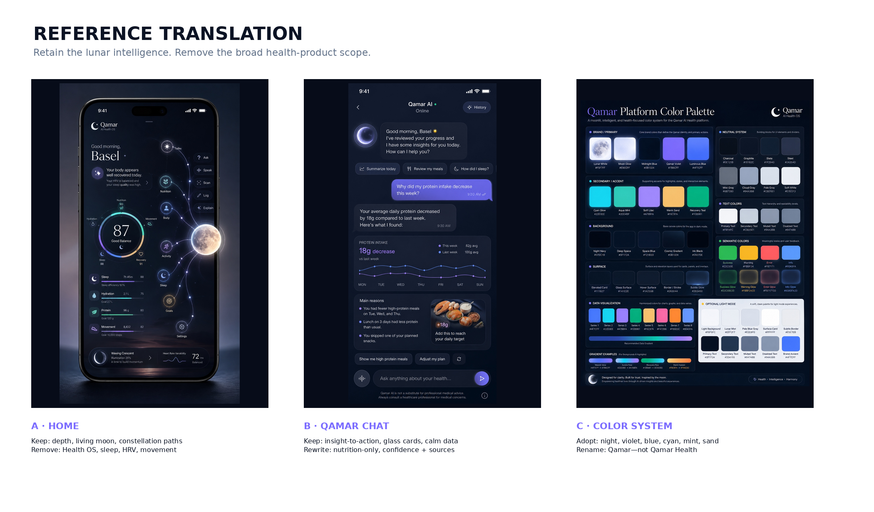
Figure 1. The supplied references define the moonlit visual language; this bible narrows their product scope.
- Retain the near-black lunar field, glass depth, luminous data rings, restrained violet-blue energy and constellation motion.
- Retain the large living-moon presence and the chat pattern that turns an insight into a clear next action.
- Remove 'Qamar Health', 'AI Health OS', body-recovery scoring, sleep, HRV, hydration and movement from launch UI.
- Replace a dashboard of equal metrics with one dominant next decision, then supporting nutrition context.
- Use the reference palette as the source; the production identity is simply Qamar.

3. Experience principles
Principle | Design test
ONE RELATIONSHIP | Every route feels like Qamar continuing the same conversation, not a new app module.
ONE NEXT ACTION | Today and every result screen end with the smallest useful decision.
REAL LIFE ADAPTS | A deviation changes the route; it never resets the journey.
EVIDENCE OVER MAGIC | Character creates warmth. Sources, confidence and editable estimates create trust.
CALM POWER | Motion has intention and an ending. Empty space is part of the character.
VISIBLE CONTROL | The user can correct food, memory, targets, permissions, rewards and data.
ACCESSIBLE BY DESIGN | Every drag, hold, chart and animation has a semantic, tap-based alternative.
NO FALSE DRAMA | No red Orb, broken streak, punishment, artificial scarcity or medical certainty.

PART II
The living Orb
A spirit made readable through matter, light, breath, posture and timing.

4. Canonical character direction
Figure 2. Canonical Orb concept: use its materiality and state language; do not add a face.
The Orb must feel as if it occupies the same world as the interface: light refracts through it, its veil carries momentum, its tail loses energy, and its halo responds to state. It is not a sticker placed above the UI. Production animation should preserve continuity of volume and light across every state.

5. Anatomy
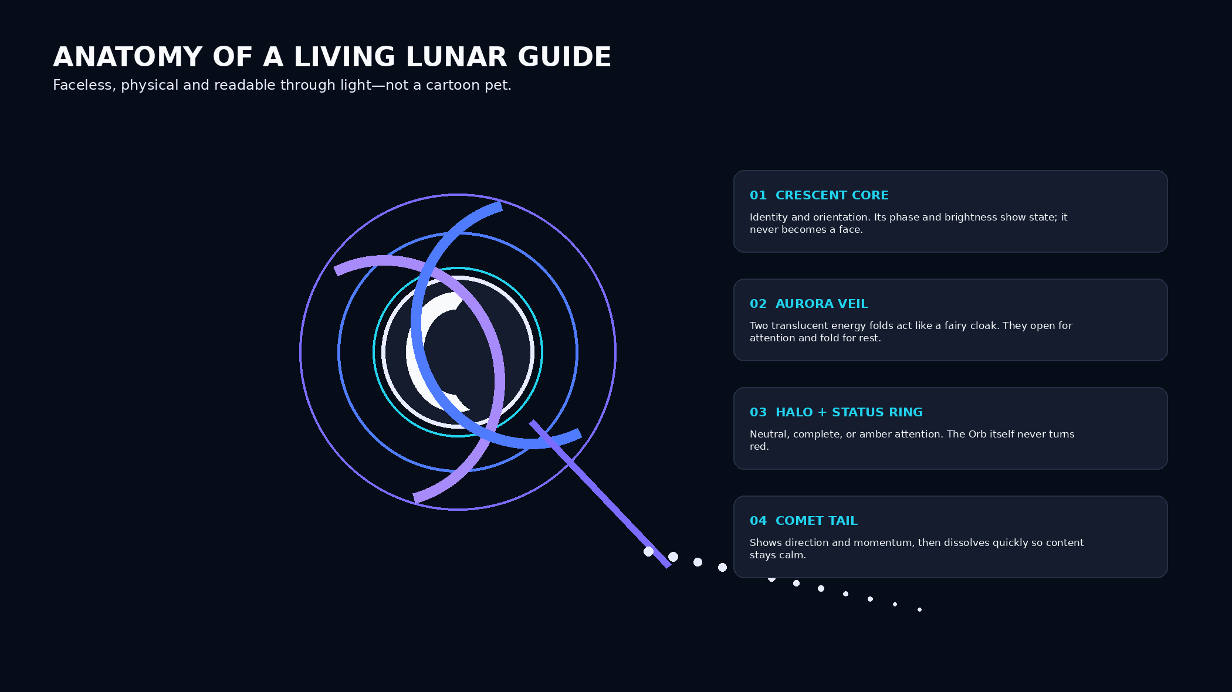
Figure 3. Orb anatomy and the functional job of each layer.
Layer | Production rule
Crescent core | Always recognizable at 24dp. Phase shifts are stateful, never used as a face or emotion icon.
Translucent shell | Premium glass/energy volume with controlled refraction; avoid soap-bubble rainbow noise.
Aurora veil | Two folded energy sheets create posture. They open, settle and trail with believable inertia.
Halo/status ring | Neutral, completion or amber attention only. Error red may appear in system copy, never as the Orb's emotional state.
Comet tail | Indicates direction and transition. It decays within 350-700ms and never writes over content.
Star motes | Maximum 3-8 visible near the Orb, reduced in Calm Mode and removed in Reduced Motion.

6. State grammar
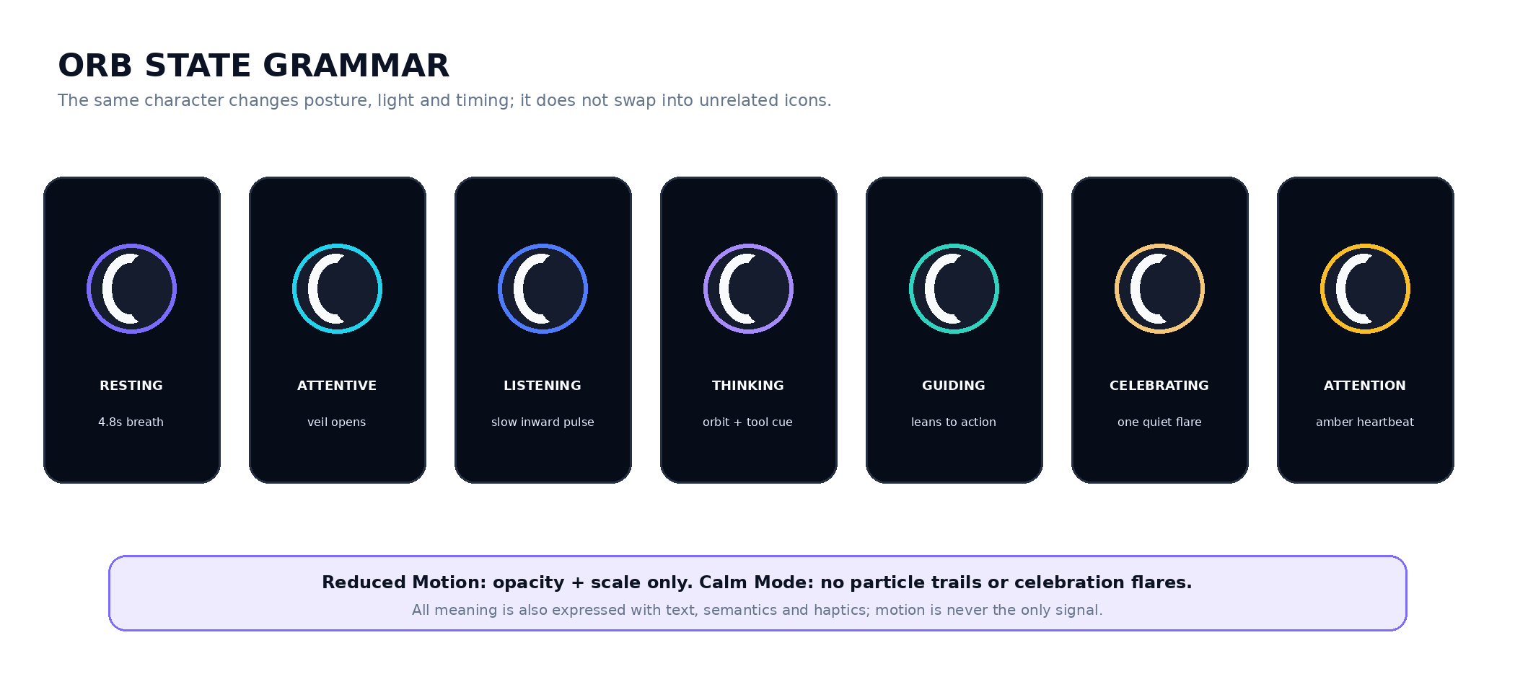
Figure 4. The same character communicates state through posture, light and timing.
State | Body language | Meaning | Timing
Dormant / boot | Thin crescent, near-silent light | Resolve startup | 0.6-1.2s; skip on warm start
Resting / breathing | 4.8s ± 0.6 irregular breath, 1-2% scale | Present without demanding attention | Pause after 3 cycles when content is static
Attentive | Veil opens 8-12°, core brightens | User pauses or focuses a decision | One cycle; no nagging loop
Listening | Inward pulse, waveform in halo | Voice or active conversation | Bound to actual capture
Thinking / working | One orbital mote + slow veil rotation | A named task is running | Expose cancel and fallback
Speaking | Core light phrases with message cadence | Qamar response is being revealed | Never lip-sync or flash each word
Guiding | Body leans 6-10°; tail points to target | One recommended action | Returns to rest after action is noticed
Witness / confirm | Symmetrical, steady, low motion | Review, evidence or sensitive input | No approval/disapproval
Celebrate | One outward veil flare + warm mote | Useful behavior completed | 650-900ms; never loops
Amber attention | Warm ring heartbeat | Uncertainty or action needed | Max two pulses, then static badge
Recovery | Dim-to-steady re-entry | User returns after interruption | No apology, loss or broken-streak imagery
Docked portal | 56dp compressed crescent, veil folded | Camera, keyboard, checkout, destructive flows | Persistent and navigable
Offline | Lower glow, static tail, small connection glyph | Cached/queued state | No red; remains usable

7. Personality and language
Dimension | Qamar expression
Voice | Warm, concise, observant and firm. Egyptian conversational Arabic; never slang-heavy or childish.
Default response | What happened → what it means → one next action.
Motivation | Recognize behavior and recovery, not body outcomes or perfect compliance.
Humor | Light and rare; never in safety, uncertainty, privacy, billing, deletion or food-fact provenance.
Fantasy language | Allowed in Journey and quest framing. Removed from nutrition facts, source explanations and legal flows.
Relationship | Qamar is available and consistent, but never says it needs the user, misses the user or is the user's only support.

8. Role by context
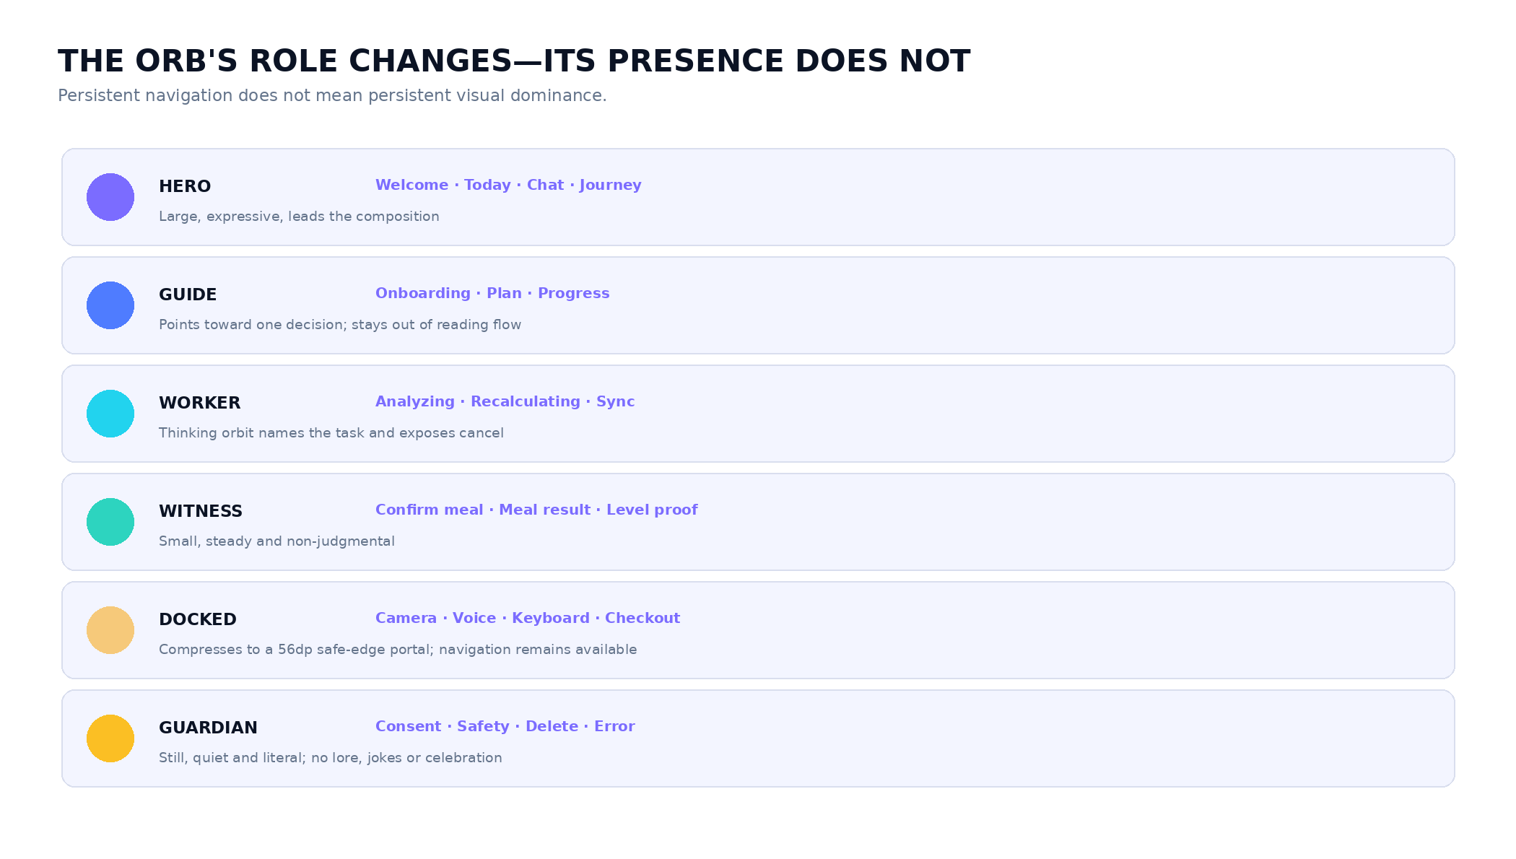
Figure 5. Persistence is constant; visual dominance is contextual.

8.1 The Orb and branches are one organism
The constellation is not a menu drawn around a character. Its branches are extensions of Qamar's lunar body: when the Orb breathes, a nearly invisible luminance moves through the closest filaments; when it becomes attentive, nearby twigs orient toward the active decision; when navigation opens, moonlight travels from the core to each destination. This shared energy origin is what makes the system feel alive rather than decorated.
Element | Relationship rule
Core → branch | Every branch begins inside the Orb's halo; no disconnected line may appear before the originating light reaches it.
Branch → node | A destination node receives and reflects the beam. It does not glow independently until the branch arrives.
Breath | Resting branches carry only a 4-8% luminance tide synchronized loosely—not mechanically—with the Orb's breath.
Focus | One branch gains width, speed and lunar-white core; siblings lower contrast but remain discoverable.
Completion | A single return wave travels node → Orb, then settles. No fireworks, vine growth or endless shimmer.
Interruption | Light pauses in place and fades to a stable resting state; it never snaps, breaks or withers.

PART III
Orb-only navigation
The Orb is not beside the navigation. The Orb is the navigation.

9. Global shell
Locked: There is no application bottom navigation bar, top tab bar, hamburger menu or duplicate persistent navigation. The only global shell is the movable Orb and its five-node constellation.

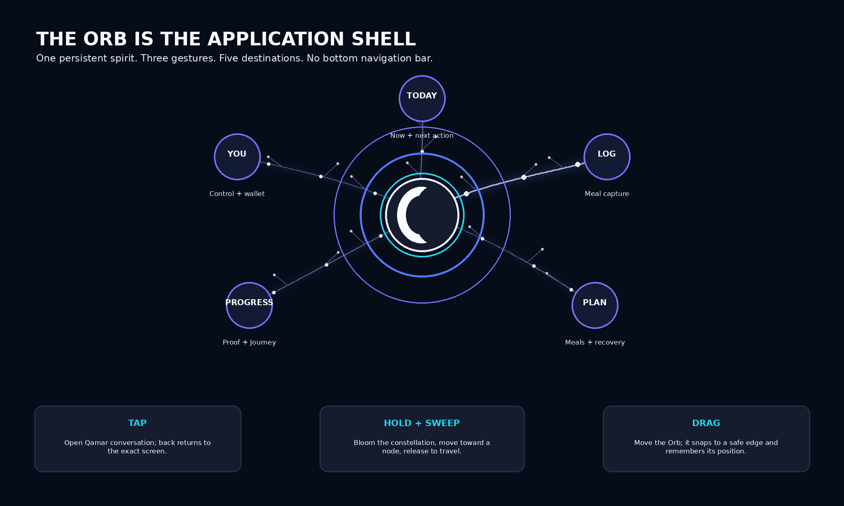
Figure 6. Orb-only global navigation contract.

10. Gesture contract
Input | Recognition | Result | Recovery / accessibility
Tap | Up within 250ms; movement <8dp | Open Qamar chat from the current route | Back returns to exact route/scroll; screen-reader action: Talk to Qamar
Hold | 350ms; movement <10dp | Bloom complete five-node constellation around safe side | Haptic tick; accessible action: Open destinations
Hold + sweep | After bloom, move focus ray to a node; release | Travel to Today, Log, Plan, Progress or You | Node names announced; tap list alternative available
Drag Orb | Movement >8dp before hold completes | Reposition; snap to left/right safe edge | Reset position action; keyboard and switch access can move edge
Double tap | Not assigned | No hidden command | Avoids conflict with assistive technologies
Voice command | From chat or OS-supported action | Open named destination or task | Same authorization and confirmation as touch

11. Constellation behavior
- The five destinations are always complete: Today, Log, Plan, Progress and You. There are no inactive future-agent nodes.
- The constellation blooms into available empty space. From a right-edge Orb it arcs left; from a left-edge Orb it arcs right. RTL does not reverse the meaning of spatial safety.
- Node orbit radius is 104-152dp depending on viewport. Maintain at least 48dp targets and 12dp separation at 200% text.
- Open in 220ms; labels reveal at 50ms stagger; selected ray gains violet-to-cyan light and one haptic tick; transition begins on release.
- Dragging outside the constellation cancels with no route change. Returning to the center opens chat only after release and explicit highlight.
- A simple vertical destination sheet replaces the constellation for screen readers, Switch Control, large text overflow or when Reduce Motion requests it.

11.1 Living moonbeam branch system
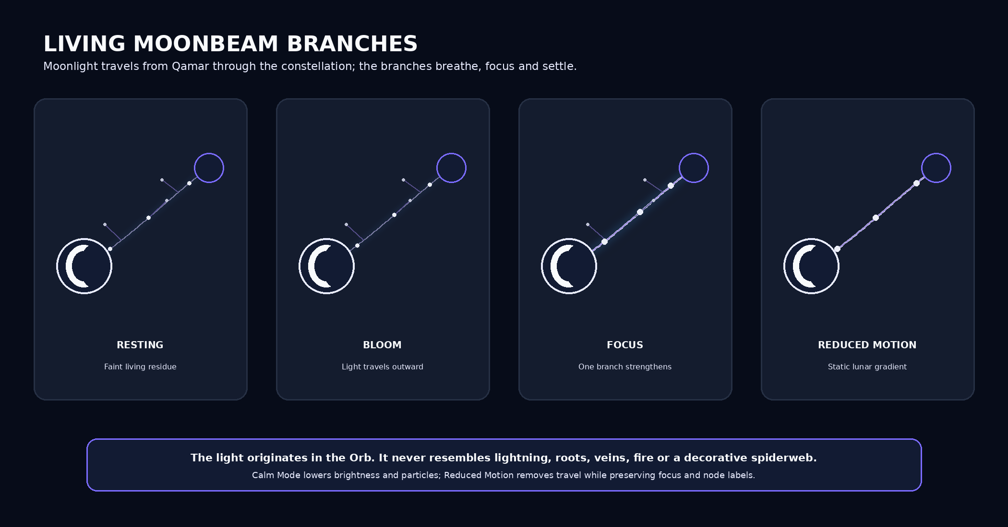
Figure 7. The branches feel alive because lunar energy moves through them with purpose.
Branch state | Visual behavior | Timing | Meaning
Hidden | No branch; only the Orb halo is visible | Default outside navigation/task hints | The interface is calm
Resting residue | Hairline silver-violet filament at 8-14% opacity; one or two dim nodes | 4.8-6.2s luminance tide | The guide is present
Bloom | Core light leaves the Orb and grows along organic curves; offshoots resolve after the trunk | 220ms trunk + 40ms/node stagger | Destinations are becoming available
Available | Five branches remain readable but restrained; nodes carry a soft lunar rim | Static with slow 3-5% light drift | Choose a destination
Hover / focus | One branch thickens 1.5x, becomes lunar-white at the core and sends a bead toward the node | 120-160ms | Current selection
Commit | Selected node pulls one beam; siblings recede; light travels Orb → node | 180-240ms | Navigation accepted
Arrival | A subtle return glint travels node → Orb before the new surface settles | 140-180ms | Route connected
Cancel | Light drains smoothly back into the Orb; node labels fade together | 160-220ms | No route change
Attention | One amber-white bead moves halfway and holds; branch never becomes red | Two pulses maximum | Action or uncertainty needs review
Offline | Travel stops; filaments remain as a stable, lower-contrast map | No loop | Cached routes still exist
Calm Mode | No offshoot particles; slower, lower-contrast branch tide | 6-8s | Same function, less game expression
Reduced Motion | Static silver-violet gradient from Orb to node; focus uses contrast/width only | 120ms crossfade | Full navigation without travel

11.2 Branch geometry and material
- Use one cubic spine per destination with one to three short secondary twigs. Curves are asymmetrical and organic, but destination geometry stays stable enough to learn.
- The branch is layered: 1-2dp lunar-white core, 3-6dp violet/cyan energy, and an 8-18dp blurred aura depending on focus. Never render a hard neon cable.
- Light always travels outward from the Orb for opening/commit and inward for completion/cancel. Reversing this grammar without a state reason weakens the character's physical logic.
- Maximum visible motes: two per branch, eight across the full tree. Motes follow the spine; random background sparkles do not communicate navigation.
- Branches route around text, camera controls, prices and destructive actions. If safe space is insufficient, use the accessible destination sheet rather than compressing the tree into clutter.
- Avoid literal roots, vascular veins, lightning, fire, spiderwebs, cables and biological growth. The material is emitted moonlight with gentle living intelligence.

12. Persistence, docking and safe areas
Context | Orb form | Navigation behavior
Standard scrolling | 64dp visual / 72dp hit area; snap edge; 16dp safe inset | Tap chat, hold constellation, drag reposition
Keyboard | 56dp dock just above keyboard edge | Fully active; route change preserves draft and asks only if data would be lost
Camera / scanner | 56dp translucent portal outside shutter controls | Hold opens constellation after a Leave capture? confirmation
Voice recording | 56dp listening portal beside Stop | Hold requires Stop and leave? confirmation
Checkout | 56dp still portal at safe edge | Hold asks Leave checkout?; payment state is preserved when possible
Destructive confirm | 48-56dp guardian portal, no particle motion | Navigation remains available but warns about abandoning the action
System sheet | Orb remains visually behind native sheet | Returns to same position and state after dismissal
Rotation / device change | Position persisted per orientation class | If invalid, snap to nearest safe point and announce movement

13. Transition language
Transition | Choreography | Duration
Destination travel | Selected node becomes a light portal; current surface recedes 2%; Orb leads a short comet path; destination resolves under it. | 280-380ms
Open chat | Orb expands toward the header presence field; source screen remains as a dim spatial memory. | 260ms
Return from chat | Presence field condenses into the exact prior Orb position; restore scroll and draft. | 220ms
Task handoff | Orb leans to the CTA, tail connects once, then the next surface replaces the card—not the whole world. | 180-260ms
Deep link | Destination appears first, then Orb arrives from the nearest edge; no fake travel through intervening pages. | 180ms
Reduced Motion | Crossfade + 1% scale only; no tail, orbit or parallax. | 120-180ms

13.1 Moonbeam choreography by event
Event | Orb | Branches | Node / surface
Hold threshold met | Core contracts 2%, then brightens | Five trunks begin growing from inside the halo | Labels wait until their branch reaches 70%
Node focus | Veil leans toward focus | Focused branch strengthens; one bead travels outward; siblings dim 20% | Node expands 4% and announces its name
Commit | Core releases one lunar pulse | Selected branch completes; siblings drain inward | Node becomes the destination portal
Arrival | Orb leads and reforms at saved edge | One short return glint confirms continuity | Destination surface resolves beneath the Orb
Cancel | Core opens to receive light | All branches drain inward without snapping | Labels fade together; source remains unchanged
Quest complete | One restrained completion flare | If visible, one outward-and-back wave through the task branch | Phoenix glints only when Su Points are credited
Redemption | Still witness posture | No global tree animation | Phoenix mark glints once; ledger and balance update atomically
Safety / billing / delete | Guardian posture | Hidden or static accessible map only | Literal information takes visual priority

PART IV
Visual and sensory system
Moonlit intelligence, Arabic clarity and disciplined cinematic motion.

14. Color system
Token | Hex | Use
Night Navy | #070C19 | Primary background
Midnight Blue | #0B1324 | Deep surfaces / headings
Space Blue | #121B33 | Raised panels
Glass Surface | #141C2E | Cards / overlays
Lunar White | #F5F7FF | Orb core / high contrast
Moon Glow | #E9ECFF | Secondary moon light
Qamar Violet | #7B6CFF | Primary action / active constellation
Luminous Blue | #4F7CFF | Information / transition
Cyan Glow | #22D3EE | Focus / live processing
Aqua Mint | #2DD4BF | Balanced / supportive signal
Soft Lilac | #A78BFA | Insight / secondary series
Warm Sand | #F6C97A | Su Points / quiet milestone
Success | #22C55E | System success—not the Orb ring
Warning | #FBBF24 | Attention / uncertainty
Error | #F87171 | Literal error copy and controls only
Primary Text | #F8FAFC | Dark-mode text

Orb color rule: The Orb may be neutral moonlight, violet/blue active, cyan working, mint complete or amber attention. It never becomes red, gray-sad, or blacked-out as emotional punishment.

14.1 Su Points phoenix identity
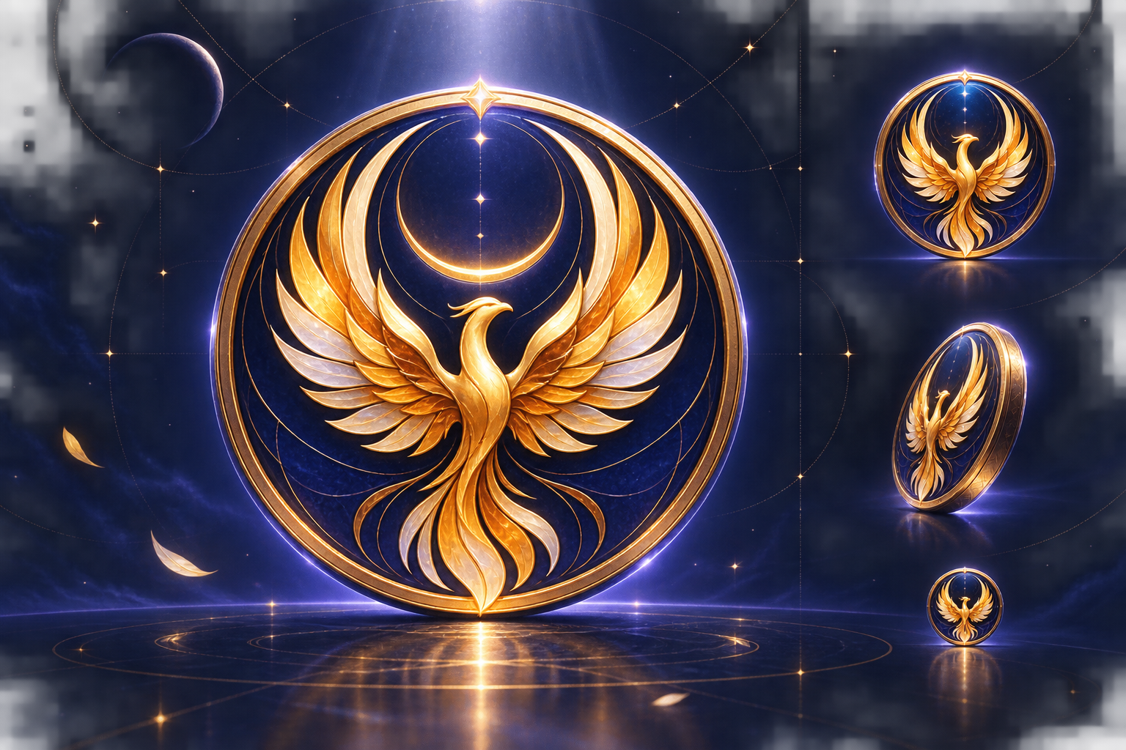
Figure 8. The rising phoenix is the only Su Points currency mark; its meaning is renewal and continued progress.
The phoenix turns Su Points from a generic reward counter into a meaningful symbol of Qamar's product promise: the user can return, recover and continue. It is a currency emblem—not a second character. It never speaks, reacts, flies through the interface or competes with the Orb.
Identity field | Design contract
Meaning | Renewal after interruption, earned progress and continuity. Never wealth, speculation, firepower or status dominance.
Master silhouette | One symmetrical rising phoenix with lifted crescent-like wings and tapered tail. Abstract head; no eyes or facial expression.
Currency token | Deep midnight-blue circular medallion; moon-gold/amber phoenix; optional pale lunar highlight and restrained violet rim.
Small mark | At 16-24dp use a simplified filled silhouette with no feather lines, crescent or outer text. It must survive grayscale and 200% zoom.
Standard mark | At 32-48dp show three primary feather groups per wing, central body and two-part tail; one enclosing ring maximum.
Hero medallion | At 64dp+ allow embossed depth, lunar crescent/halo and subtle enamel texture. No words or denomination inside the token.
Color | Phoenix uses Warm Sand #F6C97A and Warning Gold #FBBF24 as material colors, not warning semantics; highlights may use Moon Glow #E9ECFF.
Motion | One 350-500ms wing-light glint on credit; one downward dim on debit; no flapping, flame, spin, bounce, shower or slot-machine count.
Placement | Prefix wallet balances, quest rewards, spend prices and ledger amounts. Use once per numeric group; never repeat beside every word 'Su Points'.
Semantic label | Announce the numeric amount and 'Su Points'; the phoenix image is decorative when the adjacent text already names the currency.

14.2 Phoenix usage matrix
Surface | Phoenix form | Behavior
Today balance chip | 16-20dp simplified mark inside a 24-28dp medallion | Static; tap opens S59 Wallet
Quest reward | 16dp mark before amount | Warm glint only after confirmed completion
Wallet hero | 56-72dp standard/hero medallion | Low-amplitude lunar shimmer; no autonomous character motion
Ledger credit | 14-16dp simplified mark + positive amount | No animation in scrolling history
Ledger debit | 14-16dp simplified mark + negative amount | Neutral, not red; description explains the spend
Spend catalogue | 16dp mark before exact price | Selected card previews balance after redemption
Insufficient balance | Same mark at normal color; amount and CTA explain the gap | No broken, gray, caged or sad phoenix
Refund | Same mark + returned amount | One quiet reverse glint; ledger remains authoritative
Notifications | No phoenix in lock-screen payload by default | Use generic privacy-safe copy
App icon / Qamar logo | Never | The phoenix belongs only to Su Points; Qamar keeps the crescent identity

14.3 Phoenix misuse
- Do not replace Qamar's crescent, the Orb, application icon or Cipher Labs mark with the phoenix.
- Do not use an Egyptian eagle, heraldic double-headed bird, realistic animal illustration, cute mascot, flame silhouette, casino chip or cryptocurrency coin.
- Do not put 'Su', 'SP', a denomination or circular text inside the emblem. The amount and the words Su Points remain adjacent interface copy.
- Do not recolor the phoenix red for errors, green for credit or gray for insufficient funds. Status comes from text, signs and surrounding UI; the currency identity stays stable.
- Do not animate wings, fire or flight. A material light glint is the maximum movement because the phoenix is an emblem, not a second living guide.
- Do not show multiple phoenix coins raining, stacking or spinning. One mark beside one balance/reward group is enough.

15. Typography and RTL
Element | Production token | Rule
Arabic UI | Noto Sans Arabic 400/500/600/700 | Primary; generous line height; avoid condensed display faces in functional UI
Latin / numbers | Inter 400/500/600/700 | Tabular numbers for calories, macros, balances and charts
Hero greeting | 32/42 Arabic SemiBold | Maximum two lines; right aligned
Page title | 24/34 Arabic Bold | One title; do not compete with the Orb
Card title | 17/26 Arabic SemiBold | Action-led, maximum two lines
Body | 15/24 Arabic Regular | Default readable copy
Label / metadata | 12/19 Arabic Medium | Never use low contrast for essential values
Numbers + units | 28/34 or 16/24 Inter | Keep numeric-unit clusters together; localize presentation

- Primary page flow, alignment, drawers, cards and constellation labels are RTL. Directional chevrons mirror; camera, playback, brand mark and chronological charts do not.
- Charts remain chronologically left-to-right while Arabic titles, legends and text summaries remain RTL.
- The Orb may occupy either edge. Content padding reserves a dynamic 88dp avoidance lane only near its current vertical position, not across the entire page.
- Test Arabic, English food names, Arabizi, numbers and mixed-unit strings in every component.

16. Surfaces, layout and components
System | Rule
Grid | 4dp base; 8/12/16/24/32 spacing; 20dp page gutters; 48dp minimum targets; 56dp primary controls.
Glass | Use blur only on elevated interactive surfaces; border #263044; keep text on stable dark fills, not noisy imagery.
Cards | One message or action per card. 16-20dp radius. No stacked glass within glass unless it reveals evidence.
Primary CTA | One per viewport; explicit verb; violet-to-blue fill; 56dp height; loading state preserves label width.
Chips | Suggested prompts, filters and statuses; 44dp height; wrap in RTL rather than horizontal clipping.
Charts | 2-3 series maximum; direct labels where possible; always provide a text summary and source/period.
Forms | One question per screen or one coherent group; units visible; errors adjacent; keyboard never hides the active control.
Orb avoidance | Content must remain usable with the Orb at either edge and at 200% text. Dragging the Orb never changes data.

17. Motion, haptics and sound
Token | Value | Use
micro | 120-180ms | Focus, chip, small state change
standard | 220-280ms | Cards, chat expansion, sheets
travel | 280-380ms | Orb destination transition
celebrate | 650-900ms | One milestone flare
rest breath | 4.2-5.4s irregular | Low-amplitude idle presence; pauses when static
easing | cubic-bezier(.2,.8,.2,1) | Most UI and Orb settle
haptic light | one selection tick | Constellation node / toggle
haptic confirm | one medium impact | Meal confirm / redemption
sound | off by default | Optional soft chime; never required for meaning
reduced motion | crossfade + <=1% scale | No orbit, parallax, trail or particle field

17.1 Sensory separation: Orb, moonbeams and phoenix
Identity | May animate | Must remain still / absent
Orb | Breath, attention, listening, thinking, guiding, one completion flare | No face, pet behavior, emotional need or sales celebration
Moonbeam branches | Bloom, light travel, focus, return, quiet luminance tide | No random twitching, lightning, fire, breakage, withering or endless particle storm
Phoenix | One material glint on confirmed credit/debit/refund; optional static shimmer on wallet hero | No flapping, flying, speaking, flame eruption, spin, bounce, coin shower or autonomous presence

PART V
Core experience journeys
Each journey is a continuous exchange with the same guide.

18. First launch: awakening, not onboarding theatre
- A thin crescent appears; within 1.2 seconds it becomes the resting Orb. Continue is immediately available—animation never holds the user hostage.
- Qamar states the promise and AI/non-medical boundary, creates a guest identity, resolves 18+ eligibility and consent, then asks only the minimum questions needed for a target.
- Each answer physically changes the guide's attention, not its affection. The sequence ends with a usable first route before sign-in, notification or payment pressure.

19. Daily loop: guide, act, adapt
- Today opens on the next decision, not a score. The Orb occupies intentional empty space and guides once toward the highest-value action.
- The user logs what happened. Qamar analyzes, asks for confirmation, writes only the confirmed record, updates the remaining day and offers one action.
- If the day changed, Recovery redraws unconsumed meals. No restart screen, lost streak or compensatory fasting/exercise language appears.

20. Meal logging: capture without false certainty
- Hold the Orb, sweep to Log, then choose photo, voice, text, barcode, recent or manual. The same methods remain available in an accessible list.
- The living branches bloom from the Orb into capture choices, then retract before camera or microphone use. The Orb docks during capture, works visibly during analysis, and becomes a calm witness during confirmation.
- The result shows what changed and the next decision. A phoenix-marked Su Points credit may acknowledge a useful behavior, but never replace nutrition clarity or trigger a reward shower.

21. Planning and recovery: the map redraws
- The plan is a route through the day, not a rigid prescription. The Orb travels the route while the user scrolls and exposes Why for each meal.
- Substitutions compare realistic alternatives. Recovery changes only the remaining day and refuses punitive compensation.
- The chosen change animates as a path reroute, then settles; the animation is descriptive, not magical certainty.

22. Progress, Journey and Su Points
- Progress presents consistency, logged behavior, useful trends and optional weight—not a total-body score.
- Journey turns lifetime useful behavior into Levels 1-20 and controlled Orb/moonbeam-tree cosmetics. Branch maturity is expressed through richer lunar flow and more graceful structure—not more clutter. Spending points never lowers lifetime progression.
- The phoenix-branded wallet separates available balance from lifetime earned, shows every ledger entry and exact redemption price, and states no cash value, transfer or expiry at launch. The phoenix symbolizes renewal; it never becomes a second assistant.

23. Trust, billing and safety
- On source, privacy, consent, checkout, delete and unsupported states, Qamar becomes still. Information—not character performance—takes visual priority.
- The Orb remains a visible navigation portal. Leaving a transactional or destructive flow requires a plain confirmation only when work may be lost.
- No fantasy terminology appears in renewal disclosure, nutrition evidence, uncertainty, clinical boundaries or data rights.

24. Today composition reference
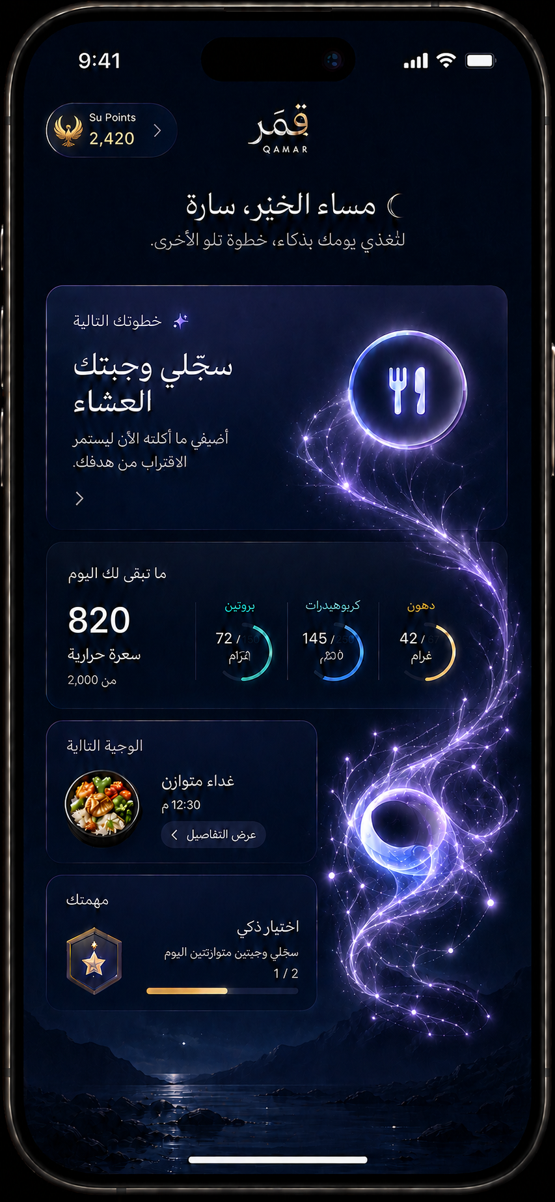
Figure 9. Version 2.0 composition: the Orb emits living moonbeam branches and Su Points carry the phoenix emblem.
The reference demonstrates the hierarchy: one next-action hero, supporting nutrition context, one quest, and the Orb occupying the open edge as a persistent living portal. The filaments visibly inherit the Orb's light and branch around content; the wallet chip uses a single compact phoenix. Production should reduce branch aura and node density wherever they approach a reading zone, preserve 48dp targets, and validate all Arabic copy and data. The iPhone home indicator is operating-system chrome—not application navigation.
PART VI
Every launch page
Sixty-two routes, one continuous character and one navigation language.

25. App shell and trust entry
The opening pages establish continuity, eligibility and consent before personalization. The Orb is present but becomes quieter as the information becomes more serious.

S01 · Splash
Experience field | Design contract
User question | Is Qamar ready for me?
Page composition | Near-black field, faint crescent, compact status line; no decorative dashboard.
Primary action | Resolve session, configuration and deep link automatically.
Orb role | Awakens from a thin crescent into one slow breath; it is the only visible product control once ready.
States / exit | Restored / first launch / offline cache / route resolved. Continue within two seconds or name the delay.

S02 · Update / Maintenance
Experience field | Design contract
User question | Why can I not continue?
Page composition | Plain service card, version/status, retry or store action. No lore.
Primary action | Retry, open the store, or use cached Today when permitted.
Orb role | Guardian: small, still and docked beside the status card; tap opens the accessible navigation sheet only when another route is valid.
States / exit | Required update / maintenance / retry / cached read-only / exit.

S03 · Welcome / Continue
Experience field | Design contract
User question | What is Qamar and can I start now?
Page composition | Hero Orb above one promise, AI + non-medical qualifier, one Continue action.
Primary action | Create a private guest identity in one tap.
Orb role | Hero: full veil, gentle forward drift, one welcoming breath; no speech bubble until the user engages.
States / exit | New / returning / restored; Continue leads to eligibility with no fields.

S04 · Save Progress
Experience field | Design contract
User question | How do I keep what I have already done?
Page composition | Dismissible sheet with Apple, Google and email; value preserved behind it.
Primary action | Link identity without creating a second profile.
Orb role | Guide: rests on the sheet edge and points once toward the platform-preferred option; never blocks Dismiss.
States / exit | Suggested / required for recovery, purchase, export / provider cancel / collision / resume source.

S05 · Email OTP
Experience field | Design contract
User question | How do I verify without a password?
Page composition | One email field, then six cells with system autofill, resend timer and change email.
Primary action | Verify the code and return to the interrupted action.
Orb role | Docked portal: 56dp safe-edge form; its inner crescent pulses once when a code is auto-filled.
States / exit | Sent / invalid / expired / resend / offline / verified.

S06 · Age Eligibility
Experience field | Design contract
User question | Can Qamar support me now?
Page composition | 18+ decision with date of birth and a clear adults-only explanation.
Primary action | Confirm eligibility or exit.
Orb role | Guardian: still, dimmer halo, no playful motion or lore.
States / exit | Eligible / under 18 blocked / inconsistent age / exit.

S07 · Consent
Experience field | Design contract
User question | What am I agreeing to?
Page composition | Layered summary: required service/privacy first; optional improvement consent separate and off.
Primary action | Accept required terms, manage optional choice, or decline.
Orb role | Guardian: stationary at the safe edge; tap exposes navigation/help without interrupting reading.
States / exit | First consent / policy update / optional on-off / decline.

26. Onboarding and first value
Onboarding is a guided conversation, one coherent decision at a time, ending in a useful route before permanent sign-in.

S08 · Name — Optional
Experience field | Design contract
User question | What may Qamar call me?
Page composition | Single field, Skip equal in dignity, short explanation of why it is optional.
Primary action | Save a preferred name or skip.
Orb role | Guide: attentive posture; its light warms slightly after a valid entry but does not celebrate personal data.
States / exit | Empty / valid / invalid length / skip.

S09 · Body Inputs
Experience field | Design contract
User question | What information is needed for an estimate?
Page composition | One input per step: age, biological estimate input, height and weight; visible units and Why link.
Primary action | Enter or correct inputs and continue.
Orb role | Guide: moves with the active field and collapses beside the keyboard; tap remains chat/navigation.
States / exit | Metric / imperial / validation / Why / keyboard / back.

S10 · Goal
Experience field | Design contract
User question | What route am I choosing?
Page composition | Lose, maintain or gain cards; conservative pace; optional target weight.
Primary action | Choose a goal and review the pace.
Orb role | Guide: traces a short path between choices; no trophy or body imagery.
States / exit | Selected / contradictory / unsafe request / edit.

S11 · Activity & Routine
Experience field | Design contract
User question | What does my real day look like?
Page composition | Plain-language activity examples, meal times, work pattern and one common break point.
Primary action | Build a realistic routine model.
Orb role | Attentive: small orbit follows the active question; one-question-at-a-time pacing.
States / exit | Required minimum / optional detail / time picker / skip detail.

S12 · Food Preferences
Experience field | Design contract
User question | What must Qamar respect?
Page composition | Separate hard exclusions/allergies from dislikes, favorites, cooking access and common Egyptian meals.
Primary action | Save rules and preferences.
Orb role | Guardian for hard rules, guide for preferences; color and copy distinguish must-not from prefer-not.
States / exit | Empty / conflict / hard rule / soft preference / search / custom item.

S13 · Safety Filter
Experience field | Design contract
User question | Is personalized guidance appropriate here?
Page composition | Calm checklist with plain explanations and professional-care route.
Primary action | Continue only when supported.
Orb role | Guardian: motion pauses; neutral light, literal copy, no gamification.
States / exit | Supported / pregnancy-breastfeeding / eating-disorder risk / clinical complexity / exit.

S14 · Target Review
Experience field | Design contract
User question | What is my estimate and why?
Page composition | Calories/macros, assumptions, formula version, estimate label, Edit and Confirm.
Primary action | Confirm or recalculate the route.
Orb role | Witness: floats beside the summary; crescent aligns when assumptions are opened.
States / exit | Ready / stale inputs / recalculating / Why detail / confirmed.

S15 · First Route
Experience field | Design contract
User question | What do I do first?
Page composition | One-day route, first meal suggestion, quick log CTA, no permission prompt before value.
Primary action | Log the first real meal or open the plan.
Orb role | Hero-guide: reveals the route as a short constellation and points to one starting action.
States / exit | Plan ready / empty / regenerate / save-progress suggestion / Today.

27. Today and conversation
Today is the daily home; Chat is the Orb expanded into a conversation. Neither introduces a duplicate navigation shell.

S16 · Today
Experience field | Design contract
User question | Where am I now and what is the next useful move?
Page composition | Greeting, next-action hero, remaining calories/macros, next meal, one quest and phoenix-branded Su Points chip; no bottom bar.
Primary action | Complete the next action, log, ask or open the living constellation.
Orb role | Hero: breathes in open space; dormant moonbeam filaments echo its breath, then one branch leans toward the next action while the Orb remains the global navigation portal.
States / exit | Morning / on-route / over estimate / missing log / comeback / offline / quota / Calm / Reduced Motion.

S17 · Quick Actions
Experience field | Design contract
User question | What can I do from here?
Page composition | Radial or bottom-safe sheet anchored to the Orb: Log, Ask, Adjust, Scan; not persistent navigation.
Primary action | Choose one contextual task.
Orb role | Becomes the sheet anchor; four short moonbeam twigs grow from the veil, focus one at a time, then retract into the Orb.
States / exit | Open / one-handed edge variant / large text list variant / Reduced Motion list / dismissed.

S18 · Qamar Chat
Experience field | Design contract
User question | Can Qamar help me decide?
Page composition | Orb presence field, conversation, structured insight cards, composer with text/voice/photo; history optional.
Primary action | Ask, review evidence, or execute a visible action card.
Orb role | Hero-speaker: expands into the header, listens, thinks and speaks through light; no duplicate floating Orb.
States / exit | Listening / thinking / streaming / tool action / refusal / quota / retry / back to exact source.

S19 · Suggested Prompts
Experience field | Design contract
User question | What could I ask right now?
Page composition | Three contextual chips tied to today, meals and progress; horizontal scroll avoided in RTL.
Primary action | Send or edit a suggested prompt.
Orb role | Attentive: one subtle glance of light toward suggestions; never auto-sends.
States / exit | Contextual / generic / hidden after typing / refreshed.

S20 · Quota State
Experience field | Design contract
User question | What remains free and what can I do now?
Page composition | Usage/reset, manual alternative, Su Points option where valid, and truthful Qamar+ offer.
Primary action | Continue free, redeem, upgrade or close.
Orb role | Guardian: no sad animation; neutral ring and clear routes.
States / exit | Near cap / cap reached / points available / paywall / reset / offline.

28. Meal capture and confirmation
Capture reduces friction; confirmation protects accuracy. The Orb shifts from router to worker to witness.

S21 · Log Method
Experience field | Design contract
User question | What is the easiest way to log this meal?
Page composition | Photo, voice, text, barcode, recent and manual methods bloom as a compact living constellation around the Orb.
Primary action | Choose a capture method.
Orb role | Navigation becomes task routing: six moonbeam branches grow from the core, with a slow outward pulse; the accessible list mirrors every branch.
States / exit | Available / permission denied / modality quota / recent empty / Calm / Reduced Motion / cancel.

S22 · Photo Capture
Experience field | Design contract
User question | Can I photograph the meal clearly?
Page composition | Full camera, framing guide, flash/gallery, privacy note and capture control.
Primary action | Capture or choose a photo.
Orb role | Docked but present: 56dp translucent portal outside camera controls; hold opens navigation after a leave-camera confirmation.
States / exit | Permission education / live / captured / retake / upload / low light / exit.

S23 · Voice Capture
Experience field | Design contract
User question | Can I describe what I ate naturally?
Page composition | Large waveform, timer, Stop, editable transcript preview and language hint.
Primary action | Record, stop, edit and analyze.
Orb role | Listening: crescent contracts with voice energy without mimicking every syllable; docks beside Stop.
States / exit | Permission / recording / paused / transcript / no speech / quota / cancel.

S24 · Text Entry
Experience field | Design contract
User question | Can I log this in my own words?
Page composition | Large Arabic-first composer, examples in Egyptian Arabic/Arabizi, recent foods and manual search.
Primary action | Submit text or choose a structured item.
Orb role | Docked above keyboard; one soft attentive pulse after input stops.
States / exit | Empty / composing / mixed language / suggestions / validation / cancel.

S25 · Analyzing
Experience field | Design contract
User question | What is Qamar doing with my input?
Page composition | Named steps—detecting items, matching portions, calculating—plus cancel and elapsed fallback.
Primary action | Wait, cancel, or switch to manual after threshold.
Orb role | Worker: thinking orbit and controlled veil rotation; each task step changes orbit, not character identity.
States / exit | Photo / voice / text / barcode / slow / failed / cancelled / manual fallback.

S26 · Confirm Meal
Experience field | Design contract
User question | Is this estimate actually my meal?
Page composition | Detected items, portions, methods, confidence, source labels and total; Edit precedes Confirm.
Primary action | Correct every item, then confirm the record.
Orb role | Witness: small and steady; amber attention only beside uncertain items, never red judgment.
States / exit | High/medium/low confidence / missing portion / source conflict / edit / confirmed.

S27 · Edit Food Item
Experience field | Design contract
User question | How do I correct this item?
Page composition | Search, Egyptian aliases, portion visual, cooking method, source and custom/manual values.
Primary action | Save corrected item or remove it.
Orb role | Guide: points to the one unresolved field, then returns to rest.
States / exit | Search / no match / custom / portion units / validation / delete.

S28 · Meal Result
Experience field | Design contract
User question | What changed and what should I do next?
Page composition | Updated remaining day, confidence note, one recovery or next-meal action and View details.
Primary action | Take the next action or return to Today.
Orb role | Witness-to-guide: one quiet completion flare, then leans toward the next useful action.
States / exit | On route / exceeded estimate / incomplete item / points earned / sync pending.

S29 · Meal Detail
Experience field | Design contract
User question | What exactly was saved?
Page composition | Items, portions, nutrients, source/confidence, timestamps and Edit/Delete/Report.
Primary action | Inspect, correct, delete or report.
Orb role | Guardian-witness: still beside provenance; destructive action moves it to the confirmation edge.
States / exit | Saved / edited / sync pending / delete confirm / reported.

29. Plan and recovery
The plan behaves like a route that can be redrawn without shame.

S30 · Day Plan
Experience field | Design contract
User question | What is the full route for today?
Page composition | Timeline of meals with totals, flexibility slots and recovery entry; one meal expanded at a time.
Primary action | Open, swap, log or replan a meal.
Orb role | Guide: travels down the meal path as the user scrolls but remains snapped to the safe edge.
States / exit | Current / future / consumed / skipped / stale / offline.

S31 · Plan Meal Detail
Experience field | Design contract
User question | Why is this meal here?
Page composition | Dish, portion, ingredients, macros, rationale, substitutions and Log as eaten.
Primary action | Log, swap or edit serving.
Orb role | Guide: reveals Why as a short light path from target to meal; factual copy stays literal.
States / exit | Planned / unavailable / preference conflict / logged / source detail.

S32 · Substitution
Experience field | Design contract
User question | What realistic alternative fits?
Page composition | Three options compared by fit, portion, time/cost and difference from the original.
Primary action | Choose a substitution or ask for more.
Orb role | Guide: moves once between options and settles beside the strongest fit; user remains in control.
States / exit | Candidates / none / quota / hard-rule conflict / selected.

S33 · Recovery / Replan
Experience field | Design contract
User question | How do I continue after real life changed?
Page composition | What happened, untouched meals, smallest safe adjustment, no compensation or shame.
Primary action | Accept the revised remaining day or keep the current plan.
Orb role | Recovery guide: returns from dim rest to steady light; language says route change, never failure.
States / exit | Off-plan meal / missed meal / schedule change / cannot recalculate / accepted.

30. Progress and weekly intelligence
Progress shows evidence of behavior and one actionable pattern—not a broad health score.

S34 · Progress
Experience field | Design contract
User question | Is my behavior becoming more consistent?
Page composition | 7/30/90-day range, active days, logging completeness, macro/diet-quality signals and optional weight trend.
Primary action | Inspect a pattern, open Journey or read the weekly insight.
Orb role | Guide: traces one trend at a time; chart text summary remains primary for accessibility.
States / exit | Insufficient data / 7d / 30d / 90d / guest / offline.

S35 · Add Weight
Experience field | Design contract
User question | Do I want to record an optional measurement?
Page composition | One numeric field, date/time, units and delete/edit history; neutral copy.
Primary action | Save or skip.
Orb role | Witness: still and small; no celebration or negative reaction to direction of change.
States / exit | Empty / saved / edited / deleted / implausible value.

S36 · Weekly Insight
Experience field | Design contract
User question | What mattered this week?
Page composition | One win, one evidence-backed pattern, one recommended quest, comparison chart and Why/source detail.
Primary action | Accept quest, adjust plan or ask a follow-up.
Orb role | Narrator-guide: speaks through progressive cards, then points to one action—not a wall of analysis.
States / exit | Ready / partial data / source detail / follow-up quota / dismissed.

31. User control, billing and privacy
These pages prioritize explicit control. The Orb remains available and becomes calm, literal and non-promotional.

S37 · You Hub
Experience field | Design contract
User question | How do I control my Qamar?
Page composition | Identity, goals, preferences, Journey, phoenix wallet, reminders, subscription, memory, privacy and help in grouped cards.
Primary action | Open or edit one control area.
Orb role | Portal: holds the five-destination living constellation; in-page settings radiate as a compact secondary list without imitating global branches.
States / exit | Guest / linked / stale target / subscription issue / offline / Reduced Motion.

S38 · Goals & Targets
Experience field | Design contract
User question | What assumptions guide my route?
Page composition | Current goal, pace, inputs, target version, edit/recalculate and Why.
Primary action | Preview and confirm a change.
Orb role | Guardian-guide: shows impact before commit; still during confirmation.
States / exit | Current / stale / recalculating / unsafe request / saved.

S39 · Food Preferences
Experience field | Design contract
User question | What does Qamar remember about my food?
Page composition | Hard rules first, then dislikes, favorites, routine and cooking/budget preferences.
Primary action | Add, edit, resolve or remove a rule.
Orb role | Guardian for exclusions; guide for preferences; conflict shown with amber attention.
States / exit | Empty / active / conflict / proposed memory / deleted.

S40 · Memory
Experience field | Design contract
User question | What does Qamar remember and why?
Page composition | User-controlled memory cards with category, source, date, confidence, Edit and Delete.
Primary action | Confirm, edit, reject, delete or export.
Orb role | Witness: small, transparent, never claims feelings or hidden memory.
States / exit | Empty / proposed / confirmed / conflict / deletion / sync error.

S41 · Reminders
Experience field | Design contract
User question | When may Qamar invite me back?
Page composition | Daily/meal/weekly toggles, times, quiet hours, lock-screen preview and OS status.
Primary action | Enable, edit, test or open OS settings.
Orb role | Guide: moves along a quiet time arc; respects disabled haptics and motion.
States / exit | Not asked / allowed / denied / scheduled / time-zone change.

S42 · Subscription
Experience field | Design contract
User question | What is my Qamar+ status?
Page composition | Current entitlement, renewal, manage, restore, receipt issue and included limits.
Primary action | Manage, restore or resolve billing.
Orb role | Guardian: docked, still and literal; no celebratory sales behavior.
States / exit | Free / active / trial / grace / pending / expired / restored.

S43 · Paywall & Offer
Experience field | Design contract
User question | What am I buying and what renews?
Page composition | Plans, promo box, first-period and renewal disclosure, native purchase CTA, Restore and Close.
Primary action | Apply offer, purchase, restore or continue free.
Orb role | Docked portal remains available; no movement near prices. Hold requires leave-checkout confirmation before navigation.
States / exit | Loading price / eligible / invalid code / pending / success / cancel / failed / grace.

S44 · Privacy & Consents
Experience field | Design contract
User question | How is my information used?
Page composition | Consent versions, optional improvement choice, retention summary, export and delete routes.
Primary action | Change optional choice or open a data action.
Orb role | Guardian: dim, motionless and fully semantic; no fantasy language.
States / exit | Current / policy update / withdrawal / offline.

S45 · Export
Experience field | Design contract
User question | How do I take my data with me?
Page composition | Scope, format, verification, request status, expiry and secure download.
Primary action | Request, verify and download.
Orb role | Worker during preparation, guardian at download; docked and non-intrusive.
States / exit | Needs linked identity / preparing / ready / expired / failed.

S46 · Delete Account
Experience field | Design contract
User question | What will be removed and what will not?
Page composition | Plain consequences, subscription separation, re-authentication and typed/hold confirmation.
Primary action | Delete or cancel.
Orb role | Guardian: smallest legal portal at edge; no animation after destructive intent except progress and completion.
States / exit | Warning / active subscription / reauth / processing / complete / failed.

S47 · Help & Safety
Experience field | Design contract
User question | What can Qamar do, and where do I get help?
Page composition | Scope, safety boundary, FAQ, policies, support code and replay Orb tutorial.
Primary action | Read, contact support, copy code or open policy.
Orb role | Guide for tutorial, guardian for safety; no lore in clinical boundaries.
States / exit | Search / article / support unavailable / offline.

S48 · Report Feedback
Experience field | Design contract
User question | How do I correct Qamar safely?
Page composition | Report type, what will be sent, optional note/attachment consent and support code.
Primary action | Submit, omit attachment or cancel.
Orb role | Witness: acknowledges submission once; never treats a report as a quest.
States / exit | Draft / queued offline / submitted / rate limited / failed.

32. Universal recovery and account routes
Offline, permission, error, unsupported and identity states preserve context and always offer a truthful next route.

S49 · Offline Banner
Experience field | Design contract
User question | What still works without a connection?
Page composition | Compact top banner plus queued-item state; cached content remains readable.
Primary action | Continue locally, retry or review queue.
Orb role | Offline posture: lower glow and static tail, still fully navigable to cached destinations.
States / exit | Offline / reconnecting / queued / conflict / synced.

S50 · Permission Education
Experience field | Design contract
User question | Why does Qamar need this permission?
Page composition | One purpose, one privacy promise, Enable and manual alternative.
Primary action | Open OS prompt or choose the alternative.
Orb role | Guide: indicates the relevant capability, never pressures after denial.
States / exit | Not asked / allowed / denied / limited / settings route.

S51 · Error & Retry
Experience field | Design contract
User question | Was my work preserved?
Page composition | Named error, preserved draft confirmation, Retry, Manual route and support code when needed.
Primary action | Retry, recover manually or leave.
Orb role | Recovery: pauses, regains steady light, points to the safest next action; never red.
States / exit | Transient / validation / provider / sync / preserved / unrecoverable.

S52 · Unsupported State
Experience field | Design contract
User question | Why is personalized use unavailable?
Page composition | Clear boundary, what Qamar will not provide, professional-care route and account/privacy options.
Primary action | Exit, open help or manage data.
Orb role | Guardian: neutral, still and literal; constellation only exposes safe destinations.
States / exit | Age / high-risk / region-service / temporary unsupported.

S53 · Linked Identities
Experience field | Design contract
User question | How can I recover my account?
Page composition | Apple, Google, email, sessions, link/unlink, merge status and last-used device.
Primary action | Add, verify, remove or sign out a session.
Orb role | Guardian-guide: docks during provider sheets and returns to the same location.
States / exit | Guest / linked / collision / merge review / reauth / removed.

33. Journey, achievements and wallet
Game expression makes consistent behavior visible while protecting autonomy and avoiding punishment or gambling patterns.

S54 · Journey
Experience field | Design contract
User question | How is my consistency growing?
Page composition | Level, lifetime earned Su Points, available phoenix wallet, moonbeam-tree growth, active quests and recent milestones.
Primary action | Open quest, achievements, wallet or Calm Mode.
Orb role | Hero: the spirit and living branches mature through restraint—richer lunar flow and more graceful branching, never larger clutter. The phoenix appears only on Su Points currency surfaces.
States / exit | New / active / returning / level near / Calm Mode / Reduced Motion / offline.

S55 · Quest Detail & Replace
Experience field | Design contract
User question | What counts, why, and can I choose another route?
Page composition | Objective, evidence, phoenix-marked Su Points reward, completion condition, Replace and Skip.
Primary action | Start, replace or skip without penalty.
Orb role | Guide: one moonbeam branch connects objective to evidence; reward uses the phoenix mark without coin shower or urgency.
States / exit | Available / in progress / complete / replaced / skipped / expired / Reduced Motion.

S56 · Level Up
Experience field | Design contract
User question | What changed because I stayed consistent?
Page composition | Short full-screen milestone, unlocked cosmetic/moonbeam-tree change, Continue and Calm Mode preference.
Primary action | Acknowledge and continue.
Orb role | Celebrates with one 900ms flare; a single wave travels through visible branches and settles. No phoenix unless Su Points are also awarded.
States / exit | Standard / Reduced Motion / Calm Mode / queued while busy.

S57 · Achievements
Experience field | Design contract
User question | What have I proven through behavior?
Page composition | Collection grouped by logging, learning, recovery and consistency; no body/weight trophies.
Primary action | Inspect evidence or equip a cosmetic.
Orb role | Curator: illuminates earned marks; locked items state the behavior, never tease random rewards.
States / exit | Empty / earned / equipped / Calm Mode / offline.

S58 · Journey Preferences
Experience field | Design contract
User question | How much game expression feels right?
Page composition | Calm Mode, reduced celebration, haptics, sound and motion preview.
Primary action | Set the experience intensity.
Orb role | Live preview within safe limits; changes immediately and remains reversible.
States / exit | Default / Calm / reduced motion / haptics off / sound off.

S59 · Su Points Wallet
Experience field | Design contract
User question | What do I have, how did I earn it, and where can I spend it?
Page composition | Phoenix medallion, available balance, lifetime earned, ledger, spend catalogue, prices, balance-after preview and terms.
Primary action | Inspect history or confirm a transparent redemption.
Orb role | Guide-witness: the moon-gold phoenix is the sole currency emblem; no coin shower, flame burst, gambling motion or scarcity panic. Redemption gets one quiet phoenix glint and ledger confirmation.
States / exit | Empty / available / insufficient / redeeming / success / refunded / read-only offline / Calm / Reduced Motion.

34. Packaged food and evidence
Barcode, label capture and source detail make estimates correctable and traceable.

S60 · Barcode Scan & Product
Experience field | Design contract
User question | Can Qamar identify this packaged food?
Page composition | Scanner, product source/date, serving confirmation, nutrients and manual fallback.
Primary action | Scan, confirm serving, correct or photograph the label.
Orb role | Docked beside scanner controls; thinking orbit appears only after capture.
States / exit | Permission / scanning / match / ambiguous / no match / offline cache.

S61 · Why & Source Detail
Experience field | Design contract
User question | Why should I trust this estimate or guidance?
Page composition | Claim or formula, inputs, assumptions, source title/date, confidence and what may change the answer.
Primary action | Inspect, correct inputs or return.
Orb role | Witness: small, steady and silent; evidence—not character—is the hero here.
States / exit | Formula / food source / guidance source / stale / unavailable.

S62 · Nutrition Label Capture
Experience field | Design contract
User question | Can I add a product Qamar does not know?
Page composition | Photo crop, OCR fields, serving units, edit validation, source=label and private-product notice.
Primary action | Capture, correct and confirm.
Orb role | Worker: docked for camera, thinking during OCR, witness during field confirmation.
States / exit | Permission / crop / parsing / low confidence / validation / saved / cancel.

PART VII
Design handoff and QA
A living character requires tighter implementation discipline than a static floating button.

35. Figma and component architecture
Page / library | Required contents
00 Foundations | Color variables, typography, spacing, radius, elevation, focus, RTL and accessibility annotations
01 Orb anatomy | Vector/material layers, safe silhouettes at 24/48/56/72dp, light and dark backgrounds
02 Orb states | All state variants, transition names, entry/exit frames, Calm and Reduced Motion variants
03 Orb navigation | Edge positions, five-node living constellation, branch spines/states, accessible list, drag/snap, keyboard/camera/checkout docking
04 Components | Cards, buttons, chips, fields, charts, source cards, quest cards, phoenix currency marks, wallet rows and system states
05-14 Screen families | S01-S62 organized exactly by the families in this bible; Arabic RTL is canonical
15 Prototypes | First launch, daily loop, logging, plan recovery, weekly insight, wallet redemption and checkout
16 Handoff | Motion specs, Rive/Lottie asset names, Flutter state mapping, analytics IDs and redlines

36. Orb implementation contract
Concern | Build requirement
Renderer | Rive state machine preferred for interactive vector/mesh states; use deterministic state inputs, not free-running decorative timelines.
State inputs | route, role, activity, attention, network, calmMode, reduceMotion, edge, keyboard, capture, transaction, safety context, treeOpen, focusedNode and branchPhase.
Hit testing | Visual may be 48-64dp; semantic hit area >=56dp and separated from destructive/payment controls.
Physics | Critically damped snap; no bouncy toy easing. Tail follows velocity with a capped length and decays after settle.
Branch renderer | Use stable cubic spines plus layered glow/core/motes. Branch geometry is deterministic per edge/size class; only light phase changes continuously.
Performance | 60fps target; degrade branch motes, aura blur and secondary twigs before frame rate. Core navigation remains responsive under AI/network load.
Persistence | Store normalized edge + vertical fraction by portrait/landscape/size class. Never sync exact coordinates across devices.
Semantics | Arabic label 'قمر'; actions: talk, open destinations, move left/right, reset position; state announced only when meaningful.
Phoenix assets | One vector master with hero, standard and micro simplifications; do not rely on raster downscaling for the wallet chip.
Analytics | orb_tap, orb_hold, orb_drag, constellation_open, branch_bloom, node_focus, node_select, cancel and accessible_action—without conversation content.

37. Acceptance checklist
- No screen contains an application bottom navigation bar or duplicate persistent tab shell.
- A visible, semantic Orb portal remains on every usable route, including camera, keyboard, checkout and confirmation contexts.
- Every global destination is reachable with hold+sweep, an accessible tap list, screen-reader actions and supported voice routing.
- Tap, hold and drag thresholds do not conflict; accidental navigation rate is tested with left- and right-handed users.
- Route changes preserve drafts, scroll, source screen and transaction state or warn before abandoning them.
- The Orb has no eyes, mouth, cartoon face, pet needs, emotional coercion or endless attention loops.
- Every animation has a semantic equivalent and a Reduced Motion variant; Calm Mode removes reward pressure without removing utility.
- Every branch begins inside the Orb halo, carries purposeful outward/inward light, avoids critical content, and has Available, Focus, Commit, Cancel, Offline, Calm and Reduced Motion states.
- Arabic RTL, mixed Arabic/English/Arabizi, 200% text, VoiceOver/TalkBack and Switch Control are validated across S01-S62.
- Nutrition estimates remain editable and confidence/source-labelled; safety, evidence, privacy and billing use literal language.
- No Health OS, sleep, HRV, hydration, movement or workout metrics appear in the nutrition MVP.
- Every Su Points surface uses the approved rising-phoenix emblem at the correct simplification level; no 'Su' coin, generic star, fire animation, casino styling or alternate currency icon remains.
- Su Points show available and lifetime values separately; redemption is explicit, deterministic, reversible on failure and never pay-to-win.
- Frame-time, battery, thermal and memory tests prove the living Orb does not damage core usability on target founder devices.

38. Prototype test script
- Start as a guest, complete eligibility/consent, create a target and reach the first route without signing in.
- Move the Orb to both edges; open and cancel the constellation; select each of the five destinations; reset position.
- Observe branch direction and light origin from both edges; verify Focus, Commit, Arrival, Cancel, Offline, Calm and Reduced Motion variants without clipped labels or obscured content.
- Log one meal by photo, one by voice and one by text; correct low-confidence portions; verify Orb worker/witness states.
- Open chat from a scrolled page, perform an action, return and confirm exact context restoration.
- Open camera, keyboard, checkout and delete confirmation; verify the Orb docks but never disappears or overlaps a critical control.
- Simulate offline, quota, provider error and app restart; verify preserved work and truthful recovery routes.
- Enable Reduced Motion, Calm Mode, 200% text, TalkBack/VoiceOver and Switch Control; complete the same journeys without gesture-only blockers.
- Inspect every Su Points occurrence at micro, standard and hero scale; verify the phoenix remains recognizable, semantic labels announce the amount, and no duplicate currency emblem appears.

39. Final design principle
The standard: If the user remembers a bar, a dashboard or a mascot, the experience is ordinary. If the user remembers that Qamar stayed present, understood where they were, and quietly showed the next path, the experience is working.

