SPARK & PYSPARK

Theophila Murphy S

DE-Batch-6

**Working with the different Files (Schema,Show,dtypes)**

**Text File**

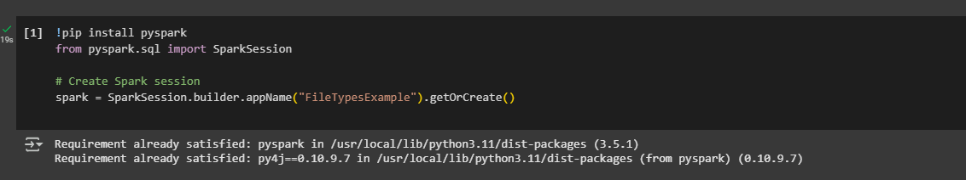

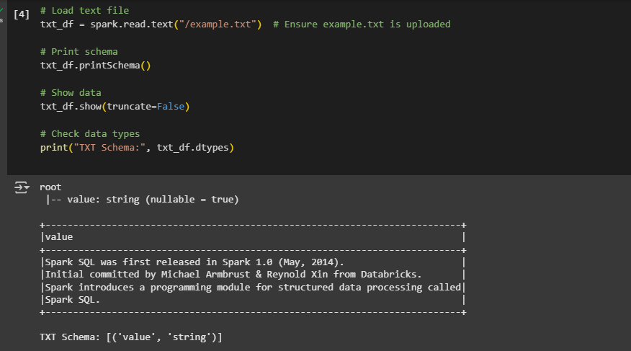

**CSV File**

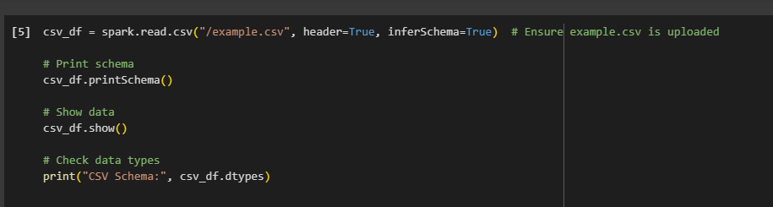

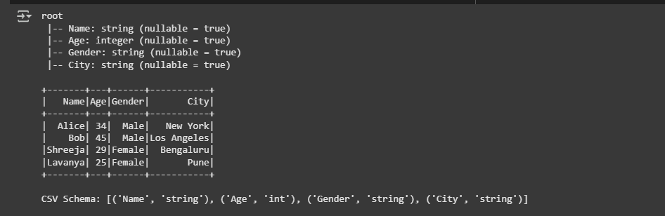

**JSON File**

