PYSPARK & SPARK CODING CHALLENGE

Theophila Murphy S

DE-Batch 6

**APPLY TRANSFORMATION & ACTIONS IN PYSPARK**

**Initialization and Loading Files**

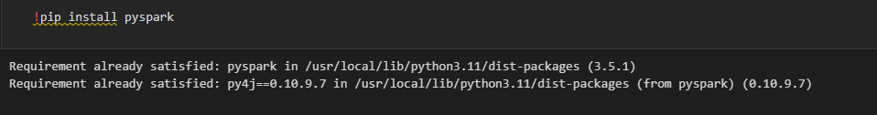

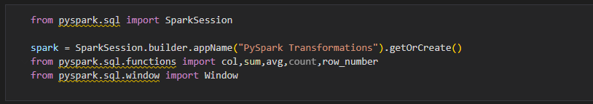

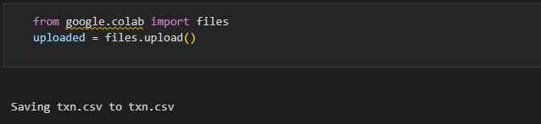

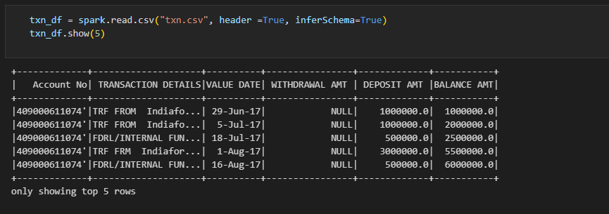

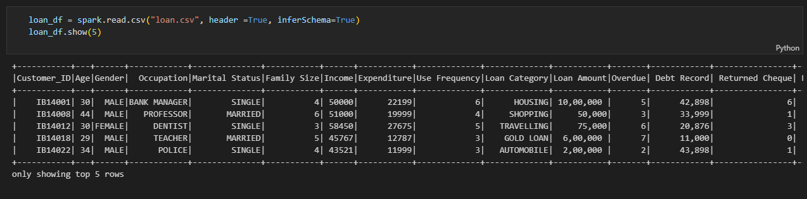

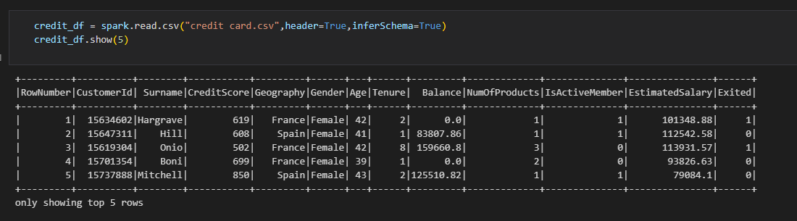

**TRANFORMATIONS**

**Filter()**

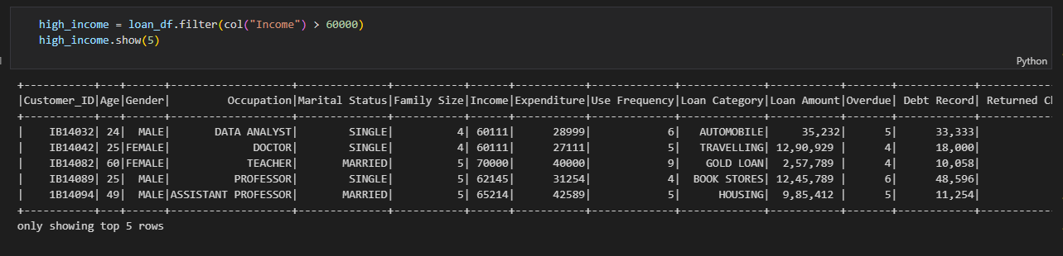

**Group By()**

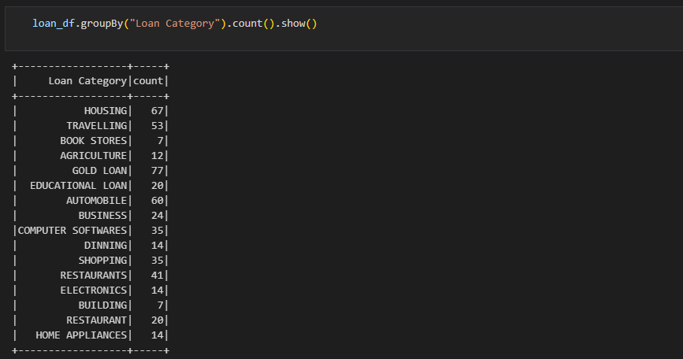

**JOINS**

**Left Join**

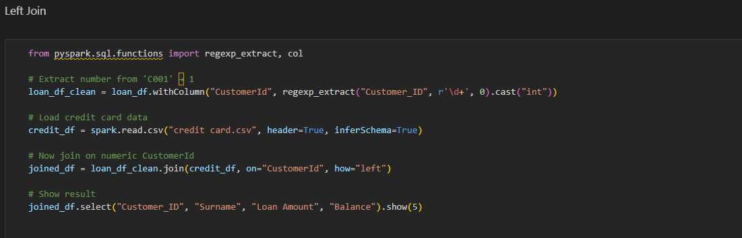

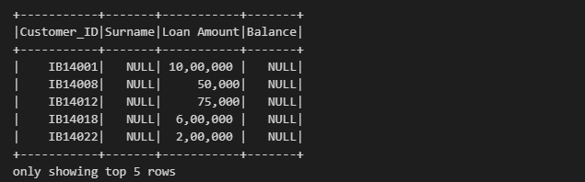

**Inner Join**

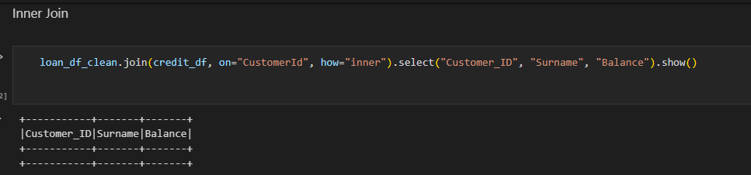

**Right Join**

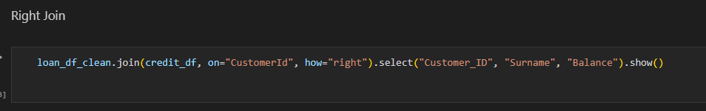

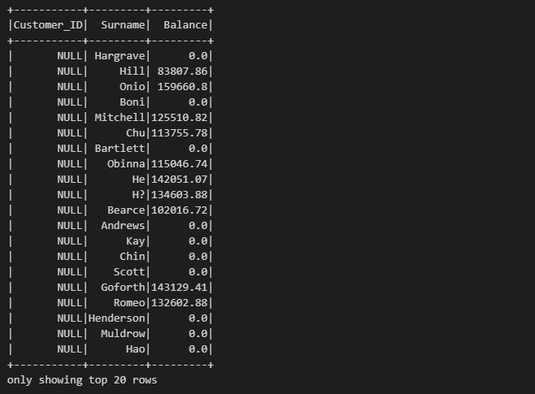

**Left Join**

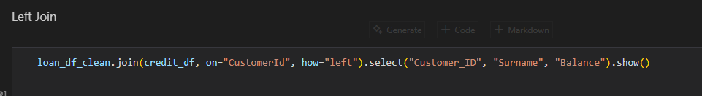

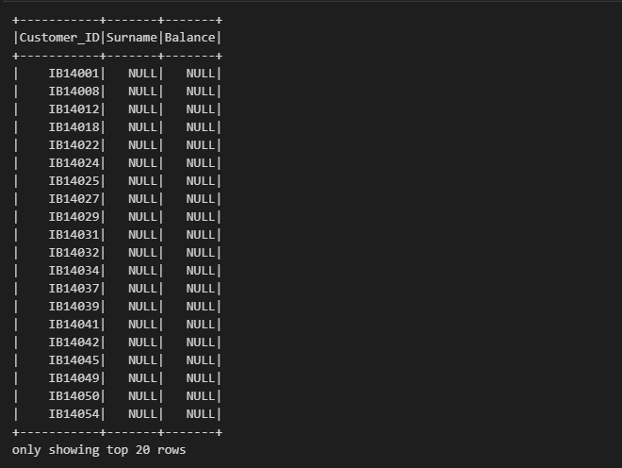

**AGGREGATIONS**

**Sum & Avg**

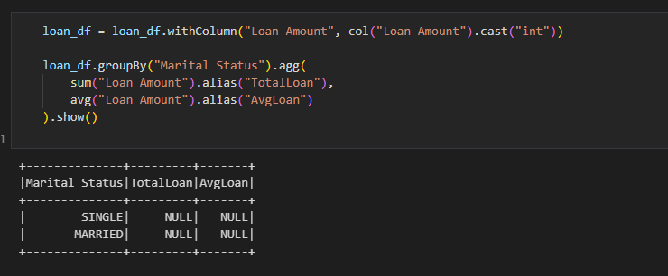

**Max & Min**

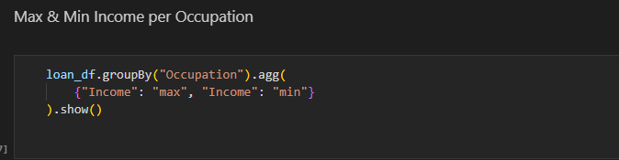

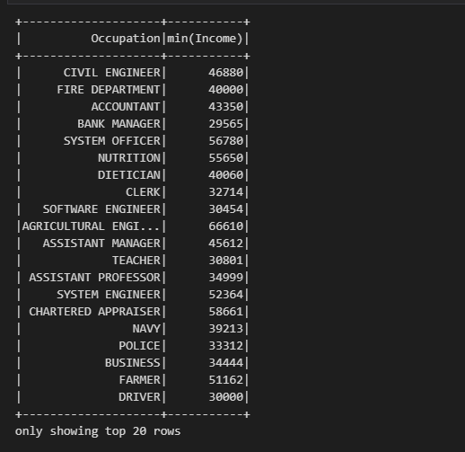

**Standard Deviation**

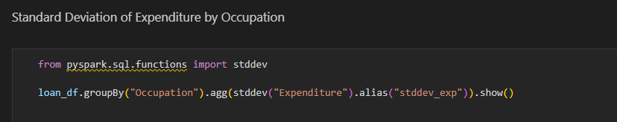

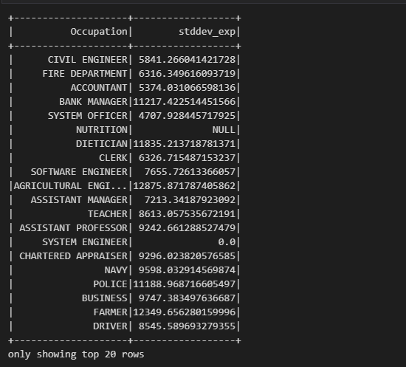

**Agg & Alias**

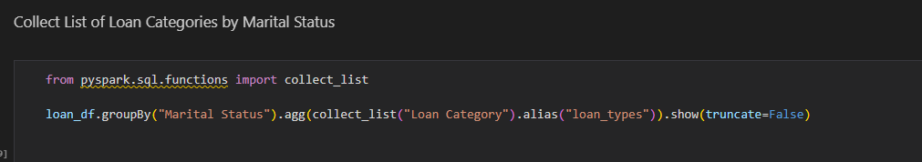

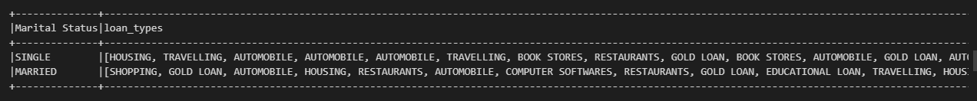

**WINDOW FUNCTIONS**

**windowSpec()**

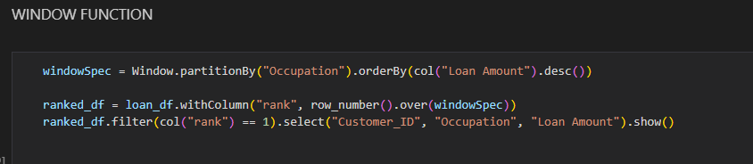

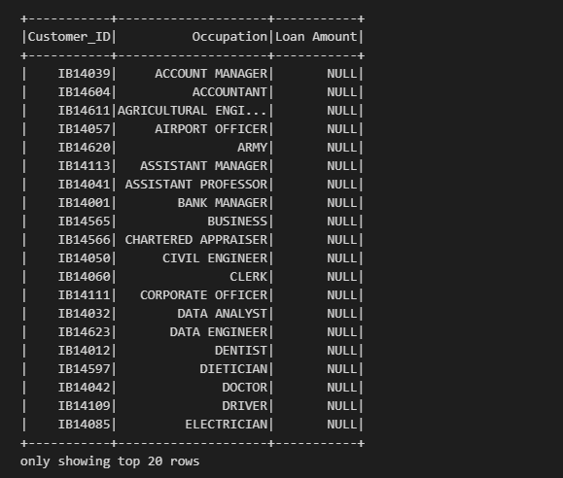

**windowSpec() with rank(), row_number(), dense_rank()**

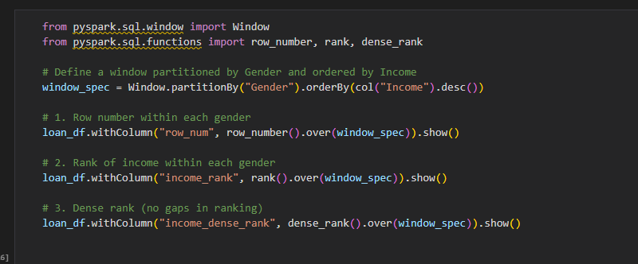

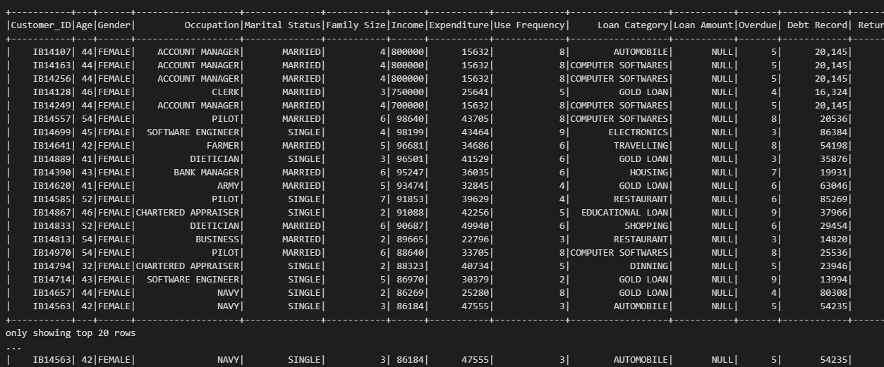

**ACTIONS IN PYSPARK**

**Show()**

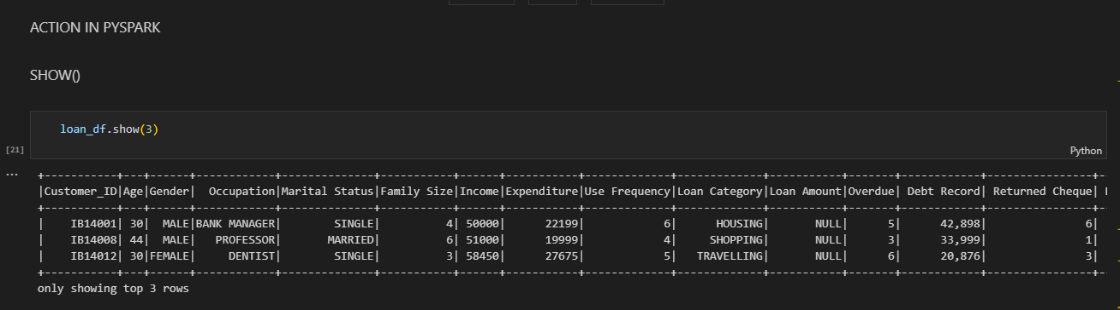

**Count()**

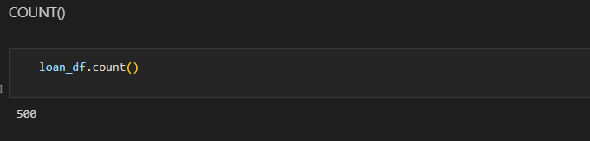

**Collect()**

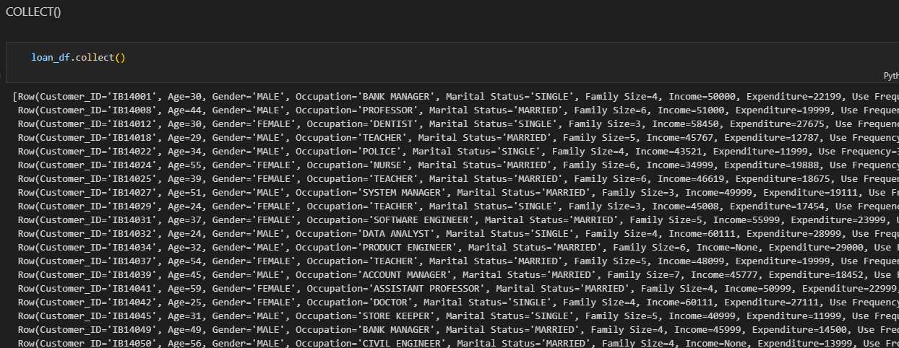

**First()**

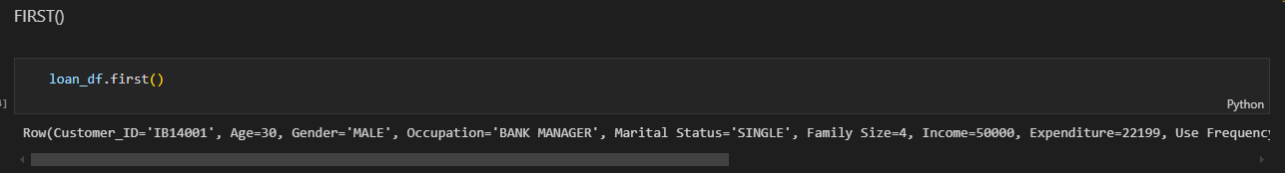

**Take()**

