PYTHON CASE STUDY

Theophila Murphy S

DE Batch-6

**LOAN DATA CASE STUDY**

**1.Loading Data in Pandas DataFrame**

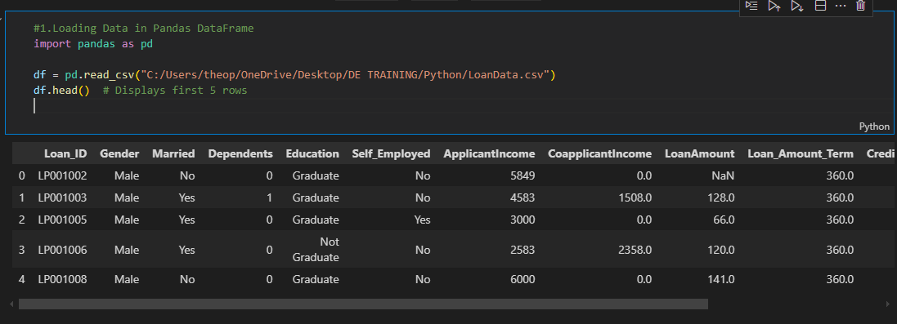

**2.Printing Rows of the Data**

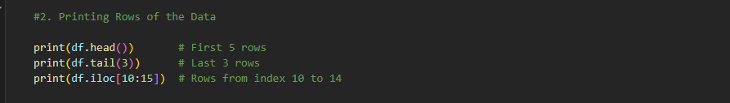

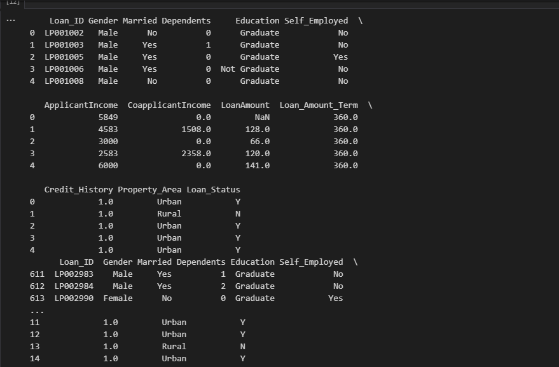

**3.Printing the Column Names**

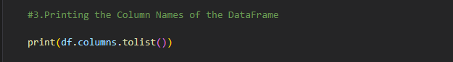



**4.Summary of Data Frame**

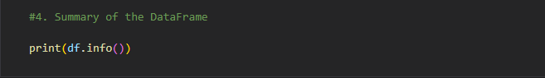

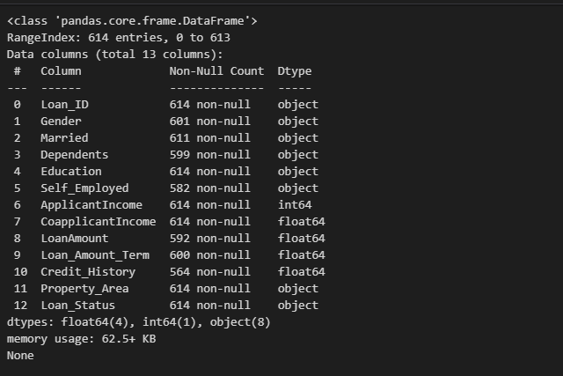

**5.Descriptive Statistical Measures of the DataFrame**

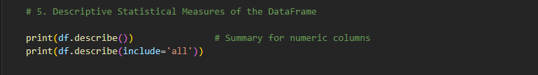

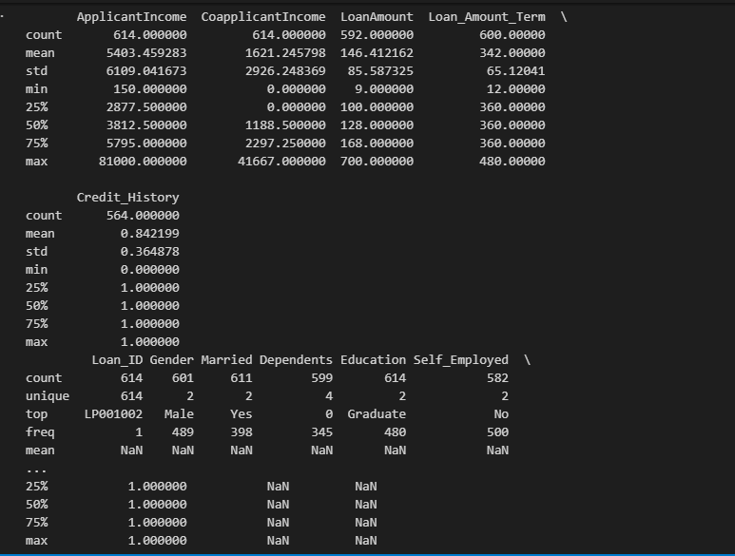

**6.Missing Data Handling**

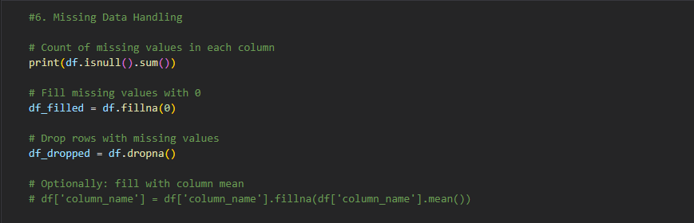

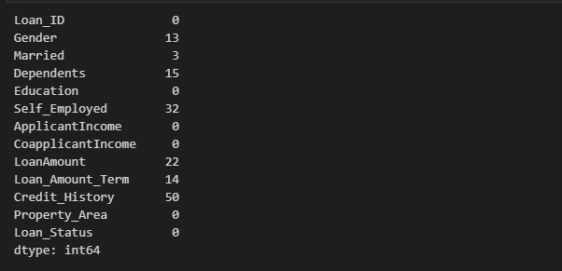

**7.Sorting DataFrame Values**

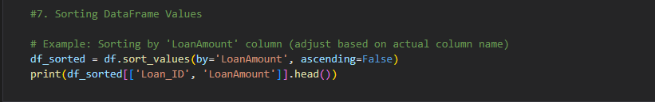

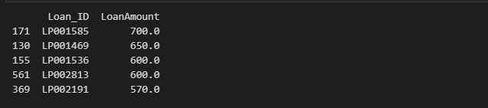

**8.Merging DataFrames**

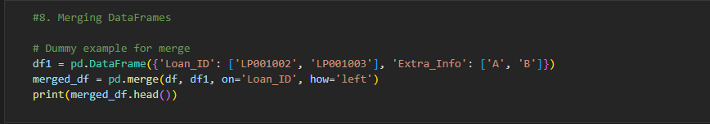

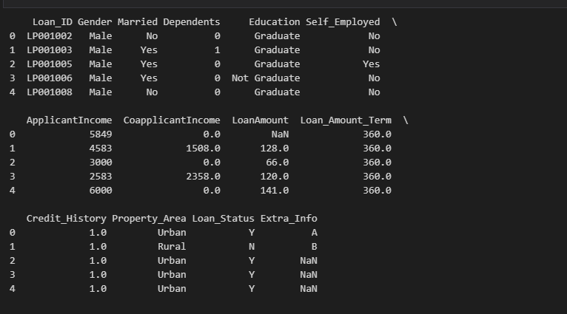

**9.Apply Function**

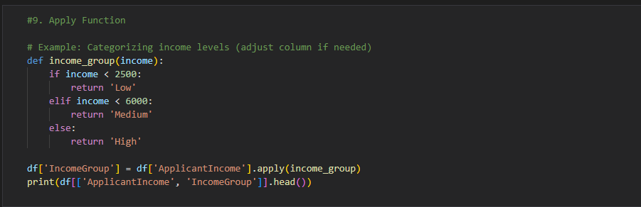

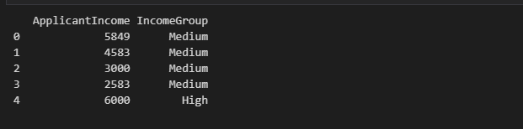

**10.Lambda Operator**

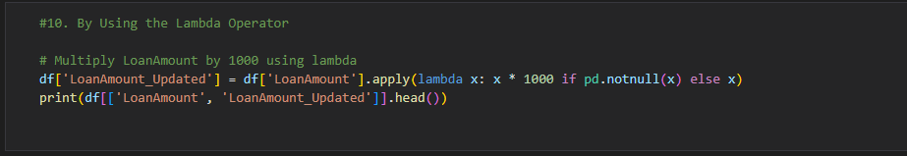

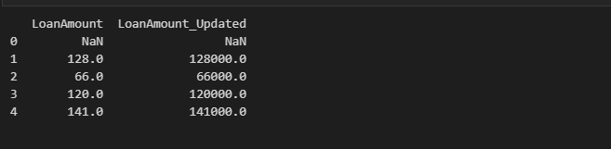

**11.Visualizing DataFrames**

