PYTHON CODING ASSESSMENT – Customers-Orders Data

Theophila Murphy S

DE – Batch 6

1. Load Sample Data (Customers & Orders)

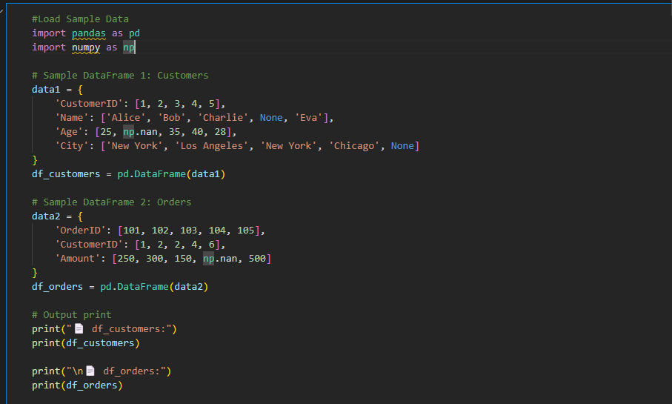

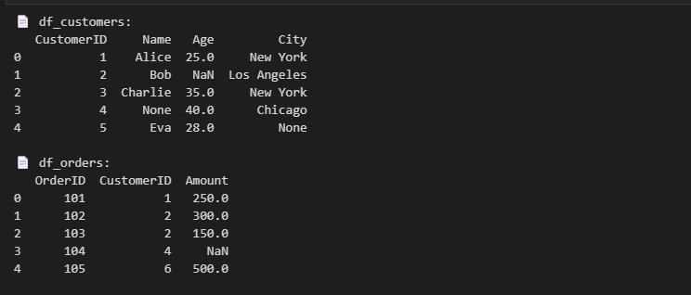

1. Data Cleaning Program 1: Handling Missing Values

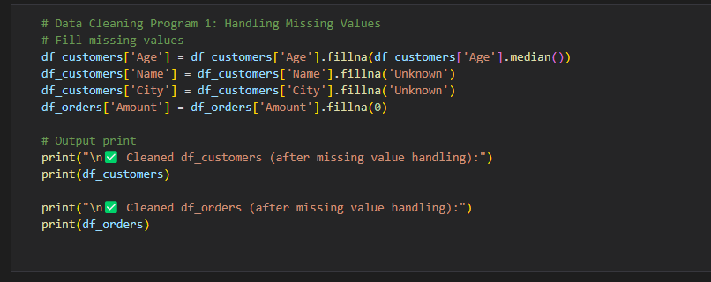

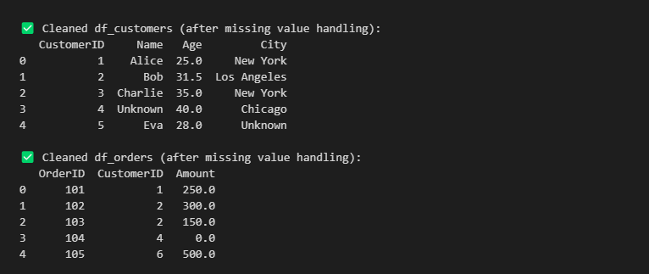

1. Data Cleaning Program 2: Remove Duplicates

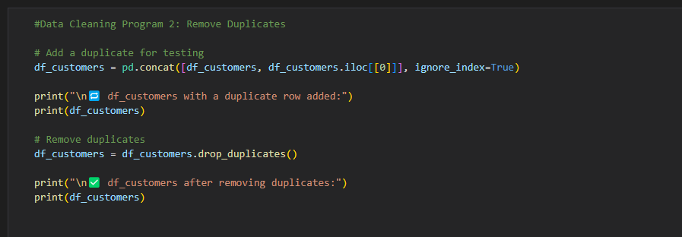

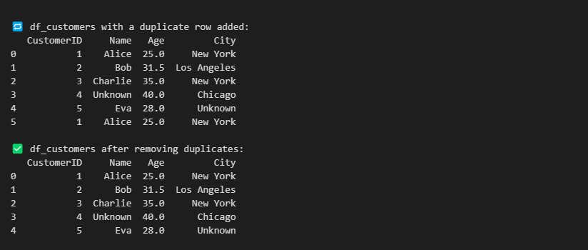

1. Data Cleaning Program 3: Data Type Conversion

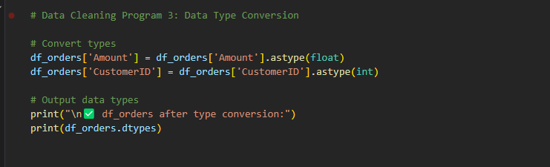

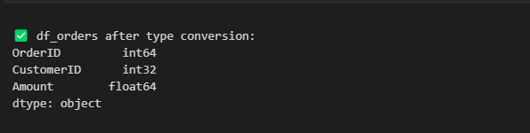

1. Pandas Joins

INNER JOIN

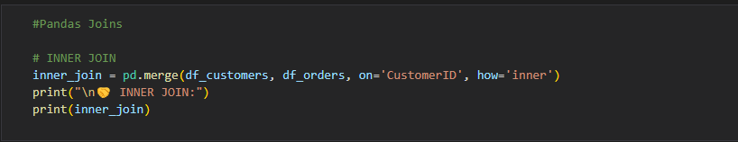

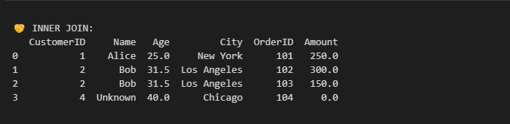

LEFT JOIN

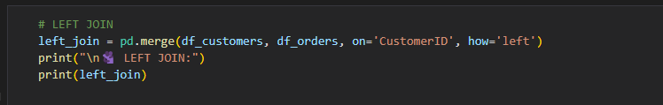

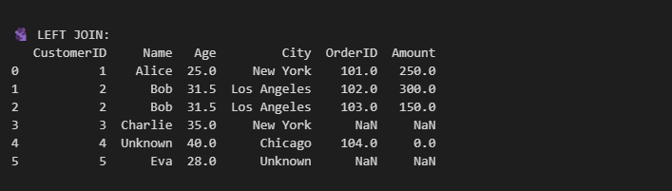

RIGHT JOIN

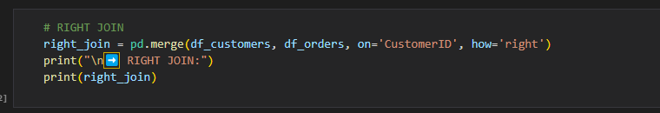

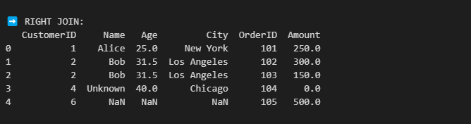

OUTER JOIN

