CONCEPTUAL DESIGN

- What are the entities?
- Employees
- Projects
- Class
- Procurement
- Suppliers
- Materials
- Project task

- What are the attributes of the entities?

- Employee
    - emp_id
    - full_name
    - job_role
    - address
    - hire_date
    - email
    - phone_number

- Purpose : To store information about company staff working on projects

Application Business rule
- An employee can work on multiple projects.
- An employee must have a unique email address.

- Clients
    - clients_id
    - client_name
    - contact_email
    - cl_phone_number
    - clients_address

- Purpose: To Support both Operators and analytics

Application Business Rule:
- A project must be linked to exactly one client
- A client can have multiple projects

- Project
    - project_id
    - project_name
    - clients_id
    - project_start_date
    - estimated_end_date
    - actual_end_date
    - estimated_cost
    - actual_cost
    - Project_status

- Purpose: constructions of projects executed for clients

Application Business Rule:
- Estimated values must exist before execution begins.
- Actual cost and end date may be null until completion
- Each project belongs to one client.

- Supplier

  - supplier_id
  - Supplier_name
  - contact_email
  - sup_phone_number
  - supplier_rating

- Purpose: To supply Materials

Application Business Rule:
- Supplier performance is evaluated over time
- A supplier can fulfill many procurement transactions.

- Materials
  - material_id
  - material_name
  - unit_of_measure
  - standard_unit_cost
  - material_cost

- Purpose: Stores construction material used across projects.

Application Business Rule:
- Material can be estimated based on the quantity of material to be used.
- Material can be used in multiple projects
- A material name must be unique

- Procurement
    - procurement_id
    - project_id
    - supplier_id
    - material_id
    - quantity_purchase
    - purchase_cost
    - procurement_date

- Purpose: To track materials purchase for projects

Application Business role:
- Each procurement is linked to one project & one supplier
- Procurement cost must be greater than zero
- The procurement date cannot

- project_task
    - project_task_id
    - project_id
    - emp_id
    - role_on_project
    - project_task_start_date
    - task_end_date

- Purpose : To many-to-many relationship between employees & projects

- Application Business Rule :
- An Employees can be assigned to multiple projects
- A project can have many employees
- Assignment dates must fall within the project timeline.

Entity Relationships (High-Level)
Relationship | Description
Client → Project | One client can have many projects
Project → Employee | Many-to-many via Project Assignments
Project → Procurement | One project can have many procurements
Supplier → Procurement | One supplier can fulfill many procurements
Material → Procurement | One material can appear in many procurements

Logical Data Modeling (ERD + Normalization)
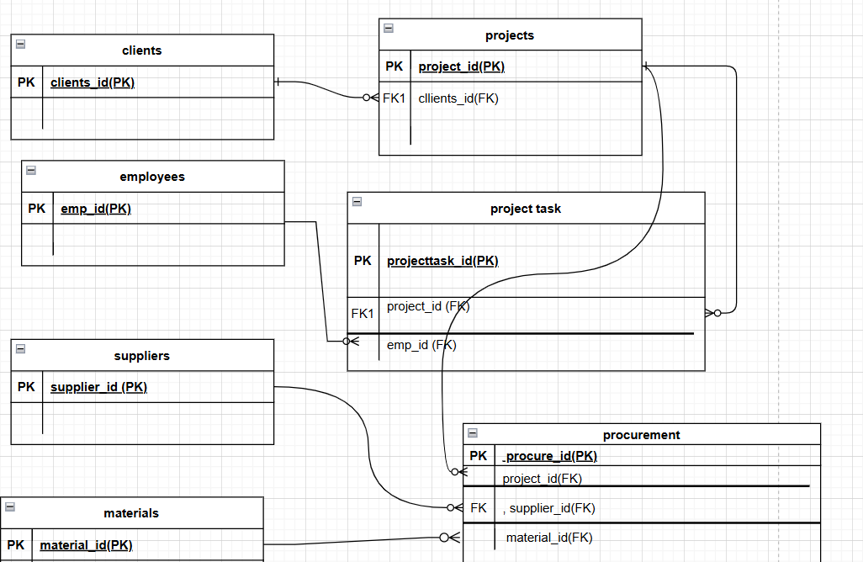

- Table Structure

- Employee Table
emp_id int (primary key)
full_name Varchar(100)
hire_date date
email Varchar(100) (UNIQUE)
employment_status Varchar(100)
emp_address Varchar(100)
emp_phone_num Varchar(100) (UNIQUE)

- Clients Table
client_id int (primary key)
client_name Varchar(100)
client_email VARCHAR(100) UNIQUE
client_phone_num Varchar(100) UNIQUE
client_address VARCHAR(100)

- Projects Table
project_id int (primary key)
project_name Varchar(100)
client_id int (FOREIGN KEY)
project_start_date Date
project_end_date Date
estimated_end_date Date
actual_end_date Date
estimated_cost int
actual_cost int
project_status Varchar(100)

- Supplier Table
supplier_id int(primary key)
supplier_name Varchar(100)
supplier_email Varchar(100) (UNIQUE)
supplier_phone_num Varchar(100) (UNIQUE)
supplier_rating Decimal(3,2)

- Material Table
material_id int(primary key)
material_name Varchar(100)
unit_of_measure Varchar(100)
unit_cost Decimal(3,2)
material_cost Decimal(3,2)

- Procurement Table
procure_id int(primary key)
project_id int(Foreign Key)
supplier_id int(Foreign Key)
material_id int(Foreign Key)
qty_purchase Decimal(12,2)
total_cost Decimal(15,2)
procure_date Date

- Project task
projecttask_id int(primary key)
project_id int(Foreign key)
emp_id int(Foreign key)
role_on_proj VARCHAR(100)
task_start_date Date
task_end_date Date

Normalization

I will be normalizing the tables into 3NF from 1NF

1NF RULE
- Every Columns/attribute need to have a single value
- Each row should be unique. Either through a single or multiple columns, it is not mandatory to have a primary key

2NF RULE
- Note you have fully satisfied the first rule, i.e., 1NF.
- All non-key attributes must be fully dependent on candidate key, i.e., if a non-key column is partially dependent on the candidate key (subset of columns forming the candidate key), then split them into separate tables
- Every table should have a primary key, & the relationship between the tables should be formed using a foreign key.

3NF RULE
- Must be in 2NF
- Avoid transitive dependencies

PHYSICAL DESIGN

