Linking the Gut Microbiome to Neurocognitive Development in Bangladesh Malnourished Infants

Portlock, T.1#, Shama, T.2#, Kakon, S.H.2#, Hartjen, B.3#, Pook, C.1#, Wilson, B.C.1#, Bhuttor A.3, Ho, D.1, Shennon, I.1, Engelstad, A.M.3, Di Lorenzo, R.3, Greaves, G.3, Kelsey, C.3, O’Sullivan, J.M.1,4,5,6,Haque, R.2,3, Forrester, T.7, Nelson, C.A.3, on behalf of the M4EFaD consortium

1The Liggins Institute, The University of Auckland, NZ., 2Infectious Diseases Division, International Centre for Diarrheal Disease Research, Bangladesh, 3Department of Pediatrics, Boston Children’s Hospital and Harvard Medical School; Harvard Graduate School of Education, Boston, USA, 4The Maurice Wilkins Centre, The University of Auckland, Auckland 1010, New Zealand, 5MRC Lifecourse Epidemiology Unit, University of Southampton, University Road, Southampton, UK, 6Singapore Institute for Clinical Sciences, Agency for Science Technology and Research, Singapore, 7Faculty of Medical Sciences, UWI Solutions for Developing Countries, The University of the West Indies (UWI), Jamaica,

*# - These authors contributed equally*

# Key points:

* There are compositional differences between the gut microbiome of malnourished and healthy infants, particularly the *Prevotella/Bacteroides* ratio and their pyruvate fermentation pathways
* Massive dysregulation in plasma lipids, particularly in depletion of ceramides and lisolipids, molecules crucial for healthy brain development, had downstream impacts on bacterial pyruvate fermentation pathways, neural activity (indexed by EEG power spectral density), and cognitive outcomes
* There was a hVjigh level of commonality in the shared features between malnutrition and low expressive communication.

# Abstract

Malnutrition affects ~30 million infants each year and has both immediate and long-term consequences. Just less than half of all childhood deaths under 5 years are related to malnutrition. Children who survive malnutrition suffer long-term consequences including impaired neurocognitive development, leading to long-term deficits in cognition and behaviour. These manifest as poor school performance in the childhood years and poor social and economic outcomes in adulthood. As a third of all living age-cohorts have suffered from moderate or severe malnutrition in early life, the global implications are substantial. The short- and long-term consequences of malnutrition have been delineated, and there is an extensive literature defining mechanistic paths that traverse nutrition, infection, metabolism, physiology, microbiome, genomics and epigenomics, however, there are still gaps in our understanding. One crucial gap is the mechanism(s) through which the gut microbiome contributes to the pathology of malnutrition in addition to its short- and long-term consequences. To this end, AI random forest classification models were trained using a combination of gut microbiome species compositional and functional profiles, plasma lipids, and electroencephalogram (EEG) data from 1 year old infants with Moderate Acute Malnutrition (MAM) (n=70) and healthy age and geographically matched controls (n=70). These data were obtained as part of the M4EFaD randomised clinical trial, run in Dhaka, Bangladesh (NCT05629624). The models were effective at predicting malnutrition (AUROC=0.71), with plasma lipids containing the highest proportion of predictive features. The abundance of *Bacteroides fragilis* and associated fermentation pathways in the gut was also predictive of healthy infants (SHAP score=0.20). Co-abundant network analysis indicated that *Bacteroides fragilis* and associated pyruvate fermentation pathways were correlated with plasma fatty acids and neural activity assessed using EEG power spectral density (PSD) as part of a distinct cluster involved in the breakdown of cholesterol esters and glucose for sphingomyelin biosynthesis - an essential precursor for cognitive maturation. Collectively, our results identify intricate and non-overlapping connections among gut microbiome composition, nutritional status, and behaviour that highlight the significance of targeted interventions in addressing both the short and long-term impacts of malnutrition.

# Background

Malnutrition affects ~30 million infants each year and is the leading cause of mortality among children under the age of five, accounting for an estimated 45% of all child-related deaths worldwide (*Malnutrition*, n.d.). Malnutrition in both animals and humans is characterised by slower growth, proportionate reductions in mass of virtually all organs and tissues, and alterations in tissue architecture. Children who survive malnutrition suffer long-term consequences including impaired neurocognitive development, leading to long-term deficits in cognition and behaviour (REF). This in turn leads to poor school performance and economic prospects as an adult (REF). Although, a large literature has characterized the health, social, and economic ramifications of malnutrition, gaps in our knowledge remain (REF). One crucial gap is the mechanism(s) through which the gut microbiome contributes to the pathology of malnutrition in addition to its impact on brain and cognitive development.

The human gut microbiome is a complex ecosystem comprised of the microorganisms lining the intestinal tract, including bacteria, viruses, fungi, and archaea. Infancy represents a sensitive period in gut microbiome formation as the gut microbiome changes drastically over this time (REF). Importantly, many aspects of malnutrition including host nutritional status, dietary intake, antibiotic administration, and infections impact the diversity, composition, and functionality of the microbiome (REF). To this end, several studies in low- and middle- income countries (LMIC) have shown differences in gut microbiome profiles between malnourished and healthy infants (REF). For example, a study in Bangladesh found that malnourished infants, compared to healthy infants, had higher abundances Proteobacteria and pathogenic genera (e.g., *Klebsiella*, *Escherichia*, and *Streptococcus*). Beyond the correlational and descriptive evidence presented, work using mouse models point to a possible causal role of the gut microbiome in growth and weight gain, as mice colonized using fecal microbial transplantation with samples from malnourished children, but not healthy controls, showed impairments in weight gain and growth (REF). Critically, perturbations of the gut microbiome associated with malnourishment may have downstream consequences for brain and cognitive development (Kelsey and Grossmann, 2019; Cowan et al., 2019; Kelsey et al., 2018).

Malnutrition, like the gut microbiome, is associated with neurocognitive impairments thought to result from structural and functional changes to the brain (Acuña et al., 2021; Carlson et al., 2018; Kar et al., 2008; Kort et al., 2021; Roger et al., 2022; Udani, 1992). More specifically, several studies conducted in healthy infants living in upper-middle-income countries have shown that the gut microbiome is associated with cognitive and brain development; although the directionality remains unclear with both increased and decreased gut microbiota alpha diversity being linked to positive cognitive outcomes and neural development (Carlson et al., 2018; Gao et al., 2019; Kelsey et al., 2021; Vaher et al., 2022). Very few studies have examined the link between the gut microbiome and cognition in malnourished children. One notable exception is a randomized control trial of nutrition, stimulation, and hygiene education to a group of rural Ugandan mothers and their infants who were moderately stunted (HAZ scores between -2 and -3 SD). Across a series of studies conducted from 2 years to 3 years of age there were mixed findings with some species such as Bifidobacterium longum found to associate with language impairment assessed using the Bayley Scales of Infant and Toddler Development and other developmental assessments but at other time points no associations were found (Atukunda et al., 2019; Iversen et al., 2020; Kort et al., 2021). Therefore, more work is needed to understand how the gut microbiome mediates that association between malnourishment and cognitive development.

Another mechanism by which brain and behavioural development may be impacted by malnutrition is through the circulating plasma lipidome (REF). Several circulating plasma lipids including cholesterol, phosphatidylcholines, phosphatidylethanolamine, and sphingolipids compromise 50% of the dry weight of the brain and have unique roles in neurological structure and function (Hornemann, 2021). The brain relies upon nutrients circulating in the blood for its supply of resources. Moreover, the blood brain barrier which plays a crucial role in regulating which circulating lipids enter and exit the brain area is impaired by malnutrition (de Aquino et al., 2019). Therefore, the present study will examine how malnutrition impacts circulating plasma lipid composition and how this in turn is associated with brain and cognitive development.

Given the importance of the composition and functions of the gut microbiome in maintaining overall health, there has been increasing interest in understanding how its alterations may contribute to malnutrition and its associated impacts on infant neurocognitive development. The present study examines the impact of malnutrition on plasma lipid composition, microbiome composition, neural activity, and cognitive outcomes in cross-sectional cohort of healthy and malnourished 1-year-old Bangladeshi infants prior to the receipt of a nutritional intervention. Random forest models were then used to integrate deeply phenotyped multi-modal data and identify correlations that provide putative mechanistic insights into damage caused by malnutrition. Overall, this study provides important information about gut-blood-brain-behaviour links of malnourished children prior to receiving a nutritional refeeding intervention.

(*Malnutrition*, n.d.)(Saunders & Smith, 2010)(Subramanian et al., 2014a; Vickers, 2022a)(Schroeder & Bäckhed, 2016; Spor et al., 2011).Acuña et al., 2021; Carlson et al., 2018; Kar et al., 2008; Kort et al., 2021; Rozé et al., 2020; Udani, 1992)(Roger et al., 2022)(Choudhury et al., 2018; Hashimoto et al., 2012)(Hornemann, 2021)(de Aquino et al., 2019)(Lamichhane et al., 2021)(Chen et al., 2021)

# Results

To assess the impact of early-life malnutrition, 156 infants at age 12 months with Moderate Acute Malnutrition (MAM) and 74 age-matched non-malnourished controls (Healthy) were recruited from the Mirpur region, in Dhaka, Bangladesh (Fig. 1a). MAM was defined according to WHO guidelines, using a threshold between two and three standard deviations below the mean z-score for weight-for-length/height (WLZ/WHZ) (Table 1) (Lenters et al., 2016). Stool and plasma samples were collected, and EEG and general development was measured for all infants (METHODS).

Table 1: Baseline infant characteristics. Significance was measured using Mann Whitney U Tests (M.W.W).

|  |  |  |  |  |
| --- | --- | --- | --- | --- |
|  | **Healthy** |  | **MAM** | **pval** |
| Weight (Kg) | 8.59 ± 0.69 |  | 6.81 ± 0.53 | 1.20E-31 |
| MUAC (cm) | 14.27 ± 0.6 |  | 12.4 ± 0.49 | 8.10E-34 |
| HC (cm) | 43.93 ± 1.35 |  | 43.01 ± 1.32 | 5.80E-06 |
| WLZ_WHZ (Z-Score) | -0.22 ± 0.48 |  | -2.24 ± 0.26 | 3.40E-34 |
| Female | 28/73 (38%) |  | 74/156 (47%) | 0.2 |

## Malnutrition is associated with a higher Prevotella/Bacteroides ratio and lower pyruvate fermentation potential in the gut of Bangladeshi infants

It was hypothesised that malnutrition impacts the diversity and composition of the infant gut microbiome. Stool metagenomes were extracted, analysed (shotgun metagenomic sequencing, 40.53 ± 8.5 million reads with no significant difference between MAM and Healthy (M.W.W. p=0.71)) and profiled according to their species and functional compositions (METHODS). Despite there being no difference in alpha-diversity (Shannon Diversity Index) between the MAM and Healthy infants (M.W.W. p=0.34, Supp Table), there was a significant difference in the Bray-Curtis dissimilarity scores (PERMANOVA, R2=2.22, p=0.008) due to differential abundance of 6/350 species (1.7%) between the groups (Fig 1b, Supp Table). There was a greater prevalence and abundance of *Prevotella copri* (Log2(Healthy/MAM)=-0.844, M.W.W. q=0.004, LEfSe=4.45) and *Streptococcus salivarius* (Log2(Healthy/MAM)=-3.928, M.W.W. q=0.001, LEfSe=3.10)) in microbiomes from MAM infants, compared to healthy controls (Fig. 1c). The increases in *P. copri* and *S. Salivarius*, were reciprocally associated with the depletion and reduction in the prevalence of the sphingolipid-producing species *Bacteroides fragilis* within the MAM microbiome (Log2(Healthy/MAM=1.20, M.W.W. q=0.002, LEfSe=4.14) (Tamana et al., 2021). This reciprocal relationship was observed as a significant increase in the *Prevotella/Bacteroides* (P/B) ratio of the MAM infants (Log2(Healthy/MAM)=-3.33, M.W.W.=0.001) (Fig. 1d).

Functional pathway analyses revealed no significant differences between MAM and healthy controls (PERMANOVA, R2=8.76, p=0.365). After false discovery rate adjustment, and using LEfSe analysis, there were no significant differences in the pathway relative abundances (supp table). However, 19/525 pathways were differentially abundant using M.W.W. without FDR adjustment between the conditions (Fig. 1e, Supplementary Table X). Specifically, MAM gut microbiomes had an over-representation of pathways involved in branch chain amino acid biosynthesis BRANCHED-CHAIN-AA-SYN-PWY (Log2(Healthy/MAM)=-0.13, M.W.W. p=0.004) including L-valine and L-isoleucine (I, III)), fatty acid synthesis (PWY-7117, FASYN-ELONG-PWY (Log2(Healthy/MAM)=-0.13, M.W.W. p=0.004) including, PWY0-862, PWY-7664, and PWY-6282), and sucrose/glucose degradation (PWY-5384, GLUCOSE1PMETAB-PWY (Log2(Healthy/MAM)=-0.19, M.W.W. p=0.009)). Conversely, there was a decrease in relative abundance anaerobic pathways including isopropanol biosynthesis (Log2(Healthy/MAM)=1.03, M.W.W. p=0.020) and pyruvate fermentation pathways to the SCFA propionate (Log2(Healthy/MAM)=0.37, M.W.W. p=0.017) in the MAM infant's gut.

## Malnutrition impacts brain activity and expressive communication

Malnourished children often present with long-term impairments in neural and cognitive development. Resting state electroencephalography (EEG) assessments of participants were performed to enable investigation of the impacts of malnutrition on brain activity (Supp Table X,Y). After exploratory comparisons between EEG PSD between infants with MAM and our healthy controls, we will subsequently focus on the high-alpha (9-12 Hz), beta (12-30 Hz) and gamma (30-45 Hz) frequency bands distributed across occipital, temporal and frontal regions of interest. These bands are generally associated with concentration, alertness, and higher mental activity and were observed to have higher amplitudes in the healthy infants compared to infants with MAM (supp table).

SECTION ON WOLKES SCORE?

We used the Bayley Scales of Infant and Toddler Development Fourth Edition (BSID-IV; Bayley & Aylward, 2019) to assess development in our cohorts. When compared to healthy infants, there was a significant reduction in the Expressive Communication score in the MAM infants (Log2(Healthy/MAM)=0.10, M.W.W. p=0.02). Expressive communication is a measure of how well a child communicates with others (Fig. 2). However, there were no significant differences in receptive language, cognitive, or motor abilities.

## Malnutrition is associated with a reduction in circulating lyso-lipids and ceramides

Adequate nutrition in infants is characterised by healthy circulating concentrations of metabolites involved in growth and development. Therefore, we used LC-MS/MS to characterise the plasma lipidome in our cohort of MAM and healthy infants.

Malnutrition was associated with significant changes (309/1041 - 30%) to the plasma lipidome. Of these changes, 140 (13%) plasma lipidome compounds increased and 169 (16%) decreased in concentration (Fig 3, supp table). We identified a reduction in the abundance of three lipid classes with diverse functions, including two that are known to be specific to neurological development and function (i.e. the long chain ceramide Cer 31:5;O2 (Log2(Healthy/MAM)=2.44, q=2.51e-8) and the lactosylceramide hex2cer 34:1 (Log2(Healthy/MAM)=1.50, q=0.004)). By contrast, long chain sphingomyelins (SM 44:3;O2, Log2(Healthy/MAM)=-1.47, q=5.81e-5)) and others were observed to increase in relative concentration in malnourished infants (Liu et al., 2021; Mielke et al., 2010). Several lysophospholipids from the Lysophosphatidylcholine (LPC), and Lysophosphatidylethanolamine (LPE) classes were enriched in healthy infant plasma.

## Interpretation of Multimodal Random Forest classifiers trained on the gut microbiome, neuroimaging data, behavioural data, and the plasma lipidome to predict malnutrition reveals cross mode influences

Having established the existence of changes associated with malnutrition across the gut microbiome, brain, and plasma lipids, the relative importance of changes in each of these domains for the prediction of malnutrition was measured. Individual and multimodal Random Forest classifiers were trained, using gut microbiome taxonomic and functional neuroimaging (EEG), lipidome and behavioural data (Bayley scale scores), to predict malnutrition in 1-year-old infants (METHODS).

Within the predictors trained on individual feature sets, plasma lipids (AUCROC=1.00, oob=1.00) were the best predictor of malnutrition in 1-year-old infants, followed by brain/behavioural metrics (i.e., EEG, and Bayley AUCROC=0.83, oob=0.64), and the gut microbiome taxonomic and functional profiles (AUCROC=0.59, oob=0.59).

Ensemble models were trained on the combined dataset (i.e. gut microbiome taxonomic, gut microbiome functional, neuroimaging (EEG), lipidome and Bayley scale scores; METHODS) using 10-fold cross validation. SHAP scoring interpretation was performed to understand the workings of these models and importance of the features without the assumption of linearity of relationship between features. Those features that changed significantly were more likely to have high importance for the model prediction, (supp table). Comparison with the individual models identified that inclusion of the other datasets into the ensemble models lead to the identification of non-linear features that contributed to the predictive power of the microbial species within the classification model. For example, these included MAM depleted *Faecalibacerium prausnitzii* (SHAP(Healthy/MAM)=-0.0076), and *Odoribacter splanchnicus* (SHAP(Healthy/MAM)=-0.0063) and MAM enriched *Bifidobacterium breve* (SHAP(Healthy/MAM)=0.0074), and *Haemophilus parainfluenzae* (SHAP(Healthy/MAM)=0.0065).

## Network Analysis reveals the importance of *Bacteroides fragilis* in infant neurocognitive development

Network analysis is a useful tool to understand complex systems that emerge from interactions between multiple components. To better understand the complexities of feature changes and correlations between the EEG, behavior, microbiome species and functions, and plasma metabolites, we mapped out their architecture using co-abundant network analysis. Spearman correlation of these features that were altered by malnutrition was calculated and filtered by significance (q<0.05) (1052/3906 correlations, supp table) and further filtered using spearman rho cut-off of 0.2 and were used as edges to construct a network.

Important features (Those which had an absolute mean absolute SHAP score of above 0.002) were more likely to be significantly correlated (q<0.05) with one another and had greater measures of Betweenness Centrality NUMBERS (Fig. 4, Methods, Supplementary Table X). Plasma lipids that were enriched/depleted in the MAM condition (Supplementary Table X) were positively correlated with the anthropometric measures WHZ/WLZ, MUAC, and weight. Cluster analyses revealed that those features which were different between MAM and Healthy were unsurprisingly more likely to be positively correlated with each other (i.e., change in the same direction; FIGURES, supp table). We identified a subcluster of *Bacteroides fragilis*, pyruvate fermentation pathways, plasma ceramides, EEG PSD and Expressive Communication that was highly correlated with the Healthy state (FIGURE, supp table). Those plasma lipids that were depleted (M.W.W. q<0.05, Log2(MAM/Healthy)<0) from the MAM infant samples were also positively correlated with EEG PSD amplitudes. Notably, EEG metrics were also correlated with bacterial pyruvate fermentation pathways that correlated with *B.* *fragilis* relative abundance. Conversely, we identified a highly correlated subcluster of *P. copri,* glycolysis, peptidoglycan biosynthesis, and BCAA pathways, and plasma sphingomyelins that are associated with the MAM condition.

## Discussion

A central goal of this study was to obtain a better understanding of how disturbances in host-microbiome interactions impact neurocognitive development in malnutrition. By examining the composition of the gut microbiome, an understanding of how these species/functions interact with dietary macronutrients and micronutrients and their potential impact on overall health was made. We observed that at the time of the malnutrition diagnosis and before administration of therapeutic feeds, malnutrition was characterised by a higher *Prevotella/Bacteroides* ratio and lower anaerobic pathways such as pyruvate fermentation potential in the gut. *Prevotella* rich microbes have been typically understudied due to their underrepresentation in industrialised populations (REF). This ratio has previously been implicated in diet and lifestyle in adults (Hjorth et al., 2018) and *Bacteroides* have been observed previously to be depleted in Bangladesh infants (Monira et al., 2011). Other studies of malnutrition have shown a decrease in alpha diversity which was unobserved in our population REF. Accelerated ageing of the gut microbiome, as indicated by the presence of specific markers such as *P. copri* and *Bifidobacterium adolescentis*, might be a possible hypothesis for its differential abundance REF. Conversely, non M.W.W. FDR significant, but SHAP important *Bifidobacterium longum* and *B. breve* were negatively correlated with *P. copri*. *B. longum* and other anaerobic species have been previously linked to moderate and severe acute malnutrition in Bangladesh (Barratt et al., 2022) (Million et al., 2016).

In line with our hypotheses, MAM infants compared to control infants showed deficits both in neural activity and expressive communication. However, in contrast, there were no differences between MAM and control groups for other developmental and cognitive domains (e.g., motor and receptive language). Therefore, it is possible that expressive language is one of the first domains to be impacted or detectable for MAM groups (REF). When investigating differences in neural activity, disruptions were evident for higher frequency power bands (alpha, beta, and gamma) but not lower frequency bands (delta and theta) in frontal, temporal and occipital areas. This pattern of results is notable given the role of alpha, beta, and gamma in language development (REF).

As anticipated from the literature, plasma lipidome was substantially different in malnourished children compared with controls (REF). Lactosylceramide is an essential precursor for synthesis of all complex glycosphingolipids and was depleted by half in malnourished infants (D’Angelo et al., 2013). LPCs and LPEs have been shown to be essential for brain development and growth as they are both vehicles for fatty acid transport across the blood-brain barrier via the major facilitator superfamily domain-containing protein 2A (Mfsd2a) (Tan et al., 2020). Malnutrition reduces circulating lyso-lipids and ceramides. Phosphatidylcholine (PC) was identified as a key factor in brain health, as it serves as a precursor to acetylcholine, an essential neurotransmitter for memory and cognitive function. Preliminary research suggests that higher levels of plasma PC35:6 may be associated with better cognitive function in older adults. Further investigations are necessary to fully comprehend the role of plasma PC 35:6 in human health, particularly in cardiovascular and liver health, as well as brain function. Propanoate is a key precursor in lipid biosynthesis and can be metabolised to propionyl-CoA, which can subsequently be incorporated into sphingolipid biosynthesis pathways REF. It remains possible that this is due to extensive metabolic and microbial programming during this period (Mahmud et al., 2019a). Dietary insufficiency in malnutrition reduces the quantity nutrients available for uptake from the gut, and plays a part in the reducing the tissue and organ function. Therapeutic interventions which restore nutritional status are frequently ineffective at remediating long-term effects of undernutrition at key stages of development, such as during the first 1,000 days of life (Subramanian et al., 2014b; Vickers, 2022b). Extensive programming of metabolic pathways is now understood to be affected during this period with lifelong consequences (Mahmud et al., 2019b).

Random Forest classification models trained on the gut microbiome, neuroimaging data, and the plasma lipidome accurately predicted malnutrition. By combining SHAP values with feature co-occurrence analysis, insights into the mechanisms underlying the relationship between the infant gut microbiome and treatment outcomes were made. This approach has the potential to inform the development of targeted and effective interventions for infants experiencing malnutrition. To contextualise the relations between the biological changes observed between malnourished and healthy infants, feature co-occurrence network analysis was performed (Methods). Network Analysis revealed the importance of *Bacteroides fragilis* as a keystone species for infant neurocognitive development. As there are less SMS, more of the ceramides are converted to hexaceramides. Sphingomyelinases (SMases) hydrolyse sphingomyelin, releasing ceramide and creating a cascade of bioactive lipids.

It is important to note that our study focused primarily on non-western populations, as infant malnutrition is typically more prevalent in these regions. Recent studies have emphasised the significant role of the gut microbiome in mediating dietary effects on host physiology, as well as its influence on the development and function of the nervous system (REFs). We examined infant malnutrition as a potential contributing factor to altered brain function and its association with development with the infant’s microbiome. It is not clear if these changes to the gut microbiome are a result of or contribute to undernutrition.

Overall, our findings underscore the growing interest in gut microbiome interventions for neurodevelopmental outcomes. The findings highlight the potential impact of the gut microbiome on brain health and the role of specific microbial components in influencing cognitive function in the hopes to assist in the development of meaningful interventions/treatments to adequately address this unanswered global challenge. By investigating the intricate relationship between the gut microbiome, plasma lipids, and brain function, we contribute to the expanding body of knowledge aimed at improving the health and well-being of individuals affected by malnutrition (Gehrig et al., 2019).

# Methods

Ethics

The M4EFaD intervention was registered NCT05629624 on clinicaltrials.gov. The study was approved by icddr,b Ethical Review Committee PR-21084 and the Bangladesh Directorate General of Drug Administration (#FOR NAVIN). Ethical review for the analytical component was obtained from Auckland Health Research Ethics Committee approval AH23922 (metabolomics, metagenomics, machine learning).

Study Design and Participants

The study was performed on the baseline data from three cohorts of infants who were enrolled (between Jan – April 2022) as part of the M4EFaD intervention within the Mirpur slum, Dhaka, Bangladesh. The cohort consisted of healthy 12-month-old (+/- 15 days) children (n=70) and 12-month-old children (+/- 17 days) suffering from MAM (n=70). Inclusion criteria included a diagnosis of malnutrition, no history of chronic medical conditions, and no antibiotic use within the past month.

Recruitment and anthropometric collection:

Enrolment was initiated on February 7, 2022, and will continue until February 2024. Study surveillance workers (SWs) conducted a door-to-door census (~ 100,000 households) in Mirpur DNCC wards ward 2, 3 and 5 between January and December 2022. Verbal consent was obtained to participate in the census. The census identified 5736 children aged between 11 to 13 months and 2,314 children aged between 34 to 38 months. During the census, if the guardian verbally consented to the study procedure, and the babies met the inclusion and exclusion criteria of the study (Table 1), the SWs proceeded to measure the mid-upper arm circumference (MUAC) of the child. Mothers of babies who were within the MUAC range were invited to visit the icddr,b study clinic for further assessment and enrolment.

Final screening for eligibility and study consent occurred at the icddr,b Mirpur study clinic. The consenting process was tailored to each mother's literacy level and involved reviewing the inclusion and exclusion criteria. Comprehension of the study was assessed using scripted points and open-ended questions.

Following consent, the clinical screening team completed a screening form, capturing the date of visit, sex, date of birth (DOB), weight (in kg), length/ height (in cm), head circumference (in cm), and Mid-Upper Arm Circumference (MUAC) measurements of the child. The WLZ/WHZ Z-score for each child was calculated using the WHO anthropometric calculator. The child's age was validated using the EPI vaccination card.

The control group consisted of 70 well-nourished children at 1 year ± 1m (WLZ z-score >-1 SD); the intervention group consisted of 150 children with WLZ <-2 and ≥-3 z-score, and/or MUAC <12.5 and ≥11.5 cm having MAM at 1year ± 1m; and the Outcome Reference group consisted of 70 children with WHZ <-2 and ≥-3 z-score, and/or MUAC <12.5 and ≥11.5 cm having stable MAM at 3 years ± 2m.

EEG data collection and analysis:

Continuous scalp EEG was recorded using NetStation 4.5.4. and 128-channel Hydrocel Geodesic Sensor Nets modified to remove eye electrodes (Electrical Geodesics, Inc. (EGI), Eugene, OR, USA). Data was sampled at 500 Hz. Impedances were kept under 100 kΩ when possible and measured once at the beginning of the session, and again halfway through. Sessions were conducted in a dimly lit room with the participants sitting on the parent’s lap. The participants were separated from the research staff conducting the session by a curtain, but the testing area was not acoustically or electrically shielded. A second research staff member was present in the testing area to help keep the participant engaged. EEG sessions consisted of 6 paradigms, i.e., resting state, visual working memory, flanker, disengagement, visual evoked potential, and auditory stimuli. The subsequent (pre-)processing steps were applied to the resting state data where participants watched a 3-minute video that featured toys (Add REF for the stimuli).

EEG data were preprocessed offline with MatLab (R2021B) using the Harvard Automated Processing Pipeline for Electroencephalography (HAPPE) Version 3 (Gabard-Durnam et al., 2018). A specified subset of 30 channels was excluded (‘E1’, ’E8’, ’E14’, ’E17’, ’E21’, ‘E25’, ’E32’, ‘E38’, ‘E43’, ’E44’,’ E48’, ’E49’, ’E56’, ’E63’, ’E68’, ’E73’, ’E81’, ’E88’, ’E94’, ’E99’, ’E107’, ’E113’, ’E114’, ’E119’, ’E120’, ’E121’, ‘E125', 'E126', 'E127', 'E128'). Data were downsampled to 250Hz, bandpass filtered (1-100Hz), and filtered using a 50Hz *cleanline* filter for line noise removal. Bad channels were then automatically identified and rejected, and wavelet-enhanced Independent Component Analysis (ICA) and the Multiple Artifact Rejection Algorithm (MARA) were performed to detect and impute artifacts. Resting state data were segmented into 2s epochs; epochs with an amplitude >±150mV were rejected. Segments were also rejected using segment similarity criteria. Data were then re-referenced to the average of all channels.

EEG outputs from HAPPE were then reformatted and processed using the Batch Electroencephalography Automated Processing Platform (BEAPP) (Levin et al., 2018) to extract power spectra for each participant across the following frequency bands: delta (2-4Hz), theta (4-6Hz), low alpha (6-9Hz), high alpha (9-12Hz), beta (12-30Hz), and gamma (30-45Hz) and the following regions of interest (see Supp Figure 2): occipital (‘E70’, ’E71’, ’E75’, ‘E76’, ‘E83’), temporal (‘E36’,‘E40’, ‘E41’, ‘E45’, ‘E46’, ‘E102’, ‘E103’, ‘E104’, ‘E108’, ‘E109’), parietal (‘E52’, ‘E53’, ‘E59’, ‘E60’, ‘E85’, ‘E86’, ‘E91’, ‘E92’), and frontal (‘E5’, ‘E6’, ‘E12’, ‘E13’, ‘E24’, ‘E27’, ‘E28’, ‘E33’, ‘E34’, ‘E112’, ‘E116’, ‘E117’, ‘E122’, ‘E123’, ‘E124’). Further, PSD values were normalized by a log 10 transform.

Developmental Outcomes (Bayley):

The Bayley Scales of Infant and Toddler Development, Fourth Edition (BSID-IV) cognitive, language, and motor subscales were administered to all participants. Research assistants were trained to research reliability in the administration and scoring of the Bayley-4. Due to cultural differences between the Bangladesh and the United States where the assessment was developed, Bangladeshi researchers modified some assessment stimuli to improve cultural responsiveness and relevancy. For example, pictures for the item naming series and action naming series of the expressive language and receptive language subscales were adapted to include items that Bangladeshi children are more likely to be familiar with and bedtime clothing that would signify the child in the picture was going to sleep instead of the one-piece pajamas worn in the original picture, which the Bangladeshi children would not be familiar with.

Biological sample collection

*Stool samples:* were collected from each infant during X or at their home at the baseline visit. Samples were collected in DNA/RNA Shield Fecal Collection Tubes (Zymo Research, #R1101) and stored at (RT? -20? -80C?)

*Blood:* Peripheral venous blood samples were collected in EDTA Vacutainers, separated into plasma and RBCs and immediately frozen at -80°C. Batches of blood and stool samples were air-freighted on dry ice from Bangladesh to the Liggins Institute, New Zealand for processing and analysis.

Microbiome DNA extraction, sequencing, and analysis

DNA was extracted from stool samples using the ZymoBIOMICS MagBead DNA/RNA extraction kit (Zymo Research, #R2136) following the standard protocol. Samples (1mL) were mechanically lysed in bead bashing tubes using the MiniG tissue homogenizer prior to extraction of DNA. 200 µL of the sample was used post-bead bashing for extraction of DNA following the protocol. A volume of 50 µL of elute was collected in DNAse/RNAse Free Water. Samples with a DNA concentration </= 14.5ng/µL were re-extracted following the ZymoBIOMICS DNA extraction protocol. Samples were sequenced (Illumina NovaSeq 150PE reads) to an average sequencing depth of 20M read-pairs/sample. Raw sequences were processed using BioBakery3 tools (Beghini et al., 2021), specifically read quality filtering and human decontamination with KneadData (Version 1), taxonomic profiling with MetaPhlAn3 (Version 3.1) and functional profiling using presence/absence and abundance of microbial pathways with HUMAnN3 (Version 3.6). A minimum threshold of >0.1% relative abundance and ≥5% prevalence for all detected species was applied.

Plasma lipidomics

Plasma samples for lipidomics were thawed on ice and extracted according to a method modified from Liu et al. (2016). Briefly, 10 µL volume was placed in an amber glass autosampler vial and 300 µL of a mixture of Type 1 water, butanol, methanol, chloroform and SPLASH Lipidomix in a ratio of 4:15:15:20:1 was added. The mixture was vortexed and sonicated at room temperature before the protein precipitate was removed by centrifugation and an aliquot of supernatant transferred to an amber glass autosampler for negative ionisation LC-MS/MS. A second aliquot of supernatant was diluted 5 times with 75% IPA for positive ionisation LC-MS/MS. A 5 µL volume of each sample was injected onto a Phenomenex Kinetex F5 column (100 mm × 2.1 mm × 2.6 µm) and lipids were separated using a ternary gradient of Type 1 water, methanol and isopropanol containing ammonium acetate. Lipids were quantified and identified with a Q-Exactive mass spectrometer (Thermo Fisher Scientific, Germany) equipped with a heated electrospray ionisation [HESI] source. Data was processed using MS-DIAL v4.92 92 (Tsugawa et al. 2015, Tsugawa et al. 2020). For full methodological details see the supplementary information.

Statistical Analyses

Python version 3.9.2 was used to perform all analysis. Due to the unequal sample sizes and non-normally distributed data; non-parametric statistical approaches were used for differential abundance analysis. Relative abundances were adjusted by Centred Log Ratio to account for the compositional nature of the dataset REF. Log adjusted fold change significance was measured using Mann Whitney Wilcoxon (M.W.W.) using the ‘mannwhitneyu’ function from ‘scipy.stats’ and adjusted for multiple testing using the ‘fdrcorrection’ function from statsmodels.stats.multitest. In addition to this, to measure significance of the gut microbiome taxonomic differences, a LEFSE method was used REF. Spearman correlation rho and p-values for correlation analysis between species relative abundance and clinical metadata were calculated using the python SciPy package, and the p-values were adjusted to q-values with Benjamini-Hochberg where False Discovery rate (FDR) < 5%. Principal Coordinates Analysis (PCoA) ordinations were used to visualise the clustering of samples from their species composition REF. PERMANOVA p-values were calculated from Bray-Curtis Dissimilarities using the ’permanova’ function from the skbio.stats.distance python package.

Machine learning

Machine learning models were used to classify malnourished from healthy infants. Extra-trees Random Forest models were trained on functional and microbial taxa relative abundances. This model was selected as it had a higher Area Under the Receiver Operating Characteristic Curve (AUCROC) than other models (shown using ‘pycaret’ python package REF, Supplementary Table X). Model hyperparameters including the number of trees in the forest, maximum tree depth, and minimum sample numbers needed to split internal nodes were tuned using grid searching. A 5-fold cross-validation was used to measure the performance of each hyperparameter combination and to identify overfitting. Model performance was measured with AUCROC and out-of-bag error analysis (oob). SHAP Value (SHapley Additive exPlanations) interpretation was used to interpret the contributions (direction and magnitude) each function and species had on the model's performance using the ‘shap’ python package (Lundberg et al., n.d.).

Network analysis

Absolute spearman rho of above 0.3 were used as edges and gut bacterial species and functional profiles, EEG, and plasma lipids were used as nodes coloured by their mean directional SHAP scores for classifier models that distinguish MAM from Healthy conditions. Centrality and edge-betweenness were calculated with the ‘networkx’ VER python package REF.

### Code availability

All plots were generated using ‘seaborn’ and ‘matplotlib’ python packages REF. All analysis code is available on the GitHub repository. The codebase is organised into scripts, providing a comprehensive framework for replicating the experiments. Detailed documentation and instructions on how to use the code are provided in the repository's README file.

### Data availability

Data is available at PRJNAXXX on the SRA

**Acknowledgements**

**References**

Acuña, I., Cerdó, T., Ruiz, A., Torres‐espínola, F. J., López‐moreno, A., Aguilera, M., Suárez, A., & Campoy, C. (2021). Infant gut microbiota associated with fine motor skills. Nutrients, 13(5). HYPERLINK "https://doi.org/10.3390/NU13051673/S1"https://doi.org/10.3390/NU13051673/S1

Barratt, M. J., Nuzhat, S., Ahsan, K., Frese, S. A., Arzamasov, A. A., Sarker, S. A., Munirul Islam, M., Palit, P., Islam, M. R., Hibberd, M. C., Nakshatri, S., Cowardin, C. A., Guruge, J. L., Byrne, A. E., Venkatesh, S., Sundaresan, V., Henrick, B., Duar, R. M., Mitchell, R. D., … Gordon, J. I. (2022). Bifidobacterium infantis treatment promotes weight gain in Bangladeshi infants with severe acute malnutrition. *Science Translational Medicine*, *14*(640). <https://doi.org/10.1126/SCITRANSLMED.ABK1107>

Carlson, A. L., Xia, K., Azcarate-Peril, M. A., Goldman, B. D., Ahn, M., Styner, M. A., Thompson, A. L., Geng, X., Gilmore, J. H., & Knickmeyer, R. C. (2018). Infant Gut Microbiome Associated With Cognitive Development. *Biological Psychiatry*, *83*(2), 148–159. <https://doi.org/10.1016/J.BIOPSYCH.2017.06.021>

Chen, R. Y., Mostafa, I., Hibberd, M. C., Das, S., Mahfuz, M., Naila, N. N., Islam, M. M., Huq, S., Alam, M. A., Zaman, M. U., Raman, A. S., Webber, D., Zhou, C., Sundaresan, V., Ahsan, K., Meier, M. F., Barratt, M. J., Ahmed, T., & Gordon, J. I. (2021). A Microbiota-Directed Food Intervention for Undernourished Children. *The New England Journal of Medicine*, *384*(16), 1517–1528. <https://doi.org/10.1056/NEJMOA2023294>

Choudhury, N., Ahmed, T., Hossain, M. I., Islam, M. M., Sarker, S. A., Zeilani, M., & Clemens, J. D. (2018). Ready-to-Use Therapeutic Food Made From Locally Available Food Ingredients Is Well Accepted by Children Having Severe Acute Malnutrition in Bangladesh. *Food and Nutrition Bulletin*, *39*(1), 116–126. <https://doi.org/10.1177/0379572117743929/ASSET/IMAGES/LARGE/10.1177_0379572117743929-FIG2.JPEG>

D’Angelo, G., Capasso, S., Sticco, L., & Russo, D. (2013). Glycosphingolipids: synthesis and functions. *The FEBS Journal*, *280*(24), 6338–6353. <https://doi.org/10.1111/FEBS.12559>

de Aquino, C. C., Leitão, R. A., Alves, L. A. O., Coelho-Santos, V., Guerrant, R. L., Ribeiro, C. F., Malva, J. O., Silva, A. P., & Oriá, R. B. (2019). Effect of hypoproteic and high-fat diets on hippocampal blood-brain barrier permeability and oxidative stress. *Frontiers in Nutrition*, *5*, 416795. <https://doi.org/10.3389/FNUT.2018.00131/BIBTEX>

Gabard-Durnam, L. J., Leal, A. S. M., Wilkinson, C. L., & Levin, A. R. (2018). The harvard automated processing pipeline for electroencephalography (HAPPE): Standardized processing software for developmental and high-artifact data. *Frontiers in Neuroscience*, *12*, 316496. <https://doi.org/10.3389/FNINS.2018.00097/BIBTEX>

Gehrig, J. L., Venkatesh, S., Chang, H. W., Hibberd, M. C., Kung, V. L., Cheng, J., Chen, R. Y., Subramanian, S., Cowardin, C. A., Meier, M. F., O’Donnell, D., Talcott, M., Spears, L. D., Semenkovich, C. F., Henrissat, B., Giannone, R. J., Hettich, R. L., Ilkayeva, O., Muehlbauer, M., … Gordon, J. I. (2019). Effects of microbiota-directed foods in gnotobiotic animals and undernourished children. *Science (New York, N.y.)*, *365*(6449). <https://doi.org/10.1126/SCIENCE.AAU4732>

Hashimoto, T., Perlot, T., Rehman, A., Trichereau, J., Ishiguro, H., Paolino, M., Sigl, V., Hanada, T., Hanada, R., Lipinski, S., Wild, B., Camargo, S. M. R., Singer, D., Richter, A., Kuba, K., Fukamizu, A., Schreiber, S., Clevers, H., Verrey, F., … Penninger, J. M. (2012). ACE2 links amino acid malnutrition to microbial ecology and intestinal inflammation. *Nature 2012 487:7408*, *487*(7408), 477–481. <https://doi.org/10.1038/nature11228>

Hjorth, M. F., Blædel, T., Bendtsen, L. Q., Lorenzen, J. K., Holm, J. B., Kiilerich, P., Roager, H. M., Kristiansen, K., Larsen, L. H., & Astrup, A. (2018). Prevotella-to-Bacteroides ratio predicts body weight and fat loss success on 24-week diets varying in macronutrient composition and dietary fiber: results from a post-hoc analysis. *International Journal of Obesity 2018 43:1*, *43*(1), 149–157. <https://doi.org/10.1038/s41366-018-0093-2>

Hornemann, T. (2021). Mini review: Lipids in Peripheral Nerve Disorders. *Neuroscience Letters*, *740*. <https://doi.org/10.1016/J.NEULET.2020.135455>

Kar, B. R., Rao, S. L., & Chandramouli, B. A. (2008). Cognitive development in children with chronic protein energy malnutrition. *Behavioral and Brain Functions*, *4*(1), 1–12. <https://doi.org/10.1186/1744-9081-4-31/TABLES/3>

Kort, R., Schlösser, J., Vazquez, A. R., Atukunda, P., Muhoozi, G. K. M., Wacoo, A. P., Sybesma, W. F. H., Westerberg, A. C., Iversen, P. O., & Schoen, E. D. (2021). Model Selection Reveals the Butyrate-Producing Gut Bacterium Coprococcus eutactus as Predictor for Language Development in 3-Year-Old Rural Ugandan Children. *Frontiers in Microbiology*, *12*, 681485. <https://doi.org/10.3389/FMICB.2021.681485/BIBTEX>

Lamichhane, S., Sen, P., Alves, M. A., Ribeiro, H. C., Raunioniemi, P., Hyötyläinen, T., & Orešič, M. (2021). Linking Gut Microbiome and Lipid Metabolism: Moving beyond Associations. *Metabolites 2021, Vol. 11, Page 55*, *11*(1), 55. <https://doi.org/10.3390/METABO11010055>

Lenters, L., Wazny, K., & Bhutta, Z. A. (2016). Management of Severe and Moderate Acute Malnutrition in Children. *Disease Control Priorities, Third Edition (Volume 2): Reproductive, Maternal, Newborn, and Child Health*, 205–223. <https://doi.org/10.1596/978-1-4648-0348-2_CH11>

Levin, A. R., Leal, A. S. M., Gabard-Durnam, L. J., & O’Leary, H. M. (2018). BEAPP: The batch electroencephalography automated processing platform. *Frontiers in Neuroscience*, *12*(AUG), 316258. <https://doi.org/10.3389/FNINS.2018.00513/BIBTEX>

Liu, Y., Thalamuthu, A., Mather, K. A., Crawford, J., Ulanova, M., Wong, M. W. K., Pickford, R., Sachdev, P. S., & Braidy, N. (2021). Plasma lipidome is dysregulated in Alzheimer’s disease and is associated with disease risk genes. *Translational Psychiatry 2021 11:1*, *11*(1), 1–18. <https://doi.org/10.1038/s41398-021-01362-2>

Lundberg, S. M., Allen, P. G., & Lee, S.-I. (n.d.). *A Unified Approach to Interpreting Model Predictions*. Retrieved August 11, 2023, from <https://github.com/slundberg/shap>

Mahmud, I., Kabir, M., Haque, R., & Garrett, T. J. (2019a). Decoding the Metabolome and Lipidome of Child Malnutrition by Mass Spectrometric Techniques: Present Status and Future Perspectives. *Analytical Chemistry*, *91*(23), 14784–14791. <https://doi.org/10.1021/ACS.ANALCHEM.9B03338/ASSET/IMAGES/MEDIUM/AC9B03338_0004.GIF>

Mahmud, I., Kabir, M., Haque, R., & Garrett, T. J. (2019b). Decoding the Metabolome and Lipidome of Child Malnutrition by Mass Spectrometric Techniques: Present Status and Future Perspectives. *Analytical Chemistry*, *91*(23), 14784. <https://doi.org/10.1021/ACS.ANALCHEM.9B03338>

*Malnutrition*. (n.d.). Retrieved August 11, 2023, from <https://www.who.int/news-room/questions-and-answers/item/malnutrition>

Mielke, M. M., Haughey, N. J., Ratnam Bandaru, V. V., Schech, S., Carrick, R., Carlson, M. C., Mori, S., Miller, M. I., Ceritoglu, C., Brown, T., Albert, M., & Lyketsos, C. G. (2010). Plasma ceramides are altered in MCI and predict cognitive decline and hippocampal volume loss. *Alzheimer’s & Dementia : The Journal of the Alzheimer’s Association*, *6*(5), 378. <https://doi.org/10.1016/J.JALZ.2010.03.014>

Million, M., Tidjani Alou, M., Khelaifia, S., Bachar, D., Lagier, J. C., Dione, N., Brah, S., Hugon, P., Lombard, V., Armougom, F., Fromonot, J., Robert, C., Michelle, C., Diallo, A., Fabre, A., Guieu, R., Sokhna, C., Henrissat, B., Parola, P., & Raoult, D. (2016). Increased Gut Redox and Depletion of Anaerobic and Methanogenic Prokaryotes in Severe Acute Malnutrition. *Scientific Reports 2016 6:1*, *6*(1), 1–11. <https://doi.org/10.1038/srep26051>

Monira, S., Nakamura, S., Gotoh, K., Izutsu, K., Watanabe, H., Alam, N. H., Endtz, H. P., Cravioto, A., Ali, S. I., Nakaya, T., Horii, T., Iida, T., & Alam, M. (2011). Gut microbiota of healthy and malnourished children in bangladesh. *Frontiers in Microbiology*, *2*(NOV). <https://doi.org/10.3389/FMICB.2011.00228>

Roger, K., Vannasing, P., Tremblay, J., Bringas Vega, M. L., Bryce, C. P., Rabinowitz, A. G., Valdés-Sosa, P. A., Galler, J. R., & Gallagher, A. (2022). Impact of Early Childhood Malnutrition on Adult Brain Function: An Evoked-Related Potentials Study. *Frontiers in Human Neuroscience*, *16*. <https://doi.org/10.3389/FNHUM.2022.884251/FULL>

Rozé, J. C., Ancel, P. Y., Marchand-Martin, L., Rousseau, C., Montassier, E., Monot, C., Le Roux, K., Butin, M., Resche-Rigon, M., Aires, J., Neu, J., Lepage, P., & Butel, M. J. (2020). Assessment of Neonatal Intensive Care Unit Practices and Preterm Newborn Gut Microbiota and 2-Year Neurodevelopmental Outcomes. *JAMA Network Open*, *3*(9). <https://doi.org/10.1001/JAMANETWORKOPEN.2020.18119>

Saunders, J., & Smith, T. (2010). Malnutrition: causes and consequences. *Clinical Medicine*, *10*(6), 624. <https://doi.org/10.7861/CLINMEDICINE.10-6-624>

Schroeder, B. O., & Bäckhed, F. (2016). Signals from the gut microbiota to distant organs in physiology and disease. *Nature Medicine 2016 22:10*, *22*(10), 1079–1089. <https://doi.org/10.1038/nm.4185>

Spor, A., Koren, O., & Ley, R. (2011). Unravelling the effects of the environment and host genotype on the gut microbiome. *Nature Reviews Microbiology 2011 9:4*, *9*(4), 279–290. <https://doi.org/10.1038/nrmicro2540>

Subramanian, S., Huq, S., Yatsunenko, T., Haque, R., Mahfuz, M., Alam, M. A., Benezra, A., Destefano, J., Meier, M. F., Muegge, B. D., Barratt, M. J., VanArendonk, L. G., Zhang, Q., Province, M. A., Petri, W. A., Ahmed, T., & Gordon, J. I. (2014a). Persistent gut microbiota immaturity in malnourished Bangladeshi children. *Nature*, *510*(7505), 417–421. <https://doi.org/10.1038/NATURE13421>

Subramanian, S., Huq, S., Yatsunenko, T., Haque, R., Mahfuz, M., Alam, M. A., Benezra, A., Destefano, J., Meier, M. F., Muegge, B. D., Barratt, M. J., VanArendonk, L. G., Zhang, Q., Province, M. A., Petri, W. A., Ahmed, T., & Gordon, J. I. (2014b). Persistent gut microbiota immaturity in malnourished Bangladeshi children. *Nature*, *510*(7505), 417–421. <https://doi.org/10.1038/NATURE13421>

Tamana, S. K., Tun, H. M., Konya, T., Chari, R. S., Field, C. J., Guttman, D. S., Becker, A. B., Moraes, T. J., Turvey, S. E., Subbarao, P., Sears, M. R., Pei, J., Scott, J. A., Mandhane, P. J., & Kozyrskyj, A. L. (2021). Bacteroides-dominant gut microbiome of late infancy is associated with enhanced neurodevelopment. *Gut Microbes*, *13*(1), 1–17. <https://doi.org/10.1080/19490976.2021.1930875/SUPPL_FILE/KGMI_A_1930875_SM9588.DOCX>

Tan, S. T., Ramesh, T., Toh, X. R., & Nguyen, L. N. (2020). Emerging roles of lysophospholipids in health and disease. *Progress in Lipid Research*, *80*, 101068. <https://doi.org/10.1016/J.PLIPRES.2020.101068>

Udani, P. M. (1992). Protein energy malnutrition (PEM), brain and various facets of child development. *The Indian Journal of Pediatrics*, *59*(2), 165–186. <https://doi.org/10.1007/BF02759978/METRICS>

Vickers, M. H. (2022a). Early life nutrition and neuroendocrine programming. *Neuropharmacology*, *205*, 108921. <https://doi.org/10.1016/J.NEUROPHARM.2021.108921>

Vickers, M. H. (2022b). Early life nutrition and neuroendocrine programming. *Neuropharmacology*, *205*, 108921. <https://doi.org/10.1016/J.NEUROPHARM.2021.108921>

**FIGURES**

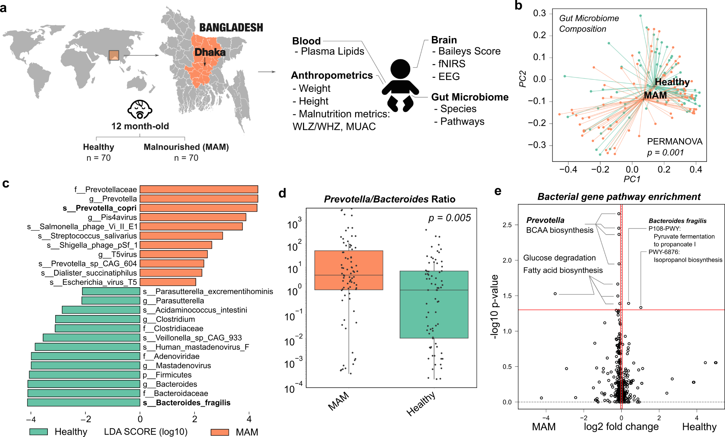

Figure 1: The 1-year-old infant microbiome is affected by malnutrition. A) Schematic of study design. B) PCoA Scatterplot of Bray-Curtis beta diversities of samples (each marker is a single sample). C) Barplot of significant taxonomic differences in relative abundance between 1-year-old Healthy and MAM samples (absolute LDA score > 2). D) Barplot of *Prevotella/Bacteroides* ratio change between study conditions. E) Volcano plot of pathways affected by malnutrition (upper left and upper right quadrants signify significant changes where the red horizontal line signifies M.W.W. q < 0.05 and vertical lines represent log2 fold change of -0.1 and 0.1 respectively).

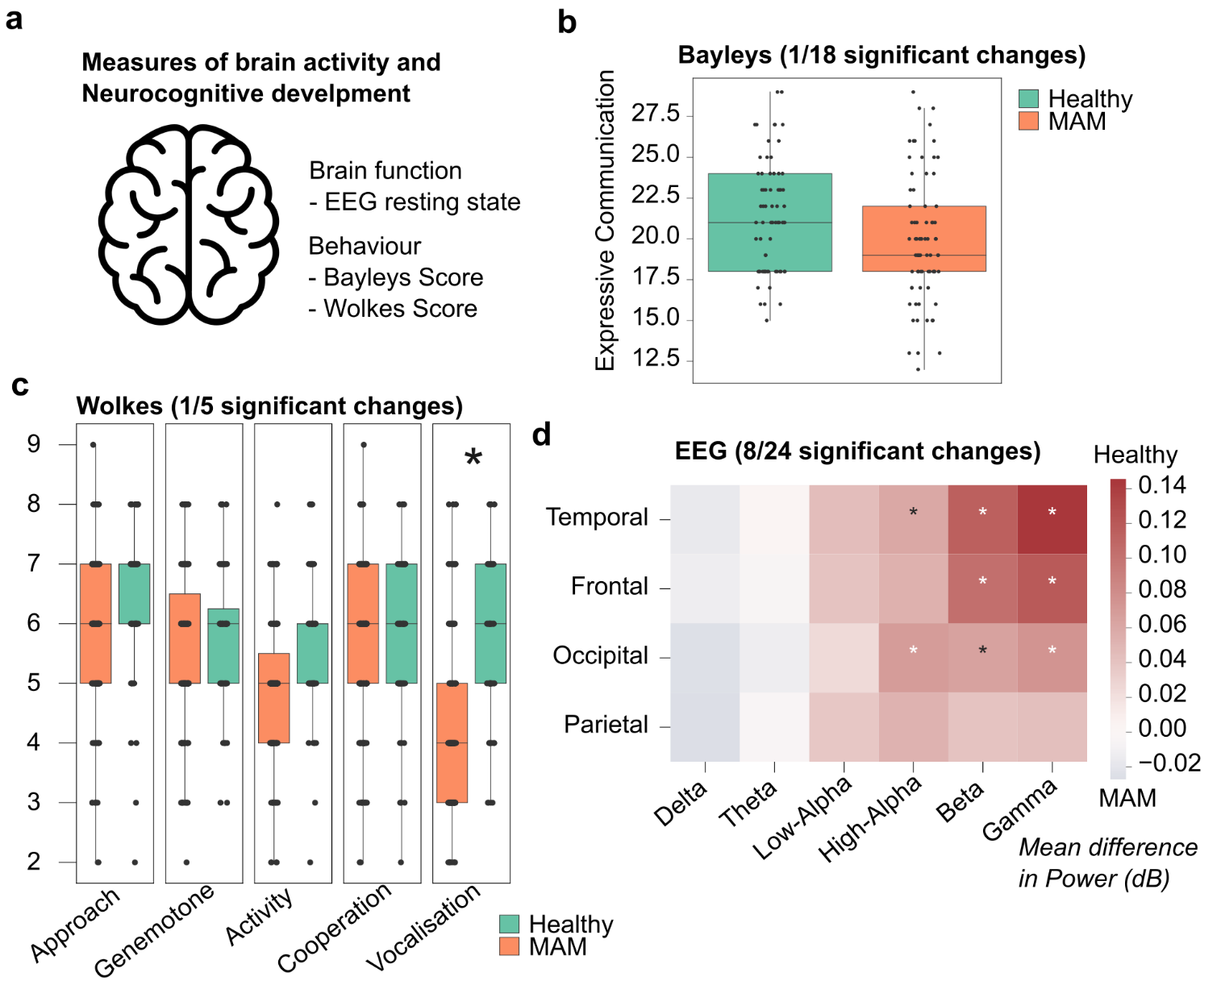

Figure 2: Contributing factors to healthy cognitive development in 12-month-old, malnourished infants. a) Schematic of approach to study neurocognitive function. b) Boxplot of significant difference in Expressive Communication Score of the children with malnutrition compared to healthy controls. c) Heatmap of lobe and frequency specific changes in EEG resting state power spectral density (PSD) in MAM versus Healthy infants. * = q < 0.05.

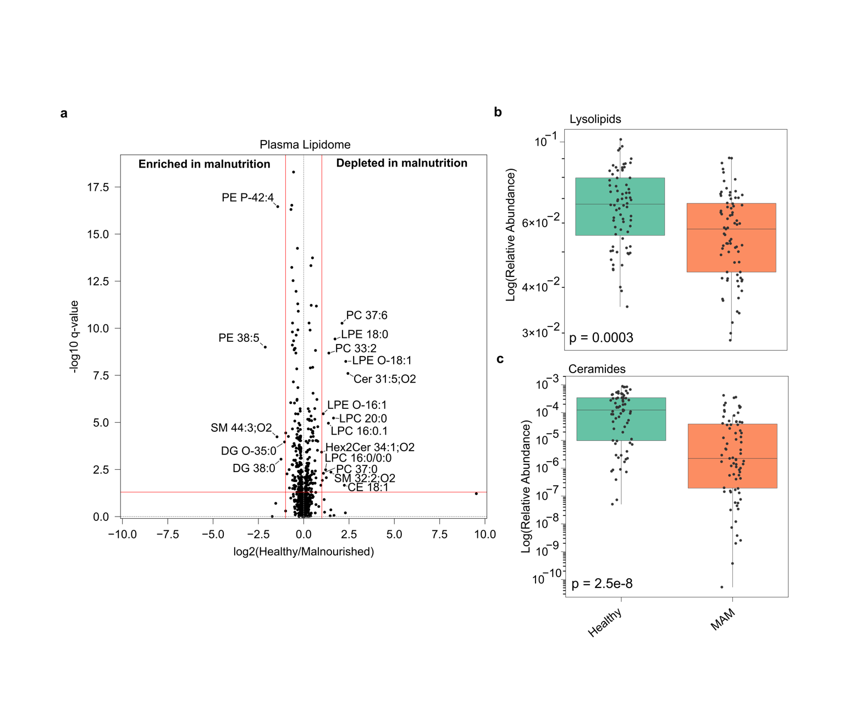

Figure 3: Malnutrition results in major, compositional differences in plasma lipids in 1-year olds. a) Volcano plot changes to plasma lipids between healthy and MAM 1-year-olds. (Upper left and upper right quadrants signify significant changes where the red horizontal line signifies M.W.W. q < 0.05 and vertical lines represent log2 fold change of -0.1 and 0.1 respectively). b) Lipidome class analysis. c) Ceramide abundance differences.

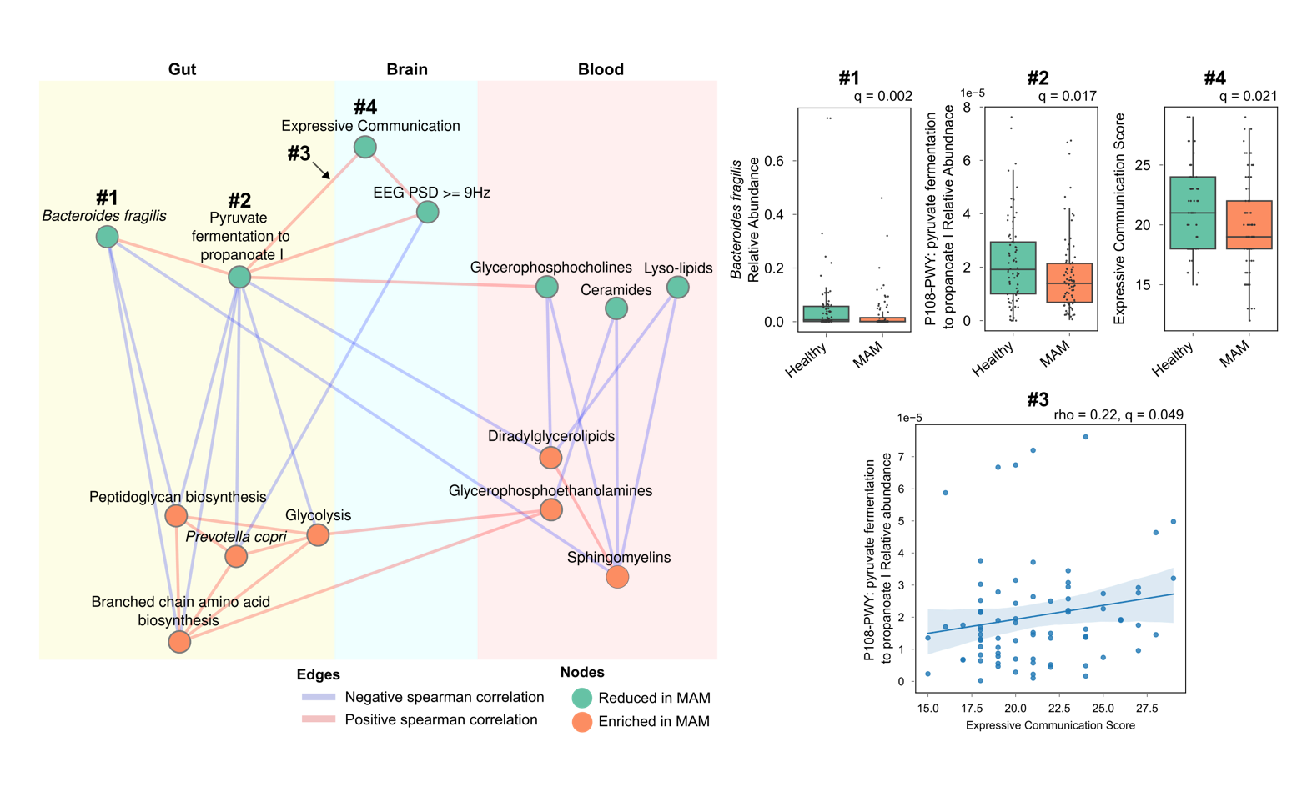

Figure 4: Species relative abundance correlation network. Nodes are species coloured by their enrichment in MAM (orange and green are enriched and depleted in MAM respectively). Edges are significant spearman correlations (filtered absolute correlation values above 0.6 and coloured red and blue being positively and negatively correlated respectively).

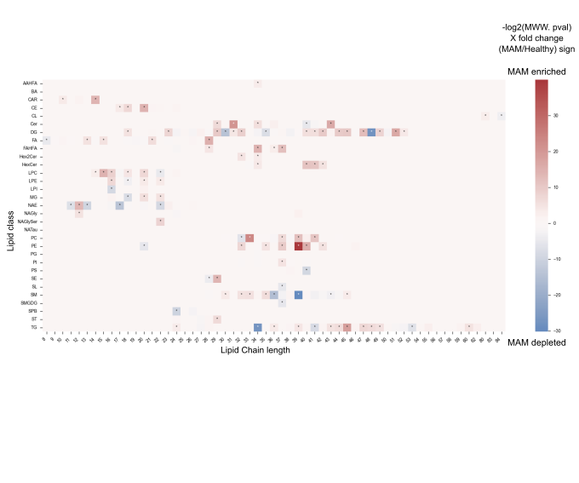

Supp Figure 1: Plasma Lipidomics chain length and class differential abundance analysis due to malnutrition

Supp Figure 2: HCGSN Electrode Configuration with regions of interest used for analysis indicated.

Supp Figure 3:

