
Datec Blog
Extension Key: datec_blog
Language: en|de
Version: 1.0.3
Keywords: datec, blog, bootstrap, filter, comment
Copyright 2015, Philipp Rönsch, <p.roensch@datec-schmidt.de>

This document is published under the Open Content License
available from http://www.opencontent.org/opl.shtml

The content of this document is related to TYPO3
- a GNU/GPL CMS/Framework available from www.typo3.org
Table of Contents
Datec Blog 1
Introduction 3
What does it do? 3
Screenshots 3
Users manual 5
Authoring 5
User Management 7
Administration 8
Installation 8
Configuration 9
Reference 9
Tutorial 12
Navigation 12
Commenting 13
Known problems 14
To-Do list 15
ChangeLog 16
FAQ 17
Help for Datec Blog 17

Introduction

What does it do?
This extension offers a simple but effective Blog integration for Typo3 Version 6.0 and higher.
Datec Blog brings a fresh and lightweight design to the blog frontend and gives administrators options for plugin display and access control.

Screenshots
Examples of the interface and options:
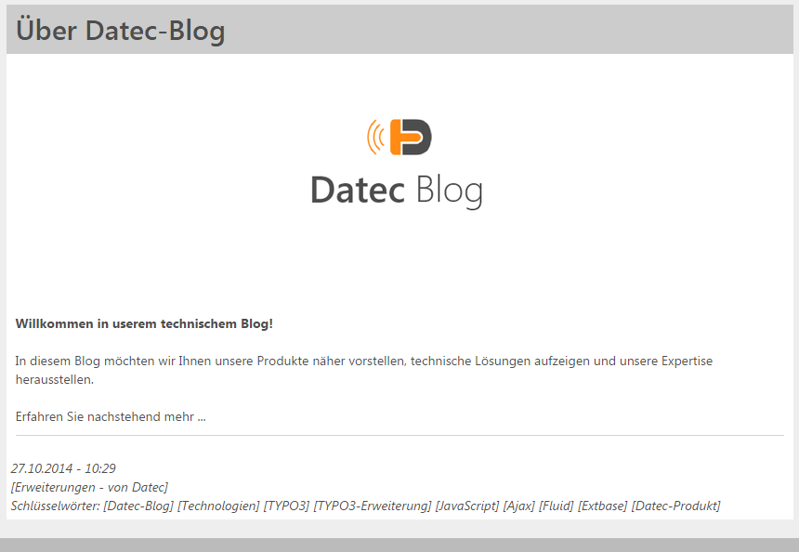
A blogpost in the list view.

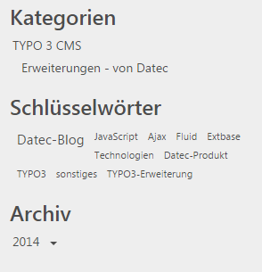
Categories, keywords and the archive on the side.
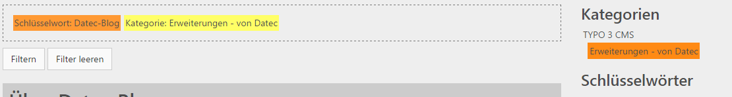
Filtering the list view.

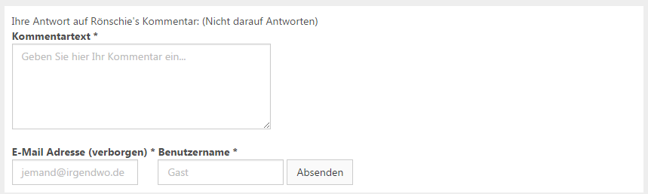
Commenting (as a reply).
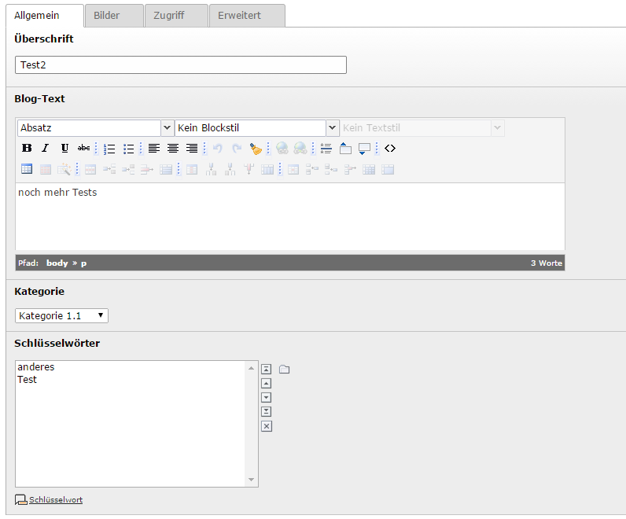
Editing a blogpost.

Users manual

Authoring
To create new blogcontent, such as categories, blogposts and keywords, take a look at these descriptive screenshots:
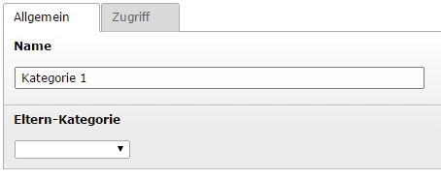
Adding a category (1) - the title and optionally a parent category to build a hierarchy.
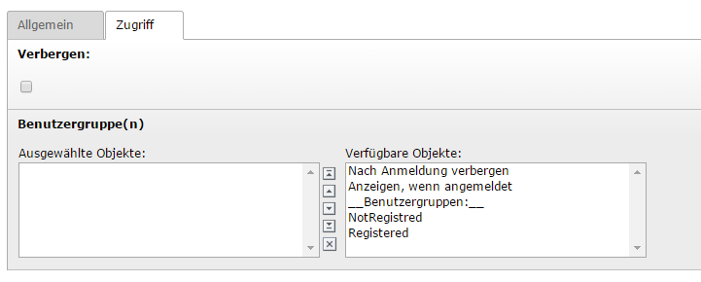
Adding a category (2) – show/hide, usergroups that have access (will be inherited by blogposts)
Adding a blogpost (1) – the title, the main text, a category (required), keyword(s)
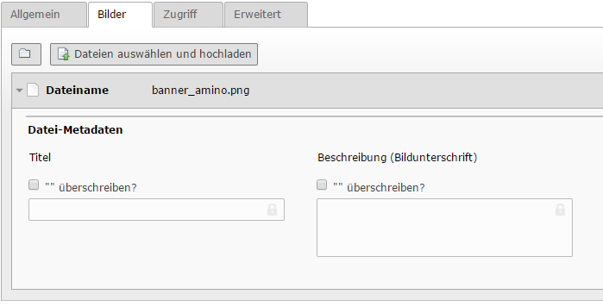
Adding a blogpost (2) – images to be displayed under the blogpost
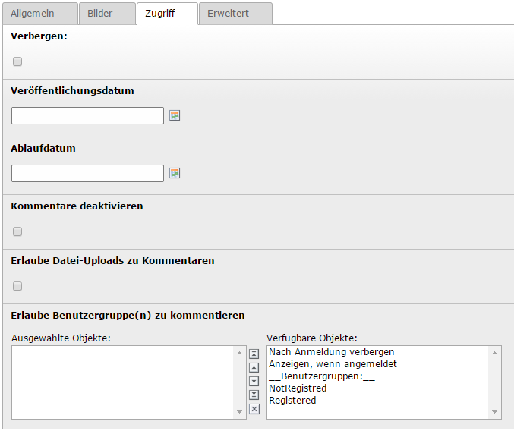
Adding a blogpost (3) – show/hide, starttime, endttime, disable comments, allow file uploads in comments, allow usergroups to comment => The blogpost inherits its access from its category.
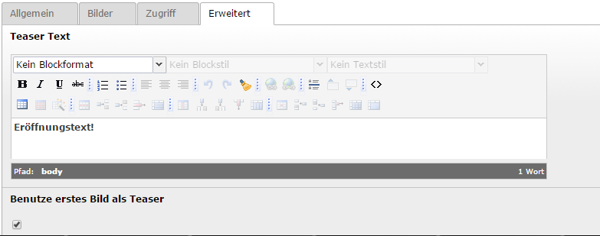
Adding a blogpost (4) – the teaser text in blogpost list view (and above the main text in single view), whether to show the first of the attached images in the teaser
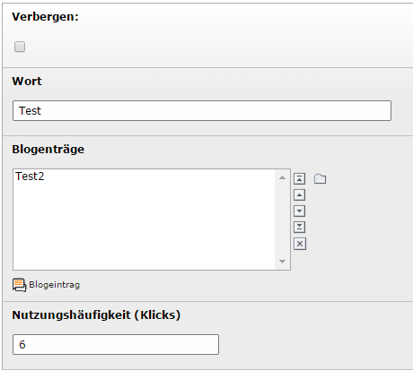
Adding a keyword – hide/show, the keyword, assigned blog posts, usage in click count (TIPP: you may put any number in here to push a keyword without clicks)

User Management
To inspect and control user input in the blog, use the list view of your system folder for comments and comment creators.
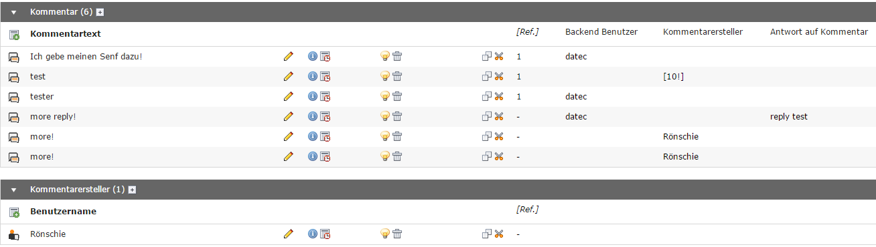
Inspecting comments and creators – Comments display the comment text, an assigned backend user or comment creator and which comment they reply to. Comment creators are identifiable by the entered username for public users or the username of the assigned frontend user
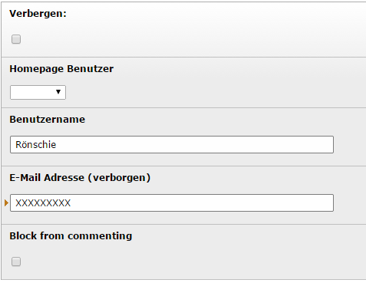
Editing a comment creator – you may change the information of the comment creator or block him from commenting here

Administration

Installation
1) Download and install the extension via the extension manager (extKey: datec_blog).
2) Add one storage folder for comments and comment creators, note down the PID of this folder.
3) Check the Configuration section of this manual for the required configuration and follow the steps there.
4) On one page in your homepage, add a plugin of each display form of Datec Blog you want, but at least the “Blog (Posts and Comments)” display. You can do it like so:
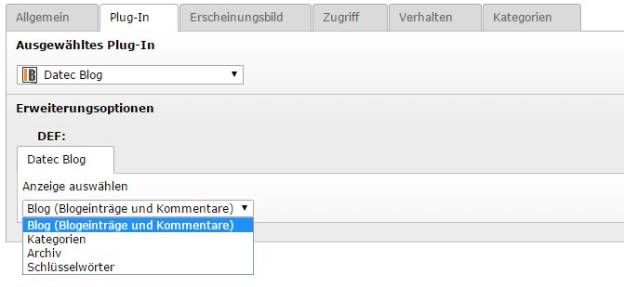
And end up with something like this:
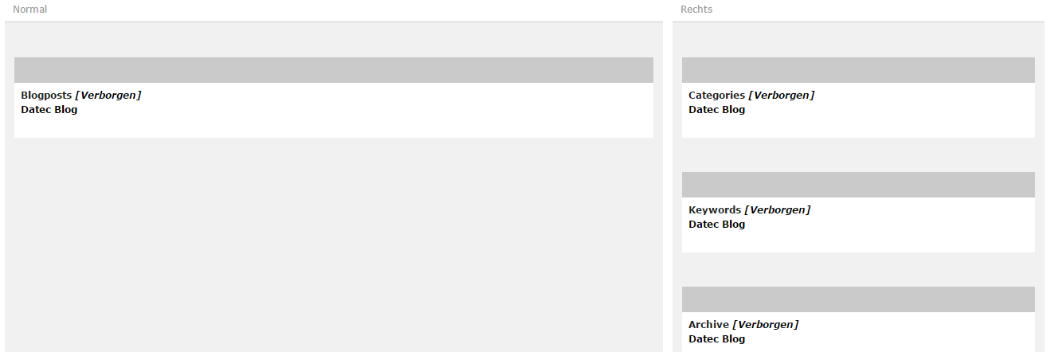
5) You may now create some blogcontent as described in the Users Manual – Authoring section of this manual.

6) DONE!

Configuration
This section describes all options you can edit for Datec Blog via TypoScript setup. To change these options please add a new extension template to your ROOT template.
On installation please add the static extension template 'Datec Blog' to your ROOT template (HOW?) and set at least settings.commentsStoragePid to your desired system folder and make sure that settings.mail.internMailFrom is a valid e-mail address.

Reference
Configuration options:
Property: | Data type: | Description: | Default:
settings.commentsStoragePid | int | System folder for comments and comment creators.
settings.mail.internMailFrom | string | E-mal address for automatic notification Mails [FROM]. | blog@no-reply.com
settings.mail.internMailFromName | string | Name to display for automatic notification Mails [FROM-NAME]. | Datec Blog
settings.maxFileSize | int | Maximum file size in bytes on comments with file attachments. | 4000000
settings.allowedFileTypes | string | File types allowed, listing comma-separated, on comments with file attachments. | pdf,zip,png,jpg,jpeg,gif,txt,doc,docx
settings.display .dateFormat | string | Date format to display dates, must be compatible to date() PHP function. | d.m.Y
settings.display .keywords .limit | int | Limit keyword results to this number, set 0 to disable. | 0
settings.display .keywords .order | string | Order keywords criteria, may be one of the following:  - 'date' => newest first, will put starttime before crdate  - 'usage' => highest click count first  - 'sorting' => respects sorting field | usage
settings.display .keywords .visual | string | Display form of keywords, may be one of the following:  - 'cloud' => cloud with most clicked keywords emphasized  - 'list' => simple listing | cloud
settings.display .posts.dateFormat. | string | Like settings.display.dateFormat just for posts only.  (Default add time display) | d.m.Y – H:i
settings.display .posts.teaserTextLength | int | If blogposts don't contain a teaser text they will be cut off at this length in the list view. (attention: formatted text might be longer than you think) | 40
settings.display .posts.sorting | string | Column name for SQL-query to sort blogposts by. | crdate
settings.display .posts.sortingDirection | string | Sorting direction for SQL-query to sort blogposts by. | DESC
settings.display .comments.dateFormat. | string | Like settings.display.dateFormat just for comments only.  (Default add time display) | d.m.Y – H:i
settings.display .comments.sorting | string | Column name for SQL-query to sort comments by. | crdate
settings.display .comments.sortingDirection | string | Sorting direction for SQL-query to sort comments by. | DESC
settings.display.feUser.nameFormat | string | How to display users, may be one of the following:  - 'username' => only username  - 'firstname_lastname' => full name  - 'firstname => only first name  - 'lastname' => only last name | username
settings.cssClasses.form | string | CSS class to use for forms.  (This and the following options defaults are optimized to use with Bootstrap 3 CSS-framework) | form form-horizontal
settings.cssClasses.formLabel | string | CSS class to use for labels. | col-sm-4 control-label
settings.cssClasses.formField | string | CSS class to use for form fields. | form-control
settings.cssClasses.formFieldWrap | string | CSS class to use in wrapping of form field + label. | form-group
settings.cssClasses.formButton | string | CSS class to use for form buttons. | btn btn-default
settings.cssClasses.listGroup | string | CSS class to use for list groups (<ul>).
settings.cssClasses.listItem | string | CSS class to use for list items (<li>).
view.templateRootPath | string
view.partialRootPath | string
view.layoutRootPath | string

Default Configuration
This is the default configuration, copy if you want to reset your settings:
plugin.tx_datecblog_blog {
view {
templateRootPath = {$plugin.tx_datecblog.view.templateRootPath}
partialRootPath = {$plugin.tx_datecblog.view.partialRootPath}
layoutRootPath = {$plugin.tx_datecblog.view.layoutRootPath}
}
persistence {

commentsStoragePid = 20
storagePid = {$plugin.tx_datecblog.persistence.storagePid}
}
settings {
storagePid = {$plugin.tx_datecblog.persistence.storagePid}
commentsStoragePid = {$plugin.tx_datecblog.persistence.storagePid}
mail {
internMailFrom =
internMailFromName = Datec Blog
}
maxFileSize = 4000000
allowedFileTypes = pdf,zip,png,jpg,jpeg,gif,txt,doc,docx
display {
dateFormat = d.m.Y
keywords {
limit = 0
order = usage
visual = cloud
}
posts {
dateFormat = d.m.Y - H:i
teaserTextLength = 40
sorting = crdate
sortingDirection = DESC
}
comments {
dateFormat = d.m.Y - H:i
sorting = crdate
sortingDirection = DESC
}
feUser {
nameFormat = username
}
}
cssClasses {
form = form form-inline
formLabel = control-label
formField = form-control
formFieldWrap = form-group
formButton = btn btn-default
listGroup =
listItem =
}
}
}

Tutorial

Navigation
In the frontend, users can navigate the blog through the blogpost list view, apply filters such as the categories, archive dates and keywords and also open a blogpost and assigned comments for single view.
Blogpost in list view – shows teaser image (optional), teaser text (optional) and (under the line) posting date/time, the category and a list of keywords
also shows last comment and comment count if any
The “sidebar” with the plugins for categories (as tree), keywords (as cloud) and the archive (as tree, auto generated)
Elements from categories, keywords and archive are clickable to act as filter for the list view, can be discarded or clicked upon to remove a single criteria.
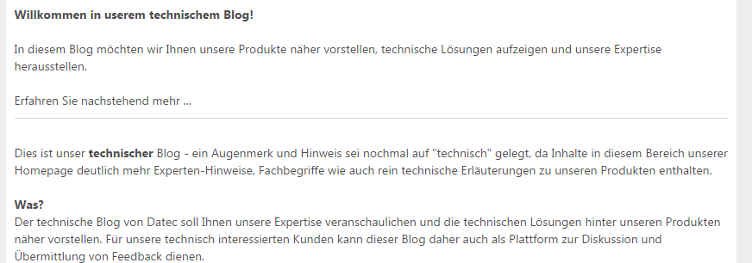
In single view, the blogpost teaser text is followed by the main text after the line.

Commenting
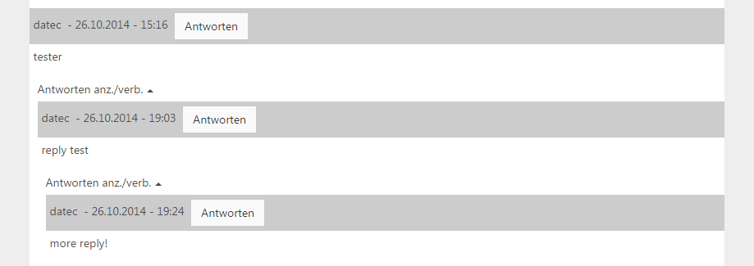
The comment form below the blogpost single view, another comments reply button was used to make this comment a reply to it, this can be discarded by clicking on “(Don't reply)”. Required fields are comment text, email and username, might also have file upload when enabled
Comments are shown below the comment form view as a tree, in which replies can be expanded to show or imploded to hide.

Known problems
Will be added here if reported.
TYPO3 Forge link to your project

To-Do list
Check the current development state online:
TYPO3 Forge link to your project.

ChangeLog
You may also check the forge roadmap: ChangeLog online

Version: | Changes:
1.0.3 | [BUGFIX] blocked attribute was not configured for BE, duh  [BUGFIX] detection of backend user as comment creator on trying to set the frontend user for the comments list
1.0.2 | [FEATURE] categories can now hold frontend user groups for access restriction, the set usergroups will be inherited by the blogposts in this category  [FEATURE] blogposts can controll access to comments by frontend user groups  [FEATURE] comments can now have files uploaded and show them below the comment  [FEATURE] direct link to blogposts and comments  [QUALITY] listing of comments checks if comments are to be displayed  [QUALITY] replying to comment down in the list sets focus back to form
1.0.1 | [BUGFIX] installation file 'ext_tables.sql' changed column name from 'commentcreator' to 'comment_creator' in 'tx_datecblog_domain_model_comment'  [BUGFIX] creating comments was only checking public users for 'blocked' attribute, now it's for all  [BUGFIX] ajaxCalls by this plugin are now configured to avoid collisions with other plugins 'ajaxCallDatecBlog'  [BUGFIX] no available categories now shows the correct error message  [BUGFIX] because the frontend user cannot be loaded with the comment creator, it will be loaded on occasions needed and only the frontend user uid is saved  [FEATURE] blogpost list now shows count of comments and last comment per post  [FEATURE] also you can click the comment information below a blogpost to show the blogpost singleview with focus on comments  [FEATURE] for comment creators feUser reference the naming format can be configured to show username,first- and lastname,only firstname or only lastname  [LANG] completed english translation
1.0.0 | This is the first full stable release of 'datec_blog'

FAQ
No questions submitted yet.

Help for Datec Blog
If you need any futher help, please contact our software team at:
info@datec-schmidt.de

