
Datec Losungen
Extension Key: datec_losungen
Language: de
Version: 1.0.0
Keywords: datec, losungen, watchwords, brüdergemeinde
Copyright 2015, Philipp Rönsch, p.roensch@datec-schmidt.de

This document is published under the Open Content License
available from http://www.opencontent.org/opl.shtml

The content of this document is related to TYPO3
- a GNU/GPL CMS/Framework available from www.typo3.org
Table of Contents
Datec Losungen 1
Introduction 3
What does it do? 3
Screenshots 3
Users manual 4
Configuration 5
Reference 5
Known problems 7
To-Do list 8
ChangeLog 9
FAQ 10
Help for Datec Losungen 10

Introduction

What does it do?
This extension add a new plugin to fetch and display the daily german watchwords (“Losungen”).
Important: This extension will only display the german verses from the official homepage of the Brüdergemeinde Hernnhut (www.losungen.de).
The current watchwords information is yearly downloaded and unzipped from above mentioned site, not manual intervention is needed for this process. This extension will use the TYPO3 temporary directory for storage of all downloaded files.

Screenshots
Here you see how it looks:
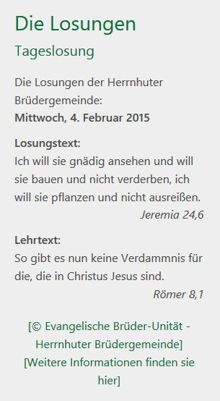
Abbildung 1: Losung Beispiel - http://efg-belzig.de, 04.02.2015

Users manual
This extension is to use out-of-the-box, please follow these steps:
- Install the extension via the extension manager (datec_losungen)
- Add a new content element of the type 'plugin' to your homepage and select 'Datec Losungen' as plugin.
- Add the static configuration file 'Datec Losungen' to your ROOT configuration template. (HOW?)
- Check the Configuration section of this manual for any changes you might have to make, by default you shouldn't have to.
- DONE!

Configuration
The extension is configured by default to use the watchwords from www.losungen.de, as is required by the attached terms of service (NUTZUNGSBEDINGUNGEN.pdf).
But if necessary, you can modify the URL of the server and the required filenames.
Every change can be done in the constants-editor in the template-section.

You may also adapt the template for layout and the stylesheet.

Reference
Property: | Data type: | Description: | Default:
view.templateRootPath | string | Constant, path to template files if you wish to use your own. | EXT:datec_losungen/Resources/Private/Templates/
view.partialRootPath | string | Constant, path to partial template files if you wish to use your own. | EXT:datec_losungen/Resources/Private/Partials/
view.layoutRootPath | string | Constant, path to layout files if you wish to use your own. | EXT:datec_losungen/Resources/Private/Layouts/
settings.display.dateFormat | string | Date format string, compatible with PHP function date().  Only used if set.
settings.display.licenses | array | Array of licenses with text and url, like so:  licences {  0 {  text = TEXT  url = http://example.com  }  1 {  ...  } | 2 default licenses
settings.xmlConf.serverUrl | string | Server root, where to download the watchwords zip from. | http://www.brueder-unitaet.de/download/
settings.xmlConf.zipName | string | Name of the ZIP file, include 'YEAR' to have it yearly replaced. | Losung_YEAR_XML.zip
settings.xmlConf.xmlName | string | Name of the XML file, include 'YEAR' to have it yearly replaced. | Losungen Free YEAR.xml
settings.xmlConf.termsName | string | Name of the terms-of-use file. | Nutzungsbedingungen.pdf
settings.xmlConf.encoding | string | Encoding of the xml file, will decode for iso or utf8 output. | iso
settings.xmlConf.xmlTree.rootNode | string | Name of the root node in XML. | FreeXml
settings.xmlConf.xmlTree.treeNode | string | Name of the tree node in XML. | Losungen
settings.xmlConf.xmlTree.branchDate | string | Name of the watchword DATE branch node in XML. | Datum
settings.xmlConf.xmlTree.branchWeekday | string | Name of the watchword WEEKDAY branch node in XML. | Wtag
settings.xmlConf.xmlTree.branchSunday | string | Name of the watchword SUN/-HOLYDAY branch node in XML. | Sonntag
settings.xmlConf.xmlTree.branchWatchwordText | string | Name of the watchword WATCHWORD TEXT branch node in XML. | Losungstext
settings.xmlConf.xmlTree.branchWatchwordVerse | string | Name of the watchword WATCHWORD VERSE branch node in XML. | Losungsvers
settings.xmlConf.xmlTree.branchDidactictextText | string | Name of the watchword DIDACTIC-TEXT TEXT branch node in XML. | Lehrtext
settings.xmlConf.xmlTree.branchDidactictextVerse | string | Name of the watchword DIDACTIC-TEXT VERSE branch node in XML. | Lehrtextvers

Known problems
Will be documented here when reported.

To-Do list
Nothing left to do.

ChangeLog
Version: | Changes:
1.0.0 | Release

FAQ
No questions submitted yet.

Help for Datec Losungen
If you need any futher help, please contact our software team at:
info@datec-schmidt.de

