1A REPORT

Github repo: https://github.com/theoreotically/ECE554SP26_Minilabs
I created this repository by using the Github UI. When you log in there is a button to create a new repository where you can name it and select whether it is private or public.
I added the files by cloning the repository and copying the quartus project folder in.

Transcript with IP:
# do run.do
# ** Warning: (vlib-34) Library already exists at "work".
# Model Technology ModelSim - Intel FPGA Edition vlog 10.5b Compiler 2016.10 Oct 5 2016
# Start time: 16:14:03 on Feb 05,2026
# vlog -reportprogress 300 -work work addsb_bb.v addsb.v fifo.sv mac.sv mult_mod_bb.v mult_mod.v tb.sv fifo2_bb.v fi
fo2.v Minilab0.v
# -- Compiling module addsb
# ** Warning: addsb.v(40): (vlog-2275) 'addsb' already exists and will be overwritten.
# -- Compiling module addsb
# -- Compiling module FIFO
# -- Compiling module MAC
# -- Compiling module mult_mod
# ** Warning: mult_mod.v(40): (vlog-2275) 'mult_mod' already exists and will be overwritten.
# -- Compiling module mult_mod
# -- Compiling module tb
# -- Compiling module fifo2
# ** Warning: fifo2.v(40): (vlog-2275) 'fifo2' already exists and will be overwritten.
# -- Compiling module fifo2
# -- Compiling module Minilab0
#
# Top level modules:
# addsb
# mult_mod
# tb
# fifo2
# End time: 16:14:03 on Feb 05,2026, Elapsed time: 0:00:00
# Errors: 0, Warnings: 3
# vsim -L /home/michael2/Documents/intelFPGA/18.1/modelsim_ase/altera/verilog/altera_mf -L /home/michael2/Documents/
intelFPGA/18.1/modelsim_ase/altera/verilog/220model work.tb -voptargs="+acc"
# Start time: 16:14:03 on Feb 05,2026
# Loading sv_std.std
# Loading work.tb
# Loading work.Minilab0
# Loading work.MAC
# Loading work.FIFO
# ** Warning: (vsim-3116) Problem reading symbols from linux-gate.so.1 : can not open ELF file.
# ** Warning: (vsim-3116) Problem reading symbols from /lib/libpthread.so.0 : module was loaded at an absolute addre
ss.
# ** Warning: (vsim-3116) Problem reading symbols from /lib/librt.so.1 : module was loaded at an absolute address.
# ** Warning: (vsim-3116) Problem reading symbols from /lib/libdl.so.2 : module was loaded at an absolute address.
# ** Warning: (vsim-3116) Problem reading symbols from /lib/libm.so.6 : module was loaded at an absolute address.
# ** Warning: (vsim-3116) Problem reading symbols from /lib/libc.so.6 : module was loaded at an absolute address.
# ** Warning: (vsim-3116) Problem reading symbols from /lib/ld-linux.so.2 : module was loaded at an absolute address
.
# Yahoo! All tests passed!
# ** Note: $finish : tb.sv(66)
# Time: 2185 ns Iteration: 0 Instance: /tb
# 1
# Break in Module tb at tb.sv line 66
add wave -position insertpoint \
sim:/tb/clk \
sim:/tb/HEX0 \
sim:/tb/HEX1 \
sim:/tb/HEX2 \
sim:/tb/HEX3 \
sim:/tb/HEX4 \
sim:/tb/HEX5 \
sim:/tb/LEDR \
sim:/tb/KEY \
sim:/tb/SW
restart -f
# Closing VCD file "dump.vcd"
run -all
# ** Warning: (vsim-3116) Problem reading symbols from linux-gate.so.1 : can not open ELF file.
# ** Warning: (vsim-3116) Problem reading symbols from /lib/libpthread.so.0 : module was loaded at an absolute addre
ss.
# ** Warning: (vsim-3116) Problem reading symbols from /lib/librt.so.1 : module was loaded at an absolute address.
# ** Warning: (vsim-3116) Problem reading symbols from /lib/libdl.so.2 : module was loaded at an absolute address.
# ** Warning: (vsim-3116) Problem reading symbols from /lib/libm.so.6 : module was loaded at an absolute address.
# ** Warning: (vsim-3116) Problem reading symbols from /lib/libc.so.6 : module was loaded at an absolute address.
# ** Warning: (vsim-3116) Problem reading symbols from /lib/ld-linux.so.2 : module was loaded at an absolute address
.
# Yahoo! All tests passed!
# ** Note: $finish : tb.sv(66)
# Time: 2185 ns Iteration: 0 Instance: /tb
# 1
# Break in Module tb at tb.sv line 66

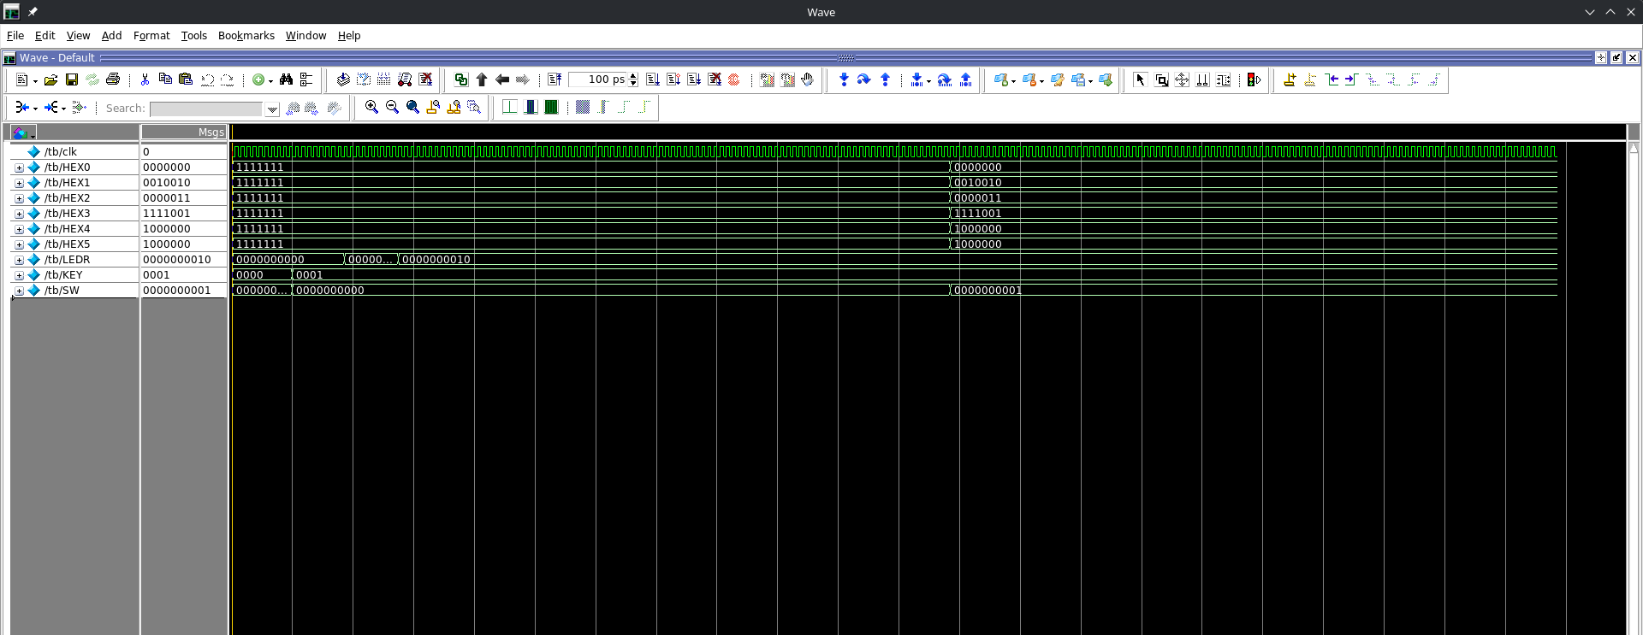
Above is a screenshot of the waves with the IP

Simulation without IP:
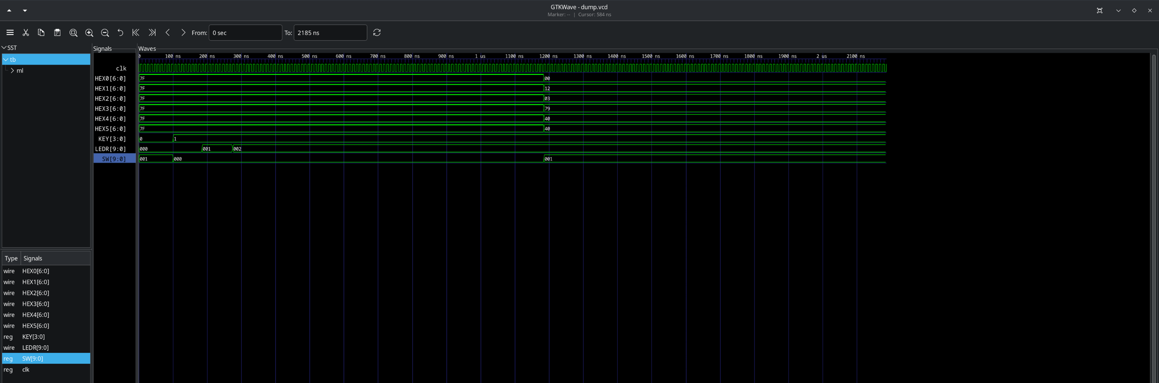

michael2@himring-2 ~/D/C/E/1a_actually0 (master)> iverilog -g2012 *.sv Minilab0.v && ./a.out && gtkwave dump.vcd
VCD info: dumpfile dump.vcd opened for output.
Yahoo! All tests passed!
tb.sv:66: $finish called at 2185 (1ns)
Transcript without IP (using our files)

Commentary on resource usage:
The one using IP was smaller.

1B REPORT

Github repo: https://github.com/theoreotically/ECE554SP26_Minilabs
I created this repository by using the Github UI. When you log in there is a button to create a new repository where you can name it and select whether it is private or public.
I added the files by cloning the repository and copying the quartus project folder in.
We tested our project by writing a testbench first for the matrix vector multiply unit as well as the top level. We first debugged the matrix vector multiply unit and then the top level using these testbenches.
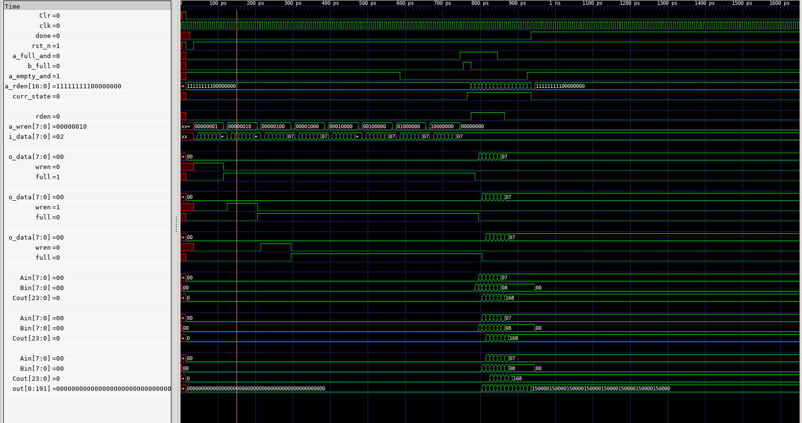
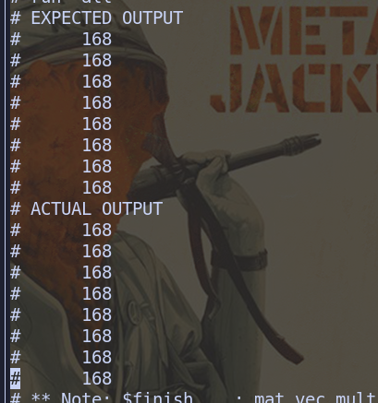
(Please excuse the background the teammate who took this screenshot uses a transparent background in their terminal)
To fix the timing constraint, we inserted a flop between the adder and multiplier in the MAC unit.

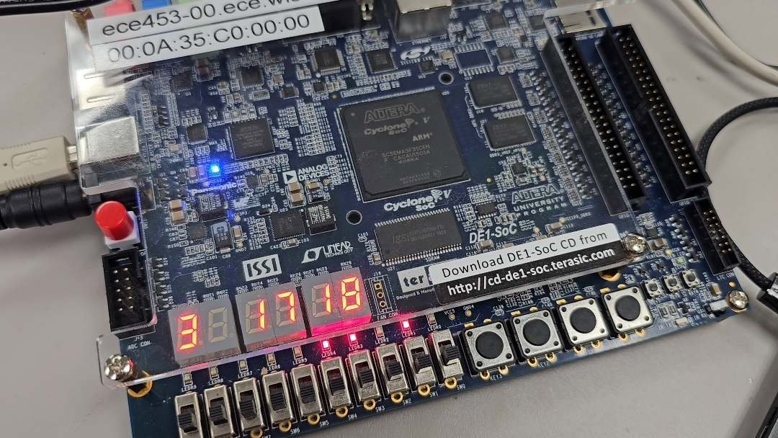
During debug of the board, we slowed down the clock and brought out signals onto the hex displays (controlled by the switch) and the LEDR outputs. This allowed us to view how the memory interface was behaving in real time.
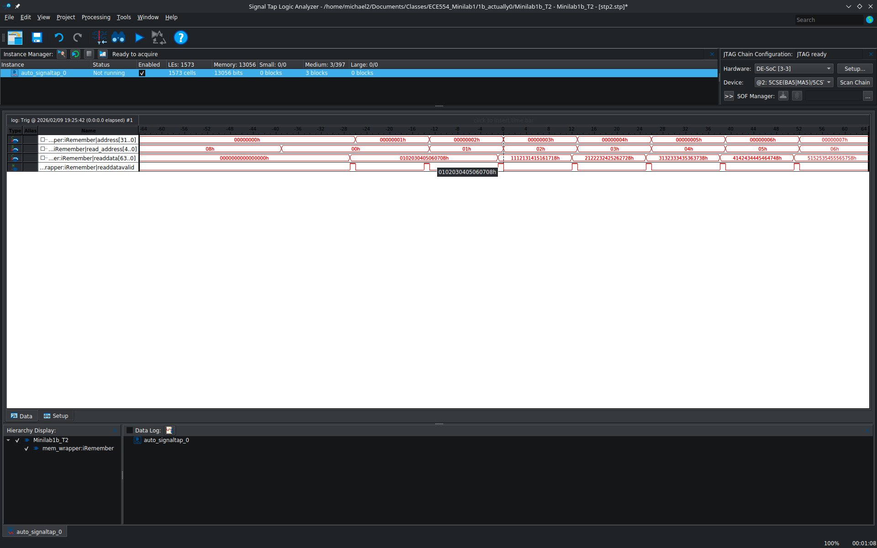
With signaltap we set triggers on the MMC address to an address in the middle. This lets us see the entire waveform.

We had some issues coordinating the process of design. The RTL took a little longer than anticipated making the rest of the process a bit rushed. We worked on this outside of class time to make up for it.

The larger issue was the fact that the code and top level we wrote transposed the input matrix, resulting in the incorrect result. We spent a lot of time fixing our macs and top level to be able to accommodate the correct solution.

