**Abstract**

The main aim of this research proposal is to design and implement **“ online product publication system**” for Kigali Buy & Sell ltd; this is an interactive web based system to Kigali Buy & Sell ltd in which it is used as the management tool for products publication and marketing.

It has been developed based on the information obtained from Rwandan customers by means of interview, observation as the instrument of data collection.

The project was focused on Kigali Buy & Sell ltd because of problem of lacking the digital way which can help them to automate their daily activities and it is difficult to reach to a great number of customers.and this cause many problems such as time consuming and expensive services.the people who need publication services had to come to Kigali Buy & Sell ltd and company helps them to publish their products through social medias, radios and make frames to put on road. It is difficult for the people who are far of Kigali because they can’t reach easily to where the company is located.

PHP, Apache and HTML were used as programming language and software such as Adobe macromedia and xampp were used to design this application.

The contribution of this project is of high value to Rwanda market where they find someone to publicity their products.

# 

# CHAPTER 1: GENERAL INTRODUCTION

## BACKGROUND OF THE STUDY

Information and Communications Technology (ICT) has become a catchword with different interpretations and viewpoints even among experts. As the name suggests, ICT encompasses all the technology that facilitates the processing, transfer and exchange of information and communication services.

Rwanda continues to be one of the fastest growing African countries in ICT and there are several avenues for growth but many institutions are still serving as they did many years ago. Same techniques are still being used whereas other sectors are migrating from manual to computerized systems that are able to handle a big number of information and process in a smaller time.

Therefore, I have decided to design and implement Kigali Buy & Sell ltd “**online product publication management system**”, a system which computerizes and simplify the way of managing activities and operations of publishing and marketize products to the market.

This system will be implemented to facilitate the management of Kigali Buy & Sell ltd to easily easily facilitate and improve the services given to their customers.

**1.3 problem statement**

Since the technology of Rwanda is rapidly growth; making relevant knowledge and information available to Kigali Buy & Sell ltd is still extremely poor and still using manual system for publishing and and making marketing their products where the customers do not have abilities of publishing their products easily and the activity. This can cause different problems such as Difficult for publisher who need to market the products and also for the customers who need these products.

**1.4 hypothesis of project**

The proposed project will reduce the problems caused by old method (paper based database) where publication will be automatically and more reliable than before, and will facilitate to wide the market of Rwanda

.

## 1.3 OBJECTIVES OF THE PROJECT

### 1.3.1 General objective:

The general objective of this project is to develop and implement a system that makes easy and faster the process of publishing, marketing products of Rwandan people and simplifying periodic activity for Kigali product and house publisher ltd.

Online product publication system can be an application within interactive and user friendly interface for any time anywhere service to Kigali Buy & Sell ltd management and customerss.

**1.6.2 Specific objectives**

* To computerized the system of record of online market in Rwanda
* To publish and sale products online
* To reduce time consumingTo make a database which allow keeping the state of your stocks

## 1.5 THE SCOPE OF THE PROJECT

Our research will emphasize in nyarugenge house publisher ltd as the case study, our project focuses on the following contents:

* Creating an interactive interface with a way in which an product owner can publish his/her product, and safely keeping the data for long period of use.
* Creating an interface that helps many people from different region to access the products they need and their information.
* Creating an interface that help the activity managers to view periodic reports.

**1.6.3 The purpose of the study**

**1.6.4 Personal interest**

This work is helpful for me to pass an academic background The knowledge from will be helpful for me for further studies and competency on labor market.

**1.6.5 Academic interest**

This ending university studies work is for students who are completing their univeristyy study where each student should be able to carry out his/her our research concerning the enterprises at his/her choice and organize the files of that enterprise.

Within this work the research has considered two academic interests:

* **Primary,** the ministry of education will be ensured that the student who is going to get the certificate is really capable of producing a work on his field of student (i.e.able to do something in ICT).
* **Secondary**, the findings of this project will be and useful for future researchers and other people who are interested in the same field of study.
* **University,** this knowledge will be helpful to the students for further studies and competency on labor market. The findings of this project will be and useful for future researchers and other people who are interested in the same field of study

### 1.7.3 Scientific interest

It will help other researchers for new information to make their own system, every it will get the job with no complexity and they will find how to use their theory studies information practice by working with the system implemented

# CHAPTER 2. LITERATURE REVIEW

## 2.0 INTRODUCTION

The purpose of this chapter is to provide the theory of definitions of the key concepts that were used in this dissertation, the comparison of this work with many others, and the contribution to solve the problems found in the read dissertation.

## 2.1. DEFINITIONS OF THE KEYWORDS

This chapter explains the technical terms we have used, and some tools that we have used when designing this system. Those definitions we have read them in different locations, some from different websites, and others from the notes from our different teachers. In order to make this work more understandable to clarify some of it keywords. They are like

### 2.1.1 Users

In this system, a user is anyone who interacts with the system by logging in that he/she want to publish his/her products or see new products for others.

### 2.1.2. Manager.

A manager in this system is anyone who is legally in the system and has duties to manage the entire system like troubleshooting of a system, backup and recovery.

**2.1.3. Published**

Are those products that has published by a user in the system

## 2.2. Information system

Information system is a set of people, procedures and resources that collects, transforms and disseminates information in an organization; a system that accepts data resources as input and processes them into information products as output; a system that uses the resources of hardware, software and people to perform input, processing, output, storage and control activities that transform data resources into information products; a purposefully designed system that brings data, computers, procedures, and people together to manage information important to an organization's mission.

### 2.3. System

**System**: A system is a collection of elements or components that are organized for a common purpose. The word sometimes describes the organization or plan itself (and is similar in meaning to method, as in "I have my own little system") and sometimes describes the parts in the system (as in "computer system").

### 2.4 Information

Information is defined as data that have been processed and presented in a form suitable for human interpretation, often with the purpose of revealing trends or patterns.

### 2.5 Information Technology

Information technology is a contemporary term that describes the combination of computer technology (hardware and software) with telecommunication technology (data, image, and voice networks).

### 2.6. Information System

An information system (IS) is an arrangement of people, data, processes, communications, and information technology that interact to support and improve day-to-day operations in a business as well as support the problem-solving and decision making needs of management and users.

## 2.7. Operating System

The Operating System is the software that shares a computer system's resources (processor, memory, disk space, network bandwidth, and so on) between users and controls access to the system to provide security.

**2.2. Database concepts**

### 2.2.1. Data

In general, data consist of propositions that reflect reality. A large class of practically important propositions is measurements or observations of a variable. Such propositions may comprise numbers, words, or images.

### 2.2.2. Database

**Database:** A database is a collection of information that is organized so that it can easily be accessed, managed, and updated. In one view, databases can be classified according to types of content: bibliographic, full-text, numeric, and images.

### 2.2.3. Entity

A person, place, object, event, or concept in the user environment about which the organization wishes to maintain data.

### 2.2.4. Table

**Table:** A table in database is a data object used to store data.

### 2.2.5. Record

A Record is a generic term for a 'row' in the database, just like a card. A record very often represents a 'piece' of content. The dynamic functionality and much of the content of Mambo relies on a database in order to function.

### 2.2.6. Field

The location in a database record reserved for a particular type of data; for example, in a library catalog, author, title, subject headings would all be stored in specific fields.

### 2.2.7. Key

Key or key field is a field (or fields) on the many side of a one-to-many relationship between tables that related to a primary key of the other table. Foreign key do not need to be unique within the table.

Key consists of:

* **Primary key:** A primary key is a special relational database table column (or combination of columns) designated to uniquely identify all table records.

key for an entry must never change: if the record is referred to by a record in a different table, the relationship (link) will be often irretrievably broken.

* **Foreign key**

The foreign key belongs to another table and has no meaning for the entity in which it is recorded. Usually a foreign key will be a primary key in another table.

### 2.8.8. Relational database

**Relational database builds the relationships between fields in tables explicitly through keyed fields.**

## 2.3. Database in a network environment

### 2.3.1. Network environment

**a. Client/server architecture**

The client-server software architecture model distinguishes client systems from server systems, which communicate over a computer network. A client-server application is a distributed system comprised of both client and server software. A client software process may initiate a communication session, while the server waits for requests from any client. [

Client/server describes the relationship between two computer programs in which one program, the client, makes a service request from another program, the server, which fulfills the request.

**b. Database server**

A computer that stores data centrally for network users & managers & often uses client-server software to distribute the processing of that data between itself & nodes (computers) requesting information.

**c. Web server**

A Web **server** is a program that, using the client/server model and the World Wide Web's Hypertext Transfer Protocol (HTTP), serves the files that form Web pages to Web users (whose computers contain HTTP clients that forward their requests). Every computer on the Internet that contains a Web site must have a Web server program. Two leading Web servers are Apache, the most widely-installed Web server, and Microsoft's Internet Information Server (IIS).

**d. Browser**

A browser is an application program that provides a way to look at and interact with all the information on the World Wide Web. The word "browser" seems to have originated prior to the Web as a generic term for user interfaces that let you browse (navigate through and read) text files online. Some of the popular browsers are: Internet Explorer, Mozilla Firefox, Netscape navigator.

## 2.4. Tools and Language used

### 2.4.1. HTML

Hypertext Markup Language (HTML) is a markup language designed for creating web pages, that is, information presented on the World Wide Web. Defined as a simple "application" of SGML, which is used by organizations with complex publishing requirements, HTML is now an Internet standard maintained by the World Wide Web Consortium (W3C). The most recent version is HTML 4.01, though it has been superseded by XHTML.

### 2.4.2. PHP

Acronym: Hypertext Pre-processor. PHP is a server-side scripting language for creating dynamic Web pages. You create pages with PHP and HTML. When a visitor opens the page, the server processes the PHP commands and then sends the results to the visitor's browser. PHP is Open Source and cross-platform. PHP runs on Windows NT and many UNIX versions..

### 2.4.3. CSS

Cascading Style Sheets (CSS): A style sheet language used to describe the presentation of a document written in a markup language. Its most common application is to style web pages written in HTML and XHTML, but the language can be applied to any kind of XML document. CSS is a W3C Standard.

### 2.4.4. MySQL

MySQL is an open source relational database management system (RDBMS) that uses Structured Query Language (SQL), the most popular language for adding, accessing, and processing data in a database. Because it is open source, anyone can download MySQL and tailor it to their needs in accordance with the general public license.

### 2.4.5. Apache web server

Often referred to as simply Apache, a public-domain open source Web server developed by a loosely-knit group of programmers. Apache has been the world’s most popular web server (HTTP Server) on the internet since April 1996 and is generally considered to be more stable than other servers.

The original version of Apache was written for UNIX, but there are now versions that run under OS/2, Windows and other platforms.

2.5. ADVANTAGE OF DATABASE

There is several advantage of storing data in database.

All data stored at one location when a database is used, all tables are stored in a single file thus, and we need not deal with separate first button use the single database file. Though all the data is stored in a single file, distinction one main faired because of the use of the tables. Each table is stored as separate entity in the file. It is possible to define relationship between tables as will be seen once defined these relationship between tables are also stored in the database.

It is possible to define validation at the field as well table level this ensures accuracy of data being stored.

We also used query, report, sorting etc.

**2.6 Methods and Techniques**

### 2.6.1 Data collection methodologies

1. The school library will help the researchers to understand basic concepts and terminology to use.

The internet, is the another source to understand deeply the technical terms for our project.

### 2.6.2 Development methodology

The Software development process methodology that will be used is the waterfall model. This is a sequential software development model of five phases which are:

* Requirement analysis,
* System and software design,
* Implementation and Unit testing,
* Integration and system testing,
* Maintenance

**CHAPTER 3: RESEARCH METHODOLOGY**

## 3.1. Introduction

The methodology may refer to nothing more than a simple set of methods or procedures, the analysis of the principals of methods, rules, postulates and philosophical assumptions that underlie a particular project relative to the scientific method applied to the specified problem in the research.

## 3.2: Data gathering methodology

### 3.2.1: Data collection Methods

There are the activities that enable a researcher in gathering information about the organization, the problems that have led to the system request and the detailed system requirements.

#### Documentation

This method consists of reading different document related to my project such as class syllabi, book (even electronic books) and internet references.

## 3.3: System Development Methodology

The waterfall model is the system development methodology that the researcher chose to use during the development of web application for managing online products publication in sale department

### 3.3.1: Waterfall model

The waterfall Mode refers to a linear-sequential life cycle model. In waterfall model, each phase must be completed fully before the next phase can begin. At the end of each phase, a review takes place to determine if the project is on the right path and whether or not to continue or discard the project. In waterfall model, phases do not overlap.

The waterfall model is a sequential design process, often used in software development processes, in which progress is seen as flowing steadily downwards through the phases of conception, initiation, analysis, design, construction, testing and maintenance. The figure below shows the sequence of phases followed in software development by using waterfall model.

**Figure** 1**: Software lifecycle in waterfall model with the stages.**

**Source**: Own drawing.

The sequential phases in Waterfall model are:

* **Requirement Gathering and analysis:**All possible requirements of the system to be developed are captured in this phase and documented in a requirement specification doc.
* **System and Software Design:** The requirement specifications from first phase are studied in this phase and system design is prepared. System Design helps in specifying hardware and system requirements and also helps in defining overall system architecture.
* **Implementation and Unit testing:** With inputs from system design, the system is first developed in small programs called units, which are integrated in the next phase. Each unit is developed and tested for its functionality which is referred to as Unit Testing.
* **Integration and System Testing:** All the units developed in the implementation phase are integrated into a system after testing of each unit. Post integration the entire system is tested for any faults and failures.
* **Operation and Maintenance:** There are some issues which come up in the client environment. To fix those issues patches are released. Also to enhance the product some better versions are released. Maintenance is done to deliver these changes in the customer environment.

All these phases are cascaded to each other in which progress is seen as flowing steadily downwards (like a waterfall) through the phases. The next phase is started only after the defined set of goals are achieved for previous phase and it is signed off, so the name "Waterfall Model". In this model phases do not overlap.

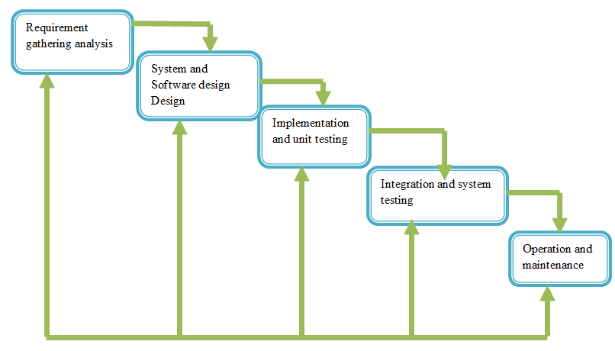

**Figure1: Waterfall model**

## 3.4: System analysis

### 3.4.1: Existing system analysis

When someone want to publish his/her products has records/ data of its clients to the papers that are used when a clients wants to get service from it. All activities are done manually; there is no computerized system which helps easily to control the clients report in the range of the date.

### 3.4.2: Proposed system.

This project will help to retrieve clients report with searching by date that easily facilitate them to manage a big number of clients who join online products publication to request services because, it has capability of displaying updated report of clients already registered. It will help people to publish their products and view quality of other products. No person will spend lot of time searching someone to publish his/her products.

### 3.4.3: Proposed system requirements

* **Software requirements**
* Internet browser software such as Internet Explorer, Mozilla Firefox, and Google chrome, Safari etc.
* Microsoft windows.
* **Hardware requirement:** The following are minimum hardware requirements for accessing this software:
* 2GB RAM
* 2GB Processor
* 500 GB free space of Hard Disk

### 3.5.2.2SYSTEM USERS ACTIVITY DIAGRAMS

Activity diagram is a flowchart to represent the flow from one activity to another activity. The activity can be described as an operation of the system.

The control flow is drawn from one operation to another. This flow can be sequential, branched, or concurrent. Activity diagrams deal with all type of flow control by using different elements such as join.

**Symbols of activity diagram**

|  |  |  |  |
| --- | --- | --- | --- |
| **Symbol** | **Name** | **Symbol** | **Name** |
|  | **Initial State** |  | **Join** |
|  | **Action** |  | **Control flow** |
|  | **Decision** |  | **Final** |

**Table 2: Activity diagram symbols**

### 3.4.5.3 ACTIVITY DIAGRAM OF ADMINISTRATOR

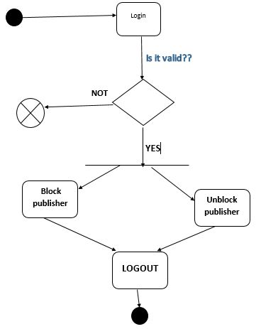

**Fig2: activity diagram of administrator**

### 3.4.3.3 ACTIVITY DIAGRAM OF PUBLISHER

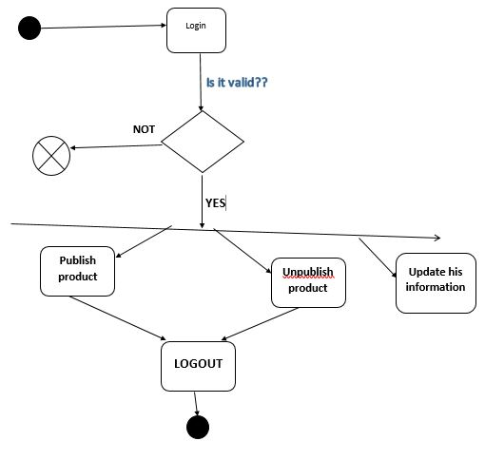

**Fig3: activity diagram for publisher**

### 3.4.4 DATABASE DESIGN

### 3.4.4.1 PHYSICAL DATA MODELING

This model diagram illustrates the organization of data in the database that stores data for the database system. It describes all the details and the relationship between the tables that make up the database.

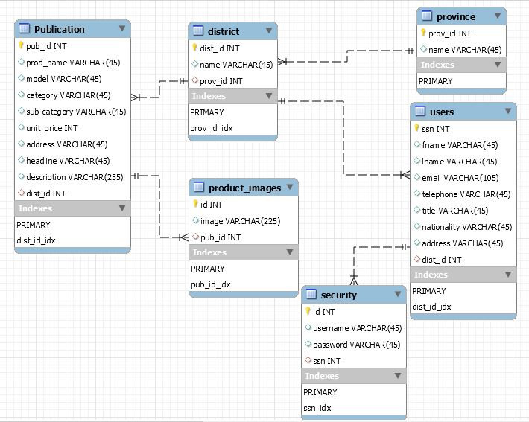

**Fig 3: physical data model**

### 3.4.4.2 ENTITY RELATIONSHIP DIAGRAM

It is defined as data modeling technique that creates a graphical representation of the entities, and the relationships between entities, within an information system.

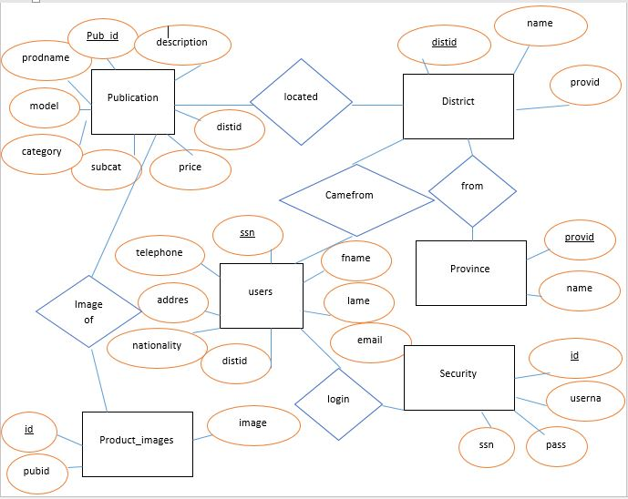

**Fig4: entity relationship diagram**

**3.4 DATA DICTIONARY**

|  |  |  |
| --- | --- | --- |
| **Publication** | | |
| **FIELD** | **TYPE** | **INTEGRITY** |
| Pubid | integer | Primary key |
| prodname | Varchar(45) | Not null |
| model | Varchar(45) | Not null |
| category | Varchar(45) | Not null |
| unitprice | Int(11) | Not null |
| address | Varchar(45) | Not null |
| headline | Varchar(45) | Not null |
| description | Varchar(255) | Not null |
| subcat | Varchar(45) | Not null |
| distid | Int(11) | Foreign key |

|  |
| --- |
| **District** |

|  |  |  |  |  |  |  |
| --- | --- | --- | --- | --- | --- | --- |
| Distid | | Int(11) | | | Primary key | |
| distname | | Varchar(255) | | | Not null | |
| provid | | | Int(11) | | Foreign key | |
| |  |  |  | | --- | --- | --- | |  | **PROVINCE** |  | | provid | Int(11) | Primary key | | name | Varchar(45) | Not null | | | | | | |
|  | **USER** | | |  | |
| ssn | Int(11) | | | Primary key | |
| fname | Varchar(255) | | | Not null | |
| lname | Varchar(255) | | | Not null | |
| email | Varchar(255) | | | Not null | |
| telephone | Varchar(255) | | | Not null | |
| title | Varchar(255) | | | Not null | |
| nationality | Varchar(255) | | | Not null | |
| address | Varchar(255) | | | Not null | |
| distid | int | | | Foreign key | |
|  | **security** | | |  | |
| id | int | | | Primary key | |
| username | Varchar(255) | | | Not null | |
| password | Varchar(255) | | | Not null | |
| ssn | Int | | | Foreign key | |

**Table2: Data dictionary**