Wave Farm
Toolkit
Development System Manual

November 17, 2024

(1) Things you will need to download

(1a) Arduino IDE

https://www.arduino.cc/en/software

We are using the "Legacy" 1.8.19 IDE, but the newer v2 IDE should also work.
Scroll down the page to find the 1.8.19 download section.

(1b) Serial Device Driver

https://www.wch-ic.com/downloads/CH341SER_ZIP.html

Arduino works by loading the code into the Toolkit over a serial port. There's a little USB to serial gadget in the package Jen sent you. You need a driver for it. It is similar to a FTDI driver, but a little bit different.

(1c) Filesystem Uploader that you can find here:

https://randomnerdtutorials.com/esp32-web-server-spiffs-spi-flash-file-system/

The Filesystem Uploader is a plugin for Arduino. There are instructions for how to install it for Arduino 1.8.19 and Arduino v2. Install the Arduino IDE first!

(2) Setting up the Arduino IDE

With Arduino, everything related to a project is stored in a "Sketch" folder. In this case we call it "InternetRadioSketch". You can download that from the github.

https://github.com/theotherjenkutler/InternetRadio

Inside the InternetRadioSketch folder there is a project/code file "InternetRadioSketch.ino".
Open this in the IDE and then you can configure the settings for it.

You will need to configure the Arduino IDE to talk to your Toolkit Board.

(2a) In the Tools menu, you will see a line called "Board: ..". This has a submenu that will take you to the "Boards Manager". Once you open the Board Manager you can type "esp32" into the search box (top right) and you get a listing of two option. The first is for one of Arduino's esp32 boards. The second is for all of the esp32 version that are supported by Espressif. You will need to install the boards for Espressif. The most recent versions are 3.0.x. These will work on newer operating systems. I am using 1.0.6 (because I have an old OS).

Program code and files are downloaded to the Toolkit using Python scripts. The python libraries that are used for this are included in the with the "board manager" files, and they only run on specific versions of Mac OS. If you are using Windows or Linux, it should work regardless.

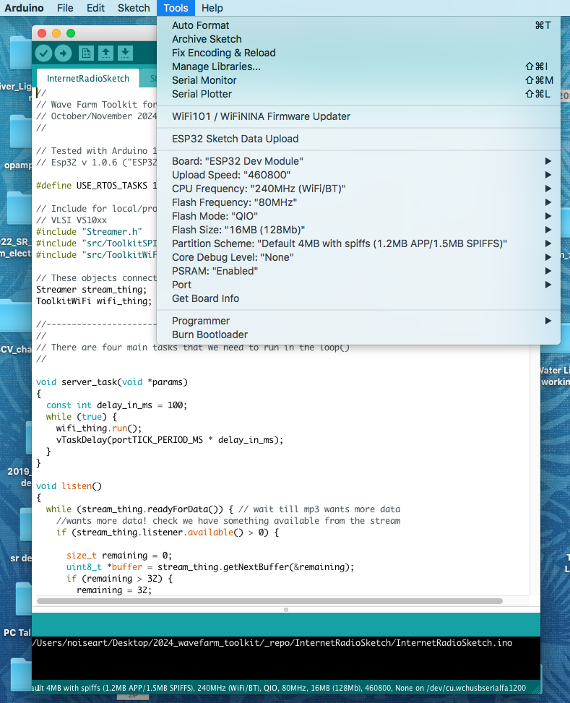

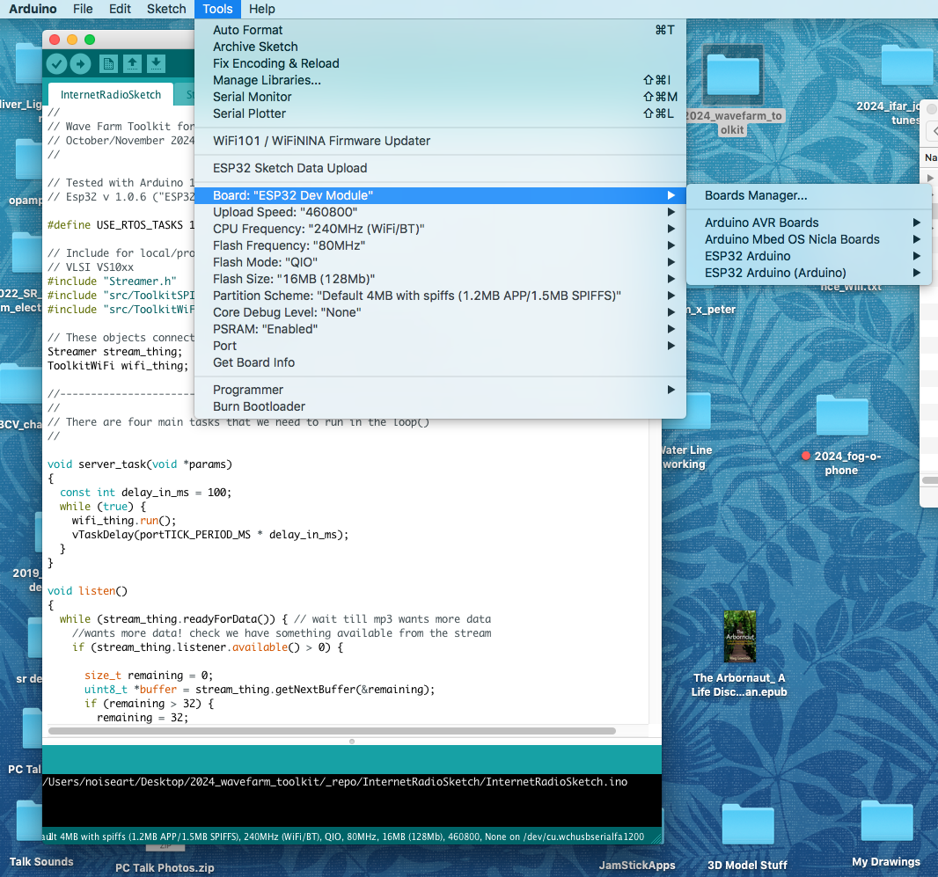

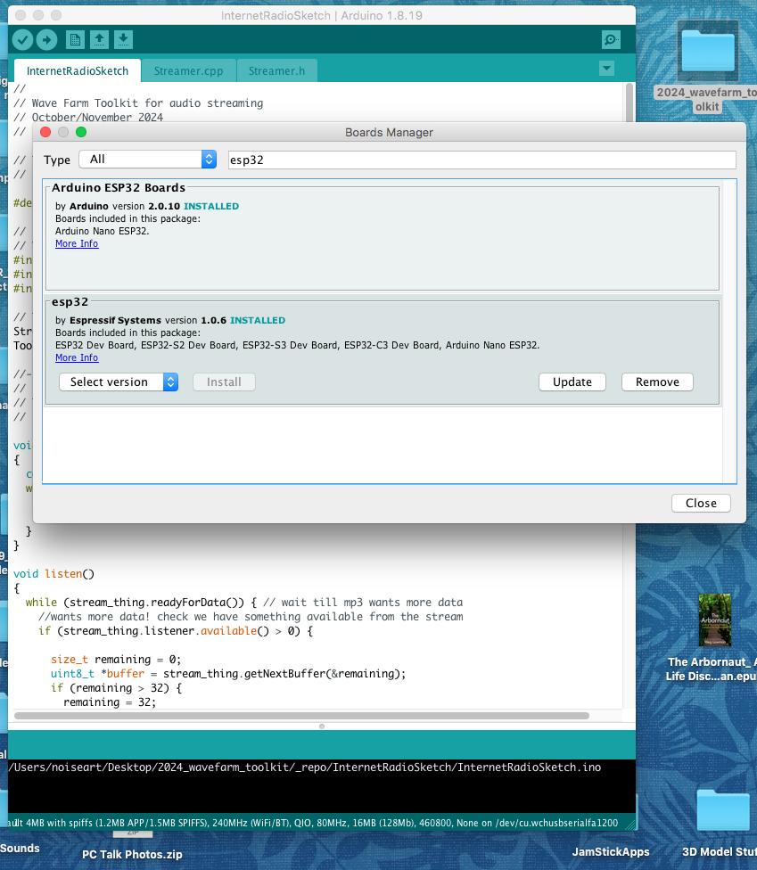

In the first image you can see all the settings for the ESP32 board:

For 1.0.6 it is "ESP32 Dev Module"
For the newer version it is "ESP32 Wrovere Kit (all versions)"

Some board settings will get added to the tools menu:
Set Flash Size to 16MB
Set Upload Speed to 460800
Set PSRAM to enabled

You also need to set the serial port that you are going to use to talk to the Toolkit. Connect the serial gadget to your computer using a USB-C cable. After a few seconds it should appear in the "Port" submenu.

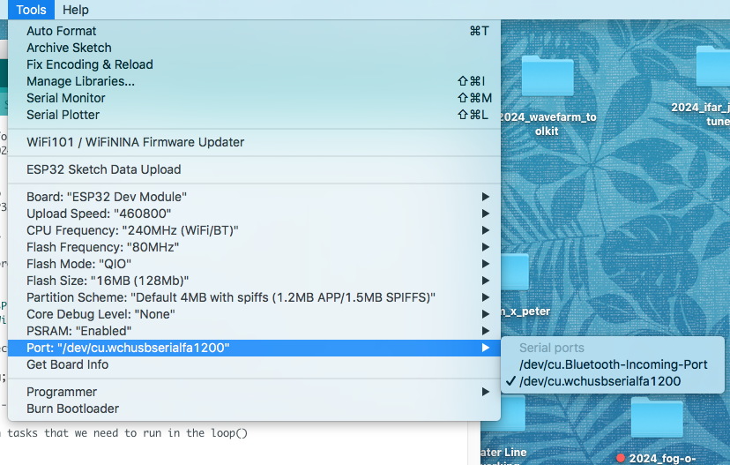

(3) Setting up the Toolkit Board

The Toolkit has two circuit boards the connect together. The top one is the audio connections and the bottom one is the esp32 board with the VLSI audio chips on it.

The Toolkit has:
- a micro-USB port for 5 Volt power. This will also charge the battery when the power switch is Off.
- a 6 pin connector that goes to the serial port gadget. I have soldered a right-angle header onto my Toolkit. You can also use the pogo-pressure-pin-thing that Jen sent you. Make sure that Ground on your serial device is on the correct side of the connector.
- a sliding power button
- 2 little buttons near the micro-USB power connector. The one closest to the usb is "boot" the other is "reset".

(4) Talking to the Toolkit from the Arduino IDE.

When you want to download something onto the Toolkit, you hold down the "boot" button and then "reset". As long as the "boot" button is down when the "reset" is released, then the board will enter download mode.

Once your USB is hooked up to the Toolkit and your Serial port settings are correct)you can click the upload button (top left corner of the Arduino window). The IDE will compile the source code and then upload it to the Toolkit. It will take some time to compile everything, and it should throw out 1 warning about the WiFi headers. But there shouldn't be any other errors or warnings.

Arduino has a "Serial Monitor" which you can open up from the Tool menu. This acts like a console terminal between Arduino and the Toolkit. When the Toolkit is running it will send messages to the serial monitor.

NOTE: if you open the Serial Monitor while you are uploading code you will crash the upload process. If the serial monitor is open when you are using the Filesystem Uploader then the filesystem upload will fail.

Once the upload process is complete, you will have to manually reset the board - either to make it run, or to place it back into download mode.

Once you have uploaded the compiled source code to the Toolkit, then you have to upload the settings and html/css/js files to the Toolkit's built in flash drive. Use the Filesystem Uploader to do this. Restart the Toolkit in download mode (boot button + reset). Then you can select "ESP32 Sketch Data Upload" from the Tools menu. You should see the upload messages at the bottom of the Arduino IDE window.

(5) Running the Toolkit

Open the tools/serial monitor in Arduino. Make sure it is running at 115200 baud (bottom of the serial monitor window). Restart the toolkit (without the boot button) and you should see a bunch of stuff on the screen.

The Toolkit currently runs in one of 3 modes - Listening, Transmitting, Waiting.

Listening connects to a remote icecast server and streams the mp3 data from the server to the audio output of the Toolkit. It also relays the mp3 data to the Toolkits "captive portal" or "configuration" web page.

Transmitting connects to a remote icecast server as a "source" client and sends mp3 data from the Toolkit's audio input to the icecast server. It also sends the mp3 data to the Toolkit's local web page.

Waiting doesn't run any audio in or out of the Toolkit, but it runs the configuration web page.

To access the web page you can lookup the Toolkit's local IP address and use that in you desktop browser. Or you can go the WiFi settings on your phone and select the Toolkit's SSID. You phone should then take you to a "captive portal" browser page where you can see the Toolkit's settings.

Sometimes the phone won't load the css and/or js files. Sometimes it will load them but not run the scripts. You can go back and reconnect to the WiFi to get it running. There is a 2 second time delay before the page loads the settings to get around some "captive portal" issues.



