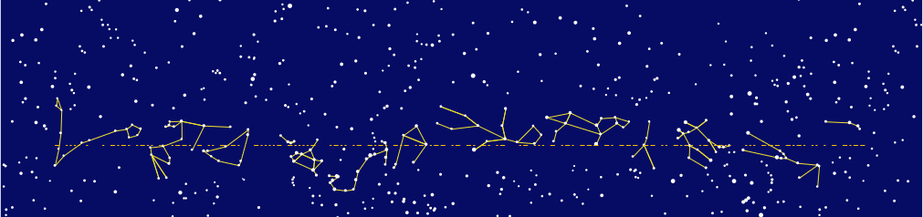
THE LACKAWANNA ASTRONOMICAL SOCIETY • VOLUME 55 ISSUE 1 • JANUARY, 2022 • OBLIQUITY 23.4376°
The Ecliptic
Ecliptic Coordinates in “Plate Carrée”
The French gave this name to the most simplistic of map projections, where one just pretends that the spherical coordinates are Cartesian ones, no fussing around with stretching or scaling. It works OK as long as you stick reasonably close to the equator of whatever sphere you are working with, which in this case is the plane of the ecliptic.
I first had the idea to do something like this for the LAS newsletter, I think it was in the mid-1980s, using my Mac 512K and probably a program I would write in Forth to generate the star chart in black and white. If I remember correctly The Ecliptic was switching from mimeograph to Xerox at the time, or something like that, so there was the possibility of a new design. But Jo-Ann and John and whoever else was working on it had gone ahead and published a newsletter before I got around to doing anything. The present announcement of another re-birth of The Ecliptic, along with an invitation to actually design something for this contest, motivated me to give it another try.
The coding, now done in Python, was just hard enough to be fun. Finding suitable data was more frustrating. I did not think it would be so difficult to find a database of nice constellation figures and I was pretty close to giving up when it occurred to me to borrow the ones in Stellarium. These are from the Sky&Telescope variation of their “Western sky lore” asset. The constellation file indexes into the Hipparcos catalog, which I obtained directly from the source, for the coordinates and magnitudes. For more details please see the README.md file found at https://github.com/theotherplanb/las_ecliptic_contest. This repository also contains the program source file and 12 versions of the star map in SVG format, one beginning with each zodiac constellation, along with the source of this document.
The fonts I used in this design are Kanit Extra Bold and Kanit, obtained from https://fonts.google.com/specimen/Kanit?category=Sans+Serif,Display&subset=latin&preview.text=The%20Ecliptic&preview.text_type=custom&thickness=8.
The ecliptic line on the chart spells out “THE ECLIPTIC -- LACKAWANNA ASTRONOMICAL SOCIETY” in Morse code. This is a nerdy detail and is obviouly optional.
Similarly, the “obliquity” joke could be done away with if it is deemed too nerdy and oblique. This is the “true obliquity” of the ecliptic for January 1, 2022, obtained from http://neoprogrammics.com/obliquity_of_the_ecliptic/. If shown to this level of precision, the value changes on a month-to-month basis, so it ought to be updated for every issue. A middle ground would be to just use 23.4° and leave it at that.
In fact, if someone else in the club with a better sense of design would like to rework this or re-use any elements of this in combination with other ideas, you have my permission. I am available to make changes to the star chart if desired. (The SVG files can also be edited in Inkscape; my advice if doing this would be to create separate layers for each group before un-grouping them, so that the different elements can be isolated easily.) Let me know if I can do anything else to assist.
- Rich Hogg, 2021-11-30
theotherplanb@gmail.com

