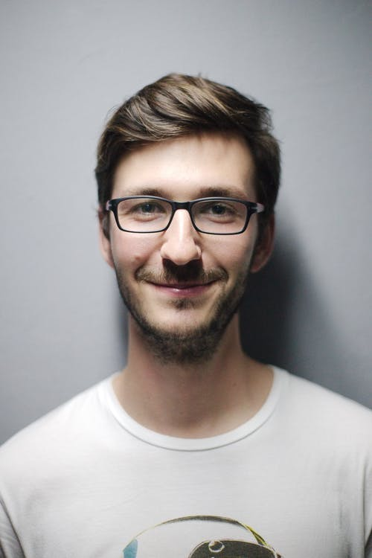

Nikos Smith | & C:/Users/Theo/AppData/Local/Programs/Python/Python39/python.exe c:/Users/Theo/Desktop/Learning-Python/my_app.py | & C:/Users/Theo/AppData/Local/Programs/Python/Python39/python.exe c:/Users/Theo/Desktop/Learning-Python/my_app.py

# About me

& C:/Users/Theo/AppData/Local/Programs/Python/Python39/python.exe c:/Users/Theo/Desktop/Learning-Python/my_app.py

# Work Experience

**& C:/Users/Theo/AppData/Local/Programs/Python/Python39/python.exe c:/Users/Theo/Desktop/Learning-Python/my_app.py** *& C:/Users/Theo/AppData/Local/Programs/Python/Python39/python.exe c:/Users/Theo/Desktop/Learning-Python/my_app.py-& C:/Users/Theo/AppData/Local/Programs/Python/Python39/python.exe c:/Users/Theo/Desktop/Learning-Python/my_app.py*& C:/Users/Theo/AppData/Local/Programs/Python/Python39/python.exe c:/Users/Theo/Desktop/Learning-Python/my_app.py

# Skills

* & C:/Users/Theo/AppData/Local/Programs/Python/Python39/python.exe c:/Users/Theo/Desktop/Learning-Python/my_app.py