FTS Config Viewer

Water Survey of Canada  
ottO Bédard, MSc.  
otto.bedard@canada.ca  
Version 2.4 – 2019-12-06

# Introduction

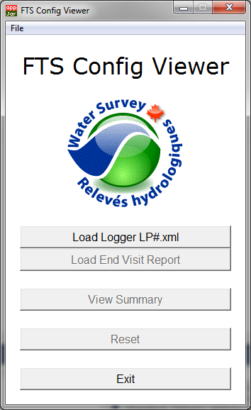This program was developed to aid WSC Technicians in the identification of issues with and the archiving of FTS Logger programming. It does not replace proper training and on site problem solving. This program fills the gap between machine readable eXtensible Markup Language (XML) and more human readable formats. This program creates a human readable copy of the configuration file, with the option of including supplemental information from the End Visit Report, which is rendered via a web browser. The rendered file can be printed, converted to PDF, or stored as needed.

The new file created by the program for the purposes of viewing CANNOT then be used in an FTS logger as a configuration file.

# Usage

The downloaded FTS logger config files (.xml) are typically renamed STATION_DATE_LP#.xml - this file should be opened by the user. The user can also name the Ending Visit Report as STATION_DATE_EVR.txt, place it in the same station folder, and optional open this file. The program reads the file(s) and creates a new configuration file with a copy of the original xml and portions of the EVR embedded. Furthermore, a pointer to a custom xsl (stylesheet) is embedded within the file. The program copies both the new file and the stylesheet to a C:\temp\FTSViewer\ folder. The program then attempts to open the new configuration file in the windows default program (likely a browser window).

1. Open the Program
2. Select the _LP#.xml file
3. OPTIONAL – Select the End Visit Report (_EVR) that matches the LP#.xml (same date)
4. View the Summary
5. Print/Save/PDF the file from within the Browser (or other editor)
6. Exit the program

# Quick Tip

* Be sure that the default program to open .xml files is a web browser (I suggest FireFox or Chrome)

# Example Output

Once open in a web browser, the user can print, or save to an alternate format such as PDF.

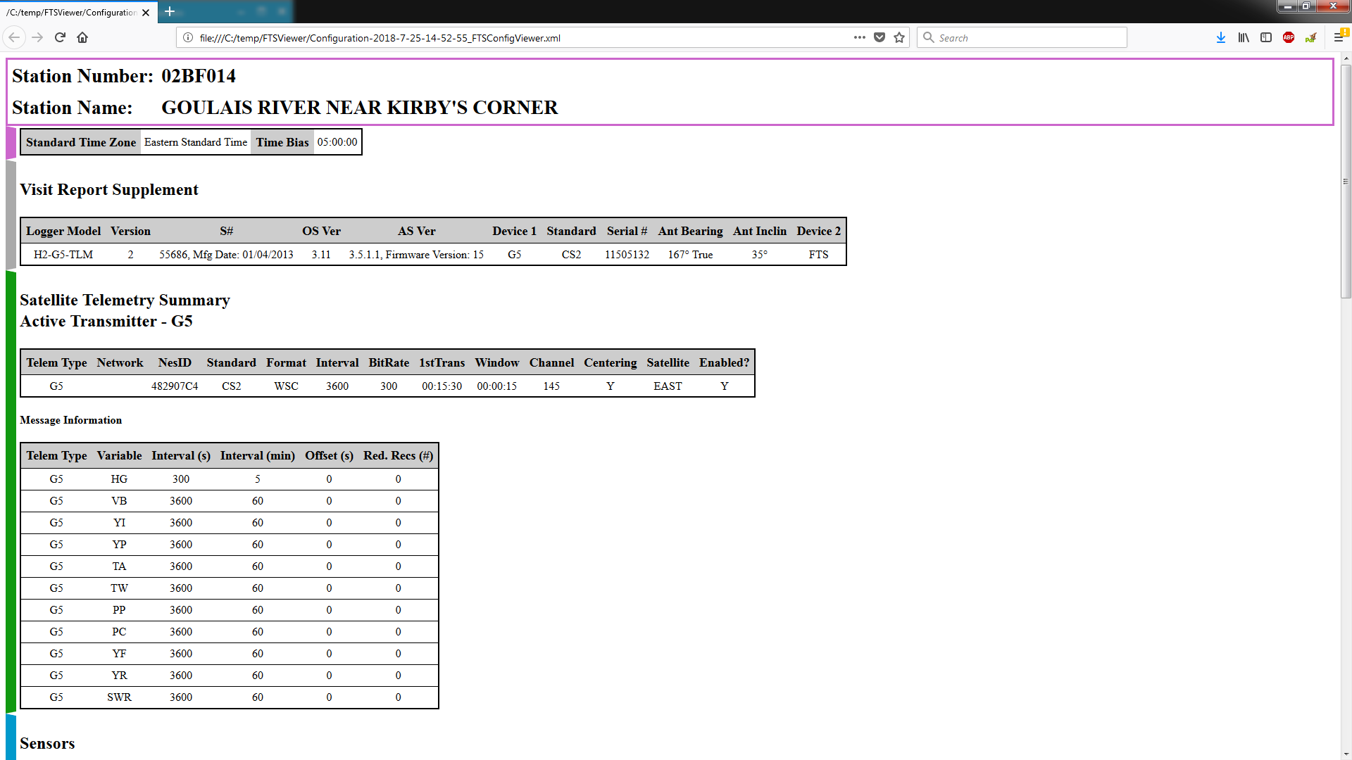

# Troubleshooting

* Ensure that you have read/write privileges in the file folder (if not, copy to a local folder)
* The command window offers insight into the background happenings. More user feedback is provided for troubleshooting purposes.

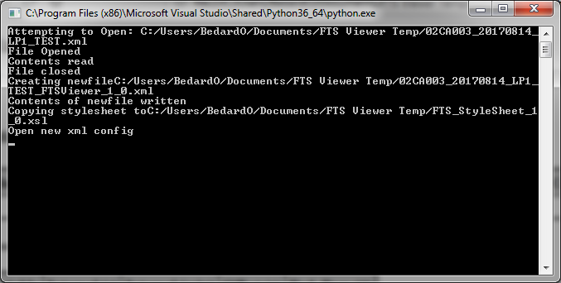

* Any issues should be directed to [otto.bedard@canada.ca](mailto:otto.bedard@canada.ca) with as thorough a description as possible – include screenshots if possible.

# Changelog

## Version 2.4

* Overhaul of the “Check Version” algorithm
  + Switched to gitraw from FTP storage

## Version 2.3

* GUI complete overhaul
* Addition of File… menu to include About, Help, Version
* Version Checking looks to FTP site for most recent versions
* Addition of error and info messages for user feedback
* Significant changes to stylesheet (see .xsl for development notes)

## Version 2.2

* Formatting and minor changes, not released

## Version 2.1

* Extended Visit Report information
* Minor formatting

## Version 2.0

* Added option to include End Visit Report Supplemental Information
* Updated Stylesheet to include End Visit Report information
* Reset Button Added
* Help Button added
* Minor formatting

## Version 1.5

* Minor formatting
* Expanded information for Processes, including scripts, delta, maxmin, etc
* Reduction of duplicate information in Telemetry section
* Updates to styling information

## Version 1.4

* Minor formatting
* Added FieldNum to sensors table

## Version 1.3

* Sticky Station Name/Number
* Expansion of SDI-AM information into separate tables
* Link to photo of SDI-AM
* Fix for Time Zone Bias
* Updates to Manual

## Version 1.2

* Files now stored in c:\temp\FTSViewer for clarity

## Version 1.1

* Formatting fixes
* Add Test for multiple Telemetry modes

## Version 1.0

* Initial Release

## Version 0.9

* Development Release