



­­­

**MUSICC database user guide**

Version 1.0.0

April 2020

Contents

Notice 1

AUTHORISATION: 1

RECORD OF CHANGES: 1

1. Introduction 2

Background information 2

Content of database 2

Purpose of this document 2

2. Web interface 3

Logging in 3

Finding scenarios 3

Exploring Scenarios 6

View more detail about a scenario 7

Downloading Scenarios 9

(New) Uploading Scenarios 12

3. Application programming interface (API) 14

/query 14

/download 14

4. Scenario curation 15

Responsibility for curation 15

Curator interface 15

5. Support and bug reports 15

Notice

CPC assumes no responsibility to any other party in respect of or arising out of or in connection with this document and/or its contents.

This document has pages including the cover.

## AUTHORISATION:

|  |  |  |
| --- | --- | --- |
| **ACTION** | **SIGNATURE BLOCK** | **NAME AND POSITION WITHIN CPC** |
| Written by: | Robert Myers | Technologist |
| Reviewed by: | Zeyn Saigol | Principal Technologist |
| Authorised by: | Richard Holland | Principal Technologist |

## RECORD OF CHANGES:

|  |  |  |  |
| --- | --- | --- | --- |
| **REALEASED TO** | **VERSION** | **REASON FOR CHANGE** | **DATE** |
| MUSICC User Trials participants, Department for Transport | 0.1 | Initial release | 30/04/2019 |
| MUSICC User Trials participants | DRAFT 0.1.2 | Updated MUSICC release | 12/07/2019 |
| MUSICC User Trials participants | DRAFT 0.3.3 | Updated MUSICC release | 11/11/2019 |
| Public | 1.0.0 | Public MUSICC release | 03/04/2020 |

# Introduction

## Background information

Ensuring the safety of Highly Automated Vehicles (HAVs) is a challenge for both regulators and the wider automotive industry. Part of the challenge is the need for extensive validation, and the growing consensus is that sufficient confidence in systems can only be attained if simulation tests are a major component of the validation process. For this to be possible, a set of test scenarios must first be identified. The MUSICC project provides a tool for collating these scenarios: a living, online, open catalogue for use by regulators, manufacturers, and approval authorities. The catalogue will specify the situations which HAVs must handle safely before release to market.

Unlike similar projects, MUSICC is designed with regulatory use in mind and is being developed on behalf of the UK’s Department for Transport. The project is led by the Connected Places Catapult (CPC) which acts as an impartial, neutral mediator.

## Content of database

MUSICC aims to create a solid foundation to enable the storage of scenarios. In support of this, CPC has created an online database which is now open for Beta testing by potential users.

For each scenario, a MUSICC record has been created consisting of 3 files:

* An OpenDRIVE file specifying road layout information
* An OpenSCENARIO file giving the parameters to be simulated.
* A MUSICC XML file containing metadata and instructions for randomisation of OpenSCENARIO file parameters.

For some scenarios, additional files (e.g. images and scenery models) are also provided.

CPC has arranged for the database to be populated with a limited number of scenarios for evaluation. Submissions of additional scenarios are welcome.

## Purpose of this document

This document provides a user guide to the MUSICC web interface and the programming API for accessing scenarios. It should be used in conjunction with the “Specification for MUSICC Scenario Description Language (SDL)” (MUSICC_SDL_Specification_1.0.0.pdf), which contains a description of the Scenario Definition Language (SDL) – the format that scenarios are stored in.

A future document will cover the administrator (curator) web interface for managing scenarios.

# Web interface

## Logging in

### Browser compatibility

The functionality of the interface has been verified in Google Chrome.

### Register for access

There is a sign up link on the main page at <https://musicc.ts-catapult.org.uk/>.

### Password changes and resets

To reset or change a password, use the “Lost password?” link on the login page.

## Finding scenarios

|  |
| --- |
| Key features |
| * Only scenarios from the selected MUSICC revision will be returned * Queries can be built using the query generator block or directly in the search bar. The search bar also contains a query builder tool. * Users can save scenarios as favourites * Use tags to find functionally similar scenarios |

### Selecting a MUSICC revision

A MUSICC revision refers to a unique combination of:

* A MUSICC XML schema (defined by the revision number)
* An OpenSCENARIO file format
* An OpenDRIVE file format

The most recent MUSICC revision is 1.0.0, which includes OpenSCENARIO v1.0.0 and OpenDRIVE v1.4H. Revision 0.1.5 (including OpenSCENARIO v0.9.1 and OpenDRIVE 1.4H) is also maintained.

The search feature always returns scenarios from a single MUSICC revision. This can be selected using the drop-down menu labelled ‘revision’ (located at the top left of the main page):



### Types of Scenario

The MUSICC system can store both logical scenarios (with parameter distributions specified in MUSICC XML) or concrete (where there is only one value allowed for each parameter). The type of scenario stored is shown in the ‘scenario type’ metadata field. This terminology was first used by the PEGASUS project (<https://www.pegasusprojekt.de/files/tmpl/PDF-Symposium/04_Scenario-Description.pdf>).

### Building queries in query bar

Queries can be typed or edited directly in the query bar. Valid operators are automatically suggested, as shown below:

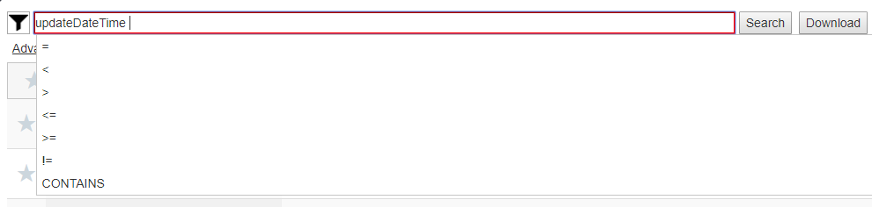

A list of all operators can also be shown by pressing the  button. To see all scenarios in the database, search for * or leave the search bar blank.

### Building queries using the query generator block

Search queries can be produced using the query generator box shown below:

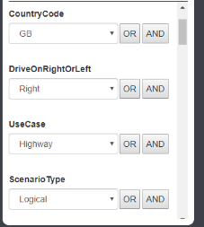

For each field to be searched, select a value from the drop-down list, then click on an operator. For example, to search for Highway scenarios in the UK:



1. Select ‘Highway’ from the ‘UseCase’ drop down list, then click ‘AND’ or ‘OR’ (for the first item, both have the same effect).
2. Select ‘GB’ from the ‘CountryCode’ drop down list, then click ‘AND’

The search bar will be automatically filled with the query:



Some fields allow more than one value per scenario. For these fields, the query builder automatically uses an INCLUDES operator. For example, selecting ‘Bus’ from KeyActorTypes gives the following query:

This means that the search will return all scenarios in which one of the primary actors is a bus (possibly as well as other vehicles).

Note that the list of available fields differs between revisions of MUSICC. The query generator block will only show fields available in the selected revision.

### Search for functionally similar scenarios using tags

There are two types of tag used to label scenarios:

* Global tags are defined in the scenario description language and are visible to all users. We anticipate that these will be used to label functionally similar scenarios. For example, the set of demo scenarios contains three with the tag '3-vehicle-highway-sideswipe'. These all contain the same pattern of movements but occur on different road networks.
* User defined tags are set in the web interface and are only visible to the user who sets them. Information about how to use these tags is included in the ‘Exploring Scenarios’ section.

Both types of tag are searched for in the same field.

### Using the favourites feature

Click on the star next to any scenario to save it as a favourite (the star will turn yellow). Click again to remove it.

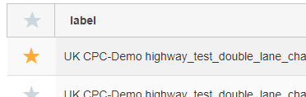

Clicking on the star at the top of the page will filter your search to only show favourite scenarios:

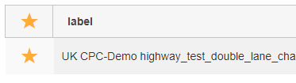

Other users cannot see which scenarios you have saved as a favourite.

## Exploring Scenarios

|  |
| --- |
| Key features |
| * Add any metadata field as a table column * Sort by any column * View all metadata for each scenario |

### Adding columns to the table

Once a search has been completed, results appear in a table. Additional columns can be added by clicking on the field name in the query generator block. Click again to remove the column.

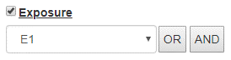

### Sorting

Clicking on a column heading sorts results by that column:

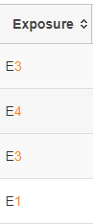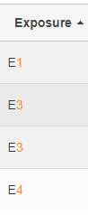

### View scenario metadata

Click anywhere on a table row to display metadata.

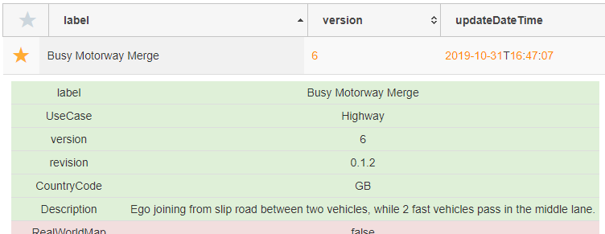

## View more detail about a scenario

|  |
| --- |
| Key features |
| * View file content and compare versions * Add comments on a file * Label a file with a user-specific tag, to make it easy to find again * View images (if uploaded by the scenario author) |

Click on the info button () next to a scenario to see more detail. This will open the scenario detail view as shown below. The screen is divided in half: the left pane shows the content of all three native files, and the right pane shows additional information about the scenario.

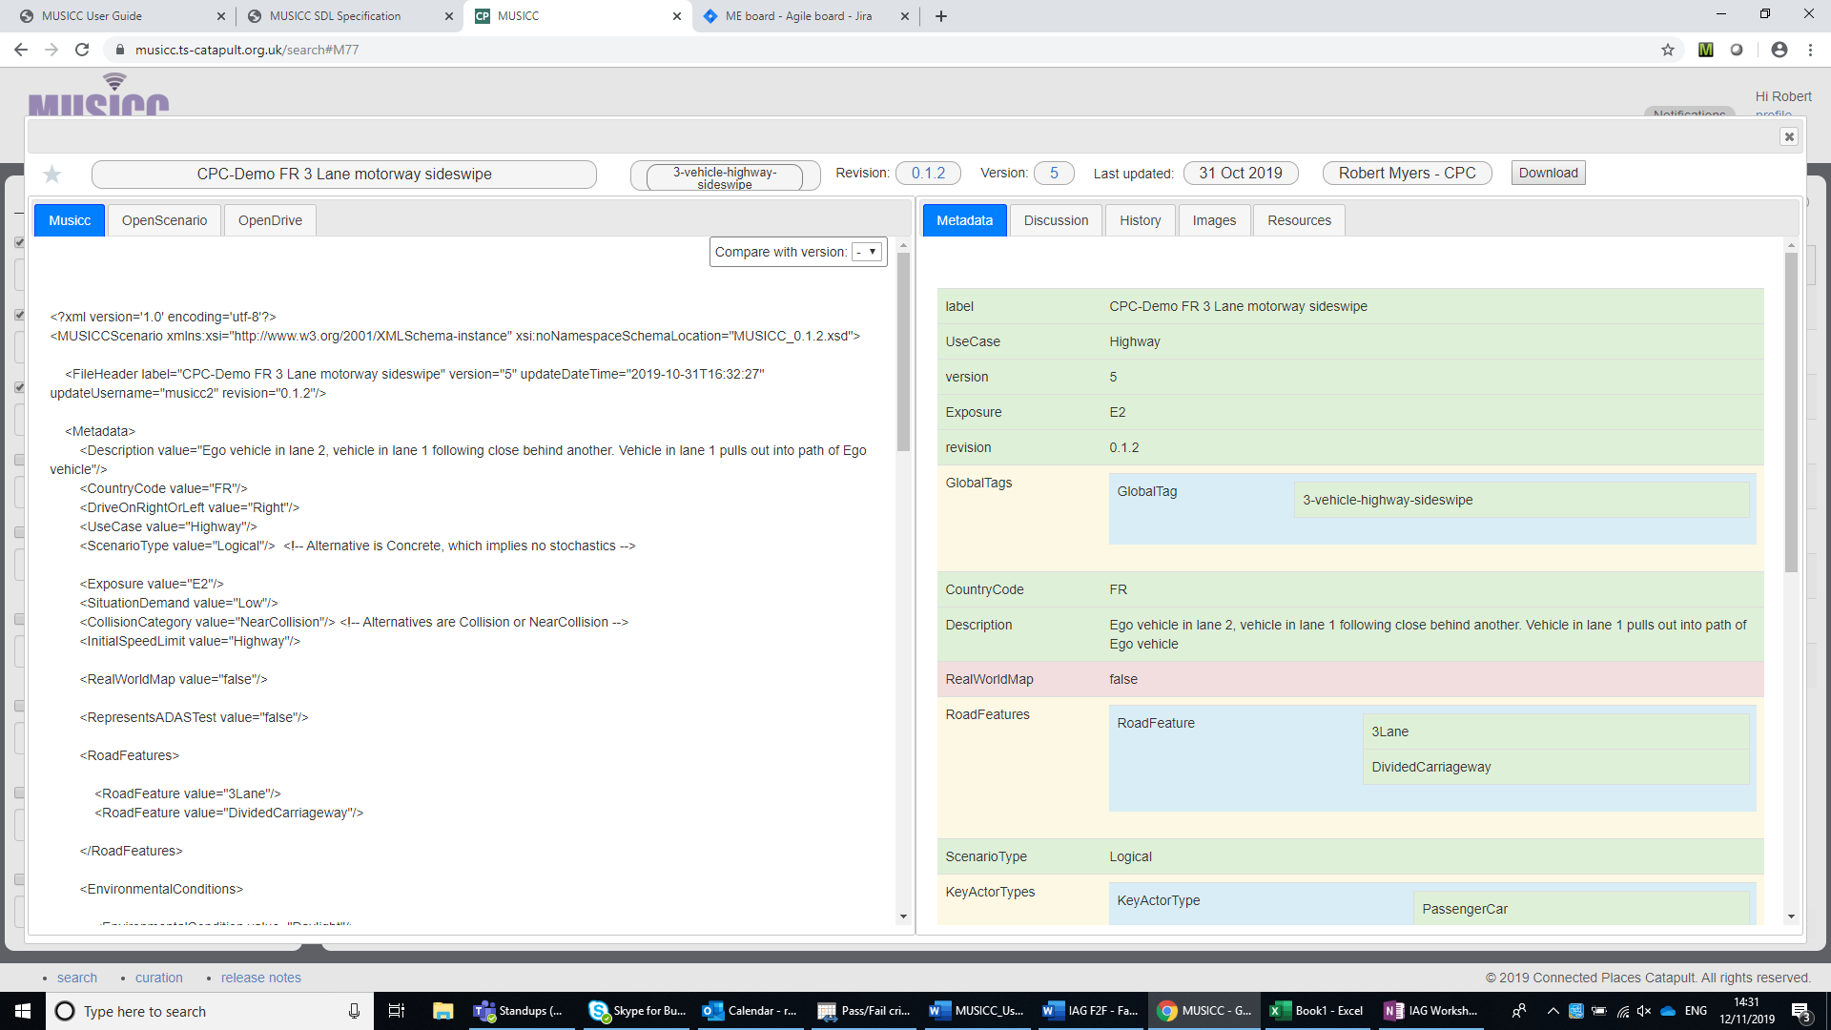

### View file history

The “History” tab on the right of the detail view shows the scenario’s version history. Note that the change history will only be shown for one revision at a time.

The example below shows a scenario where the MUSICC and OpenSCENARIO files have been updated once but the OpenDRIVE has not changed.

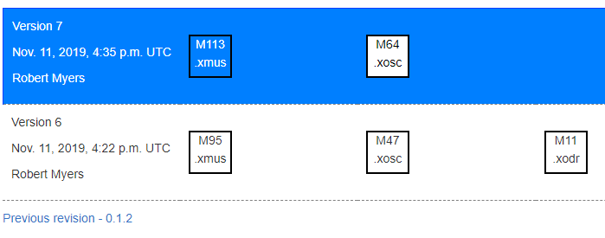

### Add comments

It is possible to add comments to a scenario in MUSICC, which will be visible to all users. Comments can be used to highlight a potentially broken scenario to other users. The curator can remove or edit comments. Switch to the “Discussion” tab to view or add comments.

### View images

The scenario author may upload images to help users visualise a scenario. These are displayed in the “Images” tab.

### Compare versions

You can compare with a different version of any of the native files using the “compare with version” drop down list or right clicking on a file name in the history view. Only versions within the same MUSICC revision will be shown.

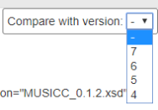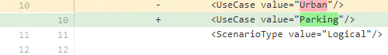

### Other revisions

If the same scenario exists in more than one revision of MUSICC, other revisions can be selected using the menu at the top of the screen:

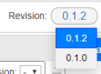

## Downloading Scenarios

|  |
| --- |
| Key features |
| * Download logical or concrete scenarios   + Concrete scenarios have randomisation of parameters pre-applied   + Logical scenarios supply a .xmus file with parameter distributions and metadata   + Download multiple concrete scenarios for every logical scenario * View an estimate of file size before downloading |

### Download all search results

To download all scenarios in the table, click on ‘download’ then select Native (logical) or Concrete:

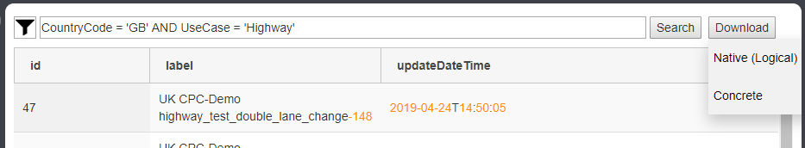

Hover over the download button to see an estimate of unzipped file size. The actual download will be provided as a ZIP file, so may be significantly smaller.

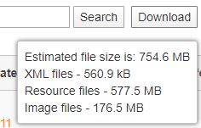

There is an option to exclude images and resource files (e.g. scenery files) under ‘Advanced Options’.

### Download a single scenario

To download a single scenario, use the download button in the scenario detail view. This is accessed using the info button () in the results table.

### Native and concrete formats

As described earlier in this section (under Finding scenarios: Types of Scenario), the MUSICC system can store either logical scenarios (with parameter distributions specified in MUSICC XML) or concrete (where there is only one value allowed for each parameter). The table below shows the format stored by the system for each type of scenario and the download options available:

|  |  |  |
| --- | --- | --- |
| **Scenario type** | **Native format** | **Available download options** |
| Logical | OSC and MUSICC XML files;  MUSICC file specifies parameter distributions and metadata | Native (logical): files as described to left  Concrete: no MUSICC XML file provided. Parameter values chosen at random according to distribution defined in MUSICC XML |
| Concrete | OSC and MUSICC files;  No parameter distributions in MUSICC file, just metadata | Native: files as described to left  Concrete: as Native without MUSICC XML file |

### Download multiple concrete scenarios per logical scenario

Under “Advanced options” it is possible to specify the number of concrete scenarios (with randomised parameters) to be generated for each logical scenario downloaded. This only applies to bulk downloads from the main screen.

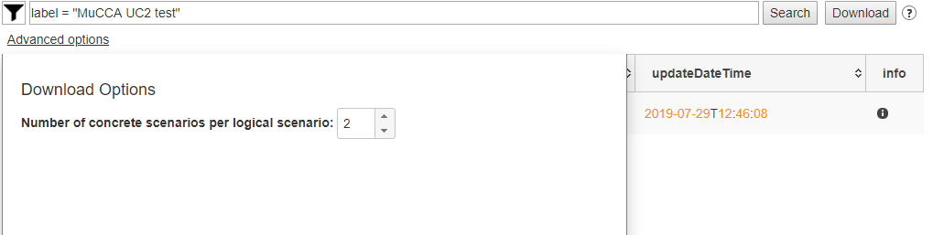

In the example above, the search returns one logical scenario. When a concrete download is requested, two OpenSCENARIO files are generated:

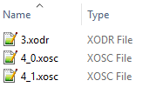

### Scenario resources

All scenarios in the demo system now contain a folder called ‘resources’. Scenarios uploaded by CPC currently use this to store the following files:

* Basic 3D models for the scenery and road network in Open Scene Graph Binary format. These are sufficient for the scenario to run in the ES-mini scenario player[1].
* A ‘CARLA.zip’ file, containing an FBX file and textures suitable for import to CARLA[2].
* A ‘RoadRunner.zip’ file, containing a RoadRunner[3] scene file for the road network.

The MUSICC system allows any type of file to be stored in this folder.

### Directory structure

A single ZIP file is provided for each download, which may contain multiple scenarios. Files within the ZIP will be structured as shown in the diagram below:

1 directory per scenario

ZIP download



OpenSCENARIO

OpenDRIVE

MUSICC



**catalogs**

Structured as uploaded



**resources**



**images**

### Naming conventions

Files will be named as shown below:

|  |  |
| --- | --- |
| **Types** | **Naming convention** |
| Top level directories (1 per scenario)  MUSICC files  OpenSCENARIO files  OpenDRIVE files  O | Numeric identifier (prefixed with ‘M’) automatically generated by MUSICC |
| Catalogs  Resources | As uploaded by scenario author |
| Images | In the format NAME_n, where NAME is the same as the MUSICC file’s name, and n is an integer |

Some files are automatically allocated identifying numbers. These are unique to a single version[4] of a file; there is a different namespace for each type of file (directories also have their own namespace). For example, this means that:

* When a new version of a scenario is released, all automatically generated file/directory names will be different to those in the previous version.
* If the file ‘M3.xosc’ appears in two different scenarios, its content will be identical.
* The directory ‘M4’, the file ‘M4.xodr’ and the file ‘M4.xosc’ may be totally unrelated.

## Uploading Scenarios

|  |
| --- |
| Key features |
| * Any user can submit scenarios to be considered for inclusion * Scenarios will appear in MUSICC after a 2-stage approval process |

### Submitting scenarios

Scenario submission is managed from the user profile page. This is accessed using the link at the top right of the search page:

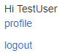

Pressing “Submit scenarios” will launch the screen below:

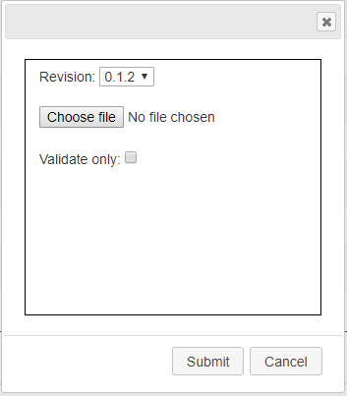

It is possible to upload scenarios which use any revision of the MUSICC standard. The revision should be selected from the drop-down list and must match the SDL format defined in the relevant version of the SDL guide.

All uploaded files are validated against the relevant XML schemas. “Validate only” can be used to validate scenarios without submitting them to the database.

### Approvals

Once a user submits a scenario, it will appear as a pending change on their profile page:



Scenarios uploaded to MUSICC must be approved by two curators. Once the first curator has approved the new scenario, the uploading user’s profile page will update:

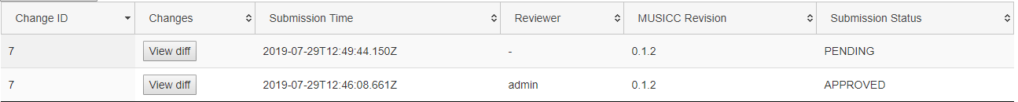

Note that there are now two approvals visible with the same Change ID. One of these will show as ‘pending’ until the second curator approves the scenario (at which point it will become visible to all users).

### Modify scenario

To add a new version of a scenario which is already in the database, follow the same process as above, making sure that the label in the MUSICC XML file is the same. The newer submission will then be treated as an update to the existing one.

Once a scenario has been submitted, click on “View diff” to see what has changed. At present this feature only shows changes to the MUSICC file, but this will be expanded to show OpenDRIVE and OpenSCENARIO files as well.

# Application programming interface (API)

The MUSICC database supports an accessible API for querying and downloading, mirroring the functionality provided in the browser. These URLs require authentication and so, in order to utilise them, you must be using a system which provides authentication and the concept of a continuous session e.g. Python’s requests library.

The API is accessed via HTTP GET requests and, where applicable, response data is sent as a JSON object. Some of the API’s functionality is shown below. More complete documentation will be issued in the future: if you have an immediate need for this, please contact us.

## /query

### Request

|  |  |  |
| --- | --- | --- |
| **Parameter** | **Optional?** | **Description** |
| **query** | Yes - Defaults to "" | The query string |
| **page_length** | Yes - Defaults to unlimited | The maximum number of records to be returned |
| **page_number** | Yes - Defaults to first page | The page of results to be returned |
| **order_column** | Yes - Defaults to 'id' | The column on which to order |
| **order_direction** | Yes - Defaults to "asc" | The direction in which to order (desc/asc) |
| **revision** | Yes - Defaults to latest revision | The MUSICC revision to search against (eg. 0.1.0) |

### Response

|  |  |
| --- | --- |
| **Parameter** | **Description** |
| **recordsTotal** | The total number of MUSICC scenarios in the specified revision |
| **recordsFiltered** | The total number of MUSICC scenarios in the specified revision which matched the query criteria |
| **estimatedDownloadSize** | The estimated uncompressed size of all files if this query's results were to be download |
| **results** | The metadata of results which match the query criteria |
| **query_id** | The unique identifier of your result set |

## /download

### Request

|  |  |  |
| --- | --- | --- |
| **Parameter** | **Optional?** | **Description** |
| **query_id** | No | The ID of the query whose results you want to download |
| **native** | Yes - Defaults to "true" | True for a native (Logical) or false for a non-native (Concrete) download |

# Scenario curation

## Responsibility for curation

Scenarios will be uploaded and managed by a curator (or curators). At present this role is filled by the Connected Places Catapult. The curator’s responsibilities include checking and approving new or revised scenarios and managing the migration to new revisions of MUSICC if changes are made.

## Curator interface

The curator will have access to a separate interface to manage scenarios in the database. Instructions on how to use this interface will be included in a separate document.

# Support and bug reports

We use GitLab's [issue tracker](https://gitlab.com/connected-places-catapult/musicc/-/issues) for bugs and feature requests. If there isn't already an issue for the bug or feature you're interested in, then please log a new one. Alternatively, you can email the team at [musicc-support@cp.catapult.org.uk](mailto:musicc-support@cp.catapult.org.uk).

­­­

The Pinnacle

170 Midsummer Boulevard

Milton Keynes

MK9 1BP

Tel: 01908 359 999

1 Sekforde Street

Clerkenwell

London

EC1R 0BE

Tel: 020 7952 5111

1. Available from <https://github.com/esmini/esmini>.
2. Support for OpenSCENARIO in CARLA is under development. Carla is available from <http://carla.org/>.
3. Available commercially from VectorZero: <https://www.vectorzero.io/>.
4. It is possible for the same version of a file to exist in more than one revision. If this is the case, file names will be different in each revision.