OPTCON USER’S GUIDE

System Requirement
OPTCON uses GNU gcc complier, which is available on most of UNIX systems. Availability of memories for running the program depends on the complexity of the problem. Once you run OPTCON, it will first check the availability of your computer memory.

Parameter File and Default Values
There are two parameter files in OPTCON package, where cg_descent_c.parm is used in CG_DESCENT subroutine. The meaning of the parameters and their default values can be found in [6]. Another parameter file optcon_c.parm is used in OPTCON subroutine. The meaning of the parameters and their default values are the following:
- PrintLevel-1 means print out the result from each iteration, 0 means no printout
- PrintFinal-1 means print out the final result, 0 means no printout
- scheme-choice of explicit Runge-Kutta schemes. (There are 6 options of schemes, see Table A-1)
Table A-1. The six provided Runge-Kutta schemes
Scheme 1 | Scheme 2 | Scheme 3
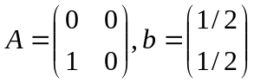 | 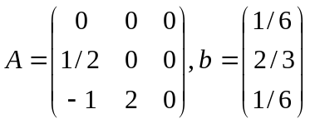 | 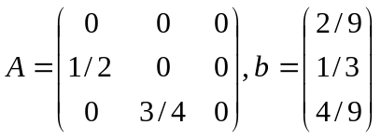
Scheme 4 | Scheme 5 | Scheme 6
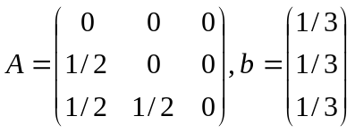 | 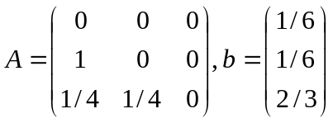 | 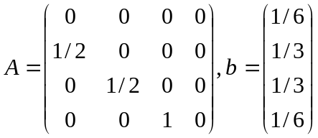
The default values of these parameters are:
Table A-2. Parameters’ default values in optcon_c.parm
Parameter’s name | Default value
PrintLevel | 0
PrintFinal | 1
scheme | 2

Running OPTCON
To run the OPTCON, the user needs to create a driver program, which should be placed in the same directory where the OPTCON package stored. I will demonstrate how to use OPTCON with the following example.
Problem 1: (can be found in [1].)
(A1) minimize 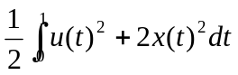
(A2) subject to 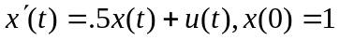
This problem can be solved with the analytic optimal solution:
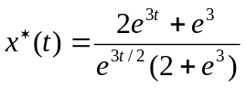, 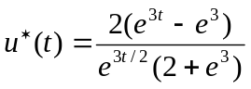.
Now, let  be denoted by 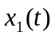 and 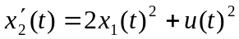, by fundamental theorem of calculus, the original cost function (A1) equals to:
(A3) minimize 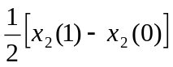.
Let's set 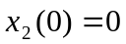, then the original problem can be transformed into:
(A4) minimize 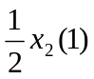
(A5) subject to 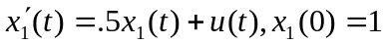
(A6) 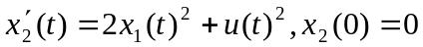
Now, we create the driver program-driver1.c of the transformed system (A4)-(A6) as the following:
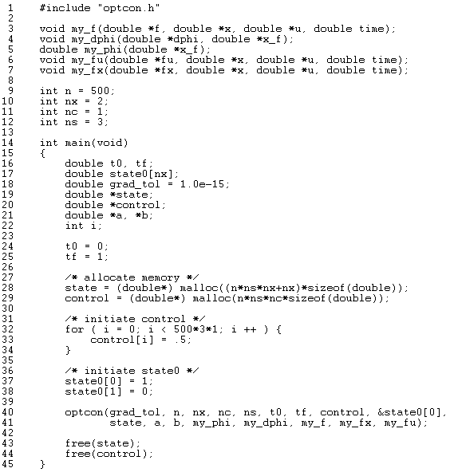
Figure A-1. Driver1.c
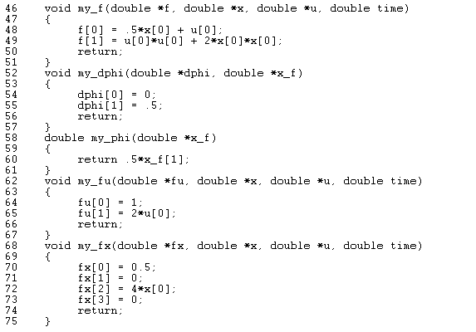
Figure A-1 Continued
We used the Runge-Kutta schemes 2 in the parameter file-optcon_c.parm. If you want to use your own Runge-Kutta schemes, you should initiate the value of and , which were defined in line 21. Line 40 shows how to call the routine OPTCON. After the computation, we obtained the final state and the optimal control of problem 1. Note that the state is defined as a double array, which has 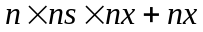 elements (see line 28, Figure A-1). The last elements stored the final state variables.
Now, let’s consider another example, which has both initial conditions and final conditions.
Problem 2: orbit transfer problem (see [7] page 66-68).
For a constant-thrust rocket with thrust T, operating from time 0 to time 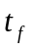, we want to find an optimal thrust angle history 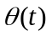 that transfer the rocket from an initial given orbit to the largest possible circular orbit.
Now, let’s transform it into a mathematical model. First, the variables and parameters are given by: -the radius of the orbit with an attracting center; -the radial velocity; -the tangential velocity; 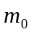-the mass of the rocket; 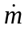-the fuel consumption rate; -the history of thrust angle; -the gravity constant of the attracting center. Then, the model is formulated by:
(A7) maximize 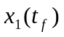,
System dynamics:
(A8) 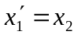,
(A9) 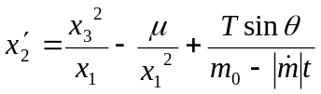,
(A10) 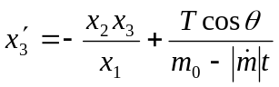.
Initial conditions:
(A11) 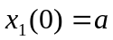,
(A12) ,
(A13) 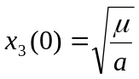.
Final conditions:
(A14) 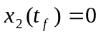,
(A15) 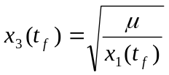.
Where,
.
Since the final conditions are given, we solve this problem using a penalty approach. At step k, the cost function is given by:
(A16) 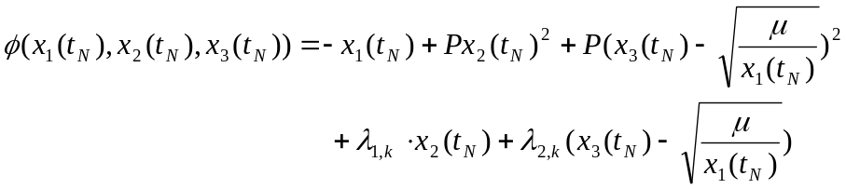
with Lagrange multipliers 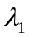 and 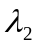, and a constant penalty factor . At step 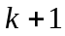, and are updated by:
(A17) 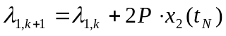,
(A18) 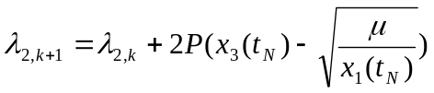.
Note that 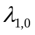 and 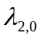 are given.
By penalty approach, we solve this problem by recursively calling OPTCON, each iteration involved in updating the value of and . The program will stop when the value 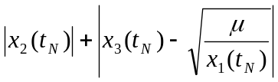 is no longer decreasing.
Please refer to the driver program-driver2.c, which can be found in the OPTCON package.

