Project 1 UI use case screens: Adding Customer into the System:
Actor | System
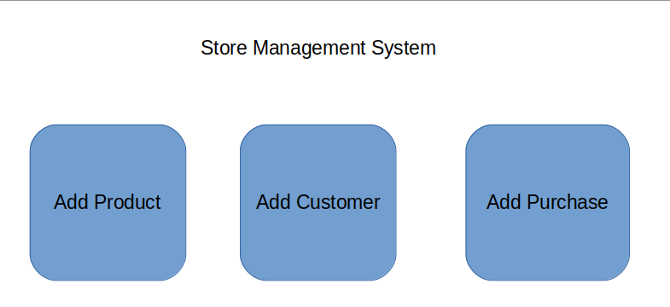  1. Main UI: Click “Add Customer”: | 2. Display “Add Customer” screen:  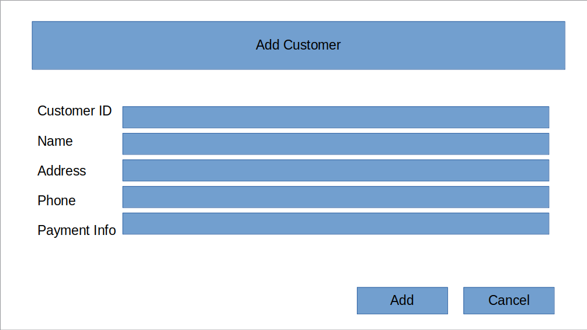
3. Input Data then click “Add” button:  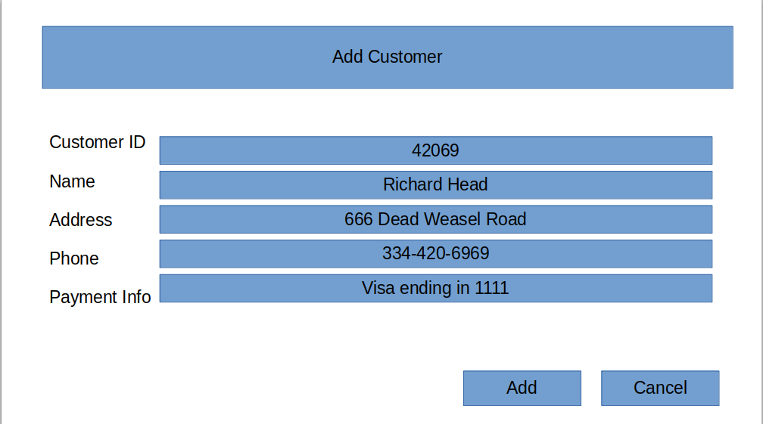 | 4. Display “Customer added Successfully” Screen:  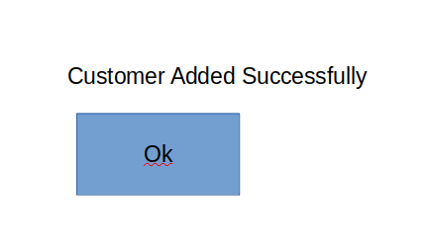
5. Click the “OK” button. | 6. Show the main UI:

Adding a new product:

Actor | System
1. Main UI: Click “Add Product”: | 2. Display “Add Product” screen:  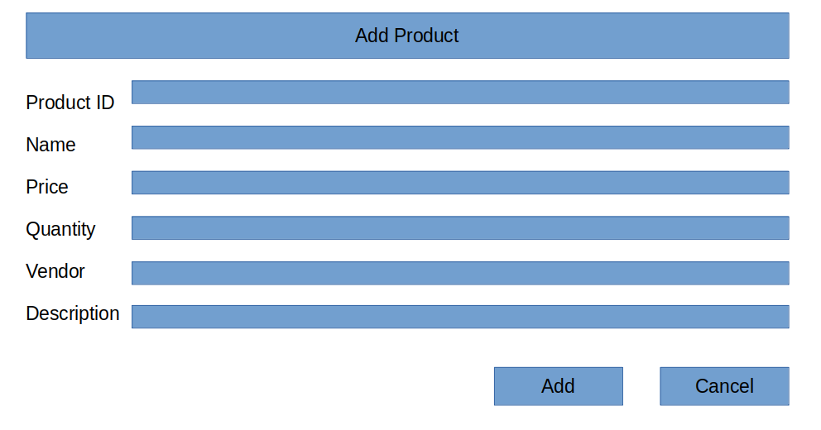
3. Input Data then click “Add” button:  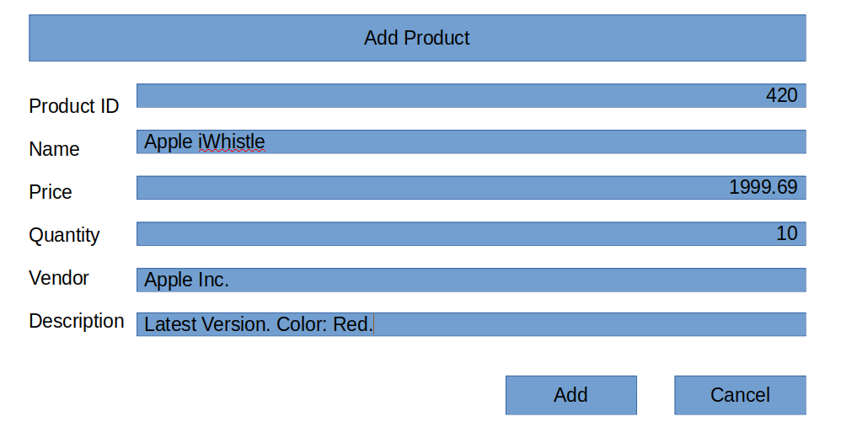 | 4. Display “Customer added Successfully” Screen:  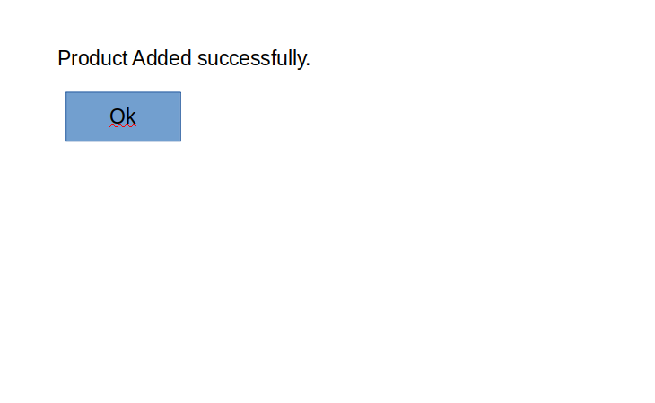
5. Click the “OK” button. | 6. Show the main UI:

Adding a new purchase

Actor | System
1. Main UI: Click “Add Purchase”: | 2. Display “Add Purchase” screen:  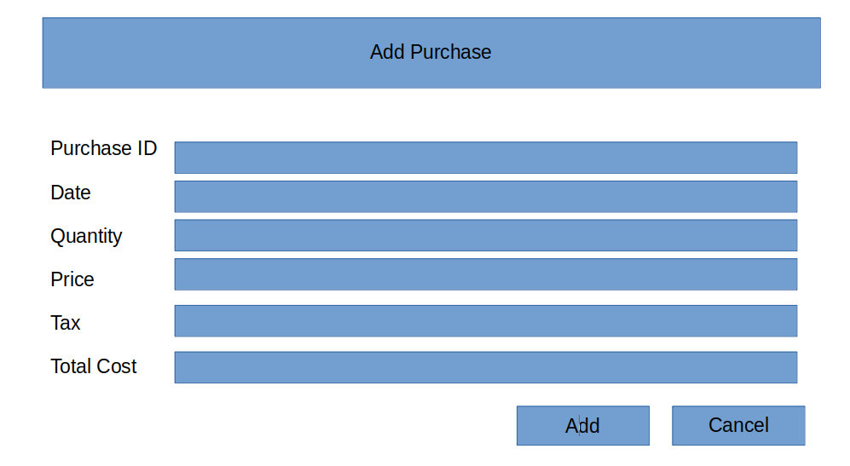
3. Input Data then click “Add” button:  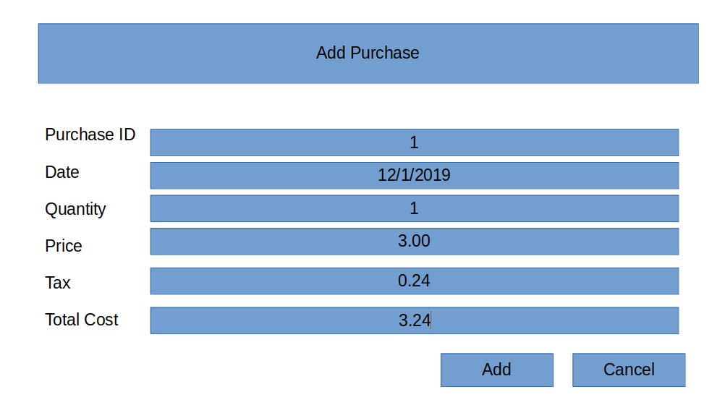 | 4. Display “Purchase added Successfully” Screen:  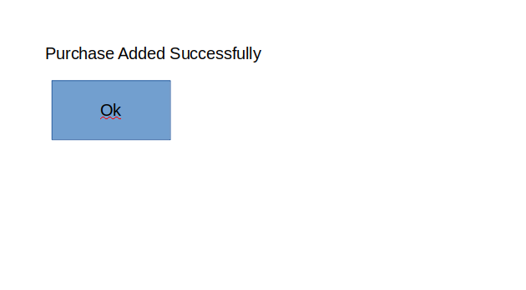
5. Click the “OK” button.  The System will print a receipt  an example can be seen here:  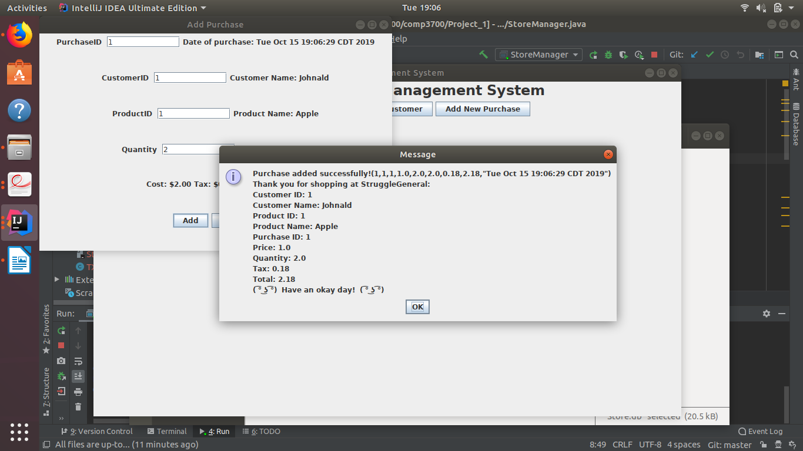 | 6. Show the main UI:

Use Cases:
1:
a) As a user I want to be in the system and add a purchase for apples. (example of successful purchase in screenshots)
b) As a user I want to purchase 100 apples.(example of buying more than in stock error in screenshots)
2:
a) I want to add a new product into the system.(example of success in screenshots)
b) I want to add a new product that does not cost anything. (example of missing price error in screenshots)
3:
a) I want to add a new customer to the system. (example of successful addition of customer in screenshots)
b) I want to add an additional customer with the same userID(example of unsuccessful addition to customer in screenshots)

There are 3 Layers:
Layer 1:
User Interface
MainView:

-productview class
-This has the UI for adding products.
-customerview class
-This has the UI for adding customers.
-purchaseview class
-This has the UI for adding purchases.

Layer 2:
Business Logic

productmodel class:
addproductcontroller
This stores information of a product.
addProductController: process events of productview.
customermodel class:
addcustomercontroller
This stores information of a customer.
addCustomerController: process events of customerview.
purchasemodel class:
addpurchasecontroller
This stores information of a purchase.
addPurchaseController: process events of purchaseview.

AddProductController: process events of productview
StoreManager: main application object

Layer 3:
Data Access
-SQLiteDataAdapter class: read/write data
-This keeps track of all customer, product and purchase data in an SQL database.
load product, save products
load purchase, save purchases
load customer, save customer

