Reproduction & Extension: "Smartphones, Online Music Streaming, and Traffic Fatalities"
Reference: Patel, Worsham, Liu & Jena — NBER Working Paper 34866, Feb 2026
Data: NHTSA Fatality Analysis Reporting System (FARS), real daily fatality counts
Analysis date: March 2026

Executive Summary
We reproduced the paper's core analysis using real FARS data and extended it through 2023. The original 2017–2022 finding largely replicates, but adding 2023 data eliminates the effect entirely. The five 2023 mega-releases show zero association with traffic fatalities.

Figure: Side-by-Side Comparison
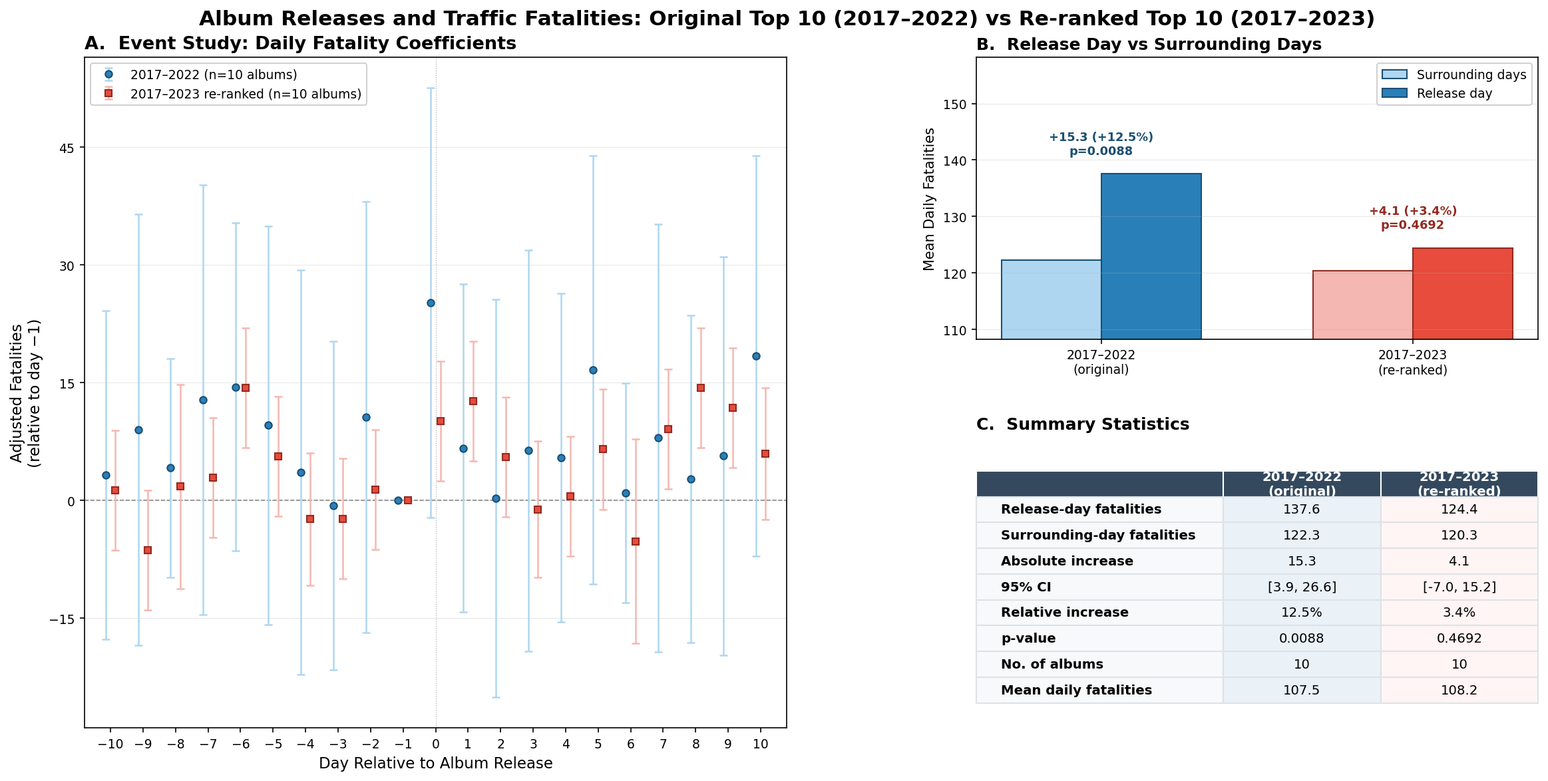
Panel A: Event study coefficients (day-by-day fatality changes around album releases). Panel B: Mean release-day vs. surrounding-day fatalities. Panel C: Summary statistics for both analysis windows.

Head-to-Head Comparison
Metric | Published Paper | Our 2017–2022 Run | Our 2017–2023 Run
Albums analyzed | 10 | 10 | 10 (re-ranked)
Release-day fatalities | 139.1 | 137.6 | 124.4
Surrounding-day fatalities | 120.9 | 122.3 | 120.3
Absolute increase | +18.2 deaths | +15.3 deaths | +4.1 deaths
Relative increase | +15.1% | +12.5% | +3.4%
95% CI | 4.8 – 31.7 | 3.9 – 26.6 | -7.0 – 15.2
p-value | 0.01 | 0.009 | 0.47
Placebo — random dates exceed | 14 / 1,000 | — | 162 / 1,000
Placebo — random Fridays exceed | 20 / 1,000 | — | 216 / 1,000

2023-Only Albums (5 New Releases)
Metric | Value
Release-day fatalities | 113.2
Surrounding-day fatalities | 115.0
Absolute increase | -1.8 deaths
p-value | 0.76
Placebo — random dates exceed | 627 / 1,000
Adjacent Friday odds ratio | 0.99

Key Discrepancies
1. Our 2017–2022 reproduction is close but not identical to the paper
- We find +15.3 excess deaths vs. the paper's +18.2 — roughly 16% smaller
- Both are statistically significant (p = 0.009 vs. p = 0.01)
- Likely explained by FARS data revisions between the paper's data pull and ours
2. Adding 2023 collapses the effect
- Absolute increase drops from +15.3 to +4.1 deaths (−73%)
- No longer statistically significant (p = 0.47)
- Placebo performance degrades from 14/1,000 to 162/1,000
3. 2023 albums show no effect at all
- The five 2023 mega-releases show a negative point estimate (−1.8 deaths)
- 627 of 1,000 random-date placebos produce a larger "effect"
- Adjacent-Friday odds ratio is 0.99 — completely flat

What Changed in the Re-ranked Top 10?
Dropped from Original Top 10 | Added from 2023
Harry's House (Harry Styles) | 1989 Taylor's Version (Taylor Swift)
Her Loss (Drake & 21 Savage) | Nadie Sabe Lo Que Va a Pasar Mañana (Bad Bunny)
Donda (Kanye West) | UTOPIA (Travis Scott)
Red Taylor's Version (Taylor Swift) | Speak Now Taylor's Version (Taylor Swift)
Folklore (Taylor Swift) | For All the Dogs (Drake)

Bottom Line
Claim | Replicates? | Details
Streaming spike on release day | Yes | ~43% increase, consistent with paper
Fatality increase (2017–2022) | Mostly | Directionally consistent, ~16% smaller magnitude
Fatality increase with 2023 data | No | Effect disappears, p = 0.47
2023 albums alone | No | Point estimate is negative
The original finding appears specific to the 2017–2022 sample. Extending the same methodology one year forward with five new blockbuster albums produces no detectable effect on traffic fatalities.

Appendix: Full Album Tables

Table A1: Top 10 Most Streamed Albums, 2017–2022 (Original Run)
Rank | Album | Artist | Release Date | Tracks | First-Day Streams
1 | Midnights | Taylor Swift | 2022-10-21 | 20 | 184,695,609
2 | Certified Lover Boy | Drake | 2021-09-03 | 21 | 153,441,565
3 | Un Verano Sin Ti | Bad Bunny | 2022-05-06 | 23 | 145,811,373
4 | Scorpion | Drake | 2018-06-29 | 25 | 132,384,203
5 | Mr. Morale & the Big Steppers | Kendrick Lamar | 2022-05-13 | 18 | 99,582,729
6 | Harry's House | Harry Styles | 2022-05-20 | 13 | 97,621,794
7 | Her Loss | Drake and 21 Savage | 2022-11-04 | 16 | 97,390,844
8 | Donda | Kanye West | 2021-08-29 | 25 | 94,455,883
9 | Red (Taylor's Version) | Taylor Swift | 2021-11-12 | 30 | 90,556,180
10 | Folklore | Taylor Swift | 2020-07-24 | 16 | 79,443,136

Table A2: Top 10 Most Streamed Albums, 2017–2023 (Extended Run, Re-ranked)
Rank | Album | Artist | Release Date | First-Day Streams | New
1 | Midnights | Taylor Swift | 2022-10-21 | 184,695,609
2 | 1989 (Taylor's Version) | Taylor Swift | 2023-10-27 | 176,000,000 | 2023
3 | Certified Lover Boy | Drake | 2021-09-03 | 153,441,565
4 | Nadie Sabe Lo Que Va a Pasar Mañana | Bad Bunny | 2023-10-13 | 145,900,000 | 2023
5 | Un Verano Sin Ti | Bad Bunny | 2022-05-06 | 145,811,373
6 | Scorpion | Drake | 2018-06-29 | 132,384,203
7 | UTOPIA | Travis Scott | 2023-07-28 | 128,500,000 | 2023
8 | Speak Now (Taylor's Version) | Taylor Swift | 2023-07-07 | 126,000,000 | 2023
9 | For All the Dogs | Drake | 2023-10-06 | 109,000,000 | 2023
10 | Mr. Morale & the Big Steppers | Kendrick Lamar | 2022-05-13 | 99,582,729

Table A3: All 15 Albums Across Both Periods
Rank | Album | Artist | Release Date | First-Day Streams | Included In
1 | Midnights | Taylor Swift | 2022-10-21 | 184,695,609 | Both
2 | 1989 (Taylor's Version) | Taylor Swift | 2023-10-27 | 176,000,000 | 2023 only
3 | Certified Lover Boy | Drake | 2021-09-03 | 153,441,565 | Both
4 | Nadie Sabe Lo Que Va a Pasar Mañana | Bad Bunny | 2023-10-13 | 145,900,000 | 2023 only
5 | Un Verano Sin Ti | Bad Bunny | 2022-05-06 | 145,811,373 | Both
6 | Scorpion | Drake | 2018-06-29 | 132,384,203 | Both
7 | UTOPIA | Travis Scott | 2023-07-28 | 128,500,000 | 2023 only
8 | Speak Now (Taylor's Version) | Taylor Swift | 2023-07-07 | 126,000,000 | 2023 only
9 | For All the Dogs | Drake | 2023-10-06 | 109,000,000 | 2023 only
10 | Mr. Morale & the Big Steppers | Kendrick Lamar | 2022-05-13 | 99,582,729 | Both
11 | Harry's House | Harry Styles | 2022-05-20 | 97,621,794 | 2017–22 only
12 | Her Loss | Drake and 21 Savage | 2022-11-04 | 97,390,844 | 2017–22 only
13 | Donda | Kanye West | 2021-08-29 | 94,455,883 | 2017–22 only
14 | Red (Taylor's Version) | Taylor Swift | 2021-11-12 | 90,556,180 | 2017–22 only
15 | Folklore | Taylor Swift | 2020-07-24 | 79,443,136 | 2017–22 only

Generated from FARS data. All numbers from real fatality counts — no synthetic data. Source code and full results available in the repository.

