Apex Screenshot Evidence:  
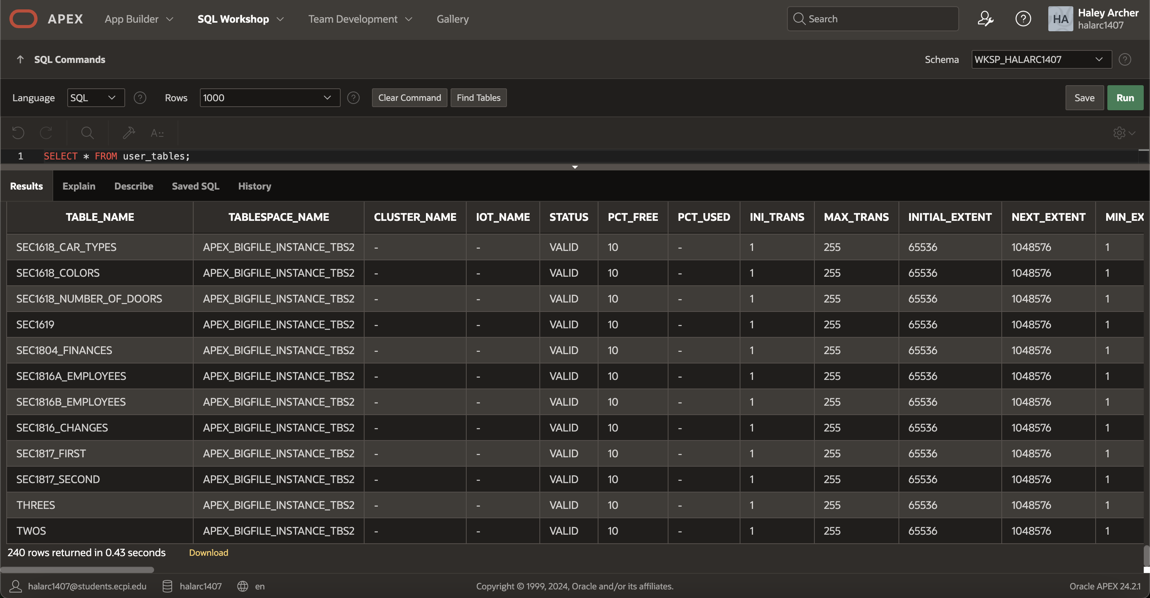  
GitHub repo: <https://github.com/thepacketpoet-school/sdc250>

Git commit evidence:  
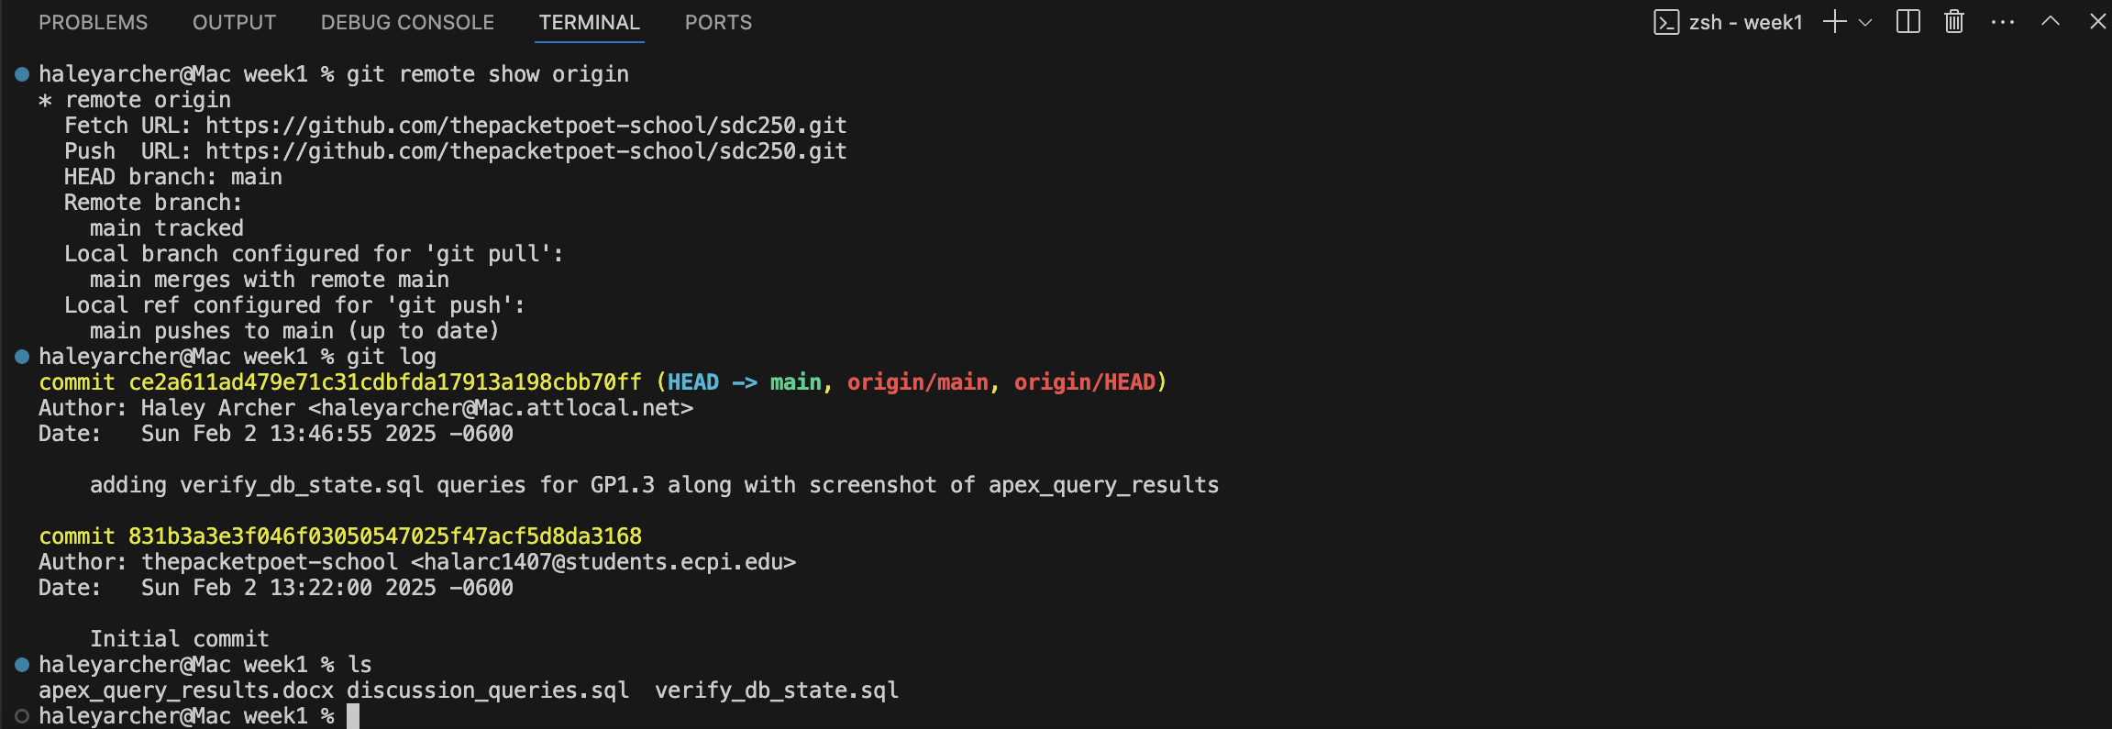  
  
SQL Queries:  
-- SQL script to verify the current database state for VaporGames

-- Step 1: Check which users have access to the database

SELECT USER_ID, USERNAME, CREATED, PASSWORD_CHANGE_DATE

FROM USER_USERS;

-- Step 2: Check what tables are present in the database

SELECT * FROM USER_TABLES;

-- Step 3: Examine the structure of key tables

DESCRIBE ORDERS;

DESCRIBE PRODUCTLIST;

DESCRIBE REVIEWS;

DESCRIBE STOREFRONT;

DESCRIBE USERBASE;

DESCRIBE USERLIBRARY;

-- Step 4: Display all data from each table

SELECT * FROM ORDERS;

SELECT * FROM PRODUCTLIST;

SELECT * FROM REVIEWS;

SELECT * FROM STOREFRONT;

SELECT * FROM USERBASE;

SELECT * FROM USERLIBRARY;

-- Step 5: Check database constraints

SELECT TABLE_NAME, CONSTRAINT_NAME, CONSTRAINT_TYPE, STATUS

FROM USER_CONSTRAINTS;

-- Step 6: Check database views

SELECT VIEW_NAME, TEXT

FROM USER_VIEWS;

-- Step 7: Retrieve every username in alphabetical order

SELECT USERNAME

FROM USERBASE

ORDER BY USERNAME ASC;

-- Step 8: Find users with Yahoo email addresses

SELECT FIRSTNAME, LASTNAME, USERNAME, PASSWORD, EMAIL

FROM USERBASE

WHERE EMAIL LIKE '[%@yahoo.com](mailto:%@yahoo.com)';

-- Step 9: Find users with less than $25 in wallet funds

SELECT USERNAME, BIRTHDAY, WALLETFUNDS

FROM USERBASE

WHERE WALLETFUNDS < 25;

-- Step 10: Retrieve users who have played more than 100 hours

SELECT USERID, PRODUCTCODE

FROM USERLIBRARY

WHERE HOURSPLAYED > 100;

-- Step 11: Retrieve games that have been played for less than 10 hours

SELECT PRODUCTCODE

FROM USERLIBRARY

WHERE HOURSPLAYED < 10;

-- Step 12: Retrieve all unique publishers

SELECT DISTINCT PUBLISHER

FROM PRODUCTLIST;

-- Step 13: Display all products sorted by genre

SELECT PRODUCTNAME, RELEASEDATE, PUBLISHER, GENRE

FROM PRODUCTLIST

ORDER BY GENRE ASC;

-- Step 14: Find products in the ‘Strategy’ genre

SELECT PRODUCTCODE, PUBLISHER

FROM PRODUCTLIST

WHERE GENRE = 'Strategy';

-- Step 15: Retrieve all products that cost more than $25, sorted from highest to lowest price

SELECT PRODUCTCODE, DESCRIPTION, PRICE

FROM PRODUCTLIST

WHERE PRICE > 25

ORDER BY PRICE DESC;

-- Step 16: Retrieve storefront inventory sorted by lowest price first

SELECT INVENTORYID, PRICE

FROM STOREFRONT

ORDER BY PRICE ASC;

-- Step 17: Retrieve all reviews with a rating of 1

SELECT PRODUCTCODE, REVIEW

FROM REVIEWS

WHERE RATING = 1;

-- Step 18: Retrieve all reviews with a rating of 4 or higher

SELECT PRODUCTCODE, REVIEW

FROM REVIEWS

WHERE RATING >= 4;

-- Step 19: Retrieve every unique user ID from users who have placed an order

SELECT DISTINCT USERID

FROM ORDERS;

-- Step 20: Retrieve all orders sorted by earliest purchase date

SELECT *

FROM ORDERS

ORDER BY PURCHASEDATE ASC;