My SQL script (committed to Github and executed in Apex):

-- Question 1:

SELECT

MIN(num_1) AS minimum,

MAX(num_1) AS maximum

FROM sec1103;

-- Haley Archer

-- Question 2:

SELECT

MIN(num_1) AS minimum,

MAX(num_1) AS maximum

FROM sec1103

WHERE row_ID < 8;

-- Haley Archer

-- Question 3:

SELECT

COUNT(*) AS total_rows,

COUNT(num_1) AS non_null_num1,

COUNT(*) - COUNT(num_1) AS null_num1

FROM sec1106;

-- Haley Archer

-- Question 4:

SELECT COUNT(DISTINCT num_1 || '-' || num_2) AS distinct_values

FROM sec1103;

-- Haley Archer

-- Question 5:

SELECT

num_1,

num_2,

num_1 + num_2 AS row_wise_addition,

(SELECT SUM(num_1) FROM sec1103) + (SELECT SUM(num_2) FROM sec1103) AS column_wise_addition,

COALESCE(num_1, 0) + COALESCE(num_2, 0) AS nulls_treated_as_zero

FROM sec1103;

-- Haley Archer

-- Question 6:

SELECT

col_1,

SUM(col_3) AS total_col_3

FROM sec1202

GROUP BY col_1;

-- Haley Archer

-- Question 7:

SELECT

col_1,

col_2,

SUM(col_3) AS total_col_3

FROM sec1202

GROUP BY col_1, col_2;

-- Haley Archer

-- Question 8:

SELECT * FROM sec1202

UNION ALL

SELECT NULL, NULL, NULL, SUM(col_3) FROM sec1202;

-- Haley Archer

-- Question 9:

SELECT

col_1,

SUM(col_2) AS total_col_2

FROM sec1211

GROUP BY col_1

HAVING SUM(col_2) > 20;

-- Haley Archer

(11-3) Question 1:

Table *sec1103* contains two columns, *row_ID* and *num_1*. (It also contains a column named *num_2*, but we are not going to use that column now.) Find the minimum and maximum values of the *num_1* column. Name these values “minimum” and “maximum.”

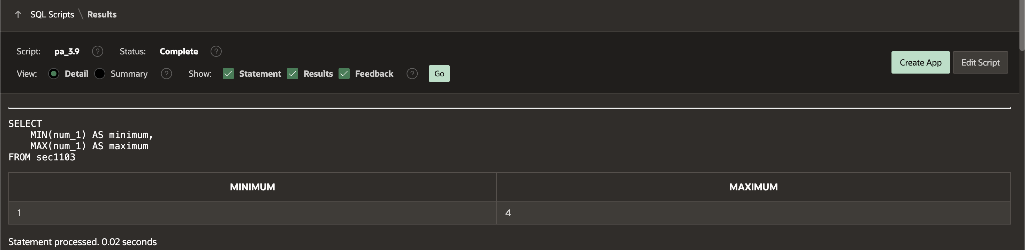

(11-4) Question 2:

Repeat the exercise in the previous section, except this time add a *where* clause that limits the *row_ID* column to values less than 8. Is there any change in the minimum and maximum values?

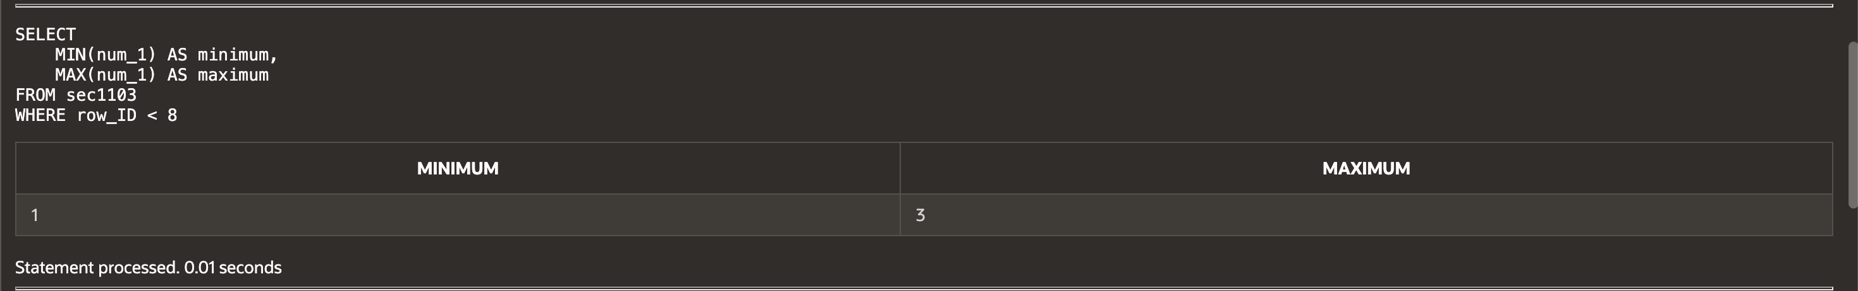

(11-6) Question 3:

In table *sec1106*, find the following information:

■ The number of rows in the table

■ The number of rows that have a non-null value in the *Num_1* column

■ The number of rows that have a null value in the *Num_1* column  
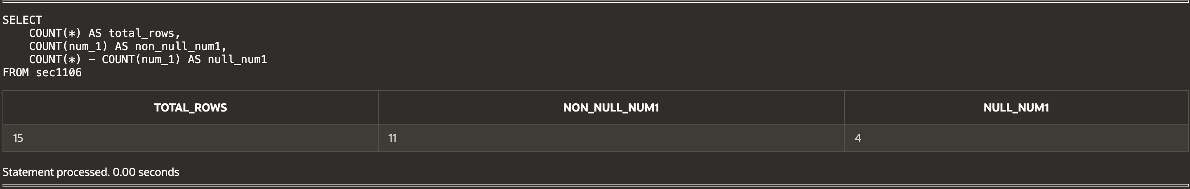

(11-9) Question 4:

In table *sec1103*, find the number of distinct values in the *num_1* and *num_2* columns, taken together.



(11-11) Question 5:

In table *sec1103*, show the problem with nulls in addition and how to solve it.

1. Add columns *num_1* and *num_2*, adding each row first.

2. Add columns *num_1* and *num_2*, adding each column first.

3. Add columns *num_1* and *num_2*, changing all the nulls to zeros first.

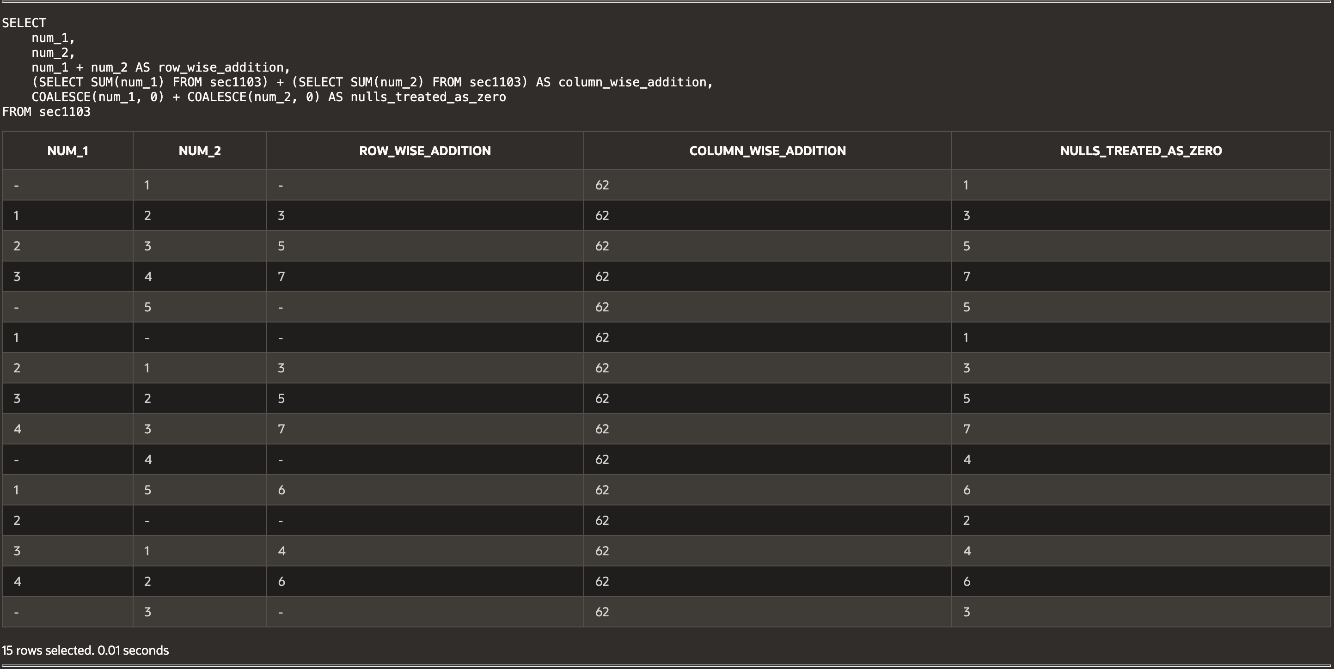

(12-2) Question 6:

Table *sec1202* has four columns: *row_id, col_1, col_2,* and *col_3*. Write a select statement that groups the rows by the value in *col_1* and for each group determines the sum of the values in *col_3*.  
 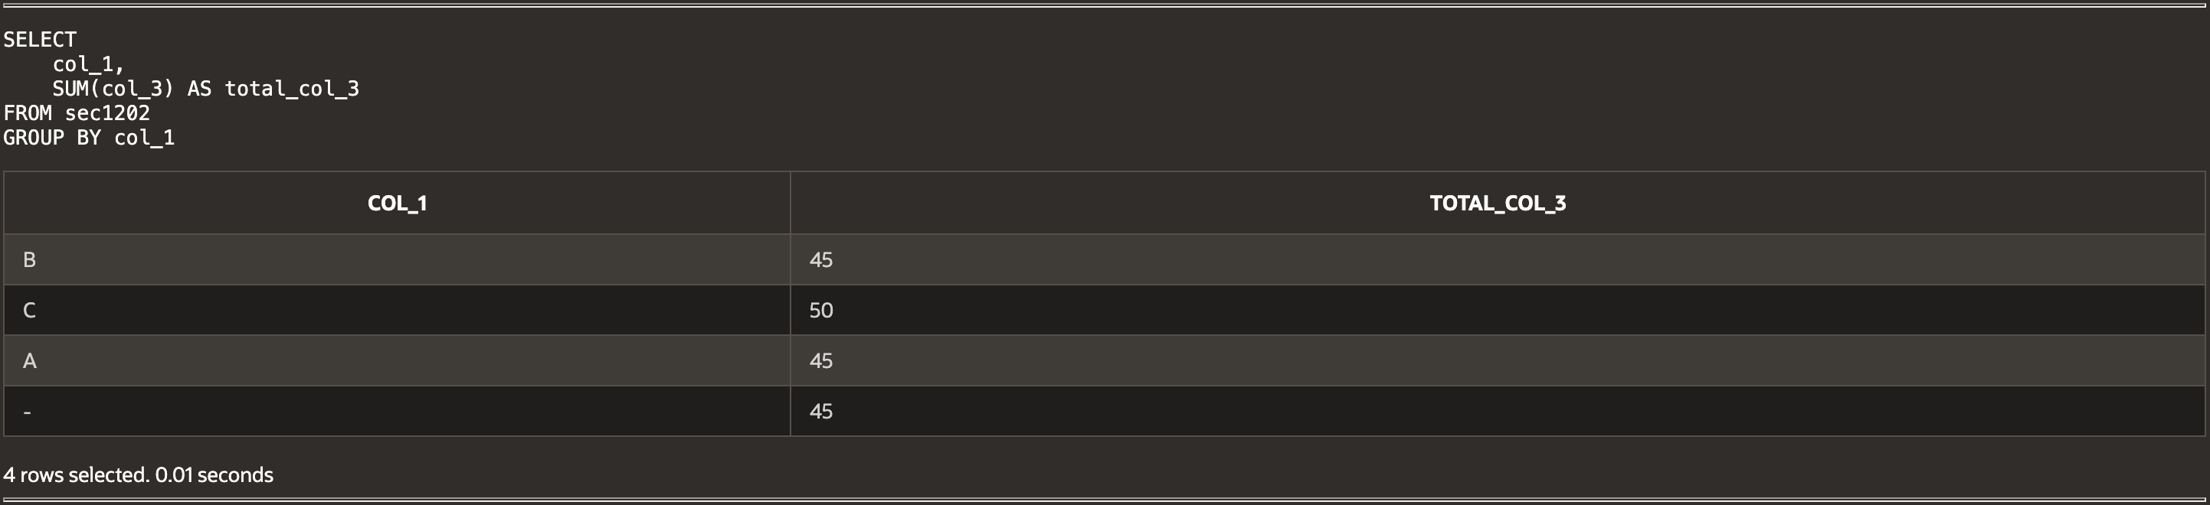

(12-4) Question 7:

Use table *sec1202*. Write a select statement that groups the rows by the value in *col_1* and *col_2*. For each group determine the sum of the values in *col_3*.

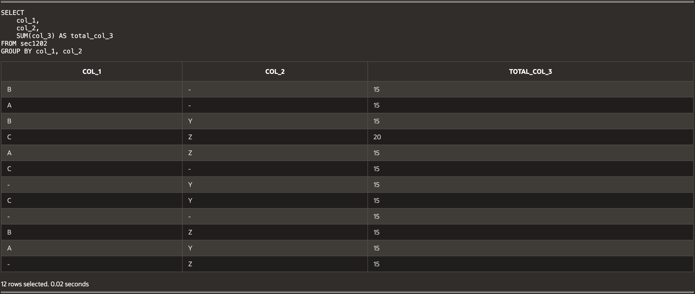

(12-7) Question 8:

Suppose you wanted to show all the data in table *sec1202* and you also wanted to show the total for *col_3*. Could you do this with SQL?

The answer is no. The best you can do is to run two queries. One would show the data with:

*select \**

from *sec1202;*

The other would show the total with:

select *sum(col_3)* as *grand_total*

from *sec1202;*

Then, if you were desperate, you could paste the two pieces of paper together. Or you could do the same thing in SQL using a union.

Fortunately, most SQL products give you a better way. There is usually some sort of report level to the software that will do totals and subtotals for you.

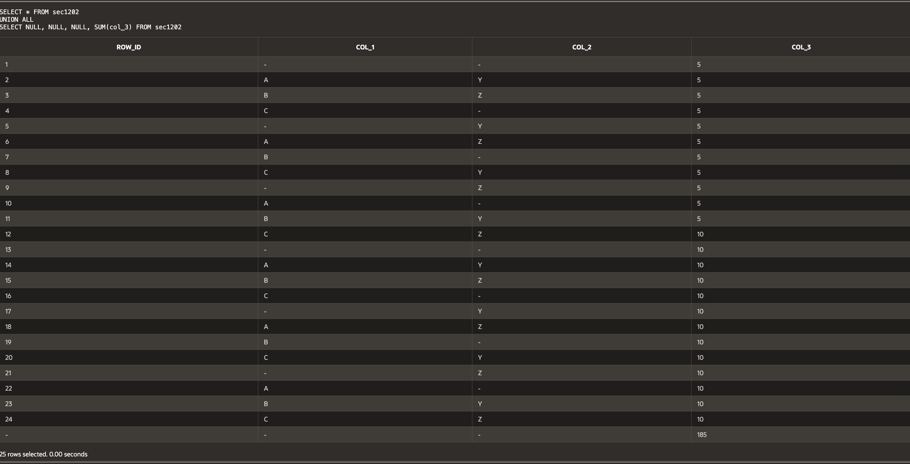

(11-11) Question 9:

Table *sec1211* has three columns: *row_id,* *col_1*, and *col_2*. Group on *col_1* and get the sum of *col_2*. Add a having clause to show only the rows of the result table where the sum is greater than 20.

