**Week 4 Guided Practice: Inner Joins Part 2**

The following questions come from the Task examples of Chapter 13 in your textbook.

After you are finished, please submit the Microsoft Word file that contains screenshots of the SQL queries and the output, along with a comment in the query containing your name. Your document should be named **W4_GP_InnerJoins2_Lastname.docx**.

(13-10) Question 1:

Join the *sec1310_fruits* table and the *sec1310_colors* table with an inner join. Use a join condition that matches rows when the first two columns of each table are equal.

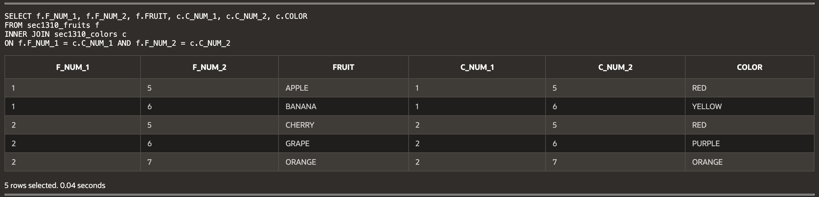

(13-11) Question 2:

Assign grades to students by placing their individual test scores within one of the grading ranges.

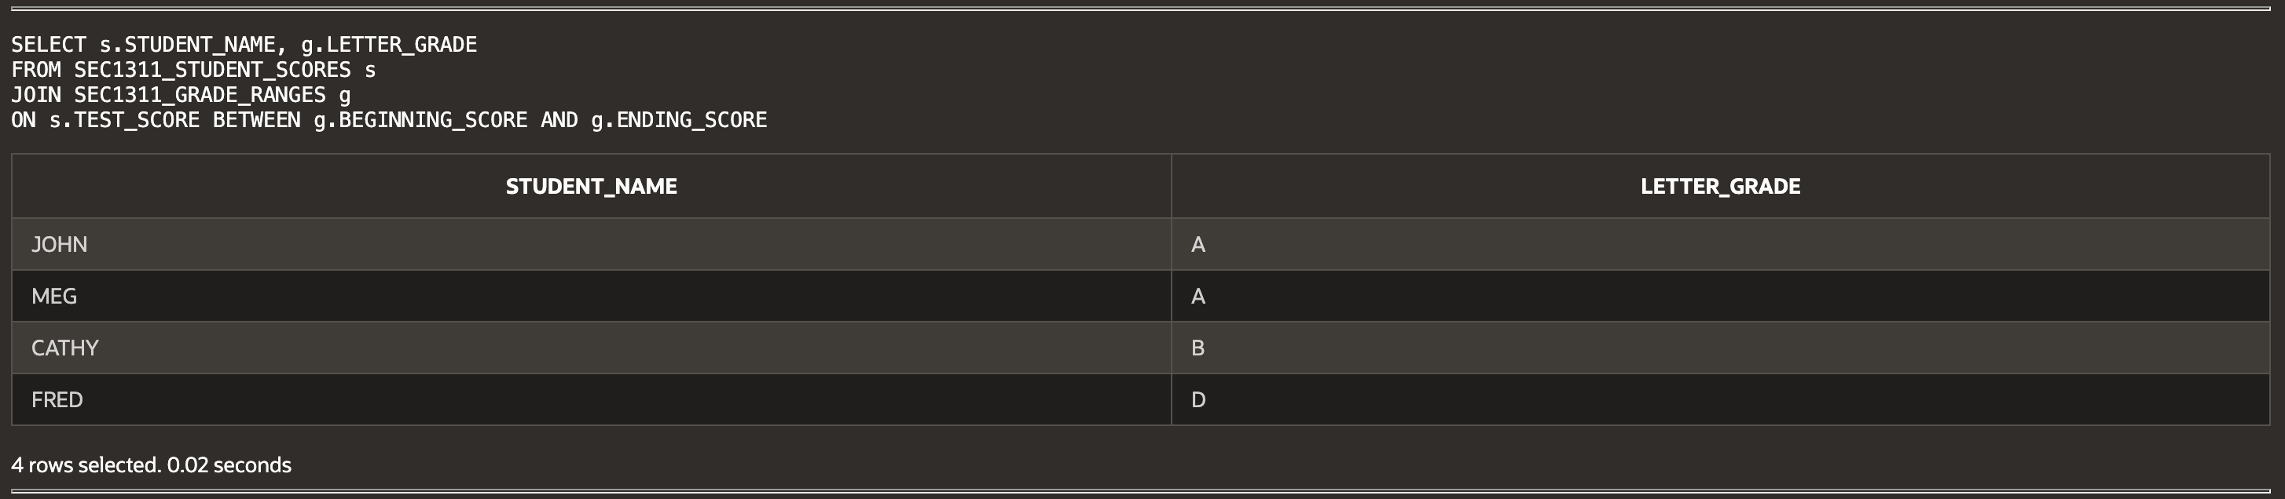

(13-12) Question 3:

Join the *sec1312_bigger_numbers* table with the *sec1312_smaller_numbers* table. Create a join condition that pairs each bigger number with all the smaller numbers that are less than it.

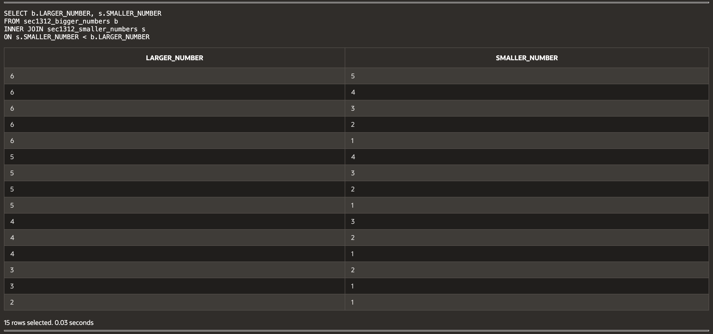

(13-14) Question 4:

Show the syntax for joining two tables in the *from* clause. Join the *sec1314_fruits* table and the *sec1314_colors* table using newer syntax.

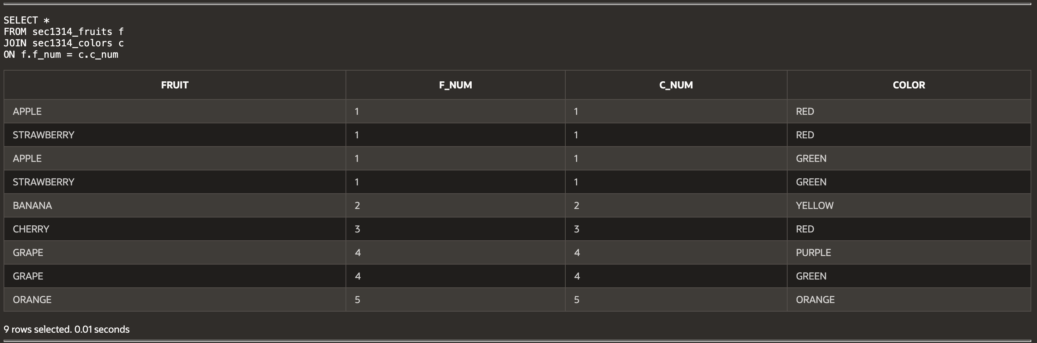

(13-15) Question 5:

For each employee show the *employee_id*, *first_name, last_name, dept_code*, and *department_name*. Sort the rows by the *employee_id*. Use an inner join to get the *department_name* from the *L_DEPARTMENTS* table.

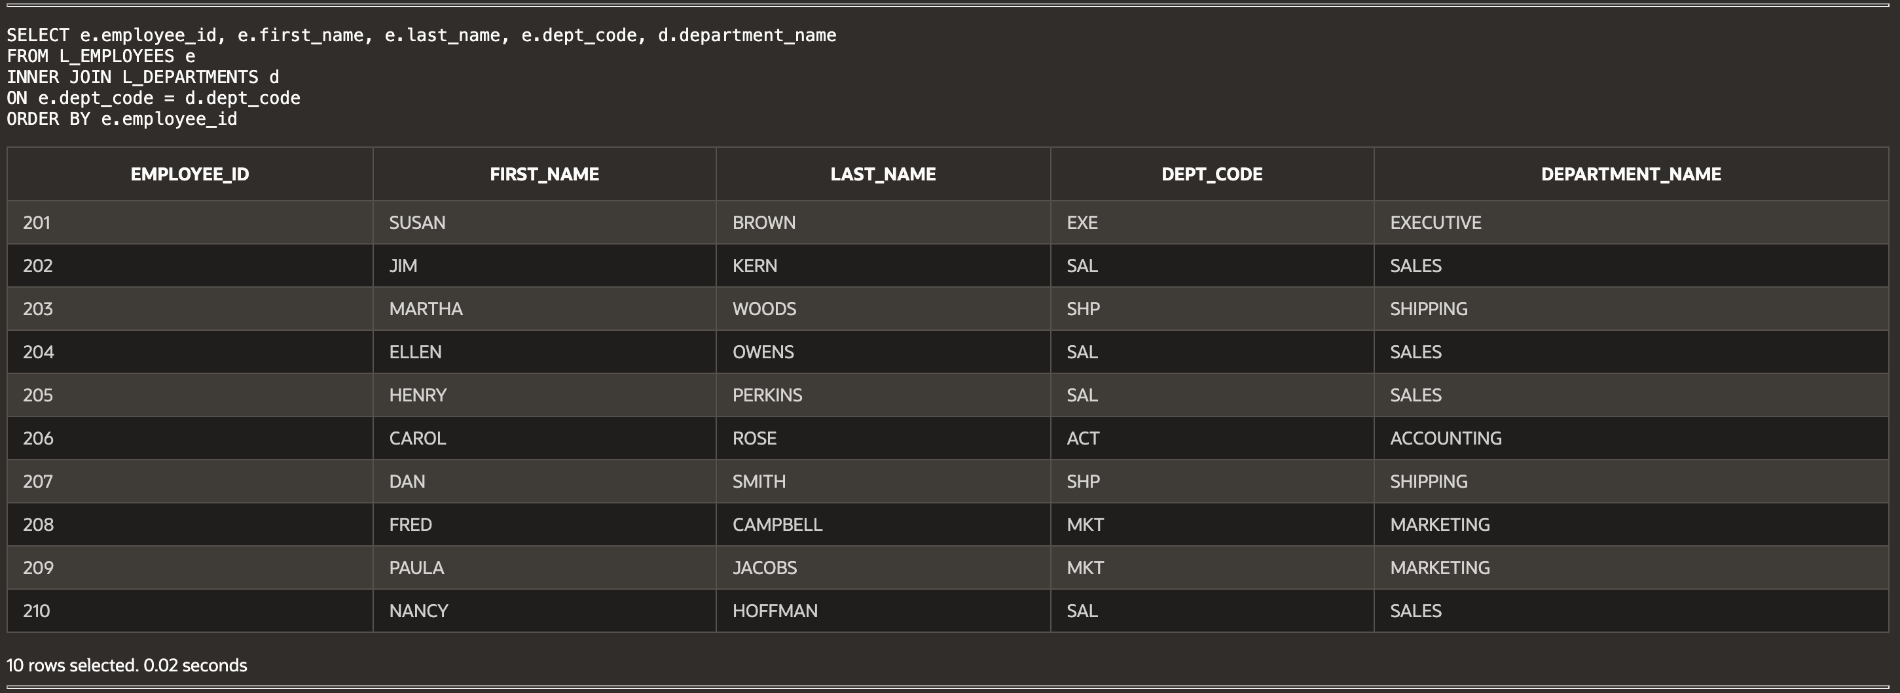

(13-17) Question 6:

List all the employees who are attending more than one lunch, except employee 208. Show the following columns: *employee_id, first_name, last_name*, and *number_of_lunches*.

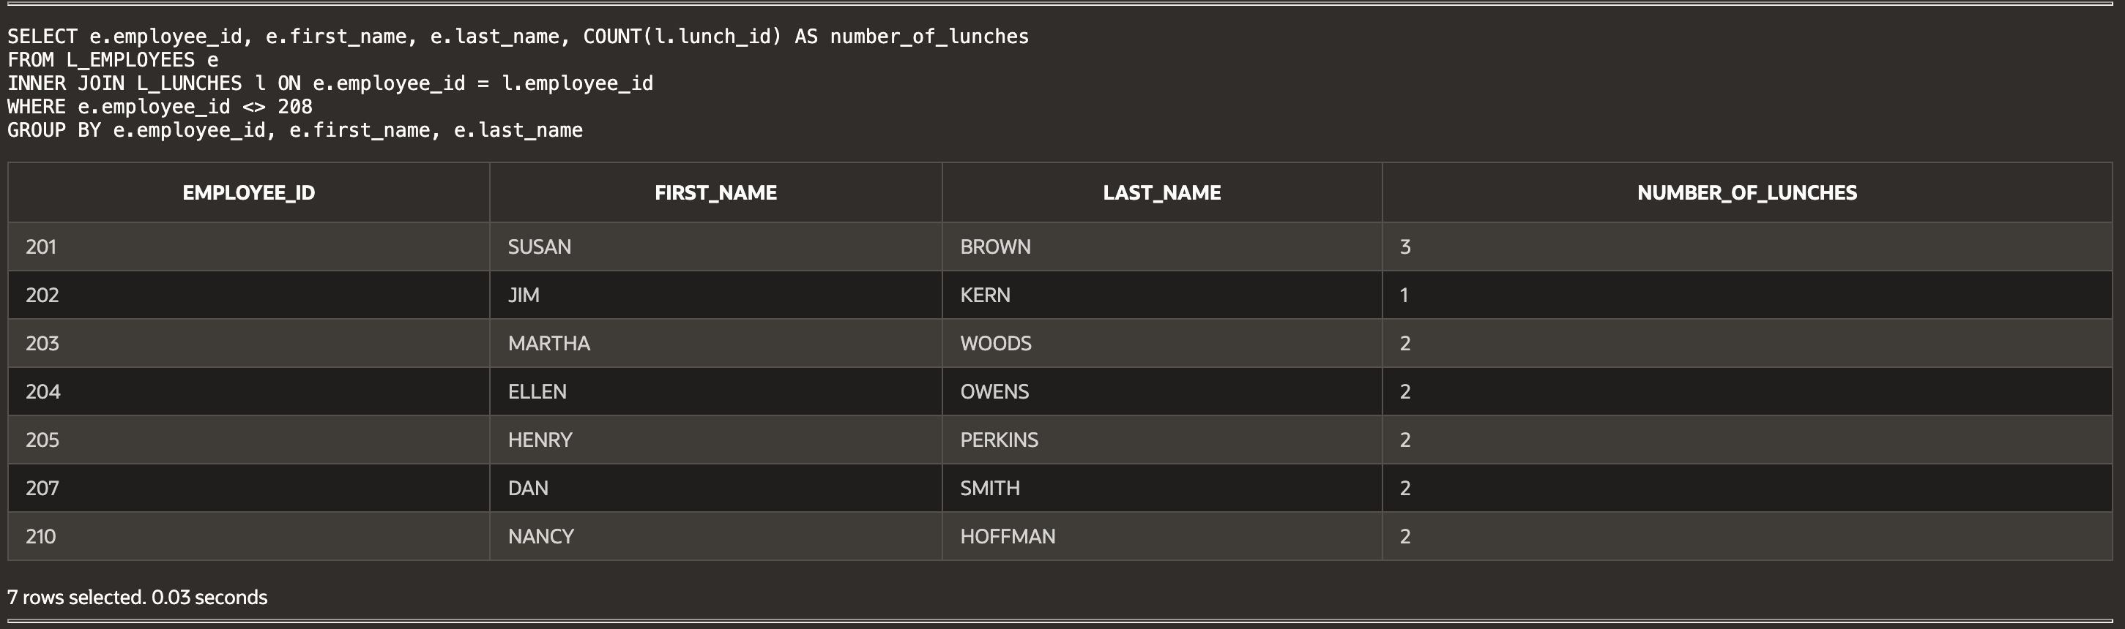

(13-18) Question 7:

Find all the columns in the primary key of the *L_FOODS* tables.

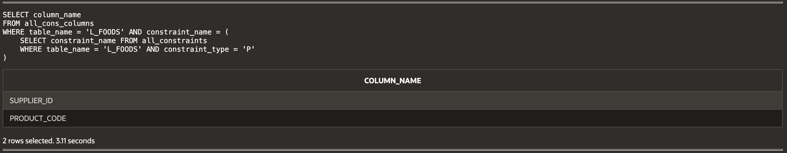

(13-19) Question 8:

Show information about all the lunches ordered by people in the shipping department. Show the employee ID, names of the employees, the lunch date, and the descriptions and quantities of the foods they will eat. Sort the result by the *employee_id* and the *lunch_date* columns. To do this you need to join four tables.

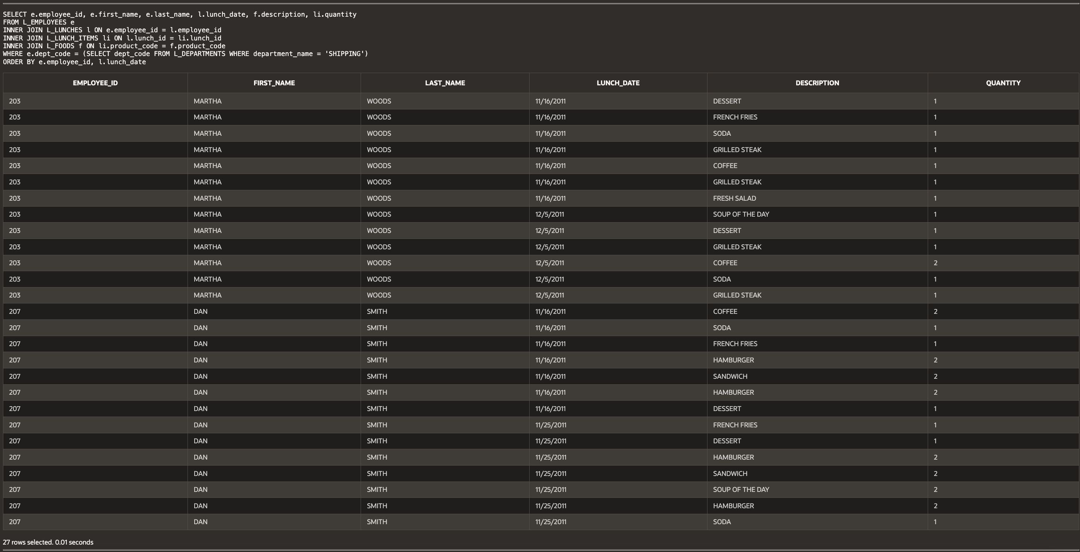  
  
  
**Script:**

-- W4_GP_InnerJoins2_Archer.sql

-- Haley Archer

-- (13-10) Question 1

SELECT f.F_NUM_1, f.F_NUM_2, f.FRUIT, c.C_NUM_1, c.C_NUM_2, c.COLOR

FROM sec1310_fruits f

INNER JOIN sec1310_colors c

ON f.F_NUM_1 = c.C_NUM_1 AND f.F_NUM_2 = c.C_NUM_2

-- (13-11) Question 2

SELECT s.STUDENT_NAME, g.LETTER_GRADE

FROM SEC1311_STUDENT_SCORES s

JOIN SEC1311_GRADE_RANGES g

ON s.TEST_SCORE BETWEEN g.BEGINNING_SCORE AND g.ENDING_SCORE

-- (13-12) Question 3

SELECT b.LARGER_NUMBER, s.SMALLER_NUMBER

FROM sec1312_bigger_numbers b

INNER JOIN sec1312_smaller_numbers s

ON s.SMALLER_NUMBER < b.LARGER_NUMBER

-- (13-14) Question 4

SELECT *

FROM sec1314_fruits f

JOIN sec1314_colors c

ON f.f_num = c.c_num;

-- (13-15) Question 5

SELECT e.employee_id, e.first_name, e.last_name, e.dept_code, d.department_name

FROM L_EMPLOYEES e

INNER JOIN L_DEPARTMENTS d

ON e.dept_code = d.dept_code

ORDER BY e.employee_id;

-- (13-17) Question 6

SELECT e.employee_id, e.first_name, e.last_name, COUNT(l.lunch_id) AS number_of_lunches

FROM L_EMPLOYEES e

INNER JOIN L_LUNCHES l ON e.employee_id = l.employee_id

WHERE e.employee_id <> 208

GROUP BY e.employee_id, e.first_name, e.last_name;

-- (13-18) Question 7

SELECT column_name

FROM all_cons_columns

WHERE table_name = 'L_FOODS' AND constraint_name = (

SELECT constraint_name FROM all_constraints

WHERE table_name = 'L_FOODS' AND constraint_type = 'P'

);

-- (13-19) Question 8

SELECT e.employee_id, e.first_name, e.last_name, l.lunch_date, f.description, li.quantity

FROM L_EMPLOYEES e

INNER JOIN L_LUNCHES l ON e.employee_id = l.employee_id

INNER JOIN L_LUNCH_ITEMS li ON l.lunch_id = li.lunch_id

INNER JOIN L_FOODS f ON li.product_code = f.product_code

WHERE e.dept_code = (SELECT dept_code FROM L_DEPARTMENTS WHERE department_name = 'SHIPPING')

ORDER BY e.employee_id, l.lunch_date