**Week 4 Guided Practice: Outer Joins Part 2**

The following questions come from the Task examples in Chapter 14 in your textbook.

After you are finished, please submit a Microsoft Word file that contains screenshots of the SQL queries, the output, and a comment in the query file with your name. Your document should be named **W4_GP_OuterJoins2_Lastname.docx**.

(14-8) Question 1:

Show the number of lunches each employee will attend. Include all the employees. Show a zero if the employee is not attending any lunches.

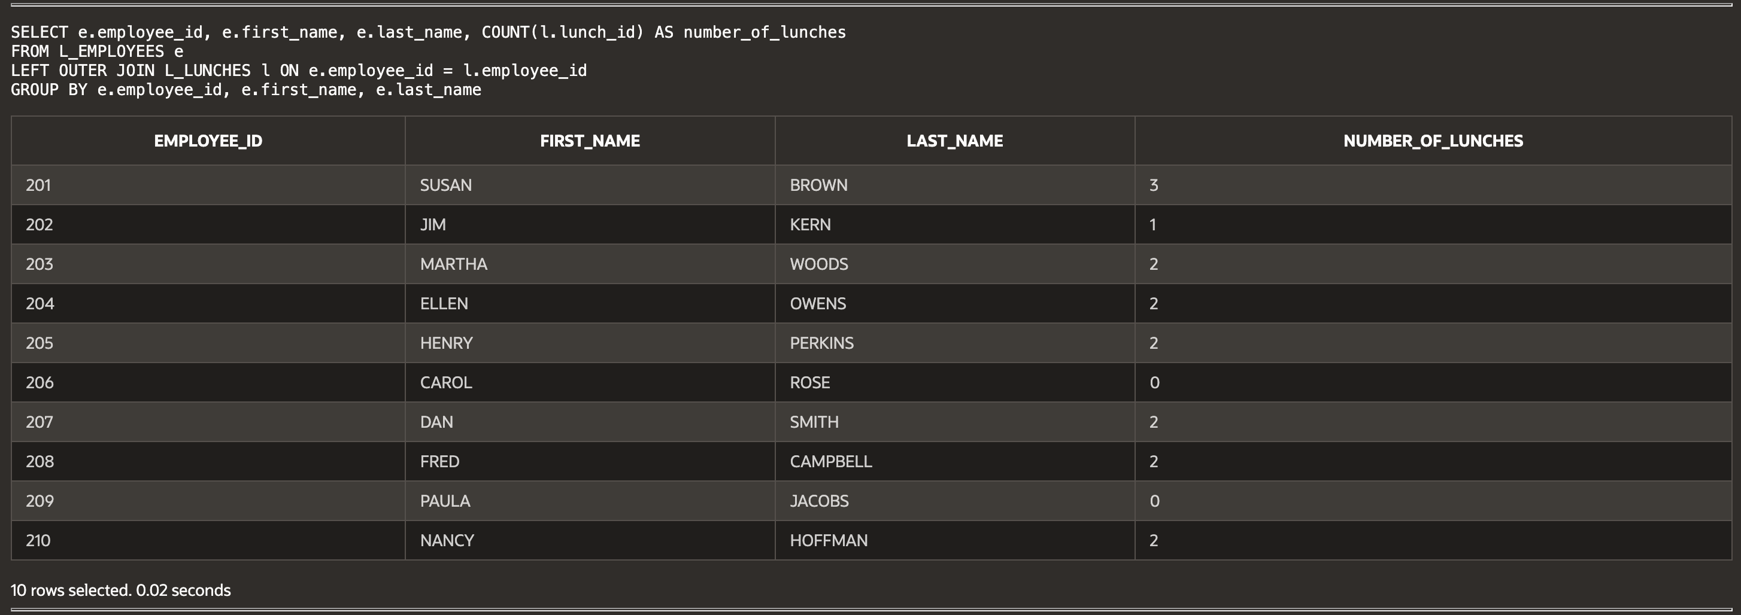

(14-9) Question 2:

Create an outer join of the *L_EMPLOYEES* table and the *L_LUNCHES* table. Retain all the rows of data from both tables.

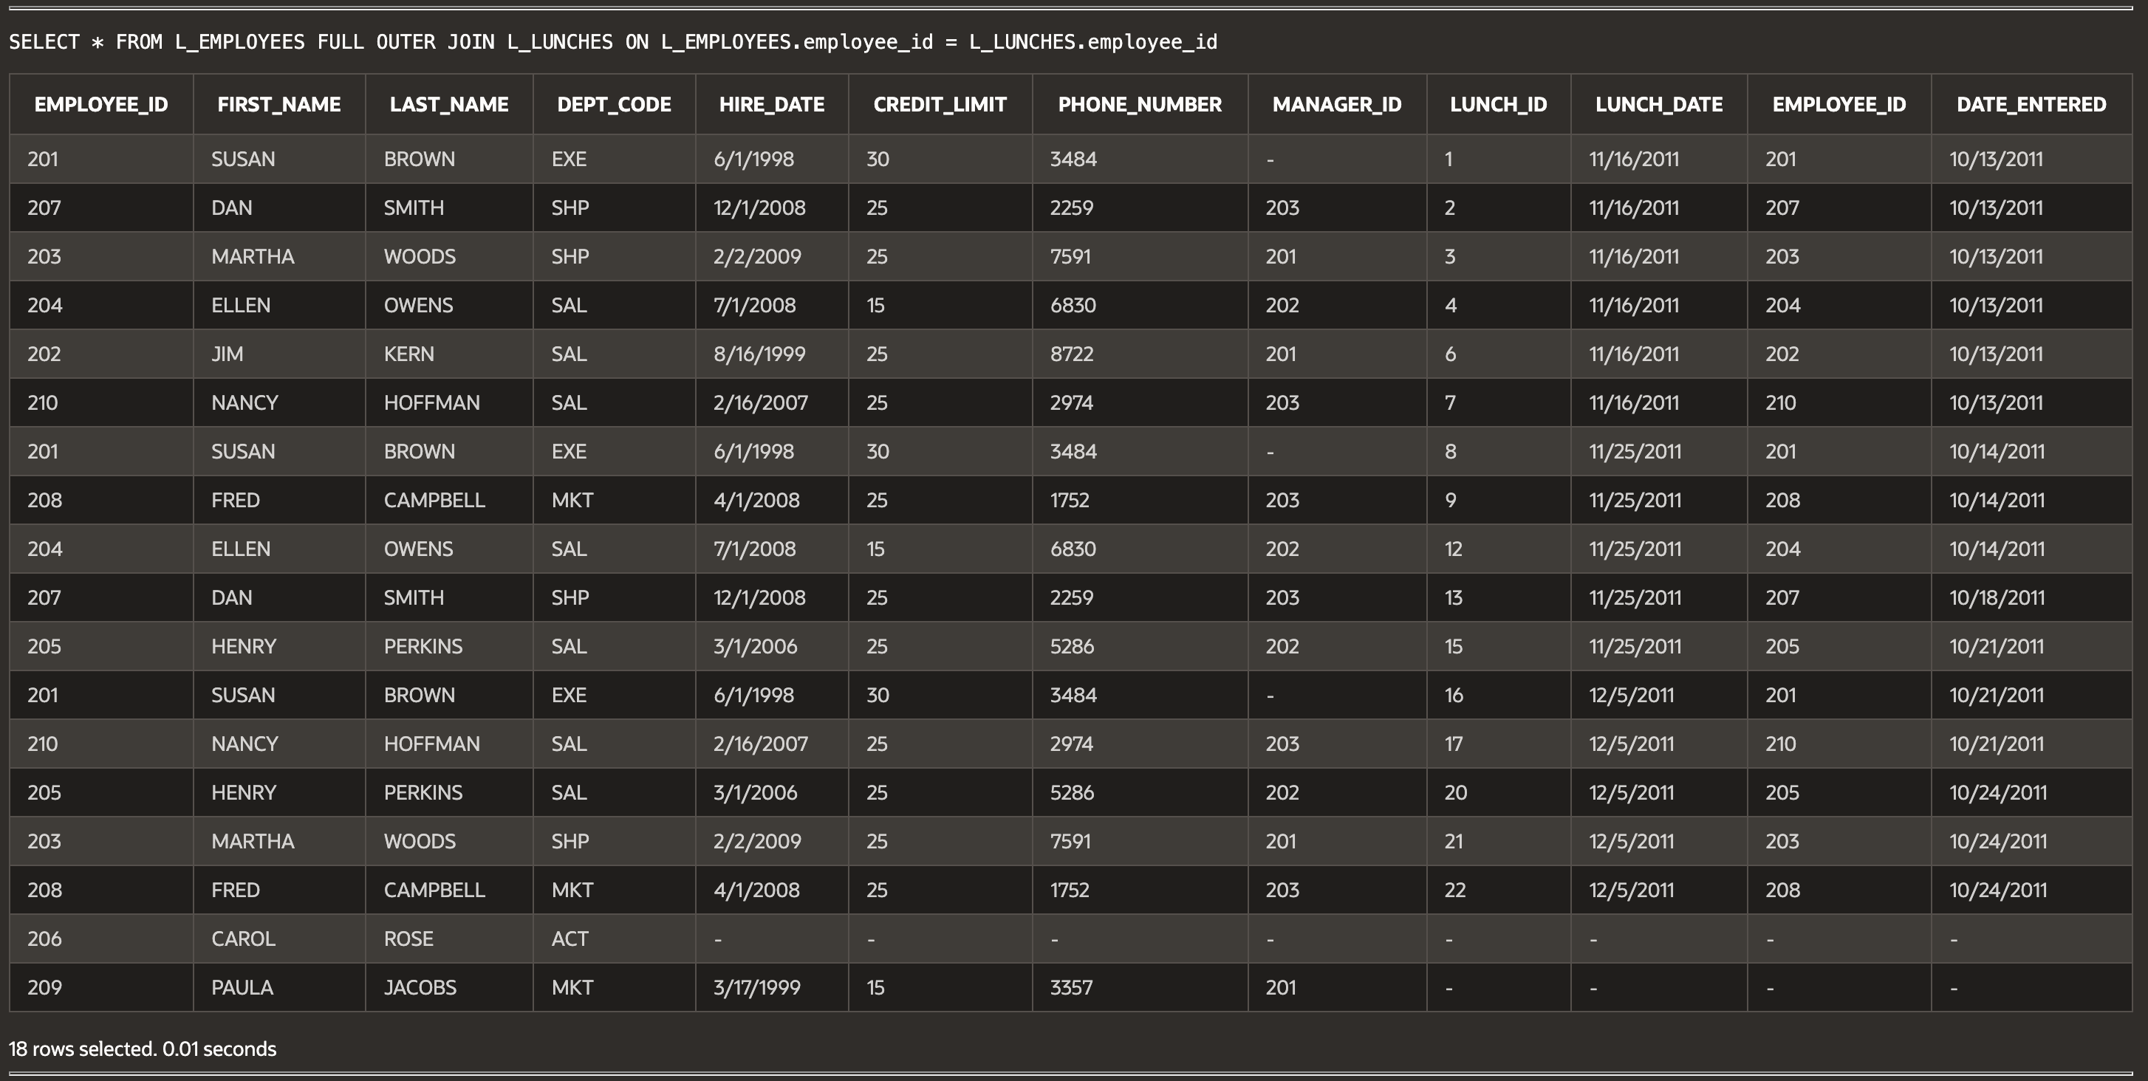

(14-9) Question 3:

Show the number of lunches each employee will attend. Start by creating a table named *sec1409*. Then select these columns: *employee_id, first_name,* and *last_name*. Group these data and summarize them to count the number of lunches each employee will attend.

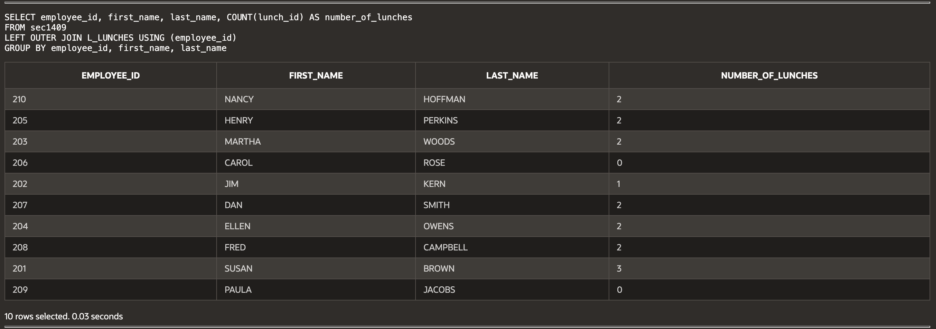

(14-10) Question 4:

Create a full outer join of the twos table and the threes table. Create a column that will sort the rows in numeric order.

(14-11) Question 5:

The table *sec1411_numbers* contains the numbers from 1 to 1,000. A few numbers are missing and a few numbers are repeated. Find all the missing numbers and all the repeated numbers. Count the number of times each of these numbers occurs. For the missing numbers, count that they occur zero times.

(14-12) Question 6:

Find the rows in the *sec1412a* table that do not exist in the *sec1412b* table.

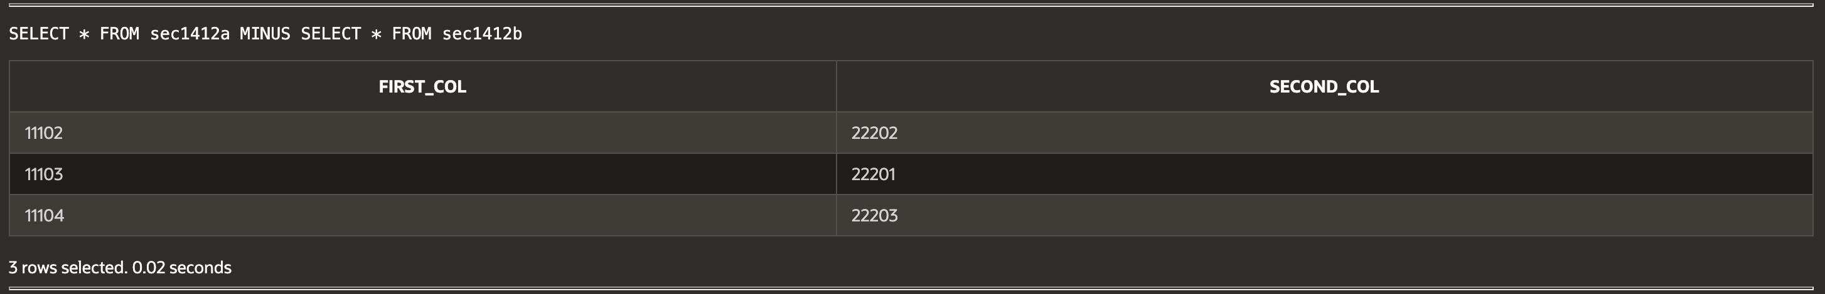

(14-13) Question 7:

Use the two tables *sec1413_fruits* and *sec1413_colors*. Form the full outer join of these tables using the join condition:

*f_num = c_num*

Then form the full outer join using the join condition:

*fruit = color*

Examine the result tables. State what is similar and what is different about these full outer joins.

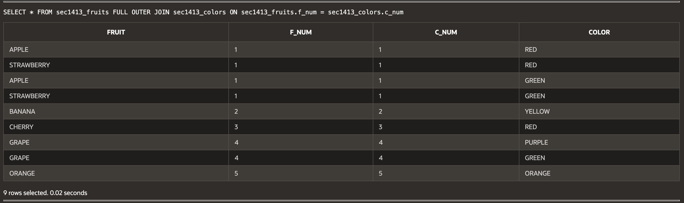

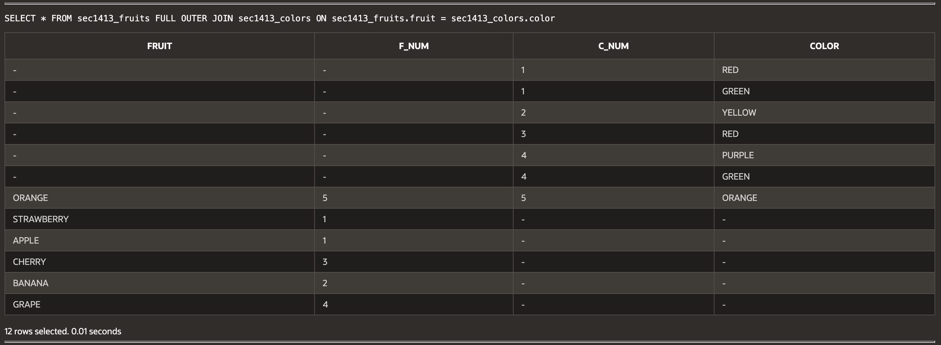  
  
**Script:**

-- W4_GP_OuterJoins2_Archer.sql

-- (14-8) Question 1: Show the number of lunches each employee will attend.

SELECT e.EMPLOYEE_ID, e.FIRST_NAME, e.LAST_NAME,

COUNT(l.LUNCH_ID) AS NUM_LUNCHES

FROM L_EMPLOYEES e

LEFT OUTER JOIN L_LUNCHES l ON e.EMPLOYEE_ID = l.EMPLOYEE_ID

GROUP BY e.EMPLOYEE_ID, e.FIRST_NAME, e.LAST_NAME

ORDER BY e.EMPLOYEE_ID;

-- (14-9) Question 2: Create an outer join of the L_EMPLOYEES table and L_LUNCHES table.

SELECT e.EMPLOYEE_ID, e.FIRST_NAME, e.LAST_NAME,

l.LUNCH_ID, l.LUNCH_DATE

FROM L_EMPLOYEES e

FULL OUTER JOIN L_LUNCHES l ON e.EMPLOYEE_ID = l.EMPLOYEE_ID

ORDER BY e.EMPLOYEE_ID, l.LUNCH_DATE;

-- (14-9) Question 3: Show the number of lunches each employee will attend (using sec1409 table).

CREATE TABLE SEC1409 AS

SELECT e.EMPLOYEE_ID, e.FIRST_NAME, e.LAST_NAME

FROM L_EMPLOYEES e;

SELECT e.EMPLOYEE_ID, e.FIRST_NAME, e.LAST_NAME,

COUNT(l.LUNCH_ID) AS NUM_LUNCHES

FROM SEC1409 e

LEFT OUTER JOIN L_LUNCHES l ON e.EMPLOYEE_ID = l.EMPLOYEE_ID

GROUP BY e.EMPLOYEE_ID, e.FIRST_NAME, e.LAST_NAME

ORDER BY e.EMPLOYEE_ID;

-- (14-10) Question 4: Create a full outer join of TWOS and THREES tables with sorting.

SELECT *

FROM TWOS FULL OUTER JOIN THREES

ON TWOS.NUMBER_2 = THREES.NUMBER_3

ORDER BY TWOS.NUMBER_2 NULLS FIRST;

-- (14-11) Question 5: Find all missing and repeated numbers in SEC1411_NUMBERS.

SELECT N, COUNT(*) AS OCCURRENCES

FROM SEC1411_NUMBERS

GROUP BY N

ORDER BY N;

-- (14-12) Question 6: Find rows in SEC1412A that do not exist in SEC1412B.

SELECT *

FROM SEC1412A

WHERE NOT EXISTS (

SELECT 1 FROM SEC1412B

WHERE SEC1412A.COLUMN1 = SEC1412B.COLUMN1

);

-- (14-13) Question 7: Perform two full outer joins on SEC1413_FRUITS and SEC1413_COLORS.

-- First join condition: f_num = c_num

SELECT *

FROM SEC1413_FRUITS f

FULL OUTER JOIN SEC1413_COLORS c

ON f.F_NUM = c.C_NUM;

-- Second join condition: fruit = color

SELECT *

FROM SEC1413_FRUITS f

FULL OUTER JOIN SEC1413_COLORS c

ON f.FRUIT = c.COLOR;