**Week 4 Performance Assessment: Inner Joins Part 1**

The following questions come from the “Check your understanding” examples of Chapter 13 in your textbook.

After you are finished, please submit a Microsoft Word file that contains your answers. In this case, since the assignments are “by hand,” you don’t have to run these in Oracle. Your document should be named **W4_PA_InnerJoins1_Lastname.docx**.

(13-3) Question 1:

**Insert a table on this document showing the result set of:** Join a row of Table 1 with a row of Table 2 if the first letters are the same. Show all the rows of both tables, even if they do not have a matching row in the other table. Create the result table and state if this is a one-to-one relationship in the mathematical sense or in the database design sense.

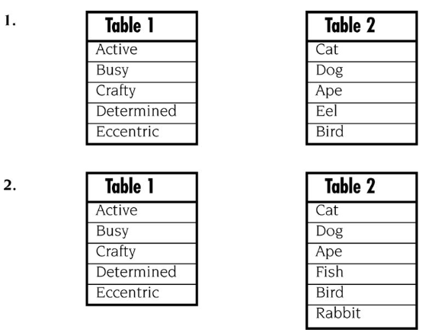

|  |  |
| --- | --- |
| **Adjective** | **Animal** |
| Active | Ape |
| Busy | Bird |
| Crafty | Cat |
| Determined | Dog |
| Eccentric | Eel |

This is a one-to-one relationship in the database design sense because each row in Table 1 is uniquely matched to one row in Table 2. There are no duplicate matches.

(13-4) Question 2:

**Insert a table on this document showing the result set of:** Join a row of Table 1 with a row of Table 2 if the first letters are the same. Create the result table and state if this is a many-to-one relationship.

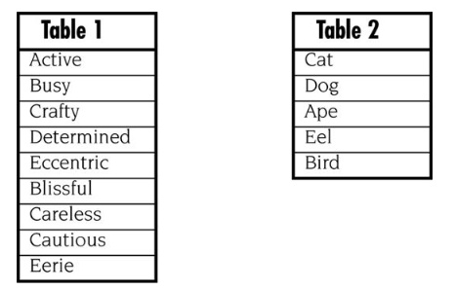

|  |  |
| --- | --- |
| Adjective | Animal |
| Active | Ape |
| Busy | Bird |
| Crafty | Cat |
| Determined | Dog |
| Eccentric | Eel |
| Blissful | Bird |
| Careless | Dog |
| Cautious | Ape |
| Eerie | Eel |

This is a many-to-one relationship because multiple adjectives (Table 1) can be associated with the same animal (Table 2). The words "Bird," "Dog," "Ape," and "Eel" appear multiple times.

(13-5) Question 3:

**Insert a table on this document showing the result set of:** Join a row of Table 1 with a row of Table 2 if the first letters are the same. Create the result table and state if this is a one-to-many relationship.

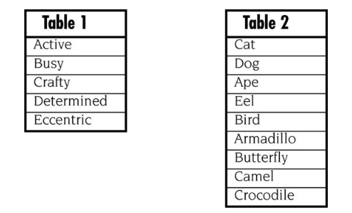

|  |  |
| --- | --- |
| Adjective | Animal |
| Active | Ape |
| Busy | Bird |
| Crafty | Cat |
| Determined | Dog |
| Eccentric | Eel |
|  | Armadillo |
|  | Butterfly |
|  | Camel |
|  | Crocodile |

This is a one-to-many relationship because some adjectives in Table 1 match multiple animals in Table 2, but there are animals with no direct match.

(13-6) Question 4:

**Insert a table on this document showing the result set of:** Join a row of Table 1 with a row of Table 2 if the first letters are the same. Create the result table and state if this is a many-to-many relationship.

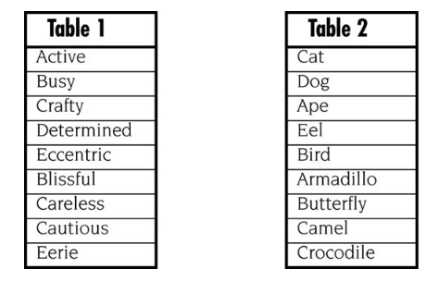

|  |  |
| --- | --- |
| Adjective | Animal |
| Active | Ape |
| Busy | Bird |
| Crafty | Cat |
| Determined | Dog |
| Eccentric | Eel |
| Blissful | Armadillo |
| Careless | Butterfly |
| Cautious | Camel |
| Eerie | Crocodile |

This is a many-to-many relationship because multiple adjectives match multiple animals, creating multiple possible combinations.

(13-8) Question 5:

Which rows from each table are unmatched and would be dropped from the inner join? Assume a row of Table 1 would be joined with a row of Table 2 if the first letters are the same.

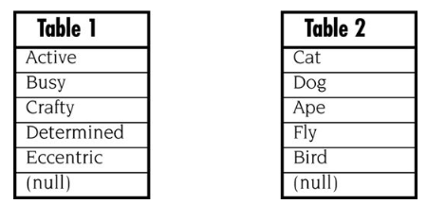

**Unmatched Rows:**

* **Table 1:** Blissful, Careless, Cautious, Eerie
* **Table 2:** Armadillo, Butterfly, Camel, Crocodile

These rows do not have a match when joined by the first letter, so they would be dropped from the result set in an inner join.

(13-9) Question 6:

**Insert a table on this document showing the result set of:** Write a *select* statement to create the inner join of these tables. Join a row of Table 1 with a row of Table 2 if the first letters are the same. Write the SQL using variation 1.

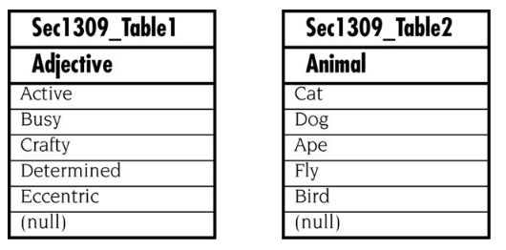

SQL Statement:  
 SELECT t1.Adjective, t2.Animal

FROM sec1309_table1 t1

INNER JOIN sec1309_table2 t2

ON SUBSTR(t1.Adjective, 1, 1) = SUBSTR(t2.Animal, 1, 1);  
  
Result:

|  |  |
| --- | --- |
| Adjective (Table 1) | Animal (Table 2) |
| Active | Ape |
| Busy | Bird |
| Crafty | Cat |
| Determined | Dog |
| Eccentric | Eel |

This inner join only includes rows where there is a match based on the first letter.