**Week 4 Performance Assessment: Inner Joins Part 2**

The following questions come from the “Check your understanding” examples of each section of chapter 13 in your textbook.

After you are finished, please submit a Microsoft Word file that contains screenshots of the SQL queries and the output, along with a comment in the query containing your name. Your document should be named **W4_PA_InnerJoins2_Lastname.docx**.

(13-10) Question 1:

Write a select statement to create the inner join of tables *sec1310_table1* and *sec1310_table2*. The join condition should say that the first three columns of these tables are equal.

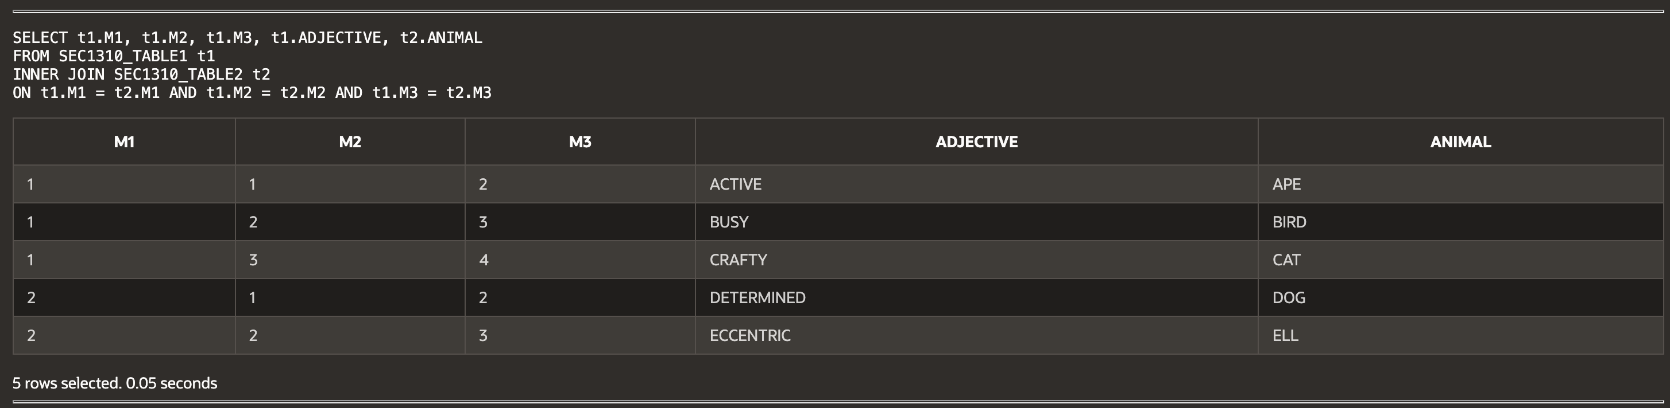

(13-11) Question 2:

A large dictionary has four volumes. Table *sec1311_dictionary* shows the range of words that are in each volume. Table *sec1311_words* contains some words that are in the dictionary. Write SQL to determine which volume of the dictionary contains each of these words.

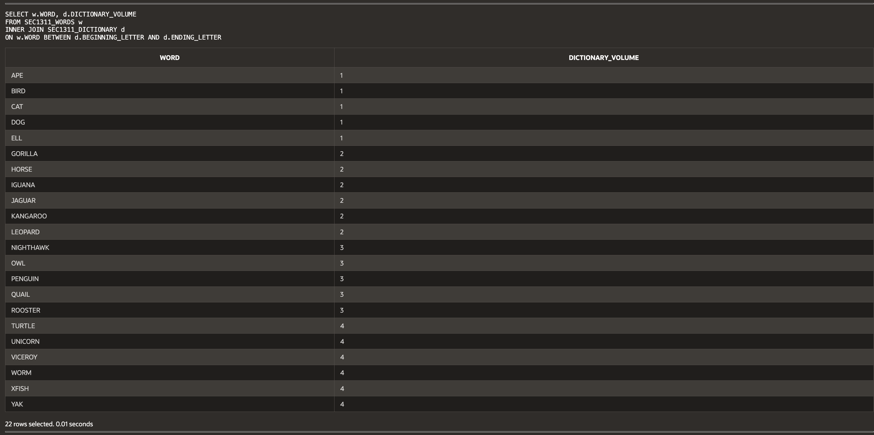

(13-12) Question 3:

List all the letters that are greater than S. Use the *alphabet* table. Put these letters in order.

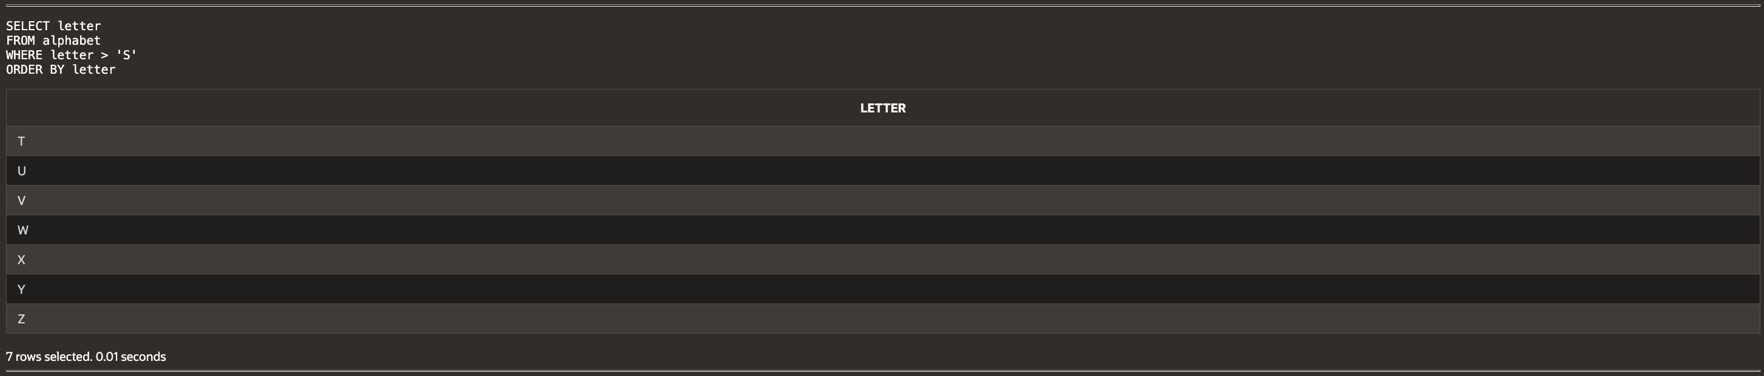

(13-13) Question 4:

Tables *sec1313_words1* and *sec1313_words2* contains words. Join these tables together when the words end in the same letter.

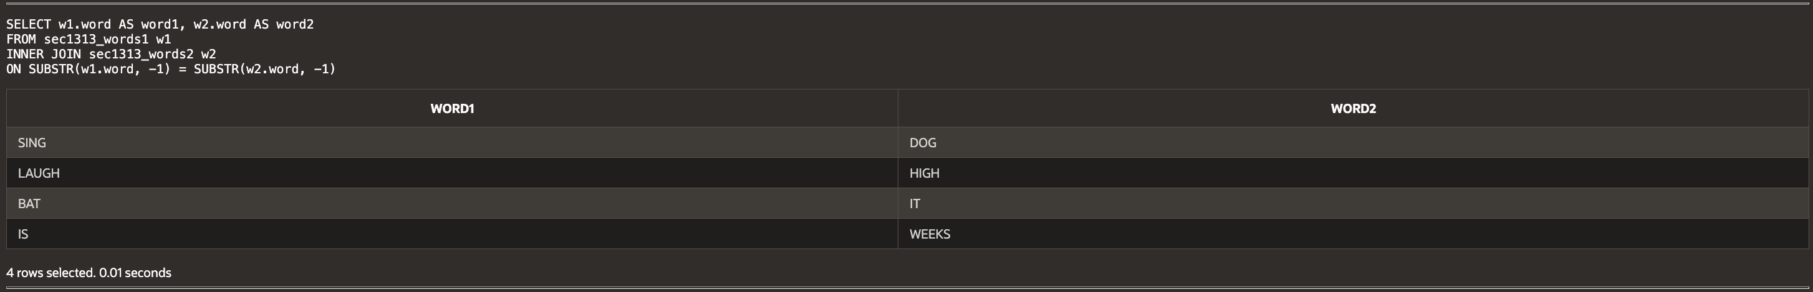

(13-14) Question 5:

Change this SQL, writing the join condition in the *from* clause.

*select a.student_name,*

*a.test_score,*

*b.letter_grade*

*from sec1311_student_scores a,*

*sec1311_grade_ranges b*

*where a.test_score between b.beginning_score*

*and b.ending_score*

*order by a.student_name;*

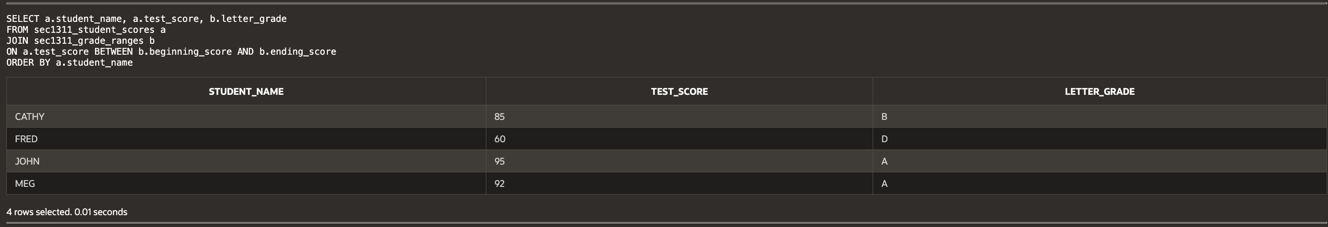

(13-15) Question 6:

Write a *select* statement to list all the foods on the lunch menu and show the full name of the supplier of each food.

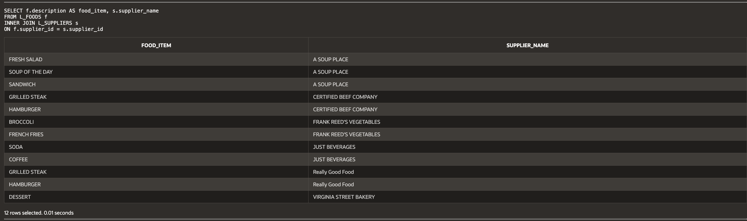

(13-16) Question 7:

Demonstrate that a *select* statement can be separated into two parts: The first part joins the tables and creates a new table, and the second part restricts the amount of data that is shown. For the following *select* statement, write two SQL statements to separate these two steps.

*select a.description,*

*b.supplier_name*

*from L_FOODS a,*

*L_SUPPLIERS b*

*where a.supplier_id = b.supplier_id*

*order* by *a.description;*

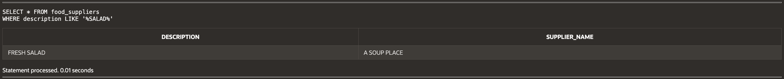

(13-17) Question 8:

List all the foods on the menu and the total number of orders for each food item. (Note that broccoli does not show up in the result because no one has ordered it.)

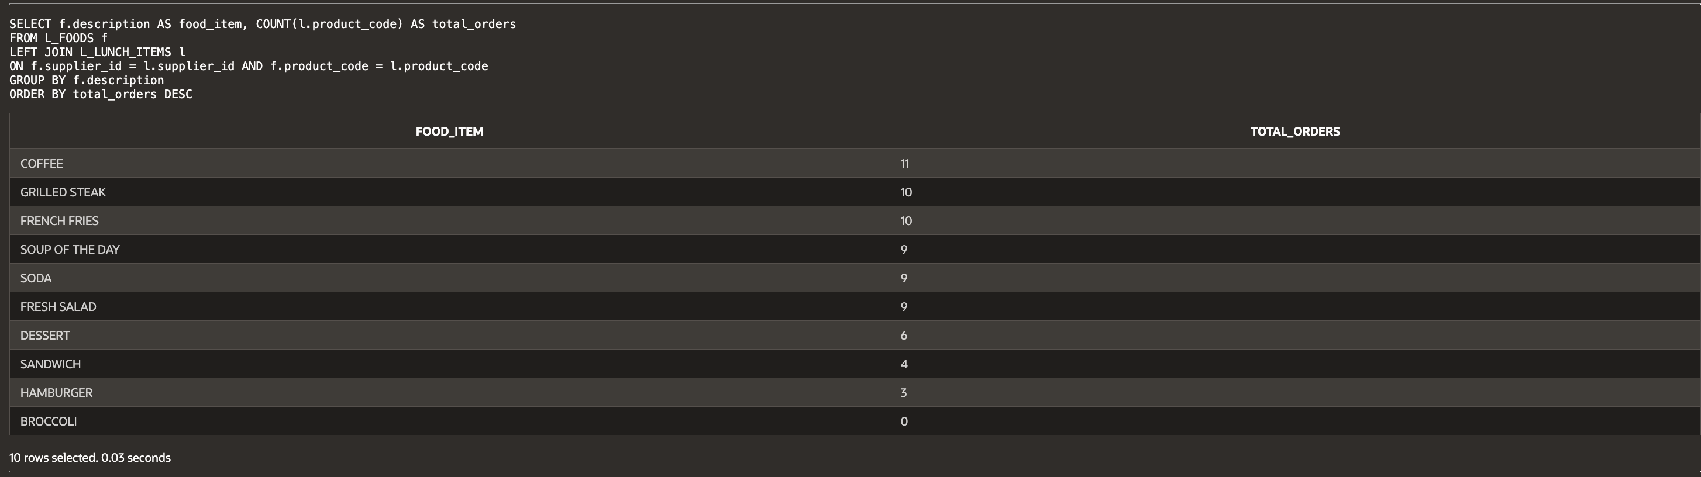

(13-19) Question 9:

Join all the tables of the *lunches* database together (Anything table starting with *L_*). Show all the columns of each table. To do this, modify the *select* statement in this section and add the three other tables to it. How many rows and columns are in this table?

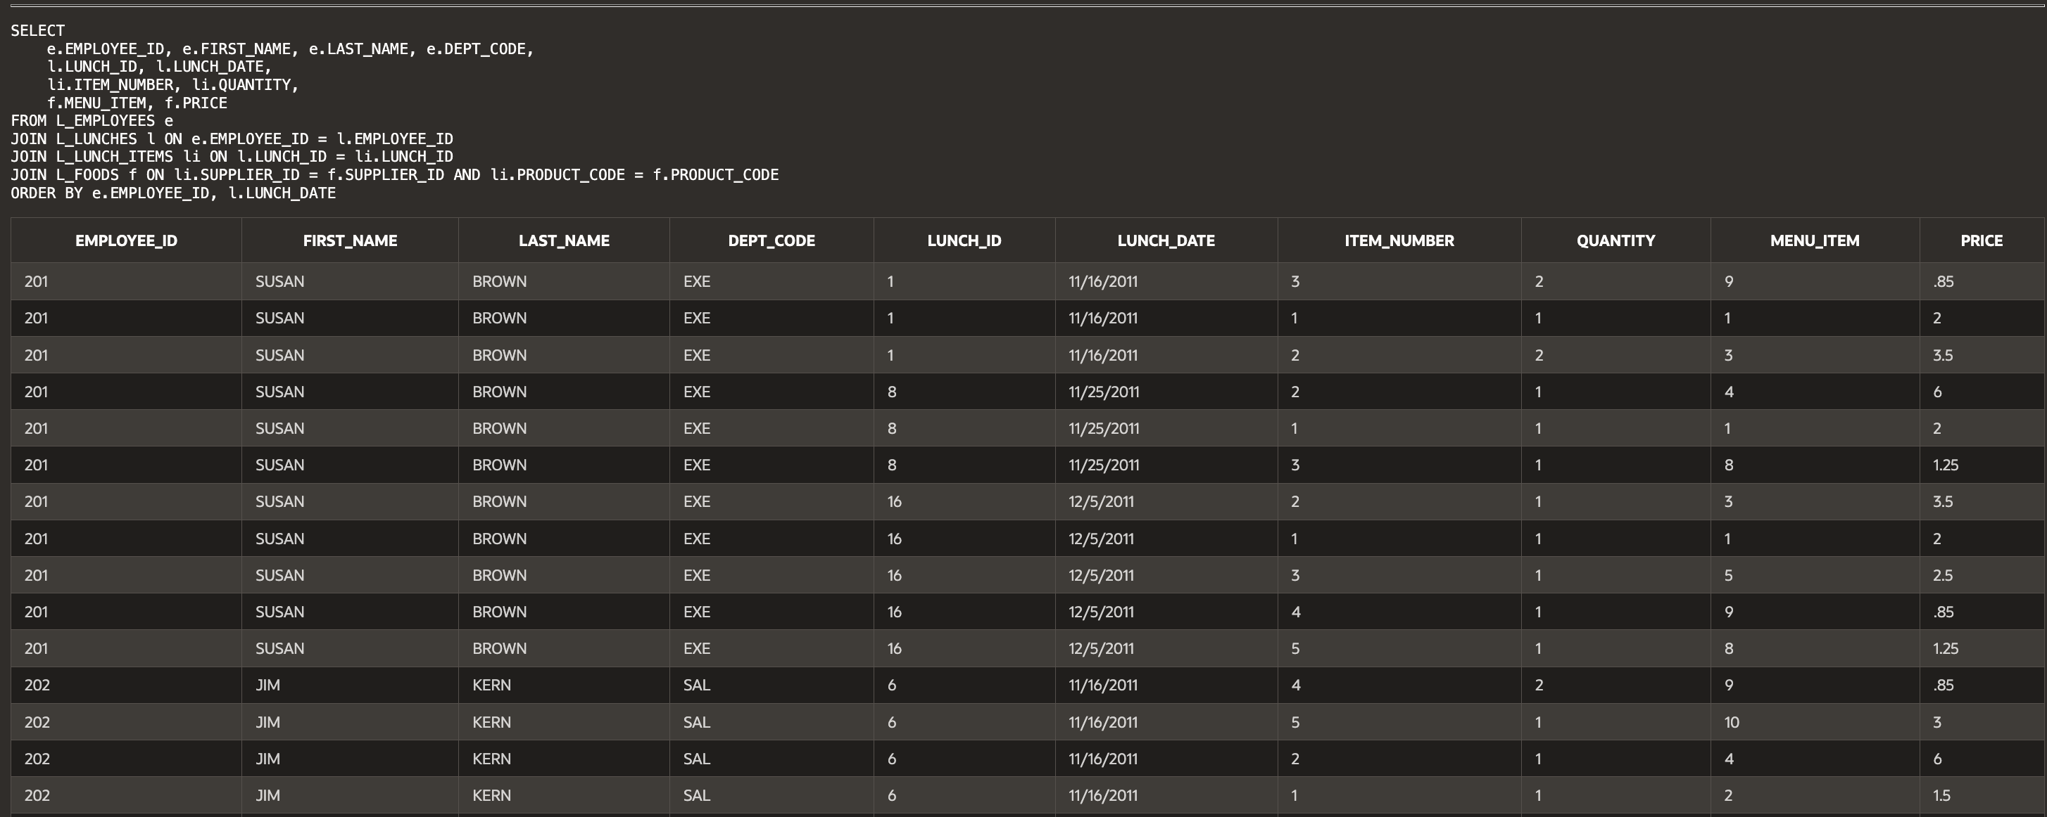...

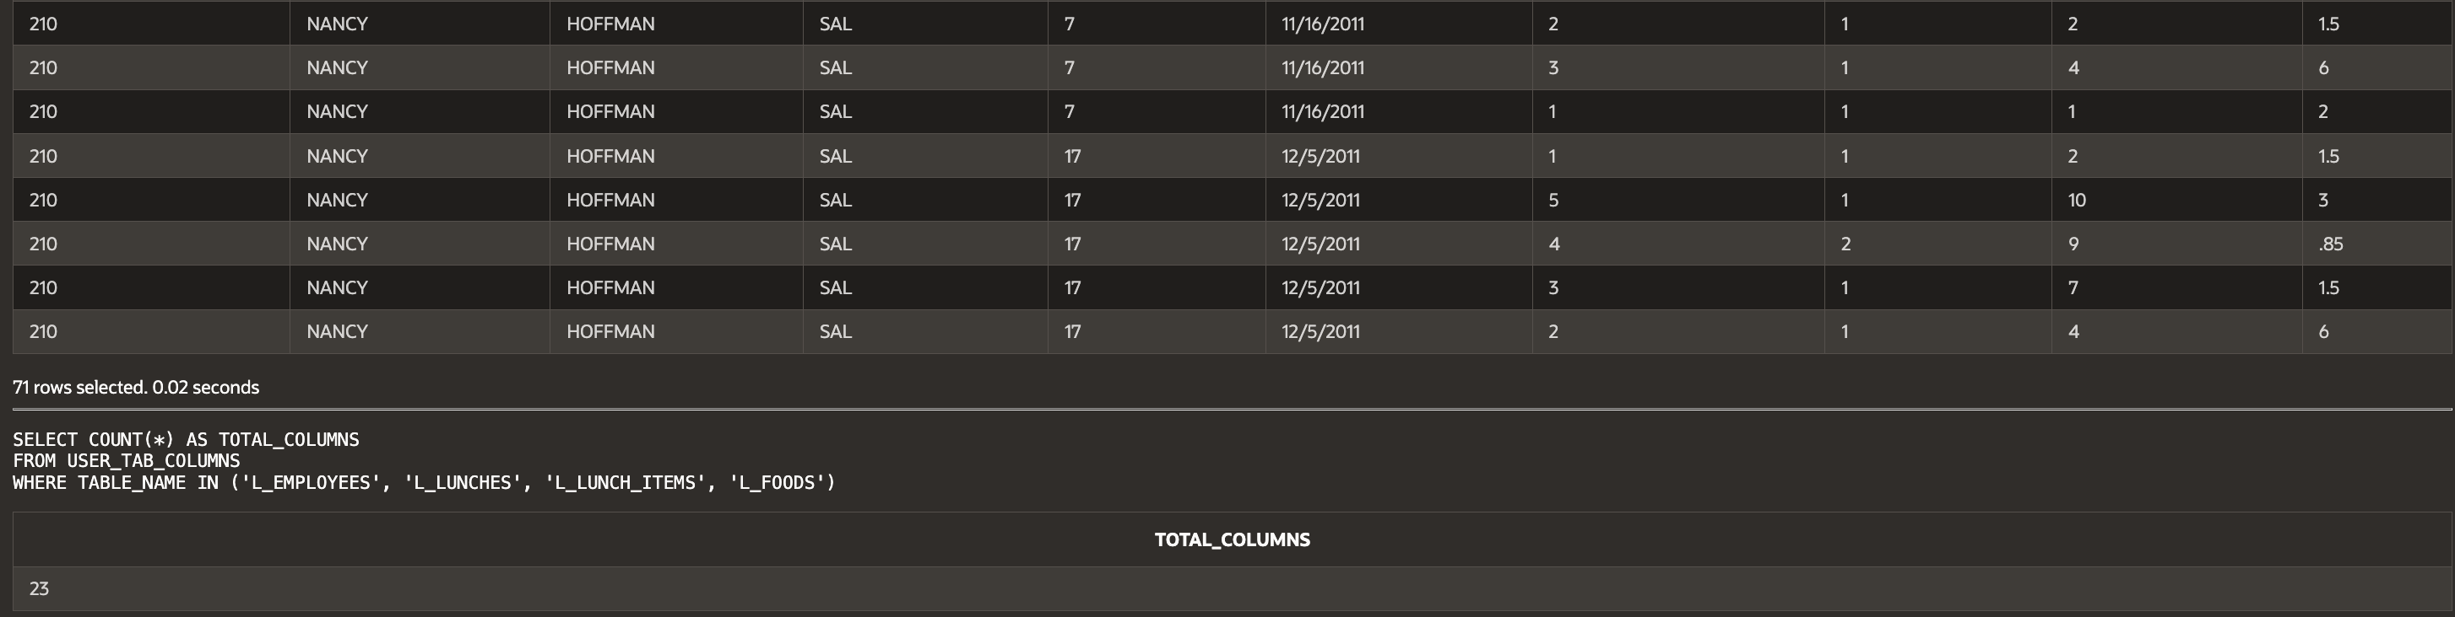

**Script:**

-- Haley Archer

-- (13-10) Question 1:

-- Write a select statement to create the inner join of tables sec1310_table1 and sec1310_table2.

-- The join condition should say that the first three columns of these tables are equal.

SELECT t1.M1, t1.M2, t1.M3, t1.ADJECTIVE, t2.ANIMAL

FROM SEC1310_TABLE1 t1

INNER JOIN SEC1310_TABLE2 t2

ON t1.M1 = t2.M1 AND t1.M2 = t2.M2 AND t1.M3 = t2.M3;

-- (13-11) Question 2:

-- A large dictionary has four volumes. Table sec1311_dictionary shows the range of words that are in each volume.

-- Table sec1311_words contains some words that are in the dictionary. Write SQL to determine which volume of the dictionary contains each of these words.

SELECT w.WORD, d.DICTIONARY_VOLUME

FROM SEC1311_WORDS w

INNER JOIN SEC1311_DICTIONARY d

ON w.WORD BETWEEN d.BEGINNING_LETTER AND d.ENDING_LETTER;

-- (13-12) Question 3:

-- List all the letters that are greater than S. Use the alphabet table. Put these letters in order.

SELECT letter

FROM alphabet

WHERE letter > 'S'

ORDER BY letter;

-- (13-13) Question 4:

-- Tables sec1313_words1 and sec1313_words2 contain words.

-- Join these tables together when the words end in the same letter.

SELECT w1.word AS word1, w2.word AS word2

FROM sec1313_words1 w1

INNER JOIN sec1313_words2 w2

ON SUBSTR(w1.word, -1) = SUBSTR(w2.word, -1);

-- (13-14) Question 5:

-- Change this SQL, writing the join condition in the from clause.

SELECT a.student_name, a.test_score, b.letter_grade

FROM sec1311_student_scores a

JOIN sec1311_grade_ranges b

ON a.test_score BETWEEN b.beginning_score AND b.ending_score

ORDER BY a.student_name;

-- (13-15) Question 6:

-- Write a select statement to list all the foods on the lunch menu and show the full name of the supplier of each food.

SELECT f.description AS food_item, s.supplier_name

FROM L_FOODS f

INNER JOIN L_SUPPLIERS s

ON f.supplier_id = s.supplier_id;

-- (13-16) Question 7:

-- Demonstrate that a select statement can be separated into two parts:

-- The first part joins the tables and creates a new table, and the second part restricts the amount of data that is shown.

-- Step 1: Create the joined table

CREATE VIEW food_suppliers AS

SELECT f.description, s.supplier_name

FROM L_FOODS f

INNER JOIN L_SUPPLIERS s

ON f.supplier_id = s.supplier_id;

-- Step 2: Restrict the data shown

SELECT * FROM food_suppliers

WHERE description LIKE '%SALAD%';

-- (13-17) Question 8:

-- List all the foods on the menu and the total number of orders for each food item.

SELECT f.description AS food_item, COUNT(l.product_code) AS total_orders

FROM L_FOODS f

LEFT JOIN L_LUNCH_ITEMS l

ON f.supplier_id = l.supplier_id AND f.product_code = l.product_code

GROUP BY f.description

ORDER BY total_orders DESC;

-- (13-19) Question 9:

-- Join all the tables of the lunches database together (Anything table starting with L_).

-- Show only the most relevant columns to avoid excessive duplication.

SELECT

e.EMPLOYEE_ID, e.FIRST_NAME, e.LAST_NAME, e.DEPT_CODE,

l.LUNCH_ID, l.LUNCH_DATE,

li.ITEM_NUMBER, li.QUANTITY,

f.MENU_ITEM, f.PRICE

FROM L_EMPLOYEES e

JOIN L_LUNCHES l ON e.EMPLOYEE_ID = l.EMPLOYEE_ID

JOIN L_LUNCH_ITEMS li ON l.LUNCH_ID = li.LUNCH_ID

JOIN L_FOODS f ON li.SUPPLIER_ID = f.SUPPLIER_ID AND li.PRODUCT_CODE = f.PRODUCT_CODE

ORDER BY e.EMPLOYEE_ID, l.LUNCH_DATE;

-- Count the total number of columns

SELECT COUNT(*) AS TOTAL_COLUMNS

FROM USER_TAB_COLUMNS

WHERE TABLE_NAME IN ('L_EMPLOYEES', 'L_LUNCHES', 'L_LUNCH_ITEMS', 'L_FOODS');