**Week 4 Performance Assessment: Outer Joins Part 1**

The following questions come from the Check your understanding examples of each section of chapter 14 in your textbook.

After you are finished, please submit the Microsoft Word file that contains screenshots of the SQL script and the resulting tables. Your document should be named **W4_PA_OuterJoins1_Lastname.docx**.

(14-3) Question 1:

The following *select* statement shows all the employees who are in each department. First run this code as it is—as an inner join. Then change it to a left outer join. What is the difference in the result tables?

*select a.department_name,*

*b.first_name,*

*b.last_name*

*from L_DEPARTMENTS a,*

*L_EMPLOYEES b*

*where a.dept_code = b.dept_code;*

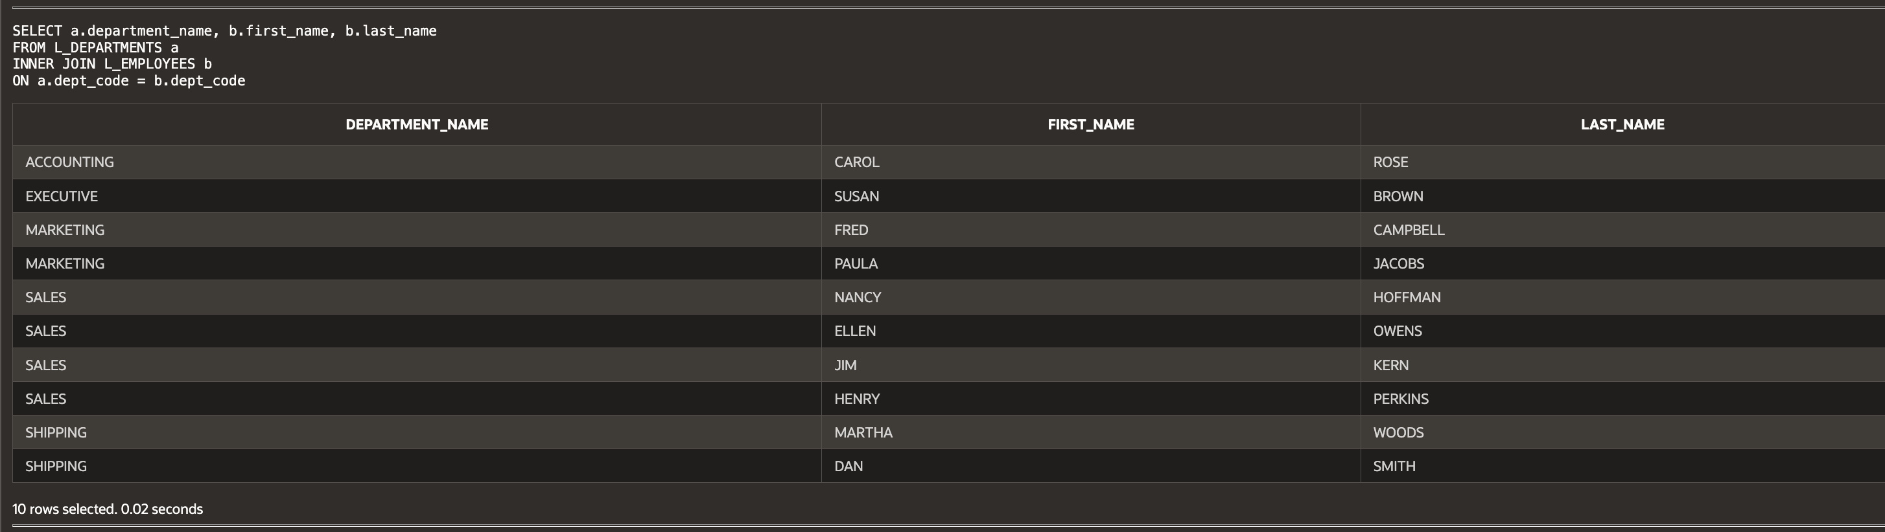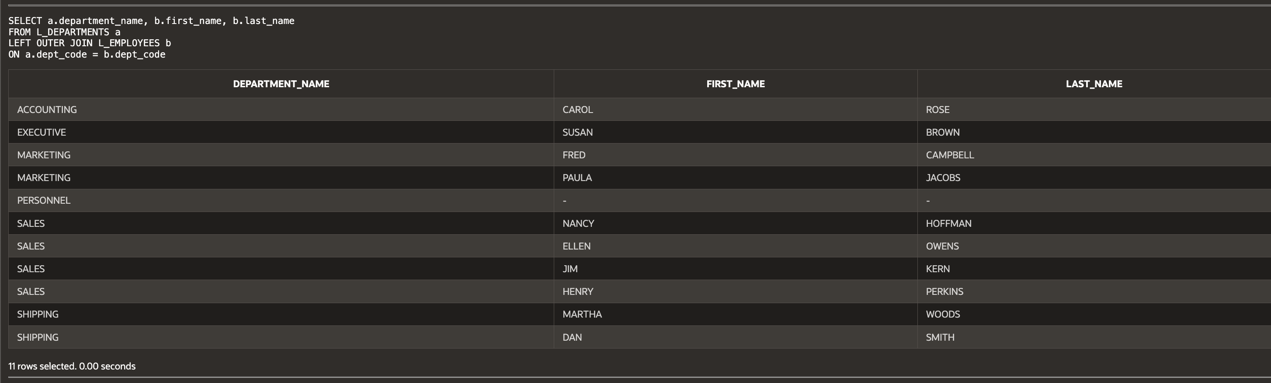Difference: The LEFT OUTER JOIN includes all departments, while the INNER JOIN only includes those with employees.

(14-4) Question 2:

This is a modification of the exercise in **section 14-3**. The only thing that has been changed is the order of the tables in the *from* clause. First run this code as it is—as an inner join. Then change this select statement to a right outer join. What is the difference in the result tables?

*select a.department_name,*

*b.first_name,*

*b.last_name*

*from L_EMPLOYEES b,*

*L_DEPARTMENTS a*

*where a.dept_code = b.dept_code;*

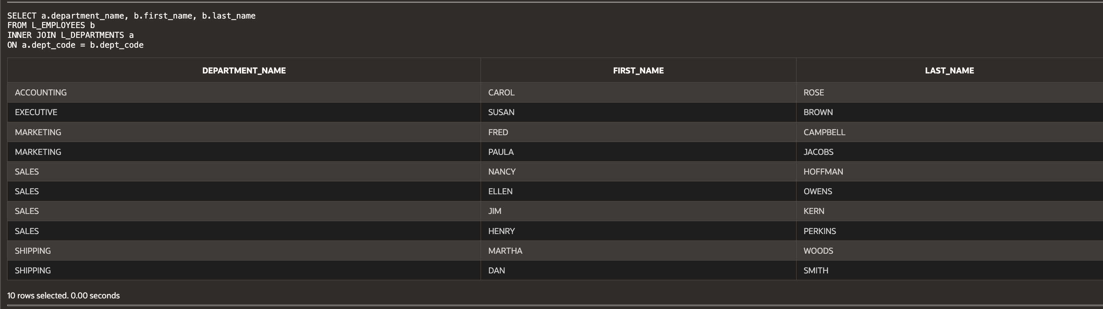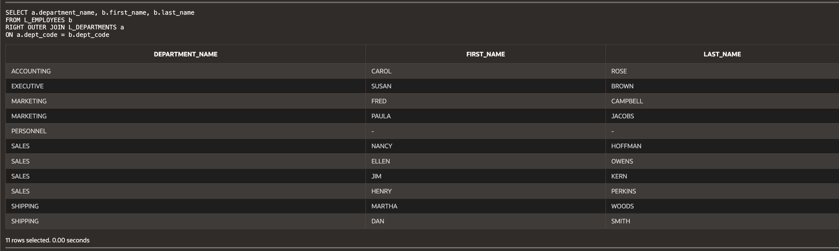Difference: The RIGHT OUTER JOIN includes all departments, even those without employees, similar to the LEFT OUTER JOIN but from the opposite perspective.

(14-5) Question 3:

This is a modification of the exercise in **section 14-3**. The only thing that has changed is that table *sec1405_employees* replaces table *L_EMPLOYEES*. The new table contains one new employee who has not been assigned to any department yet. First run this code as it is—as an inner join. Then change this *select* statement to a full outer join. What is the difference in the result tables?

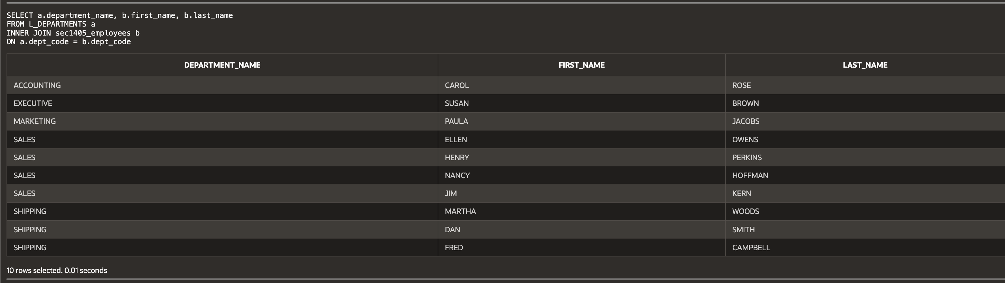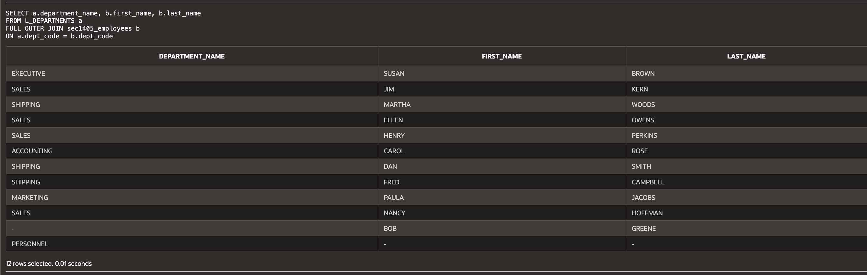Difference: The FULL OUTER JOIN ensures that all employees and all departments are included, regardless of whether they have a match.

(14-7) Question 4:

The table *sec1407_departments* has the same format as the *L_DEPARTMENTS* table. Write a *select* statement that shows the union of the two tables.

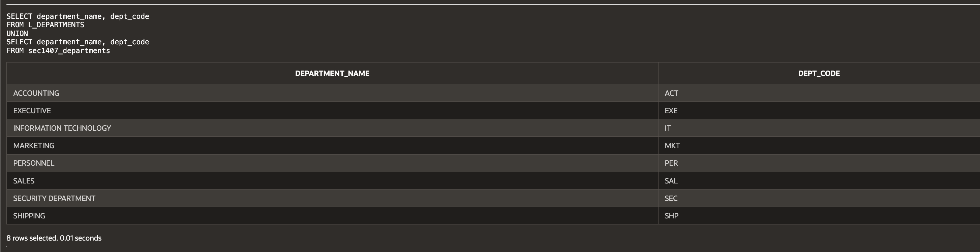

**Script:**

-- Haley Archer

-- (14-3) Question 1:

-- The following select statement shows all the employees who are in each department.

-- First run this code as it is—as an inner join. Then change it to a left outer join.

-- What is the difference in the result tables?

SELECT a.department_name, b.first_name, b.last_name

FROM L_DEPARTMENTS a

INNER JOIN L_EMPLOYEES b

ON a.dept_code = b.dept_code;

-- Left Outer Join Version:

SELECT a.department_name, b.first_name, b.last_name

FROM L_DEPARTMENTS a

LEFT OUTER JOIN L_EMPLOYEES b

ON a.dept_code = b.dept_code;

-- (14-4) Question 2:

-- This is a modification of the exercise in section 14-3.

-- The only thing that has been changed is the order of the tables in the from clause.

-- First run this code as it is—as an inner join.

-- Then change this select statement to a right outer join.

SELECT a.department_name, b.first_name, b.last_name

FROM L_EMPLOYEES b

INNER JOIN L_DEPARTMENTS a

ON a.dept_code = b.dept_code;

-- Right Outer Join Version:

SELECT a.department_name, b.first_name, b.last_name

FROM L_EMPLOYEES b

RIGHT OUTER JOIN L_DEPARTMENTS a

ON a.dept_code = b.dept_code;

-- (14-5) Question 3:

-- This is a modification of the exercise in section 14-3.

-- The only thing that has changed is that table sec1405_employees replaces table L_EMPLOYEES.

-- The new table contains one new employee who has not been assigned to any department yet.

-- First run this code as it is—as an inner join.

-- Then change this select statement to a full outer join.

SELECT a.department_name, b.first_name, b.last_name

FROM L_DEPARTMENTS a

INNER JOIN sec1405_employees b

ON a.dept_code = b.dept_code;

-- Full Outer Join Version:

SELECT a.department_name, b.first_name, b.last_name

FROM L_DEPARTMENTS a

FULL OUTER JOIN sec1405_employees b

ON a.dept_code = b.dept_code;

-- (14-7) Question 4:

-- The table sec1407_departments has the same format as the L_DEPARTMENTS table.

-- Write a select statement that shows the union of the two tables.

SELECT department_name, dept_code

FROM L_DEPARTMENTS

UNION

SELECT department_name, dept_code

FROM sec1407_departments;