**Week 4 Performance Assessment: Outer Joins Part 2**

The following questions come from the “Check your understanding” examples of Chapter 14 in your textbook.

After you are finished, please submit a Microsoft Word file that contains screenshots of the SQL queries, the output, and a comment in the query file with your name. Your document should be named **W4_PA_OuterJoins2_Lastname.docx**.

(14-8) Question 1:

The following *select* statement shows the number of orders for each food on the menu. Modify the SQL so the result table shows that there are no orders for broccoli.

*select a.description as food_item,*

*sum(b.quantity) as number_of_orders*

*from L_FOODS a,*

*L_LUNCH_ITEMS b*

*where a.supplier_id = b.supplier_id*

*and a.product_code = b.product_code*

*group by a.description*

*order by a.description;*

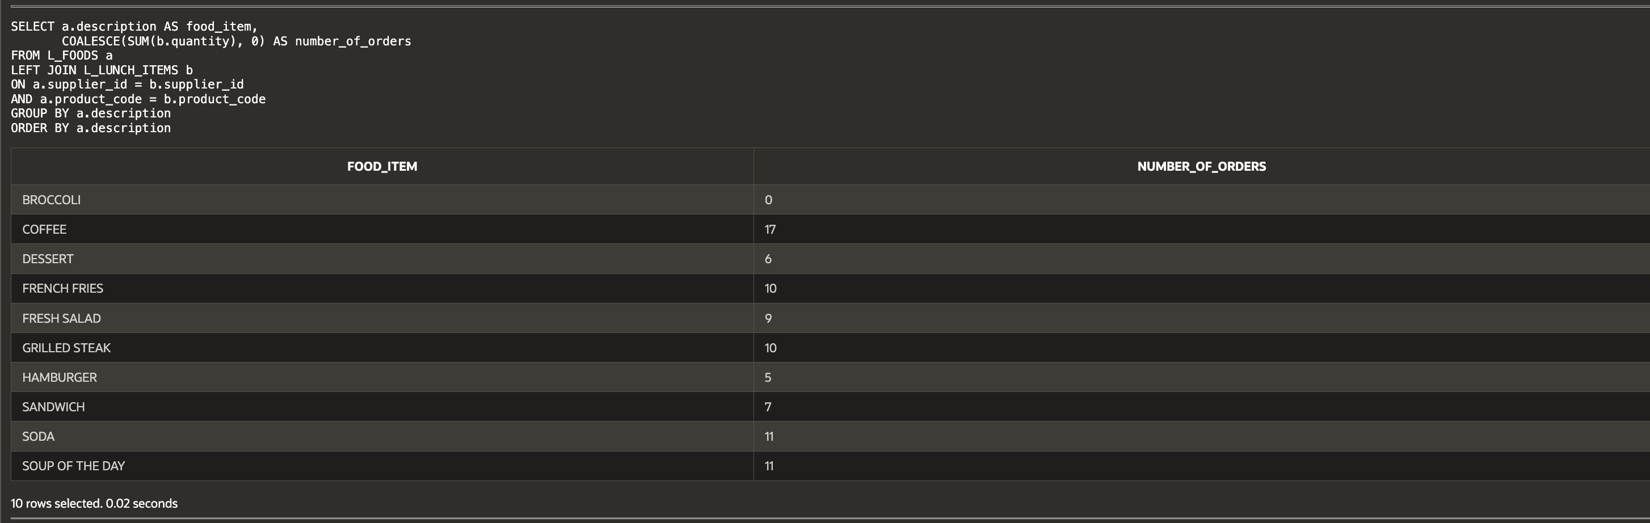

(14-12) Question 2:

The table *sec1412_departments* is similar to the *L_DEPARTMENTS*table, except that a few rows have been added, deleted, or changed. Find all the differences between the two tables.

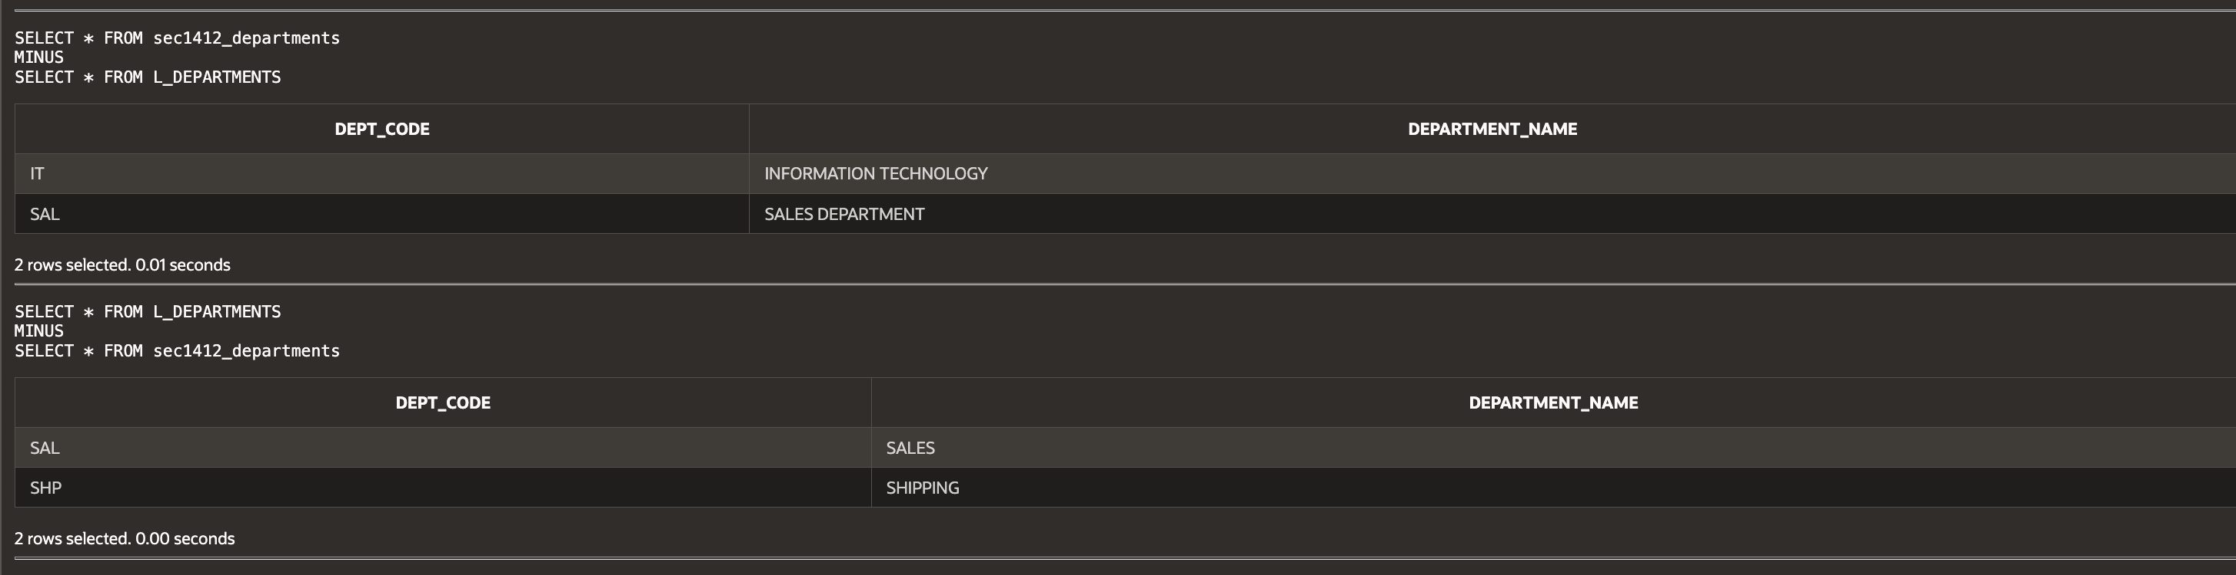

**Script:**

-- Haley Archer

-- (14-8) Question 1:

-- The following select statement shows the number of orders for each food on the menu.

-- Modify the SQL so the result table shows that there are no orders for broccoli.

SELECT a.description AS food_item,

COALESCE(SUM(b.quantity), 0) AS number_of_orders

FROM L_FOODS a

LEFT JOIN L_LUNCH_ITEMS b

ON a.supplier_id = b.supplier_id

AND a.product_code = b.product_code

GROUP BY a.description

ORDER BY a.description;

-- (14-12) Question 2:

-- The table sec1412_departments is similar to the L_DEPARTMENTS table,

-- except that a few rows have been added, deleted, or changed.

-- Find all the differences between the two tables.

SELECT * FROM sec1412_departments

MINUS

SELECT * FROM L_DEPARTMENTS;

SELECT * FROM L_DEPARTMENTS

MINUS

SELECT * FROM sec1412_departments;