**Week 4 Guided Practice: Outer Joins Part 1**

The following questions come from the Task examples in Chapter 14 in your textbook.

After you are finished, please submit a Microsoft Word file that contains screenshots of the SQL Queries, the output, and put a comment line in the query with your last name. Your document should be named **W4_GP_OuterJoins1_Lastname.docx**.

(14-1) Question 1:

Show the inner join of the *twos* table and the *threes* table. Make a list of the rows of the beginning tables that are dropped from the result table.

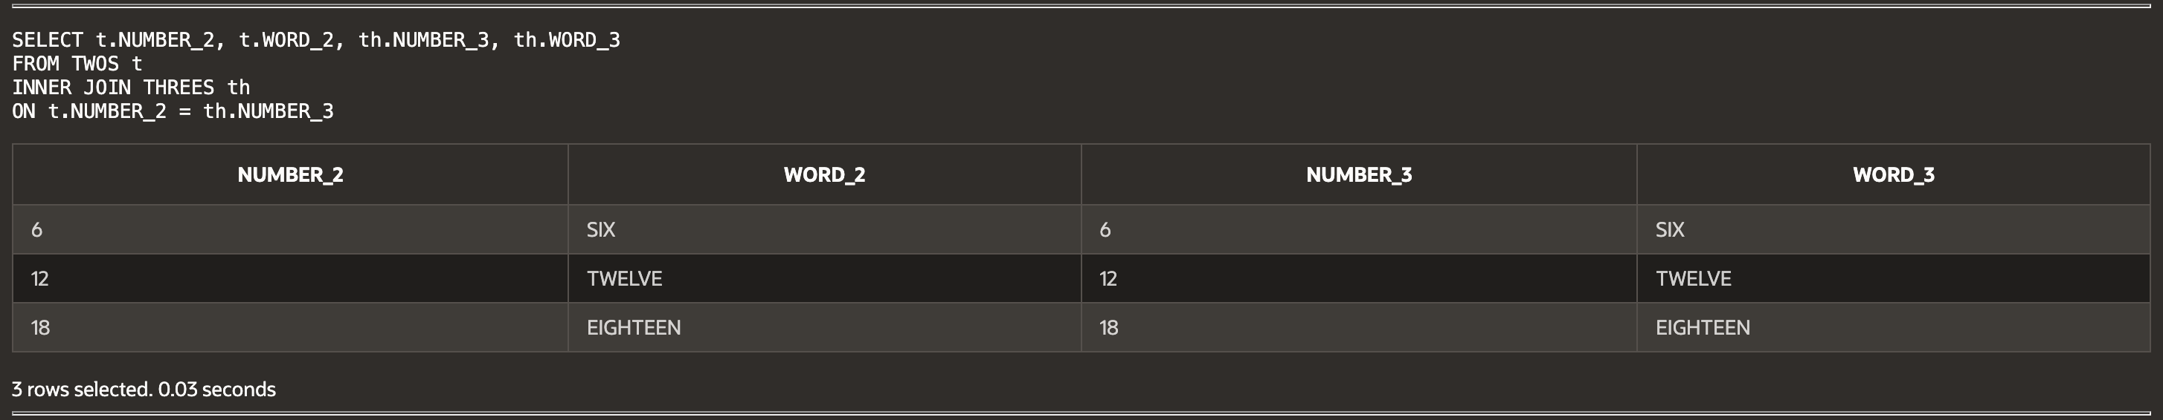

(14-2) Question 2:

For the *twos* table and the *threes* table, show the results of the three types of outer joins.

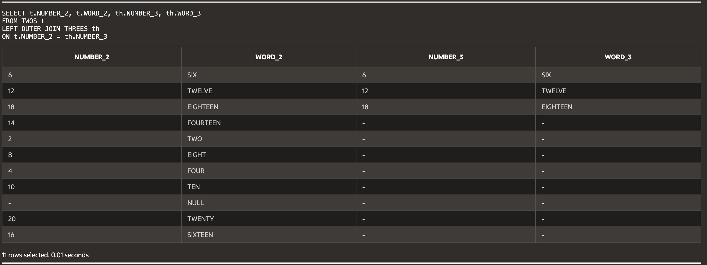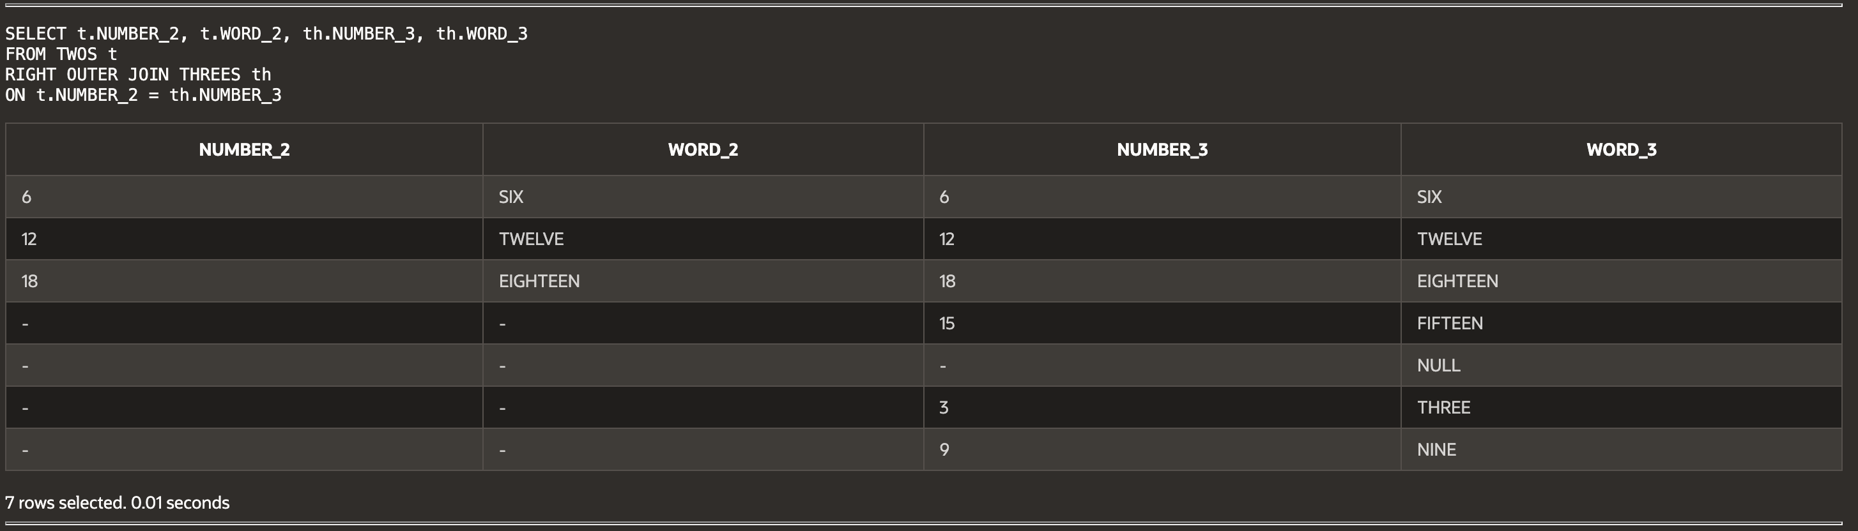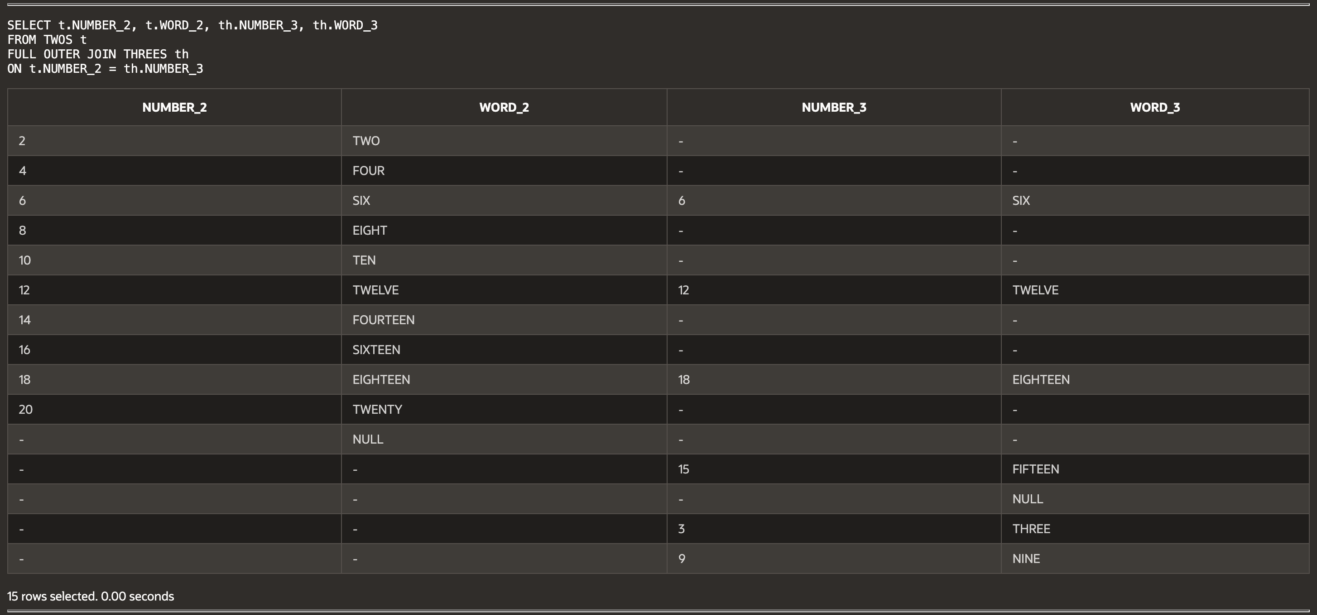

(14-3) Question 3:

Show the syntax to write a left outer join.

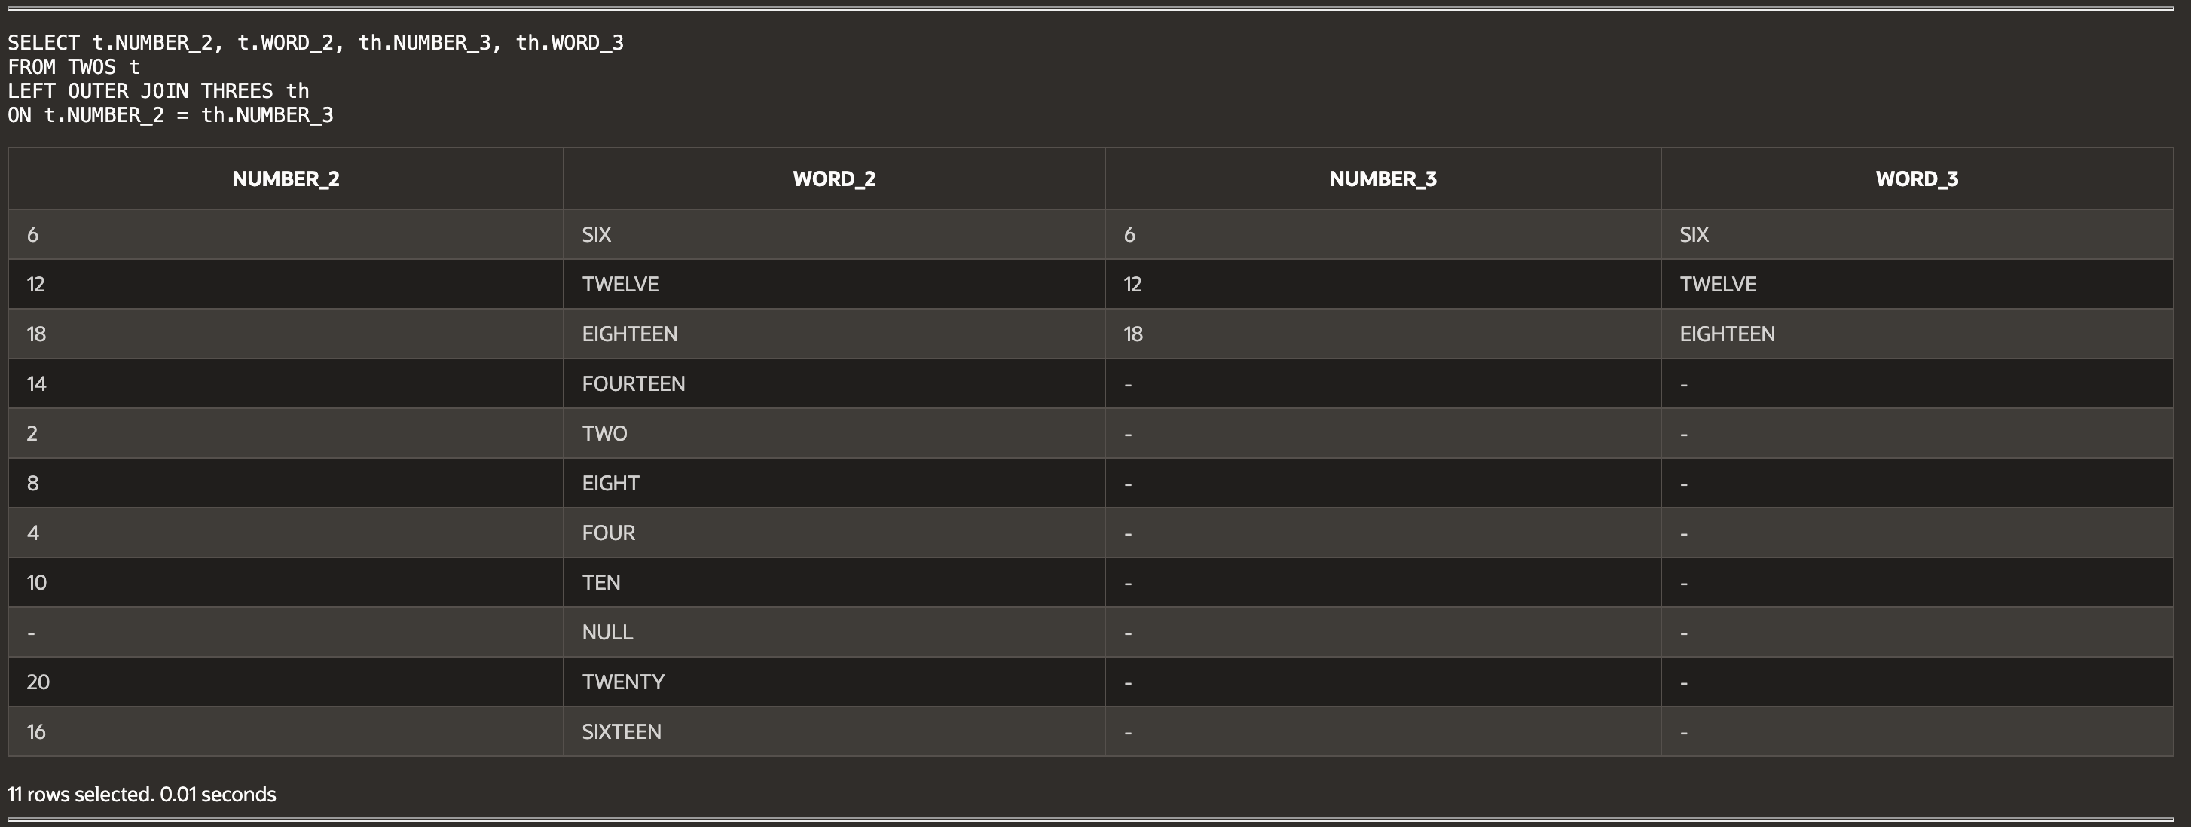

(14-4) Question 4:

Show the syntax to write a right outer join.

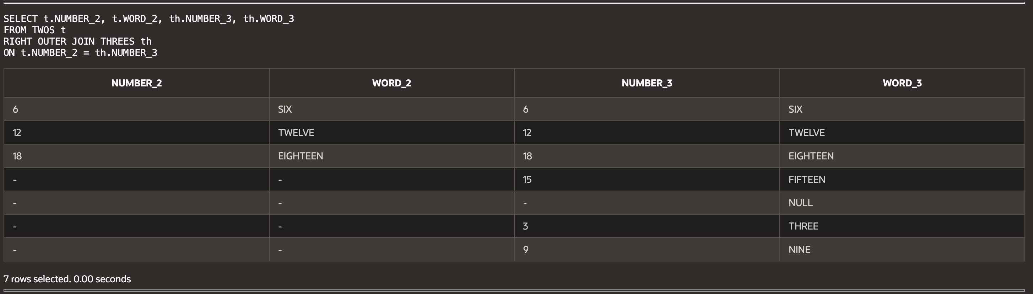

(14-5) Question 5:

Show the syntax to write a full outer join.

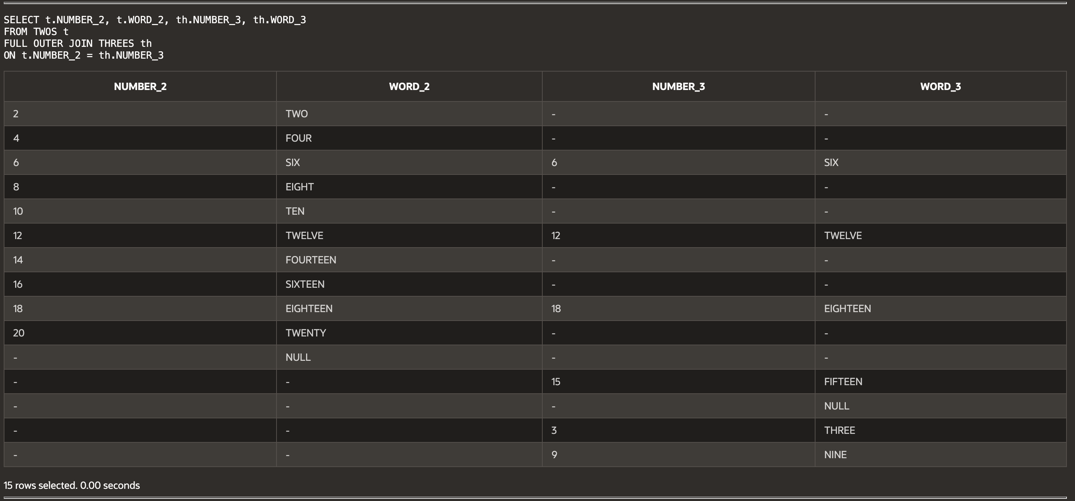

(14-6) Question 6:

Show how to write a *union* in SQL. Show the *select* statement for the preceding diagram. Write the *select* statement so that its result table is table C in the diagram.

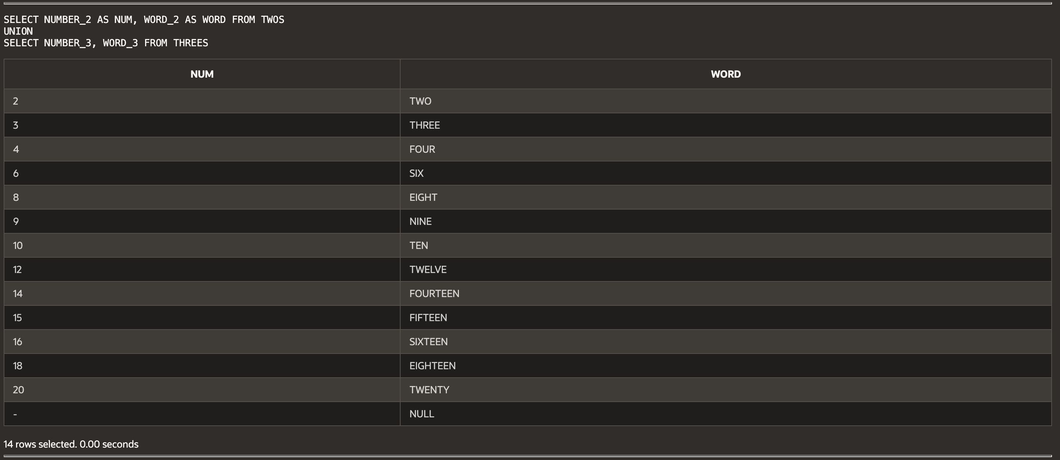

(14-6) Question 7:

Show another way to write the SQL for the preceding diagram. Write this SQL to create table C as a new table.



(14-7) Question 8:

Show an example of a *select* statement that uses a *union*.

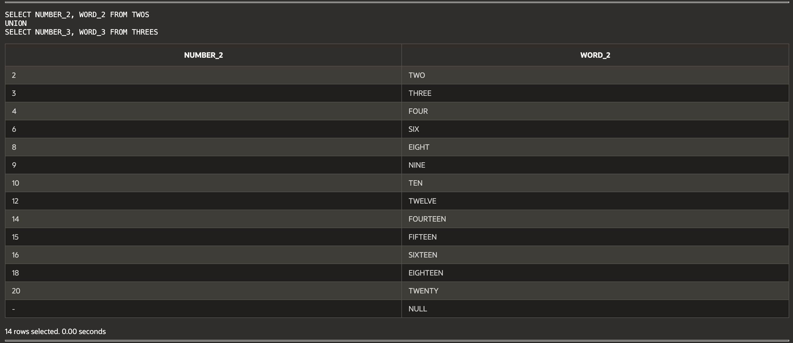  
  
  
**Script:**

-- W4_GP_OuterJoins1_Archer.sql

-- Haley Archer

-- (14-1) Inner Join of TWOS and THREES

SELECT t.NUMBER_2, t.WORD_2, th.NUMBER_3, th.WORD_3

FROM TWOS t

INNER JOIN THREES th

ON t.NUMBER_2 = th.NUMBER_3;

-- (14-2) Left, Right, and Full Outer Joins

-- Left Outer Join

SELECT t.NUMBER_2, t.WORD_2, th.NUMBER_3, th.WORD_3

FROM TWOS t

LEFT OUTER JOIN THREES th

ON t.NUMBER_2 = th.NUMBER_3;

-- Right Outer Join

SELECT t.NUMBER_2, t.WORD_2, th.NUMBER_3, th.WORD_3

FROM TWOS t

RIGHT OUTER JOIN THREES th

ON t.NUMBER_2 = th.NUMBER_3;

-- Full Outer Join

SELECT t.NUMBER_2, t.WORD_2, th.NUMBER_3, th.WORD_3

FROM TWOS t

FULL OUTER JOIN THREES th

ON t.NUMBER_2 = th.NUMBER_3;

-- (14-3) Syntax for Left Outer Join

SELECT t.NUMBER_2, t.WORD_2, th.NUMBER_3, th.WORD_3

FROM TWOS t

LEFT OUTER JOIN THREES th

ON t.NUMBER_2 = th.NUMBER_3;

-- (14-4) Syntax for Right Outer Join

SELECT t.NUMBER_2, t.WORD_2, th.NUMBER_3, th.WORD_3

FROM TWOS t

RIGHT OUTER JOIN THREES th

ON t.NUMBER_2 = th.NUMBER_3;

-- (14-5) Syntax for Full Outer Join

SELECT t.NUMBER_2, t.WORD_2, th.NUMBER_3, th.WORD_3

FROM TWOS t

FULL OUTER JOIN THREES th

ON t.NUMBER_2 = th.NUMBER_3;

-- (14-6) Writing a UNION in SQL

SELECT NUMBER_2 AS NUM, WORD_2 AS WORD FROM TWOS

UNION

SELECT NUMBER_3, WORD_3 FROM THREES;

-- (14-7) Creating TableC with UNION

CREATE TABLE TABLEC AS

SELECT NUMBER_2 AS NUM, WORD_2 AS WORD FROM TWOS

UNION

SELECT NUMBER_3, WORD_3 FROM THREES;

-- (14-8) Example of a SELECT with UNION

SELECT NUMBER_2, WORD_2 FROM TWOS

UNION

SELECT NUMBER_3, WORD_3 FROM THREES;