**SDC250 Final Exam**

For each question, fill in one SQL statement, and a screen shot of the output. Please paste the answers below the questions in this document.

Good Luck!

1. Using the course table, find all the courses that cost less than the average course price. Show description, course_no, and cost in your results. Order by cost in descending order. Make sure your cost is in $9,999 format <Hint: Use the to_char statement to format your answer>

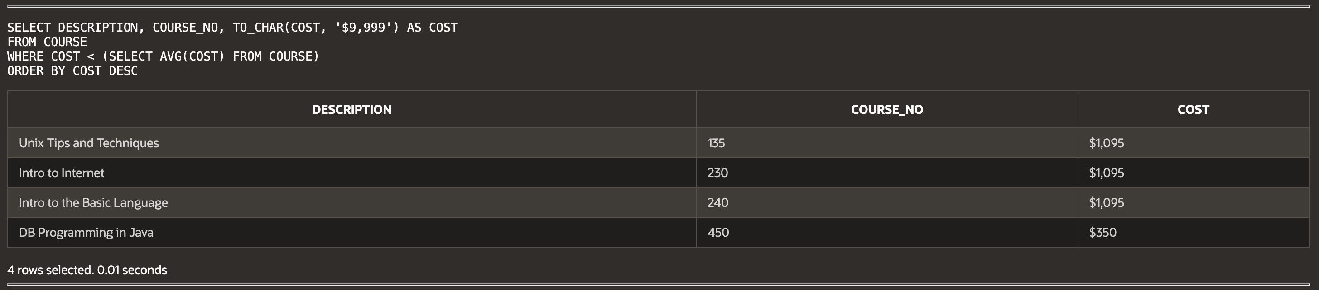

1. Using the course and section tables, list all the courses and their corresponding sections. Show course_no, description, cost, start_date_time in your results. Order your results by course_no, then description. Make sure that your course_no, description, and cost do not duplicate in the display of your results.

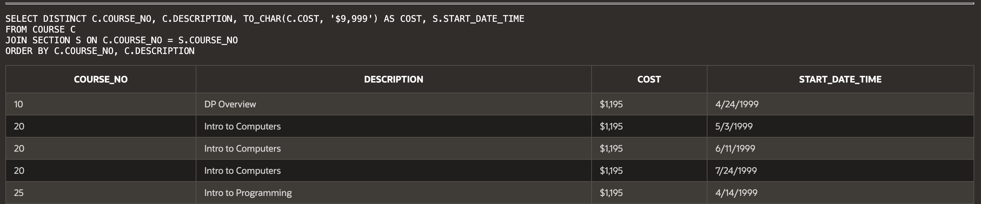...

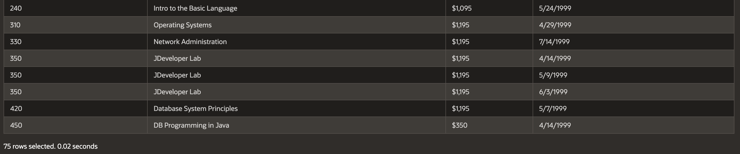

1. Using the zipcode and instructor table, show all the zipcodes and the count of instructors that live in those zipcodes.

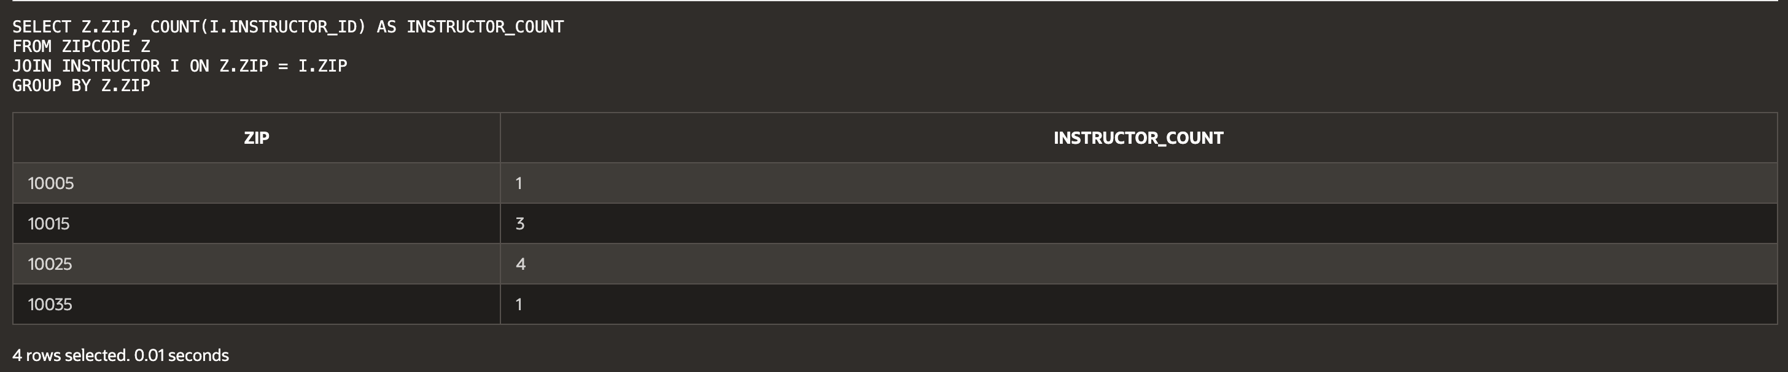

1. Using the zipcode and student table, show all the students that live in Brooklyn. Show student_id, first_name, last_name, street_address, state, and zip in your results. Order your results by last_name, then first_name.

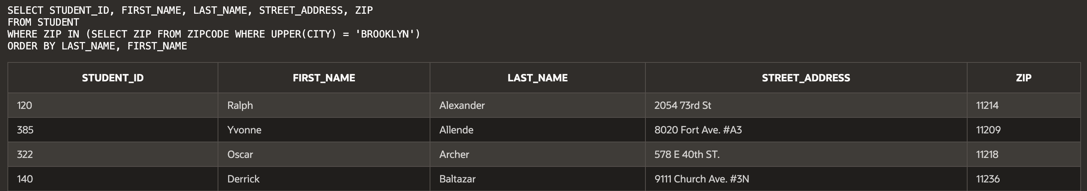...

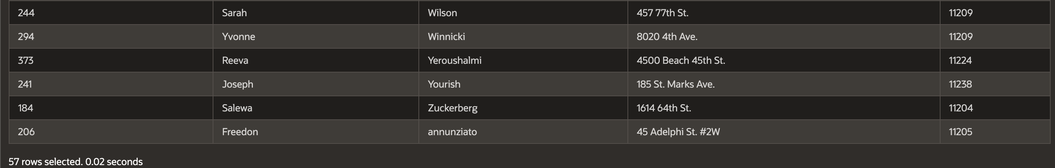

1. Using the instructor and section table, list all the instructors and the number of sections they teach. Show first_name, last_name, and the number of sections they teach. Order your results by the number of sections in descending order.

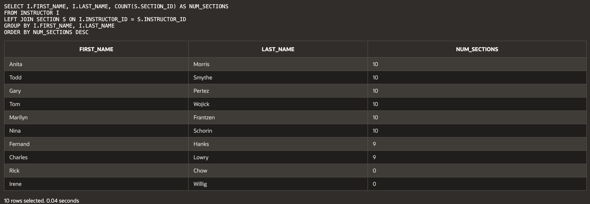

1. List all the students who live in the same zipcode as the instructor Tom Wojick. Show first_name, last_name, street_address and zip in your results.

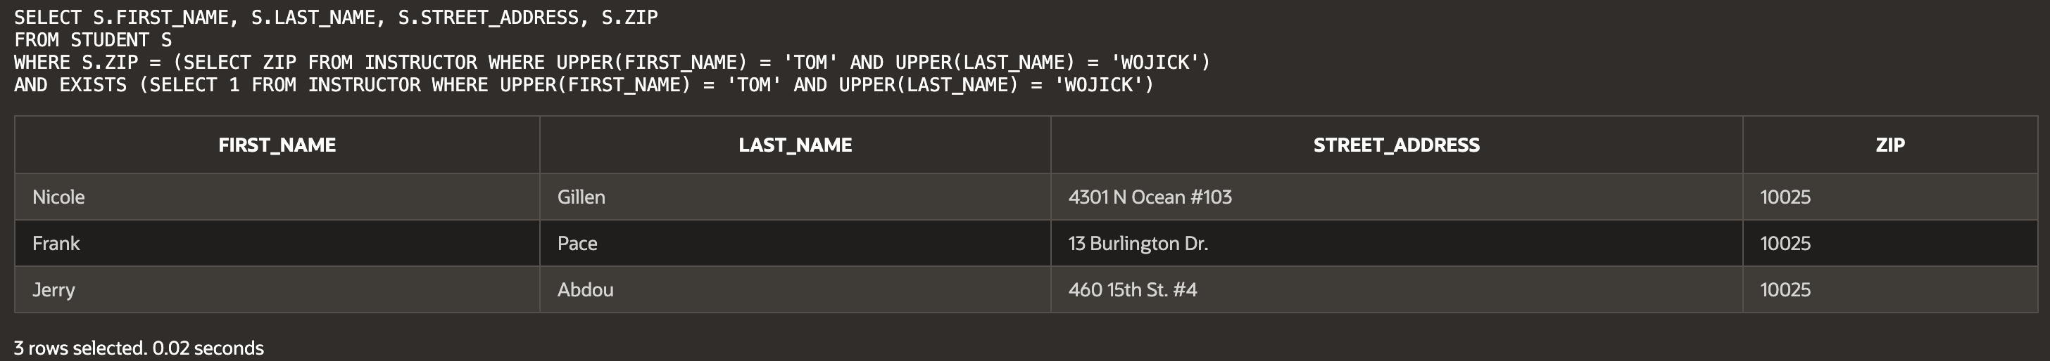

1. List all the students who registered before Vera Wetcel. Show student_id, salutation, first_name, and last_name in your results.

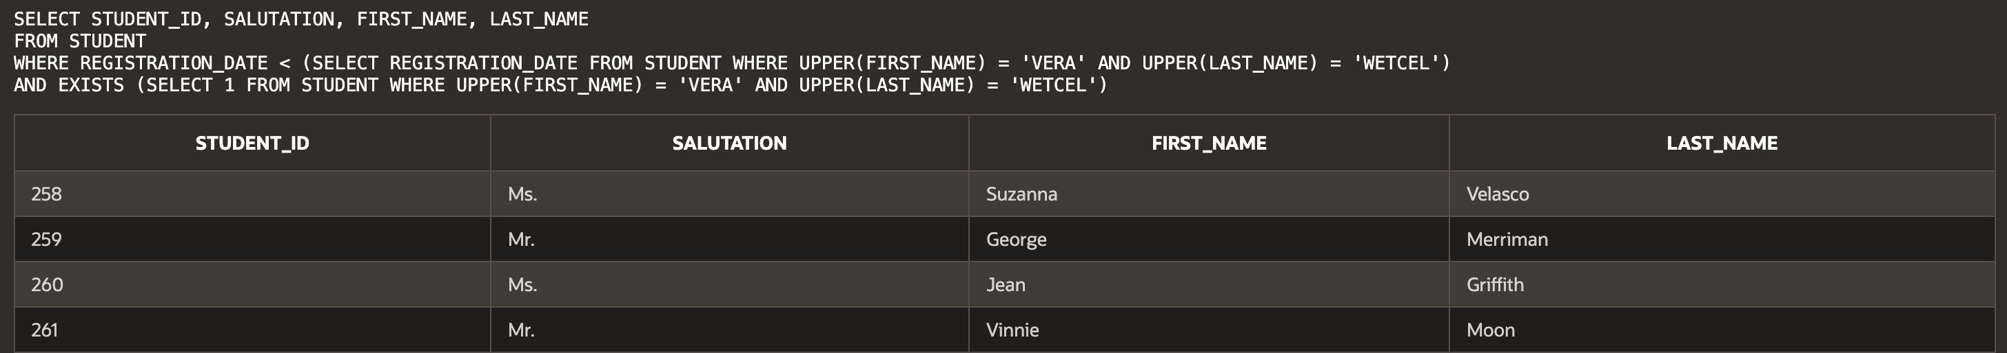...

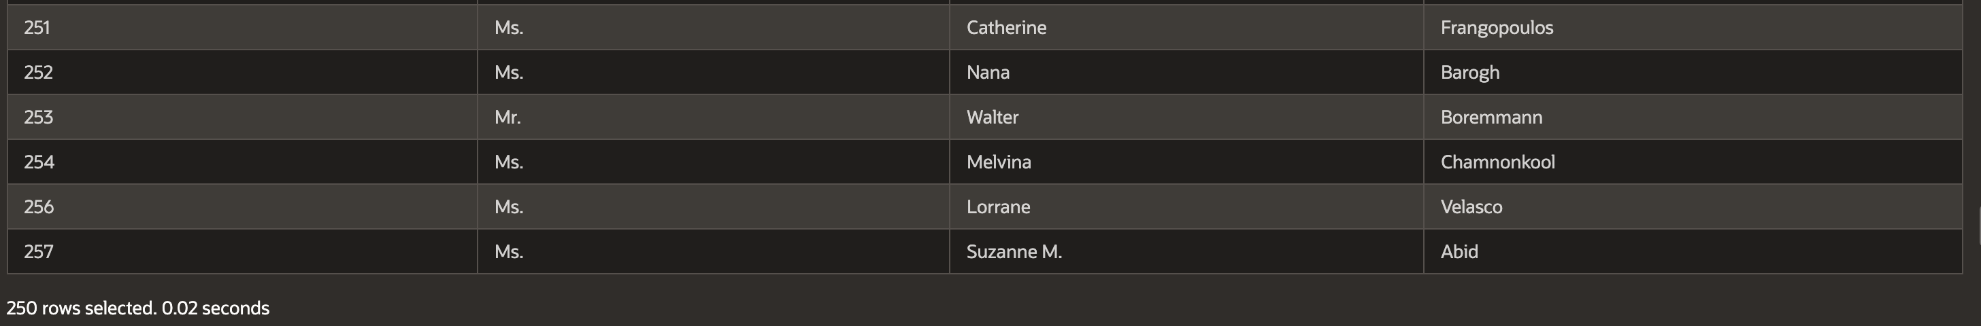

1. Using the student and enrollment table, find all the students who haven’t enrolled in any classes. Show student_id in your results.

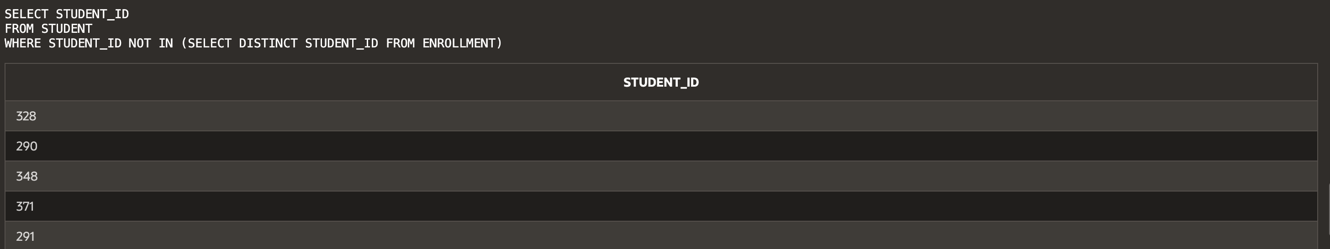...

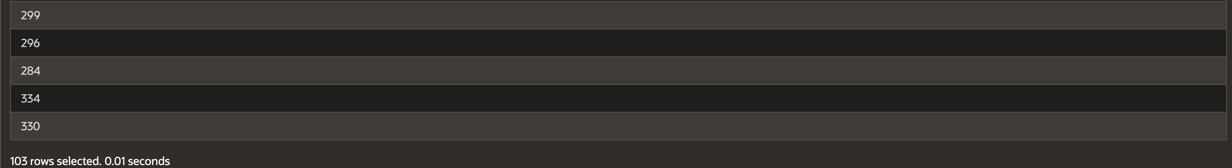

1. Create a view called all_people_view that lists all the students and instructors currently present at the university. Show salutation, full_name, street_address, zip, phone in your results. The full_name column should be the “first_name last_name” columns from the tables.



1. From the enrollment and student tables, show the student who got the highest grade. Show first_name, last_name, and student_id in your results.

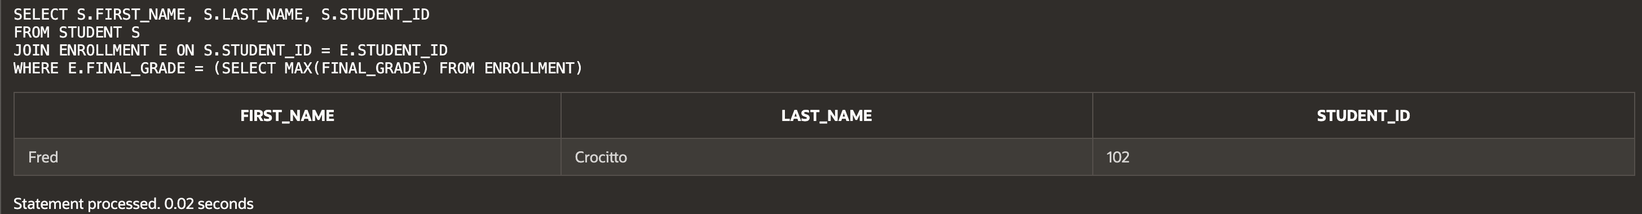

1. Using the course, section tables, list all the courses who have more than 5 sections. Show course_no, description, and number of sections.

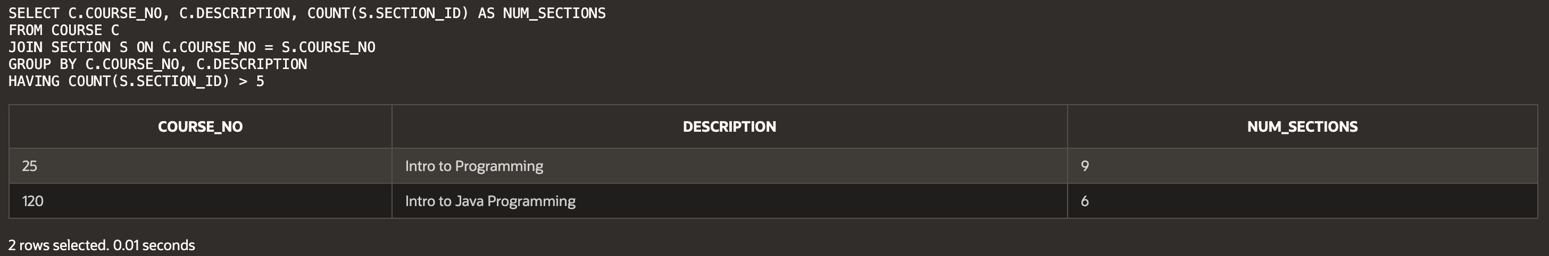

1. List all the courses and their prerequisites (if any). Show course_no, description, cost of the course, and course_no, description of the prerequisite.

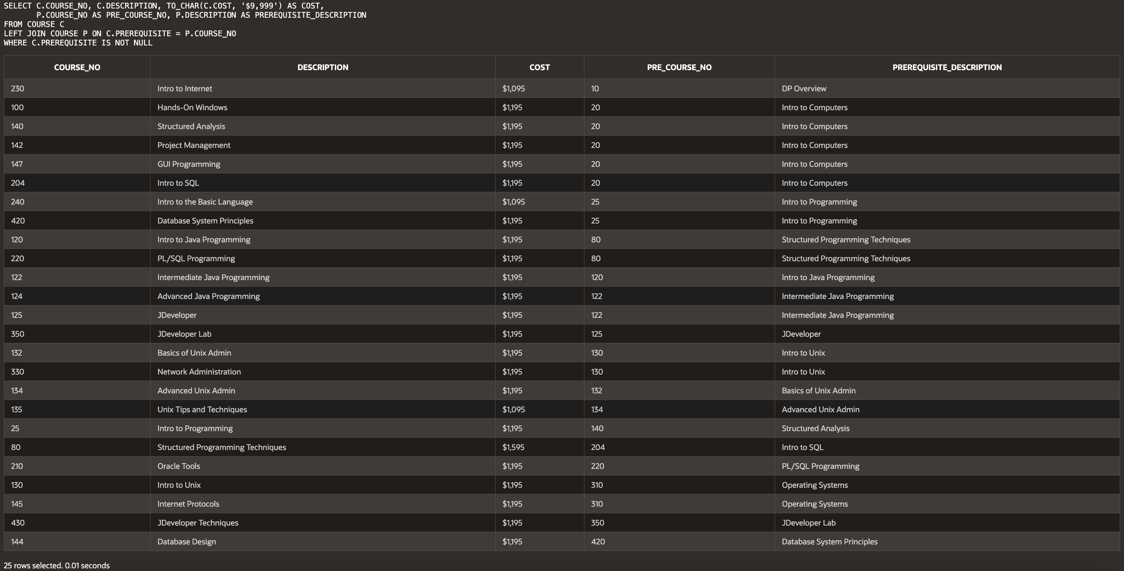

1. List the course(s) who have the most sections. Show course_no, description, and number of sections in your answer.

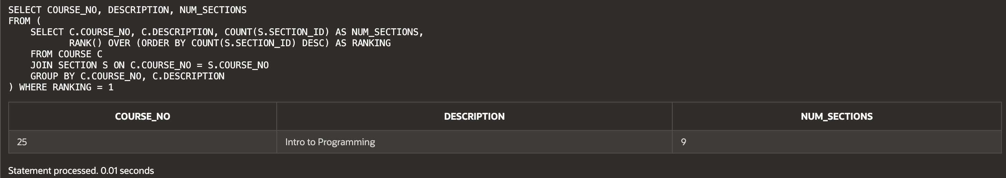

1. Using the course, section, and enrollment tables list all the courses that have more students enrolled than their capacity allows. Show course_no, description, start_date_time, capacity, and current number of enrolled students in your results.

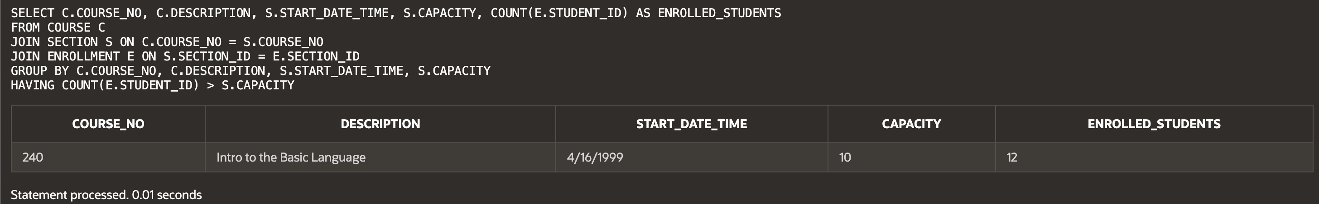

**Script:**

-- Haley Archer

-- 1) Find all courses that cost less than the average course price

SELECT DESCRIPTION, COURSE_NO, TO_CHAR(COST, '$9,999') AS COST

FROM COURSE

WHERE COST < (SELECT AVG(COST) FROM COURSE)

ORDER BY COST DESC;

-- 2) List all courses and their corresponding sections, ensuring no duplicates

SELECT DISTINCT C.COURSE_NO, C.DESCRIPTION, TO_CHAR(C.COST, '$9,999') AS COST, S.START_DATE_TIME

FROM COURSE C

JOIN SECTION S ON C.COURSE_NO = S.COURSE_NO

ORDER BY C.COURSE_NO, C.DESCRIPTION;

-- 3) Show all zip codes and the count of instructors in each zip code

SELECT Z.ZIP, COUNT(I.INSTRUCTOR_ID) AS INSTRUCTOR_COUNT

FROM ZIPCODE Z

JOIN INSTRUCTOR I ON Z.ZIP = I.ZIP

GROUP BY Z.ZIP;

-- 4) List all students that live in Brooklyn (Checking ZIP instead of CITY)

SELECT STUDENT_ID, FIRST_NAME, LAST_NAME, STREET_ADDRESS, ZIP

FROM STUDENT

WHERE ZIP IN (SELECT ZIP FROM ZIPCODE WHERE UPPER(CITY) = 'BROOKLYN')

ORDER BY LAST_NAME, FIRST_NAME;

-- 5) List all instructors and the number of sections they teach

SELECT I.FIRST_NAME, I.LAST_NAME, COUNT(S.SECTION_ID) AS NUM_SECTIONS

FROM INSTRUCTOR I

LEFT JOIN SECTION S ON I.INSTRUCTOR_ID = S.INSTRUCTOR_ID

GROUP BY I.FIRST_NAME, I.LAST_NAME

ORDER BY NUM_SECTIONS DESC;

-- 6) List all students who live in the same zipcode as instructor Tom Wojick

SELECT S.FIRST_NAME, S.LAST_NAME, S.STREET_ADDRESS, S.ZIP

FROM STUDENT S

WHERE S.ZIP = (SELECT ZIP FROM INSTRUCTOR WHERE UPPER(FIRST_NAME) = 'TOM' AND UPPER(LAST_NAME) = 'WOJICK')

AND EXISTS (SELECT 1 FROM INSTRUCTOR WHERE UPPER(FIRST_NAME) = 'TOM' AND UPPER(LAST_NAME) = 'WOJICK');

-- 7) List all students who registered before Vera Wetcel (Ensuring Vera Exists)

SELECT STUDENT_ID, SALUTATION, FIRST_NAME, LAST_NAME

FROM STUDENT

WHERE REGISTRATION_DATE < (SELECT REGISTRATION_DATE FROM STUDENT WHERE UPPER(FIRST_NAME) = 'VERA' AND UPPER(LAST_NAME) = 'WETCEL')

AND EXISTS (SELECT 1 FROM STUDENT WHERE UPPER(FIRST_NAME) = 'VERA' AND UPPER(LAST_NAME) = 'WETCEL');

-- 8) Find all students who haven't enrolled in any classes

SELECT STUDENT_ID

FROM STUDENT

WHERE STUDENT_ID NOT IN (SELECT DISTINCT STUDENT_ID FROM ENROLLMENT);

-- 9) Create a view called all_people_view listing all students and instructors

CREATE VIEW ALL_PEOPLE_VIEW AS

SELECT SALUTATION, FIRST_NAME || ' ' || LAST_NAME AS FULL_NAME, STREET_ADDRESS, ZIP, PHONE

FROM STUDENT

UNION

SELECT SALUTATION, FIRST_NAME || ' ' || LAST_NAME AS FULL_NAME, STREET_ADDRESS, ZIP, PHONE

FROM INSTRUCTOR;

-- 10) Show the student who got the highest grade (Fixing grade column reference)

SELECT S.FIRST_NAME, S.LAST_NAME, S.STUDENT_ID

FROM STUDENT S

JOIN ENROLLMENT E ON S.STUDENT_ID = E.STUDENT_ID

WHERE E.FINAL_GRADE = (SELECT MAX(FINAL_GRADE) FROM ENROLLMENT);

-- 11) List all courses that have more than 5 sections

SELECT C.COURSE_NO, C.DESCRIPTION, COUNT(S.SECTION_ID) AS NUM_SECTIONS

FROM COURSE C

JOIN SECTION S ON C.COURSE_NO = S.COURSE_NO

GROUP BY C.COURSE_NO, C.DESCRIPTION

HAVING COUNT(S.SECTION_ID) > 5;

-- 12) List all courses and their prerequisites (Fixing missing table issue)

SELECT C.COURSE_NO, C.DESCRIPTION, TO_CHAR(C.COST, '$9,999') AS COST,

P.COURSE_NO AS PRE_COURSE_NO, P.DESCRIPTION AS PREREQUISITE_DESCRIPTION

FROM COURSE C

LEFT JOIN COURSE P ON C.PREREQUISITE = P.COURSE_NO

WHERE C.PREREQUISITE IS NOT NULL;

-- 13) List the course(s) with the most sections

SELECT COURSE_NO, DESCRIPTION, NUM_SECTIONS

FROM (

SELECT C.COURSE_NO, C.DESCRIPTION, COUNT(S.SECTION_ID) AS NUM_SECTIONS,

RANK() OVER (ORDER BY COUNT(S.SECTION_ID) DESC) AS RANKING

FROM COURSE C

JOIN SECTION S ON C.COURSE_NO = S.COURSE_NO

GROUP BY C.COURSE_NO, C.DESCRIPTION

) WHERE RANKING = 1;

-- 14) List all courses where the number of students enrolled exceeds capacity

SELECT C.COURSE_NO, C.DESCRIPTION, S.START_DATE_TIME, S.CAPACITY, COUNT(E.STUDENT_ID) AS ENROLLED_STUDENTS

FROM COURSE C

JOIN SECTION S ON C.COURSE_NO = S.COURSE_NO

JOIN ENROLLMENT E ON S.SECTION_ID = E.SECTION_ID

GROUP BY C.COURSE_NO, C.DESCRIPTION, S.START_DATE_TIME, S.CAPACITY

HAVING COUNT(E.STUDENT_ID) > S.CAPACITY;