**Week 5 Guided Practice: Union All, Cross Joins and CrossTab Queries.**

The following questions come from the Task examples of each section of chapter 15 & 16 in your textbook.

After you are finished, please submit the Microsoft Word file that contains screenshots of the SQL script and the resulting tables. Your document should be named **W5_GP_Unions2_Lastname.docx**.

(15-12) Question 1:

Divide the cost column from the beginning table into two columns: *debits* and *credits*.

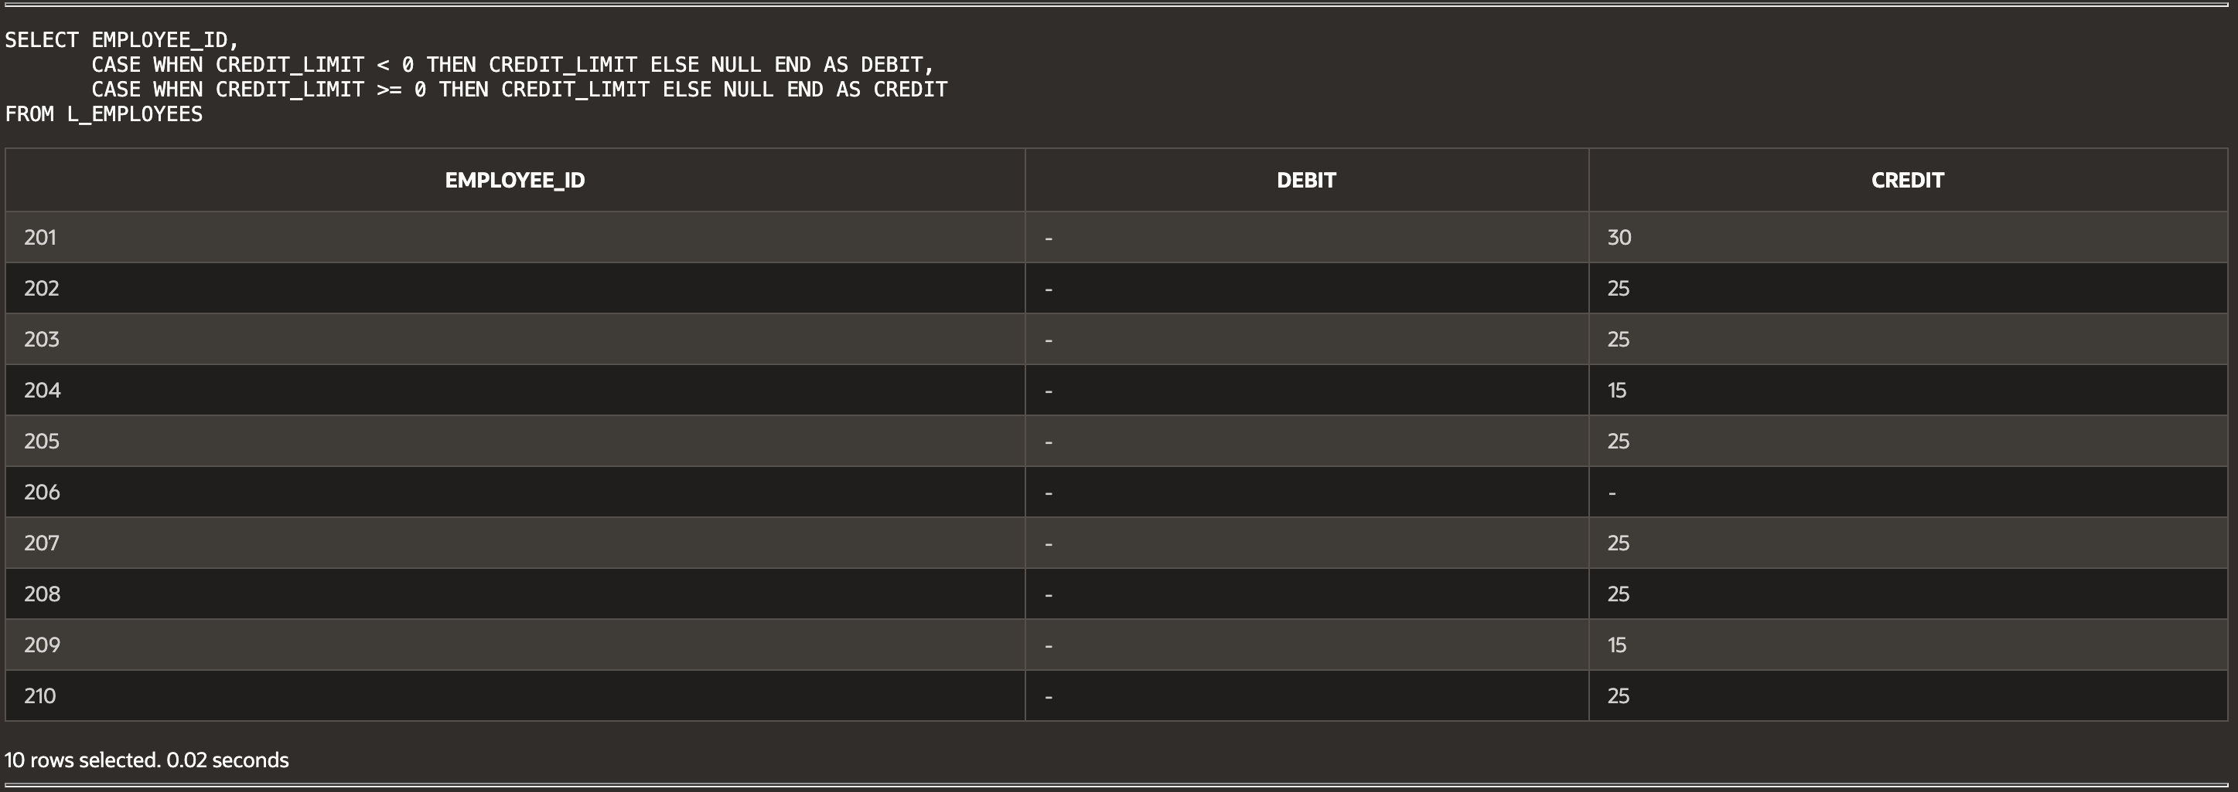

(15-13) Question 2:

Show how to make two different calculations, depending on the data in a row. Increase the price of all foods costing more than $2.00 by 5 percent. Increase the price of all other foods by 10 percent. Ignore the existing *price_increase* column.

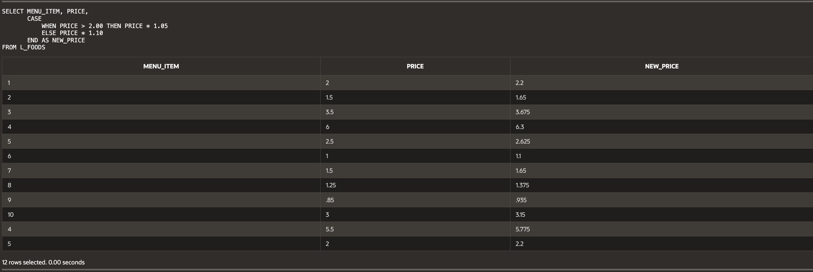

(15-14) Question 3:

List the letters from *'A'* to *'G'*. Do this as a *union* of seven tables.

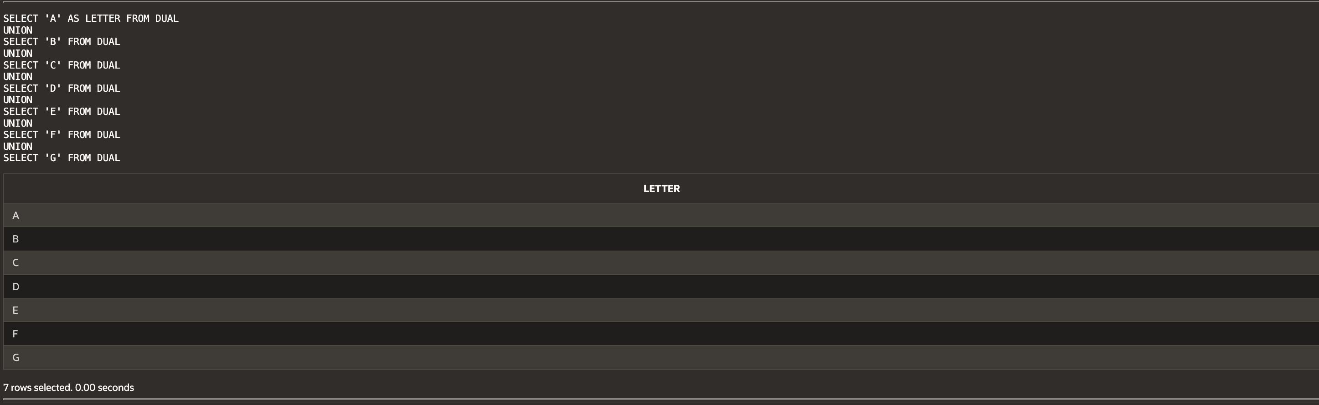

(15-15) Question 4:

Find the intersection of two tables. That is, find all the rows that occur in both tables.

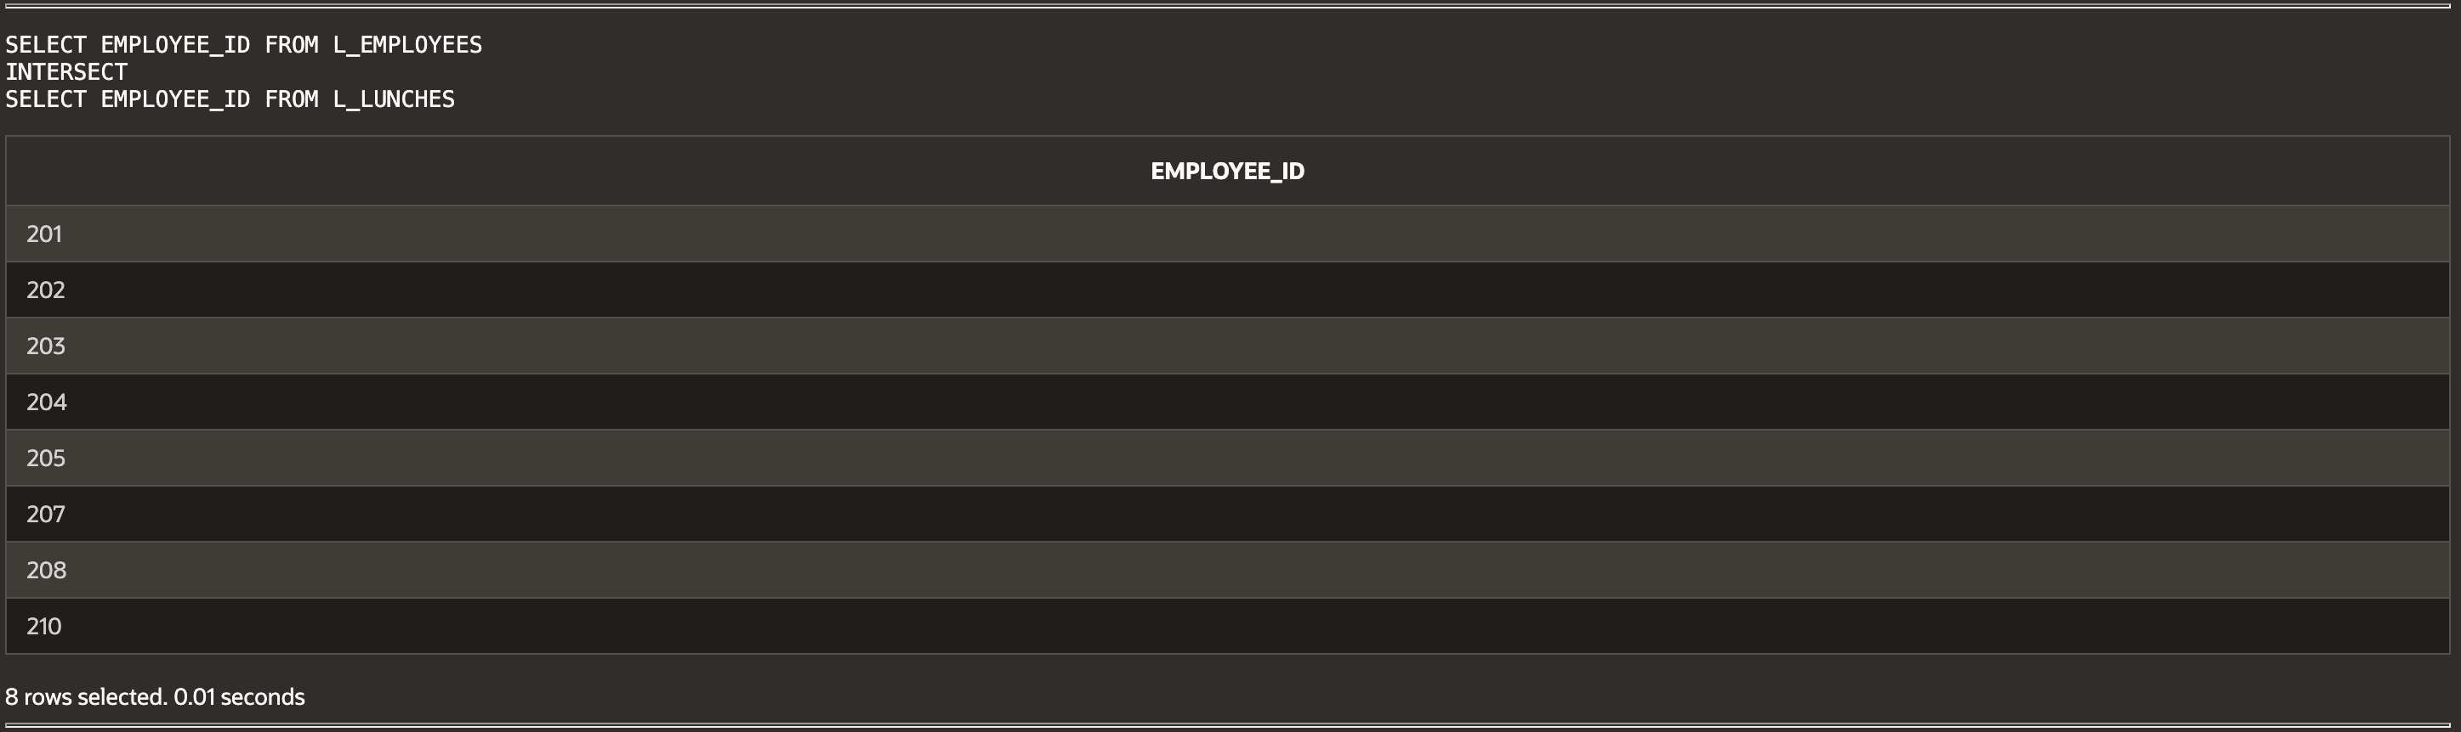

(15-16) Question 5:

Find all the rows that are in one table and not in the other table. Do this both ways to find all the differences between the two tables.

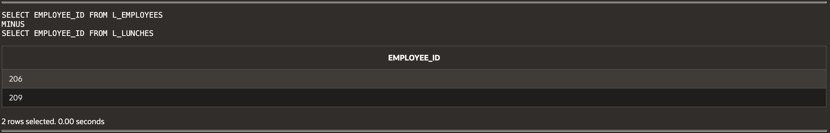

(16-1) Question 6:

Show an example of a cross join.

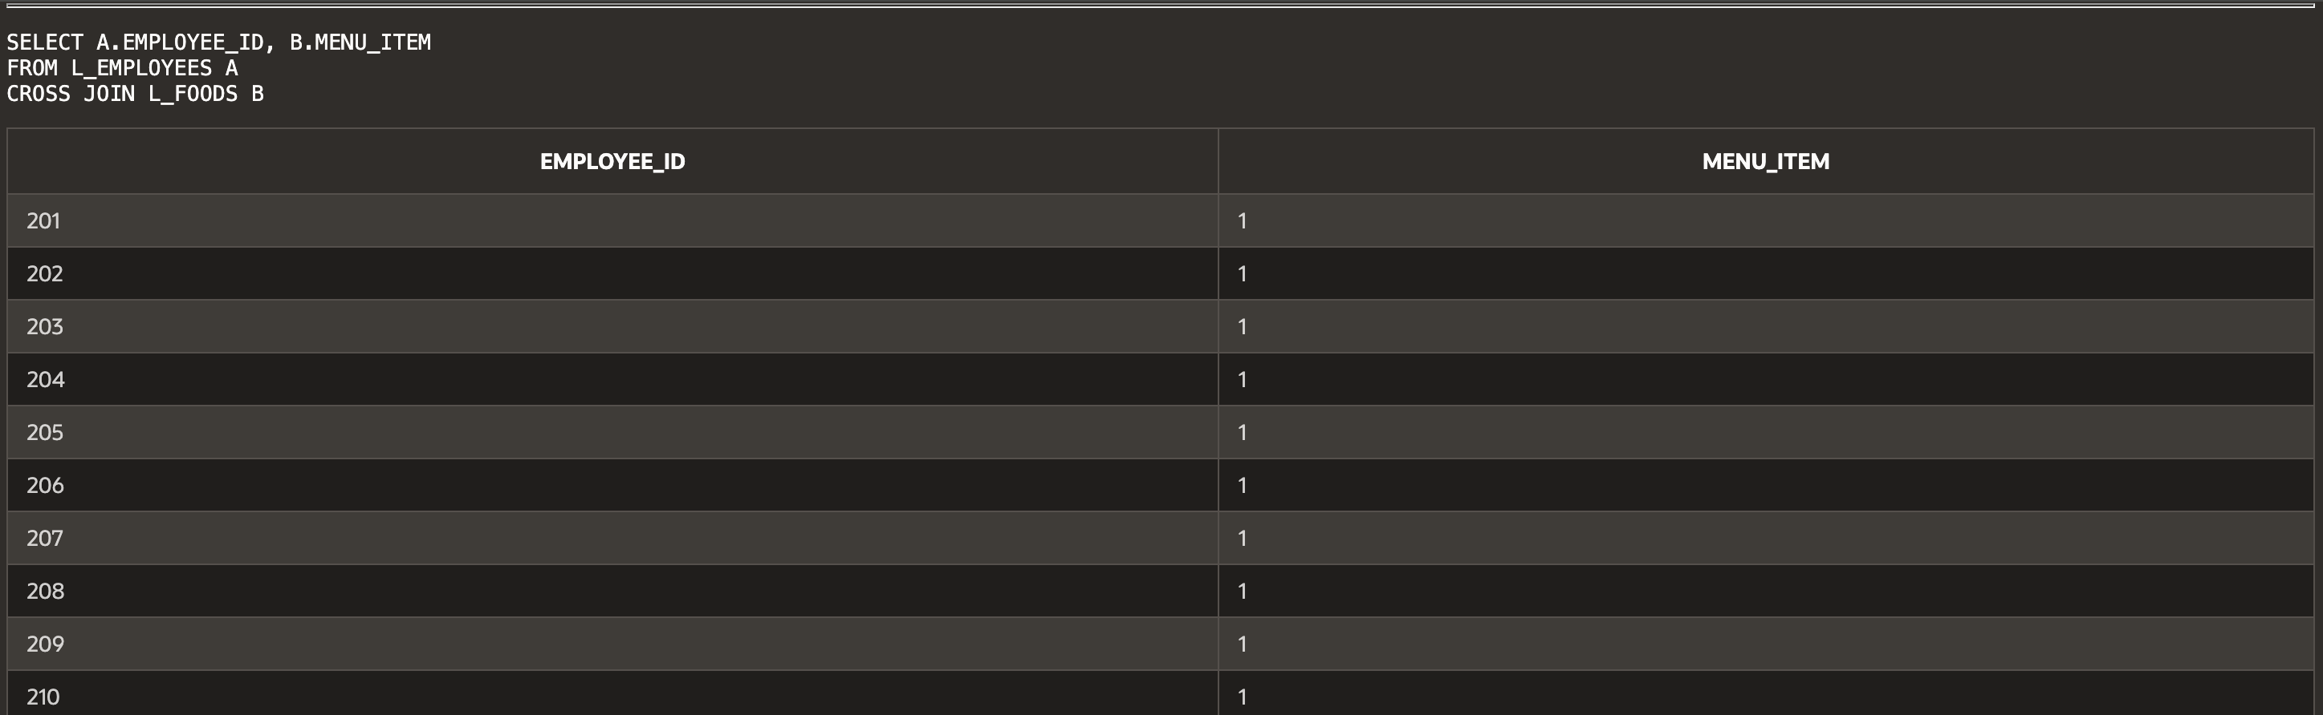...

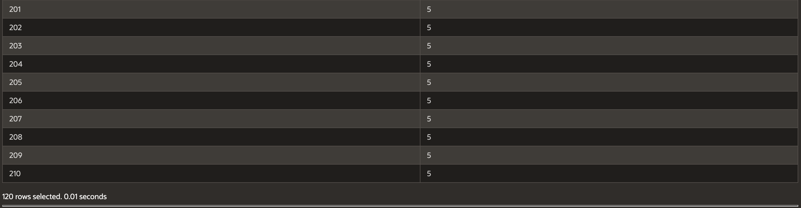

(16-3) Question 7:

Show each step of the process to create an inner join of the *sec1603_fruits* and *sec1603_colors* tables. Use the join condition *f_num = c_num*.

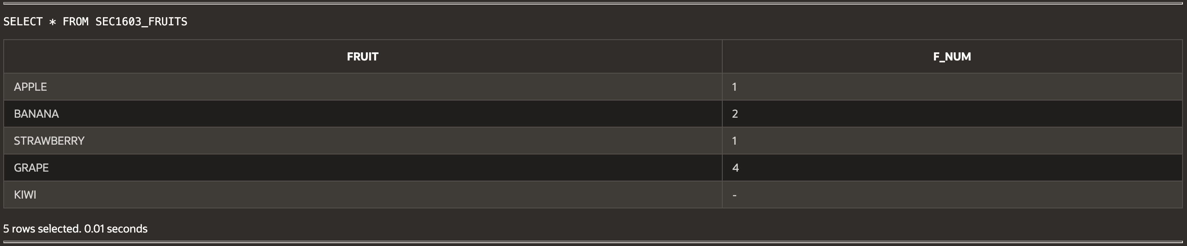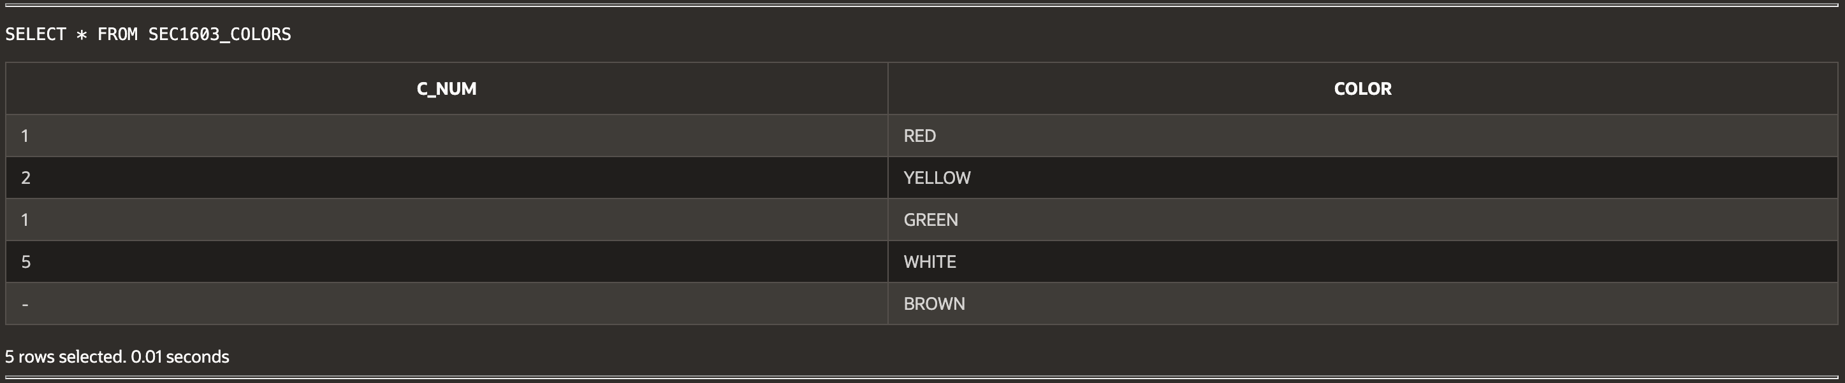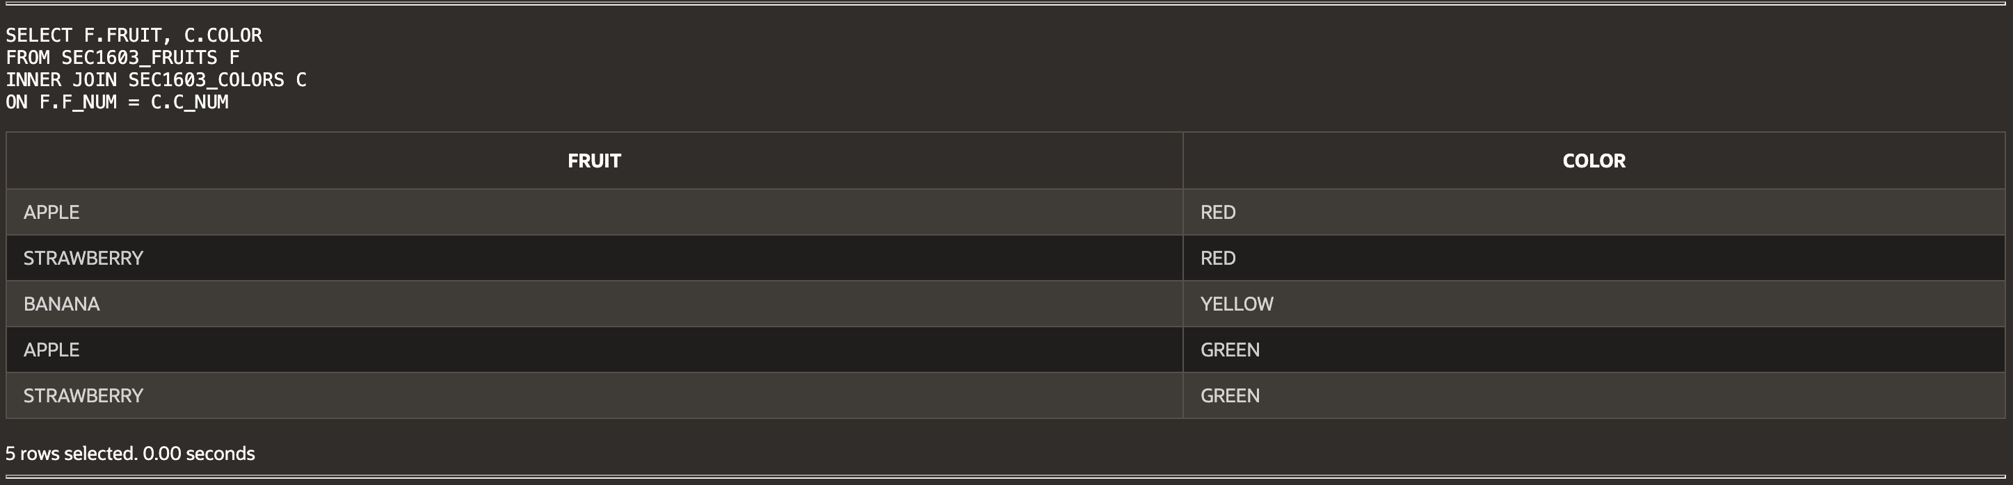

(16-5) Question 8:

Show an example of SQL that contains an error. Leave one of the join conditions out of the *where* clause. Show how we might detect this error.

For lunch 2, list the *lunch_id, supplier_id, product_code, description, price*, and *quantity* columns. Use the *L_FOODS* table and the *L_LUNCH_ITEMS* table.

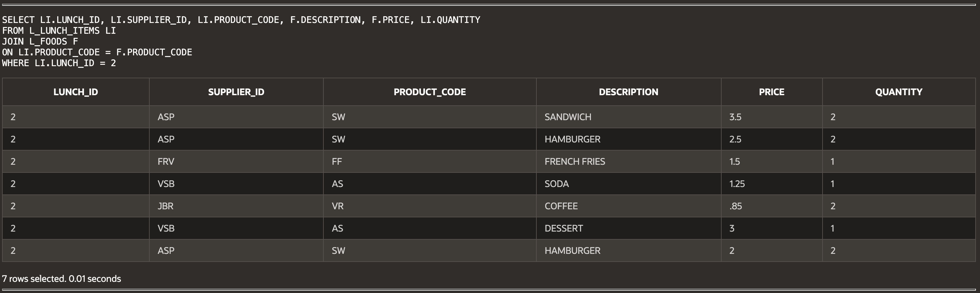

(16-9) Question 9:

Form a cross join of a table with itself.

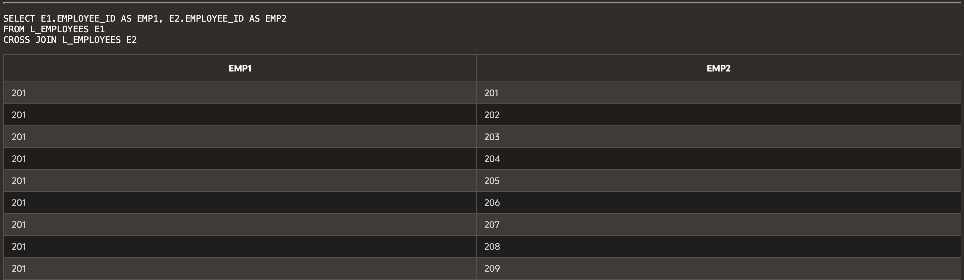...

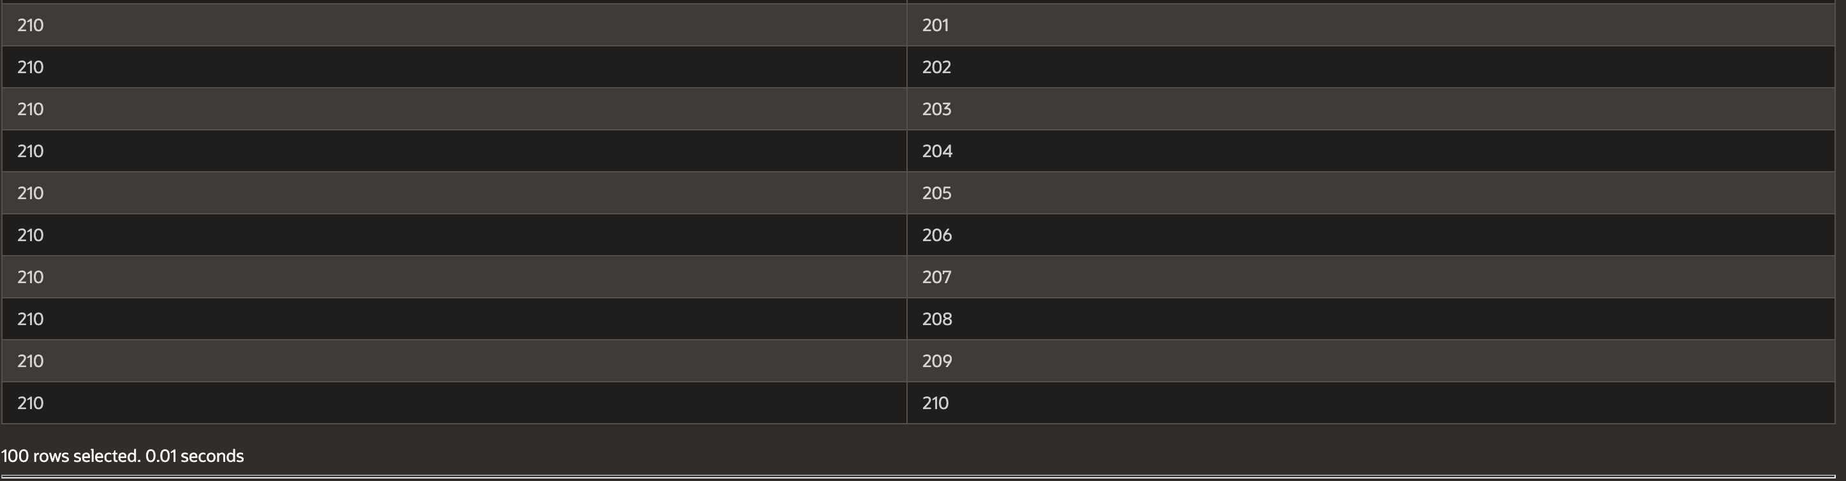

(16-10) Question 10:

From the *L_EMPLOYEES* table, list the employee ID, last name, and phone number of each employee with the name and phone number of his or her manager. Include a row for each employee, even those who do not have a manager. Sort the rows by the *employee_id* column.

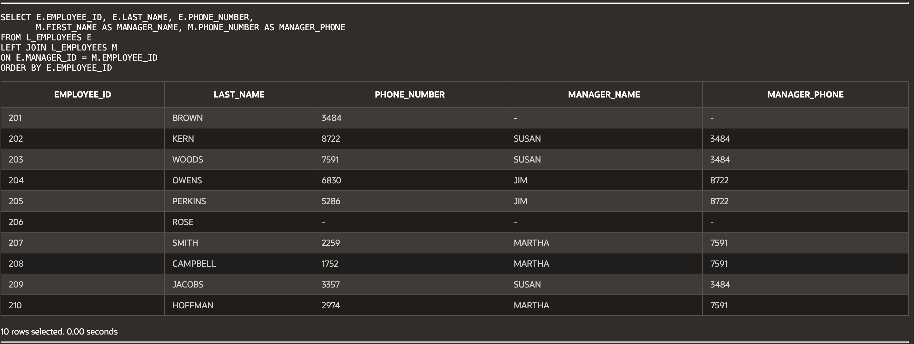

(16-11) Question 11:

Find the amount of time that has elapsed between one event and the next event.

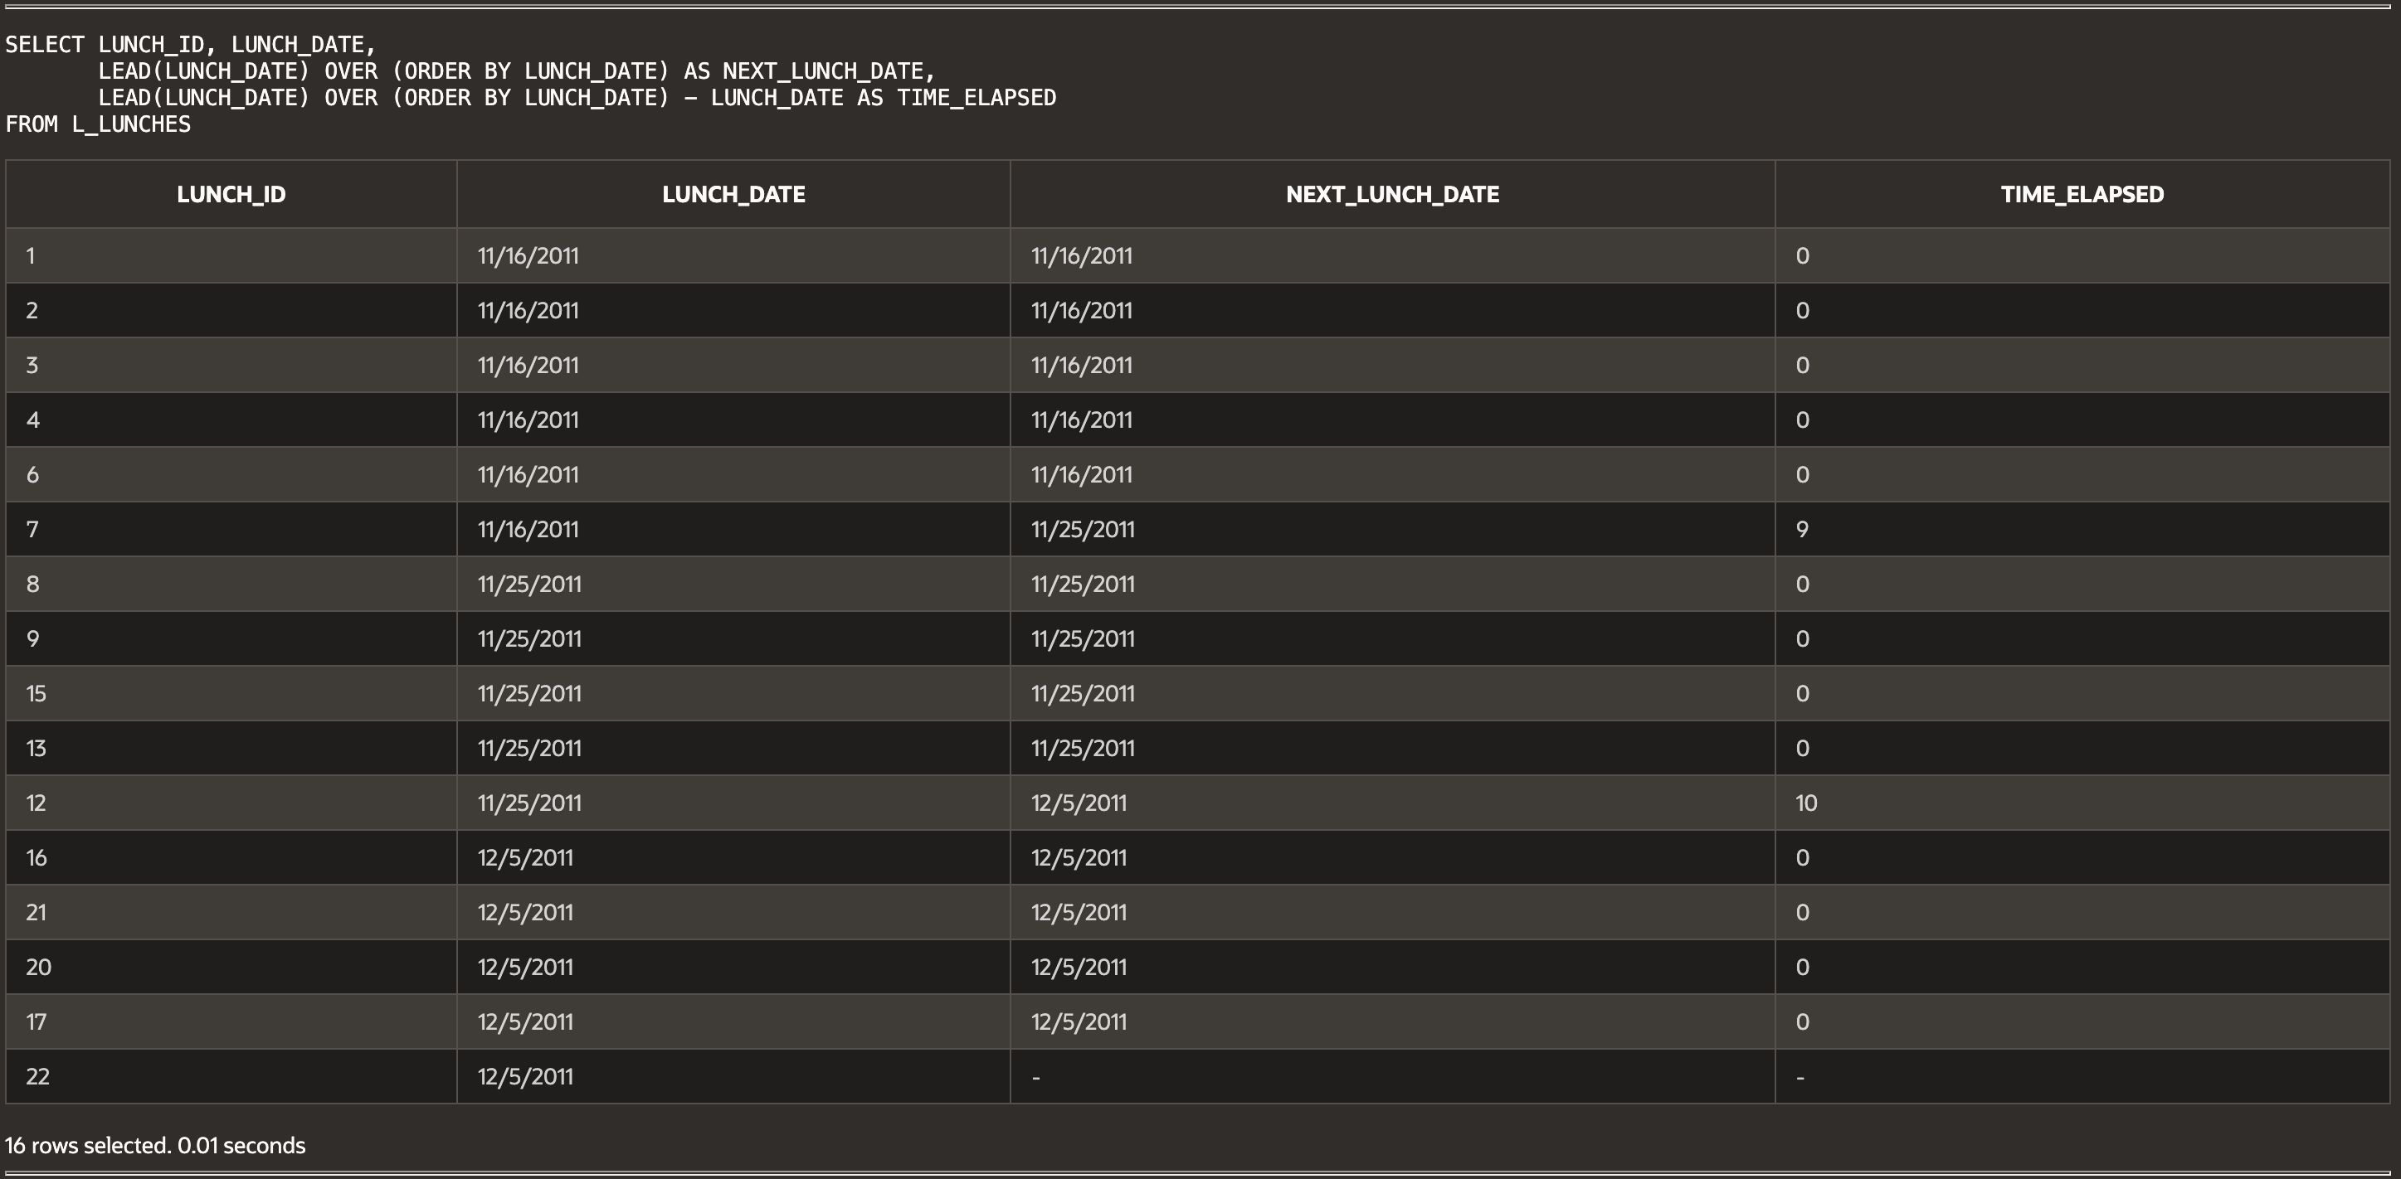

(16-12) Questions 12:

Create a table with all the numbers from 0 to 999. First, create a table of the numbers from 0 to 9. Then cross join it with itself.

We already have a table named *numbers_0_to_9* containing all the digits. We want to leave that table alone. We create a new table with a slightly different name so I can show you how this all works.



**Script:**

-- Haley Archer

-- (15-12) Question 1:

-- Divide the cost column into two columns: debits and credits.

-- FIX: Since TRANSACTIONS_TABLE does not exist, using L_EMPLOYEES (CREDIT_LIMIT as cost).

SELECT EMPLOYEE_ID,

CASE WHEN CREDIT_LIMIT < 0 THEN CREDIT_LIMIT ELSE NULL END AS DEBIT,

CASE WHEN CREDIT_LIMIT >= 0 THEN CREDIT_LIMIT ELSE NULL END AS CREDIT

FROM L_EMPLOYEES;

-- (15-13) Question 2:

-- Increase the price of all foods costing more than $2.00 by 5%.

-- Increase the price of all other foods by 10%.

SELECT MENU_ITEM, PRICE,

CASE

WHEN PRICE > 2.00 THEN PRICE * 1.05

ELSE PRICE * 1.10

END AS NEW_PRICE

FROM L_FOODS;

-- (15-14) Question 3:

-- List the letters from 'A' to 'G' using a UNION.

SELECT 'A' AS LETTER FROM DUAL

UNION

SELECT 'B' FROM DUAL

UNION

SELECT 'C' FROM DUAL

UNION

SELECT 'D' FROM DUAL

UNION

SELECT 'E' FROM DUAL

UNION

SELECT 'F' FROM DUAL

UNION

SELECT 'G' FROM DUAL;

-- (15-15) Question 4:

-- Find the intersection of two tables (common rows in both tables).

-- FIX: TABLE_A and TABLE_B do not exist. Using L_EMPLOYEES and L_LUNCHES as examples.

SELECT EMPLOYEE_ID FROM L_EMPLOYEES

INTERSECT

SELECT EMPLOYEE_ID FROM L_LUNCHES;

-- (15-16) Question 5:

-- Find all the rows that are in one table and not in the other table.

-- Do this both ways to find all the differences.

SELECT EMPLOYEE_ID FROM L_EMPLOYEES

MINUS

SELECT EMPLOYEE_ID FROM L_LUNCHES;

SELECT EMPLOYEE_ID FROM L_LUNCHES

MINUS

SELECT EMPLOYEE_ID FROM L_EMPLOYEES;

-- (16-1) Question 6:

-- Show an example of a CROSS JOIN.

SELECT A.EMPLOYEE_ID, B.MENU_ITEM

FROM L_EMPLOYEES A

CROSS JOIN L_FOODS B;

-- (16-3) Question 7:

-- Create an INNER JOIN of sec1603_fruits and sec1603_colors.

-- Use the join condition f_num = c_num.

SELECT F.FRUIT, C.COLOR

FROM SEC1603_FRUITS F

INNER JOIN SEC1603_COLORS C

ON F.F_NUM = C.C_NUM;

-- (16-5) Question 8:

-- Show an SQL error by leaving out a join condition.

-- Using the L_FOODS and L_LUNCH_ITEMS tables.

SELECT LI.LUNCH_ID, LI.SUPPLIER_ID, LI.PRODUCT_CODE, F.DESCRIPTION, F.PRICE, LI.QUANTITY

FROM L_LUNCH_ITEMS LI

JOIN L_FOODS F

ON LI.PRODUCT_CODE = F.PRODUCT_CODE

-- ERROR: Missing supplier join condition

WHERE LI.LUNCH_ID = 2;

-- (16-9) Question 9:

-- Form a CROSS JOIN of a table with itself.

SELECT E1.EMPLOYEE_ID AS EMP1, E2.EMPLOYEE_ID AS EMP2

FROM L_EMPLOYEES E1

CROSS JOIN L_EMPLOYEES E2;

-- (16-10) Question 10:

-- From L_EMPLOYEES, list employee details with their manager’s name and phone.

SELECT E.EMPLOYEE_ID, E.LAST_NAME, E.PHONE_NUMBER,

M.FIRST_NAME AS MANAGER_NAME, M.PHONE_NUMBER AS MANAGER_PHONE

FROM L_EMPLOYEES E

LEFT JOIN L_EMPLOYEES M

ON E.MANAGER_ID = M.EMPLOYEE_ID

ORDER BY E.EMPLOYEE_ID;

-- (16-11) Question 11:

-- Find the amount of time that has elapsed between one event and the next.

-- FIX: EVENTS_TABLE does not exist, replaced with L_LUNCHES (LUNCH_DATE as event timestamp).

SELECT LUNCH_ID, LUNCH_DATE,

LEAD(LUNCH_DATE) OVER (ORDER BY LUNCH_DATE) AS NEXT_LUNCH_DATE,

LEAD(LUNCH_DATE) OVER (ORDER BY LUNCH_DATE) - LUNCH_DATE AS TIME_ELAPSED

FROM L_LUNCHES;

-- (16-12) Question 12:

-- Create a table with all numbers from 0 to 999 using a cross join.

-- FIX: NUM column does not exist in NUMBERS_0_TO_9, replaced with DIGIT.

CREATE TABLE NUMBERS_0_TO_999 AS

SELECT (T1.DIGIT * 10 + T2.DIGIT) AS NUMBER_VALUE

FROM NUMBERS_0_TO_9 T1

CROSS JOIN NUMBERS_0_TO_9 T2;