**Week 5 Performance Assessment: Union All, Cross Joins and CrossTab Queries.**

The following questions come from the “Check your understanding” examples of Chapters 15 & 16 in your textbook.

After you are finished, please submit a Microsoft Word file that contains screenshots the SQL queries, the output, and please put a comment line in each query with your name. **Note: No screen shots are required for Questions 6, 7, and 8, which should be done “by hand,” (use the Insert tab to create your own Microsoft Word table) and simply answered in the same document.** Your document should be named **W5_PA_Unions2_Lastname.docx**.

(15-11) Question 1:

List all the rows and columns of the *L_EMPLOYEES* table. Add a new column that says “Old Timer” for any employee that was hired before the year 2000 and is blank for all other employees. Sort this by the *employee_id* column.

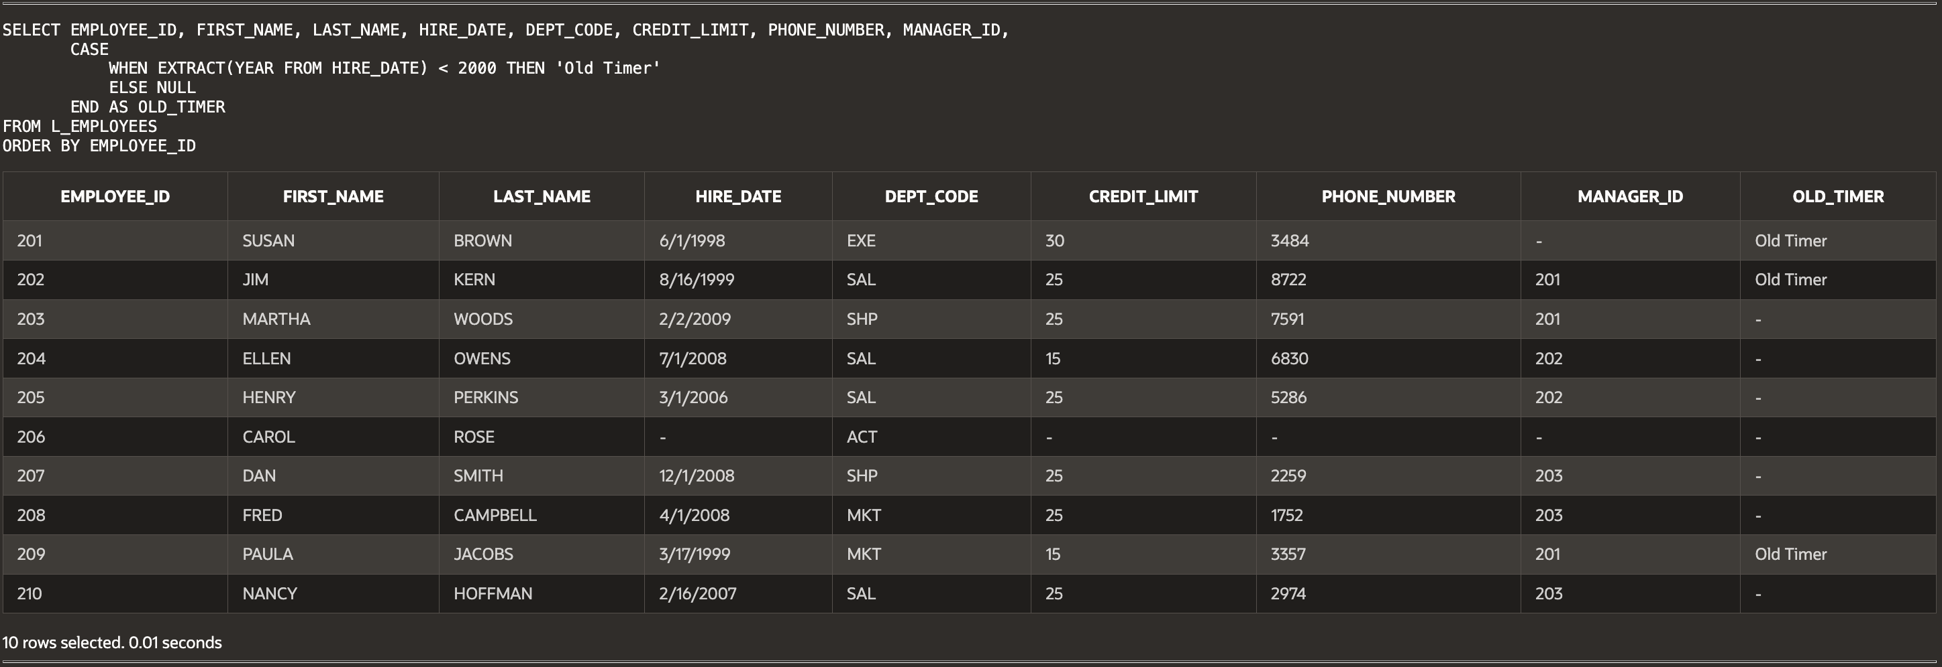

(15-12) Question 2:

List the last name, first name, and hire date of all the people in the *L_EMPLOYEES* table. Divide the hire date column into two columns: one called “old timers” for people hired before the year 2000, and one called “newer hires” for people hired after that year. Sort the result table by last name and then by first name.

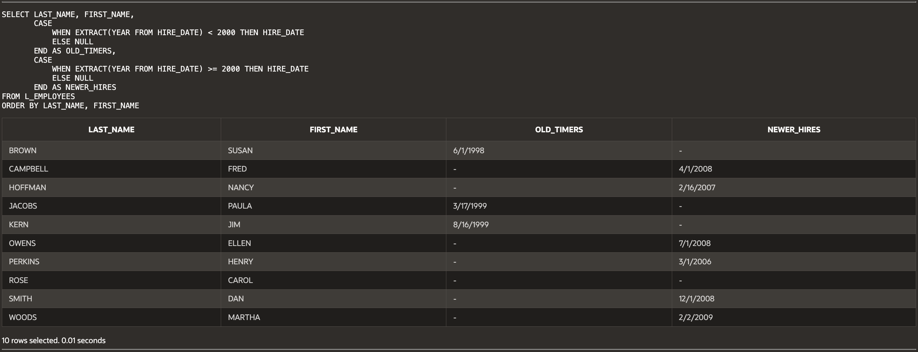

(15-13) Question 3:

The *numbers_0_to_9* table contains the numbers from zero to nine. Multiply all the even numbers by two and multiply all the other numbers by three.

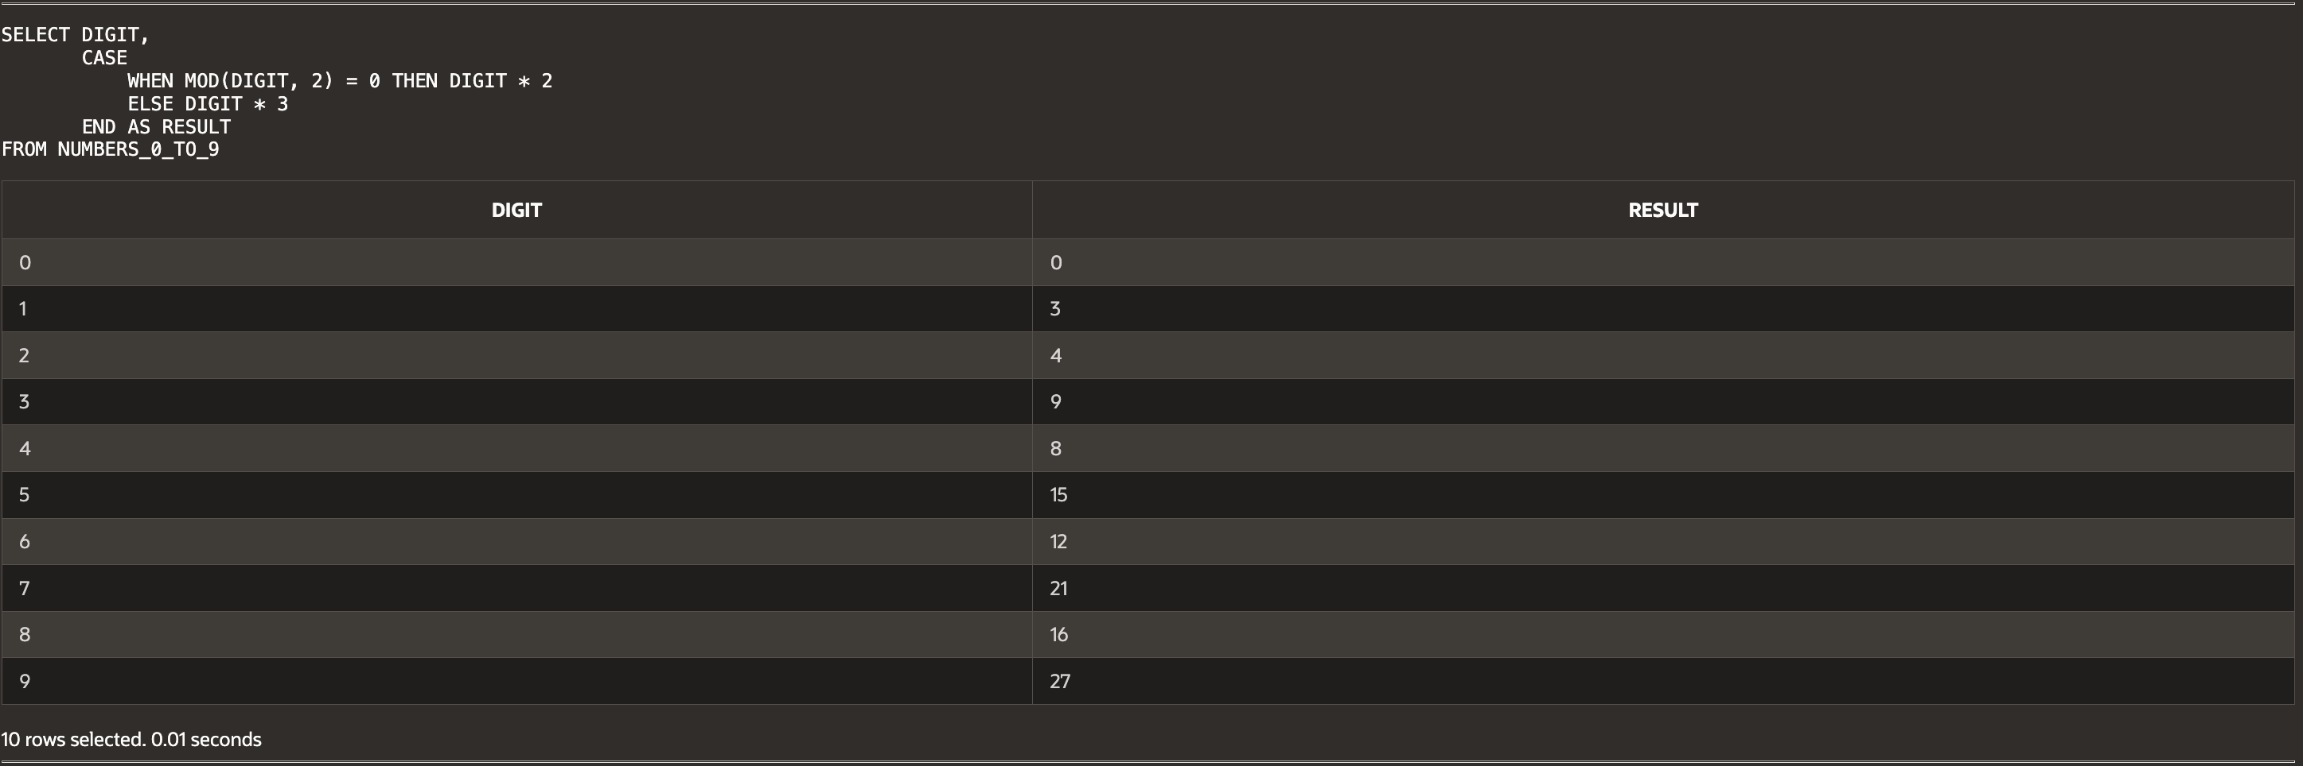

(15-15) Question 4:

Use the method of this section to find the intersection of the *twos* table and the *threes* table.

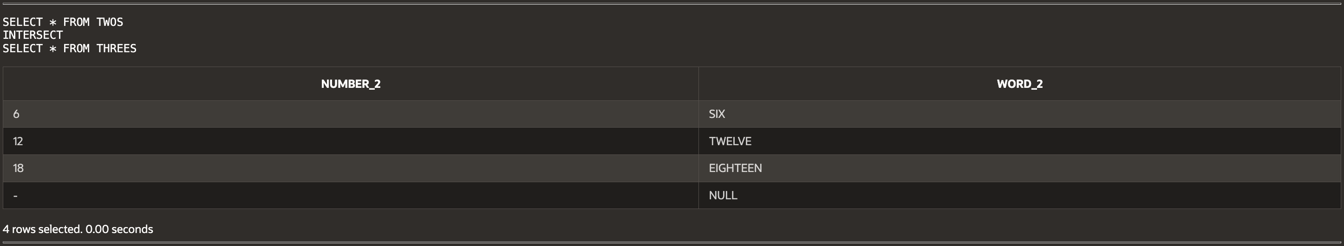

(15-16) Question 5:

Use the method of this section to find the difference of the *twos* table and the *threes* table.

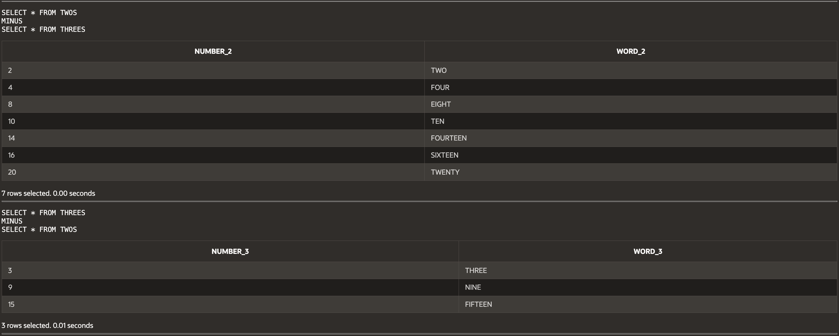

(16-1) Question 6:

**Insert a table on this document showing the result set of:** the cross join of the following two tables:

|  |  |
| --- | --- |
| **Table 1** | **Table 2** |

|  |  |
| --- | --- |
| U | 10 |

|  |  |
| --- | --- |
| U | 20 |

|  |  |
| --- | --- |
| U | 30 |

|  |  |
| --- | --- |
| U | 40 |

|  |  |
| --- | --- |
| U | 50 |

|  |  |
| --- | --- |
| V | 10 |

|  |  |
| --- | --- |
| V | 20 |

|  |  |
| --- | --- |
| V | 30 |

|  |  |
| --- | --- |
| V | 40 |

|  |  |
| --- | --- |
| V | 50 |

|  |  |
| --- | --- |
| W | 10 |

|  |  |
| --- | --- |
| W | 20 |

|  |  |
| --- | --- |
| W | 30 |

|  |  |
| --- | --- |
| W | 40 |

|  |  |
| --- | --- |
| W | 50 |

|  |  |
| --- | --- |
| X | 10 |

|  |  |
| --- | --- |
| X | 20 |

|  |  |
| --- | --- |
| X | 30 |

|  |  |
| --- | --- |
| X | 40 |

|  |  |
| --- | --- |
| X | 50 |

|  |  |
| --- | --- |
| Y | 10 |

|  |  |
| --- | --- |
| Y | 20 |

|  |  |
| --- | --- |
| Y | 30 |

|  |  |
| --- | --- |
| Y | 40 |

|  |  |
| --- | --- |
| Y | 50 |

|  |  |
| --- | --- |
| Z | 10 |

|  |  |
| --- | --- |
| Z | 20 |

|  |  |
| --- | --- |
| Z | 30 |

|  |  |
| --- | --- |
| Z | 40 |

|  |  |
| --- | --- |
| Z | 50 |

(16-3) Question 7:

**Insert a table on this document showing the result set of:** the cross join of the following two tables:

|  |  |
| --- | --- |
| **Table 1** | **Table 2** |

|  |  |
| --- | --- |
| 2 | NULL |

|  |  |
| --- | --- |
| 2 | 3 |

|  |  |
| --- | --- |
| 2 | 6 |

|  |  |
| --- | --- |
| 2 | 9 |

|  |  |
| --- | --- |
| 2 | 12 |

|  |  |
| --- | --- |
| 4 | NULL |

|  |  |
| --- | --- |
| 4 | 3 |

|  |  |
| --- | --- |
| 4 | 6 |

|  |  |
| --- | --- |
| 4 | 9 |

|  |  |
| --- | --- |
| 4 | 12 |

|  |  |
| --- | --- |
| 6 | NULL |

|  |  |
| --- | --- |
| 6 | 3 |

|  |  |
| --- | --- |
| 6 | 6 |

|  |  |
| --- | --- |
| 6 | 9 |

|  |  |
| --- | --- |
| 6 | 12 |

|  |  |
| --- | --- |
| 8 | NULL |

|  |  |
| --- | --- |
| 8 | 3 |

|  |  |
| --- | --- |
| 8 | 6 |

|  |  |
| --- | --- |
| 8 | 9 |

|  |  |
| --- | --- |
| 8 | 12 |

|  |  |
| --- | --- |
| 10 | NULL |

|  |  |
| --- | --- |
| 10 | 3 |

|  |  |
| --- | --- |
| 10 | 6 |

|  |  |
| --- | --- |
| 10 | 9 |

|  |  |
| --- | --- |
| 10 | 12 |

|  |  |
| --- | --- |
| 12 | NULL |

|  |  |
| --- | --- |
| 12 | 3 |

|  |  |
| --- | --- |
| 12 | 6 |

|  |  |
| --- | --- |
| 12 | 9 |

|  |  |
| --- | --- |
| 12 | 12 |

(16-5) Question 8:

Suppose you are developing a new *select* statement. It is fairly complex and you are using several tables. You are expecting a result with about 400 rows, but the result you get is about 2,000 rows. What part of your *select* statement would you examine first?

If a query returns far more rows than expected, the **first thing to check is the JOIN conditions**. A missing or incorrect join condition can create a **Cartesian join**, multiplying rows instead of matching them correctly. Also, verify that filters (WHERE clauses) are applied correctly and that there are no unintended duplicates in the source tables.

(16-11) Question 9:

Table *sec1611_prime_numbers* contains the first 50 prime numbers. Use a self join to determine the difference between each prime and the next one.

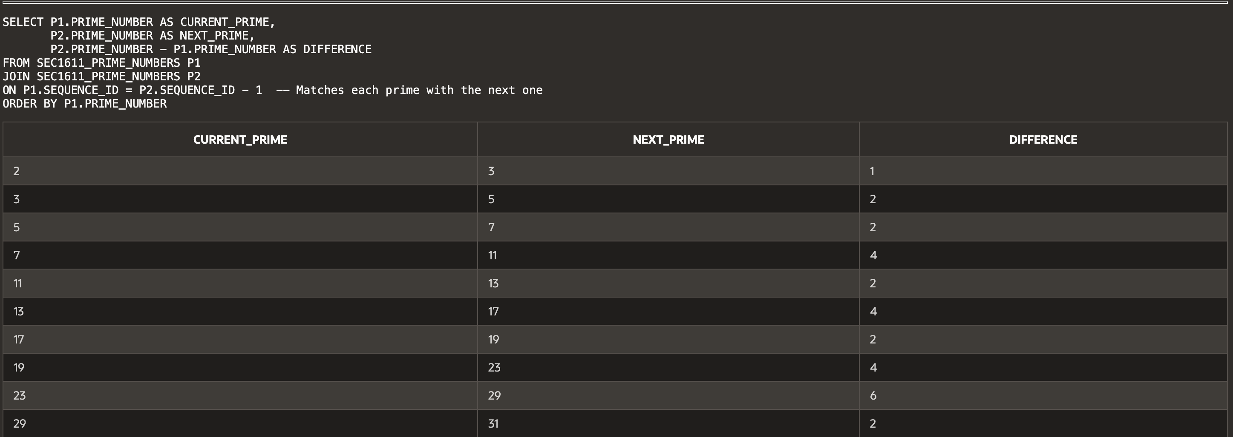...

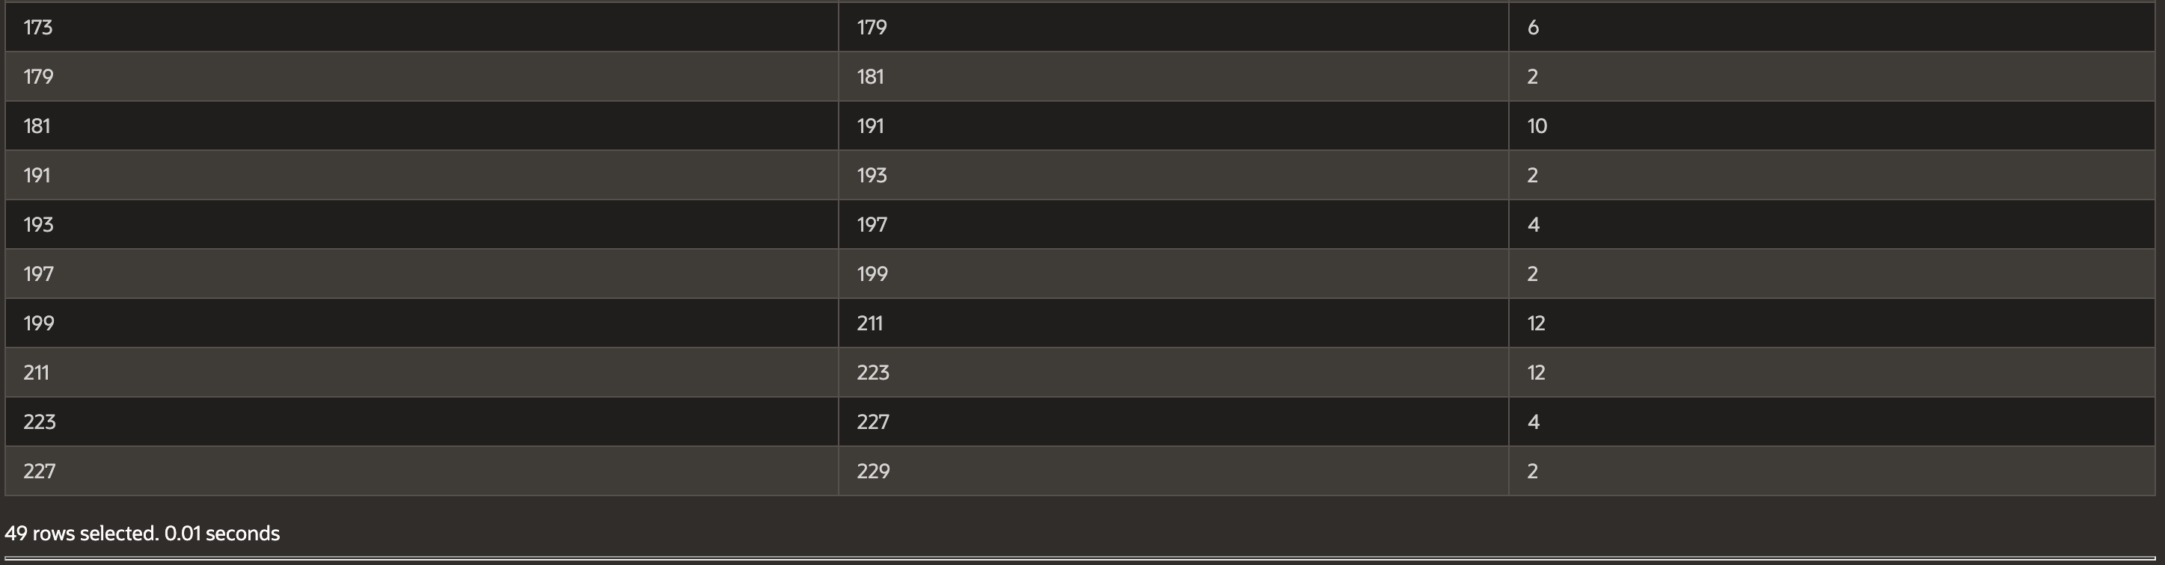

**Script:**

-- Haley Archer

-- (15-11) Question 1:

-- List all rows and columns of L_EMPLOYEES.

-- Add a column "Old Timer" for employees hired before 2000.

-- Sort by employee_id.

SELECT EMPLOYEE_ID, FIRST_NAME, LAST_NAME, HIRE_DATE, DEPT_CODE, CREDIT_LIMIT, PHONE_NUMBER, MANAGER_ID,

CASE

WHEN EXTRACT(YEAR FROM HIRE_DATE) < 2000 THEN 'Old Timer'

ELSE NULL

END AS OLD_TIMER

FROM L_EMPLOYEES

ORDER BY EMPLOYEE_ID;

-- (15-12) Question 2:

-- Divide hire date into "Old Timers" (before 2000) and "Newer Hires" (2000+).

-- Sort by last name, then first name.

SELECT LAST_NAME, FIRST_NAME,

CASE

WHEN EXTRACT(YEAR FROM HIRE_DATE) < 2000 THEN HIRE_DATE

ELSE NULL

END AS OLD_TIMERS,

CASE

WHEN EXTRACT(YEAR FROM HIRE_DATE) >= 2000 THEN HIRE_DATE

ELSE NULL

END AS NEWER_HIRES

FROM L_EMPLOYEES

ORDER BY LAST_NAME, FIRST_NAME;

-- (15-13) Question 3:

-- Multiply even numbers by 2 and odd numbers by 3 from numbers_0_to_9.

SELECT DIGIT,

CASE

WHEN MOD(DIGIT, 2) = 0 THEN DIGIT * 2

ELSE DIGIT * 3

END AS RESULT

FROM NUMBERS_0_TO_9;

-- (15-15) Question 4:

-- Find the intersection of the twos table and the threes table.

SELECT * FROM TWOS

INTERSECT

SELECT * FROM THREES;

-- (15-16) Question 5:

-- Find the difference between the twos table and the threes table (both ways).

SELECT * FROM TWOS

MINUS

SELECT * FROM THREES;

SELECT * FROM THREES

MINUS

SELECT * FROM TWOS;

-- (16-11) Question 9:

-- Find the difference between each prime number and the next in sec1611_prime_numbers.

SELECT P1.PRIME_NUMBER AS CURRENT_PRIME,

P2.PRIME_NUMBER AS NEXT_PRIME,

P2.PRIME_NUMBER - P1.PRIME_NUMBER AS DIFFERENCE

FROM SEC1611_PRIME_NUMBERS P1

JOIN SEC1611_PRIME_NUMBERS P2

ON P1.SEQUENCE_ID = P2.SEQUENCE_ID - 1

ORDER BY P1.PRIME_NUMBER;