Project Week 1
Student: Haley Archer
Course: SDC330L– Advanced Object-Oriented Programming with Java
Date: 12 Oct 2025
Repo: https://github.com/thepacketpoet-school/sdc330l

Part 1: User Interaction
Markdown link: https://github.com/thepacketpoet-school/sdc330l/blob/main/README.md
Project Part 1
Student: Haley Archer
Course: SDC330L — Advanced Object-Oriented Programming with Java
Date: October 12, 2025

Project Option
I will be building an online book-sharing library (basically a lightweight hybrid of Libby and Little Free Library).
Users can browse a catalogue of books, purchase copies, read them, and share finished books with other users. This week focuses on user interaction design and the initial application skeleton. Additional logic will be added in the coming weeks.

Application Startup
When the user launches the application, they see:
=== Online Book-Sharing Library ===

Student: Haley Archer

-------------------------------------------------------------------

"A good book is a friend you can carry anywhere; a best friend is one
who shares good books."

-------------------------------------------------------------------

Welcome to our neighborhood! This console application will let you:

• Browse the catalogue
• Purchase books
• Share books you have finished
• View your personal library

Please choose an option:

(B)rowse catalogue
(P)urchase a book
(S)hare a finished book
(M)y library
(Q)uit

Enter command:

User Input Commands
All commands use a single character followed by any required input (keeps things simple):
Action | Input Format
Purchase a book | Type P, then enter the book ID from the catalogue
Share a finished book | Type S, then enter the book ID from your library
Update book info | After selecting S, the program prompts for which field to edit and the new value
Display catalogue | Type B to see all books, or M for your personal library. Option to filter by genre afterwards

Output Format
Catalogue Display
Books are shown in a fixed-width table:
ID Title Author Genre Price Type
------------------------------------------------------------------------
1 The Time Machine H. G. Wells Sci-Fi $4.99 E-Book
2 Pride and Prejudice Jane Austen Classic $3.49 Audiobook
3 Dune Frank Herbert Sci-Fi $5.99 E-Book
Personal Library Display
Same format as the catalogue, but includes a column showing whether each book is currently shared.
Confirmation Messages
After each operation, print a simple confirmation line like "Book purchased successfully!"

Exit Options
Normal exit: Type Q or Quit at the main menu. Program displays a goodbye message and terminates.
Force exit: User can close the console window or hit Ctrl+C. The program catches the interrupt and displays the goodbye message before exiting.

Summary
This outlines the complete user interaction flow:
- Single-character commands for all operations
- Tabular output for readability
- Simple filtering options
- Clean exit handling
The design is intentionally straightforward for now - I'll refine the UX as I build out the actual implementation in the coming weeks.

What the user sees when the application starts
=== Online Book-Sharing Library – Week 1 Project ===
Student: Your Name
-------------------------------------------------
"A good book is a friend you can carry anywhere; a best friend is one who shares good books."
-------------------------------------------------

Welcome! This console application lets you:
• Browse the catalogue
• Purchase books
• Share books you have finished
• View your personal library

Please choose an option:
(B)rowse catalogue
(P)urchase a book
(S)hare a finished book
(M)y library
(Q)uit
Enter command:
Copy
- Instructions – brief list of available actions.
- Welcome – greeting line with the student’s name.
- Overview – one-sentence description of the program’s purpose.
- Witty quote – a playful twist on the classic saying, giving the UI a bit of personality.

How the user makes selections
Action | How the user selects it (console input)
Add / Purchase a book | Type P, then enter the numeric book ID shown in the catalogue.
Delete / Share a finished book | Type S, then enter the book ID that belongs to the user’s personal library.
Update information (e.g., change a book’s rating) | After selecting S, the program prompts for the field to edit and the new value.
Display information | Type B to list the whole catalogue, or M to list only the books owned by the current user. The program then asks if the user wants to filter (e.g., by genre) before showing the final list.
All selections are made via a single-character command followed by any required numeric or textual input, keeping the UI simple and consistent.

Output formatting
- Catalogue view – displayed in a tabular format with fixed-width columns:
ID Title Author Genre Price Type
---------------------------------------------------------------------------
1 The Time Machine H. G. Wells Sci-Fi $4.99 E-Book
2 Pride and Prejudice Jane Austen Classic $3.49 Audiobook
3 Dune Frank Herbert Sci-Fi $5.99 E-Book
Copy
- Personal library view – similar table, plus an extra column indicating whether the book is currently shared.
- Confirmation messages – short one-line statements (e.g., “Book purchased successfully!”) printed after each operation.

How the user exits the application
- Primary method – type Q (or the word Quit) at the main menu. The program prints a friendly goodbye line and terminates.
- Secondary methods – the user could also close the console window or press Ctrl-C; the program will still display the goodbye line if the interrupt is caught, but the intended exit path is the Q command.

Summary
The document above outlines the complete user-interaction flow for the online book-sharing library:
- Clear startup screen with welcome, instructions, and a witty quote.
- Consistent single-character commands for all actions (add, delete, update, display).
- Tabular output for easy reading.
- A straightforward quit command (Q).
These specifications will guide the implementation in the subsequent weeks while leaving room for refinements as the code evolves.

Part 2: Screenshots of Application Execution

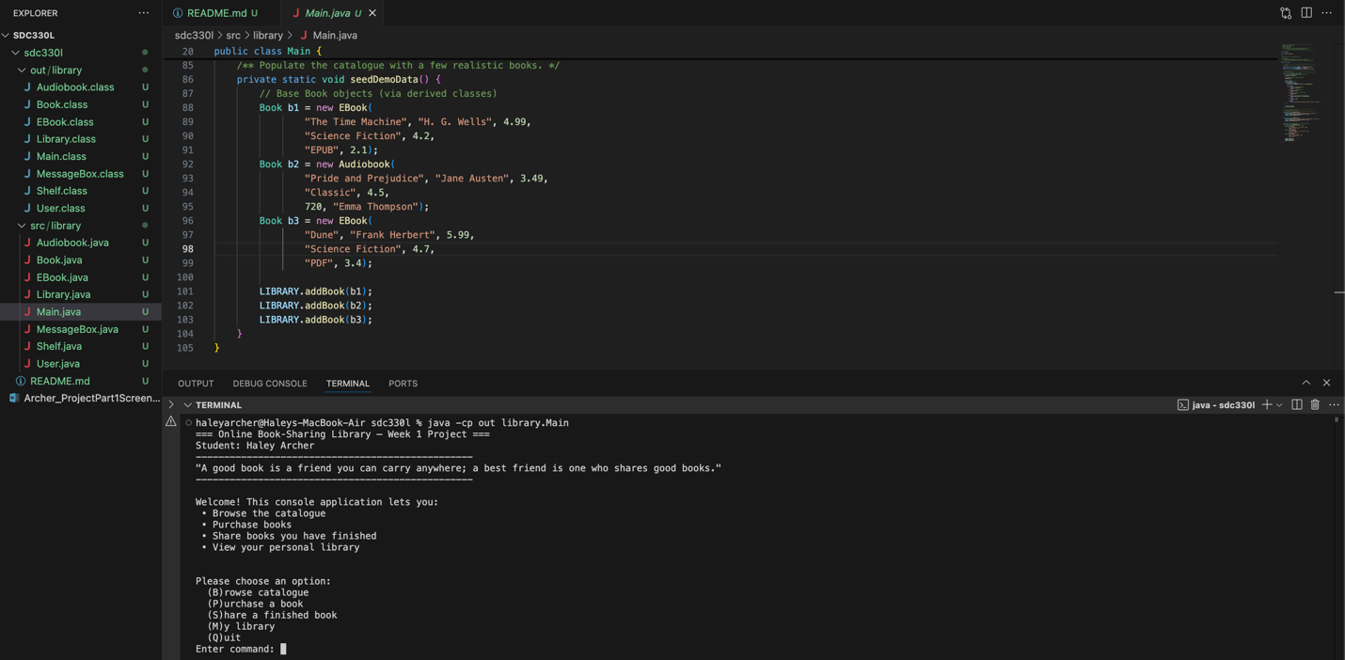
Screenshot of welcome message and initial instructions
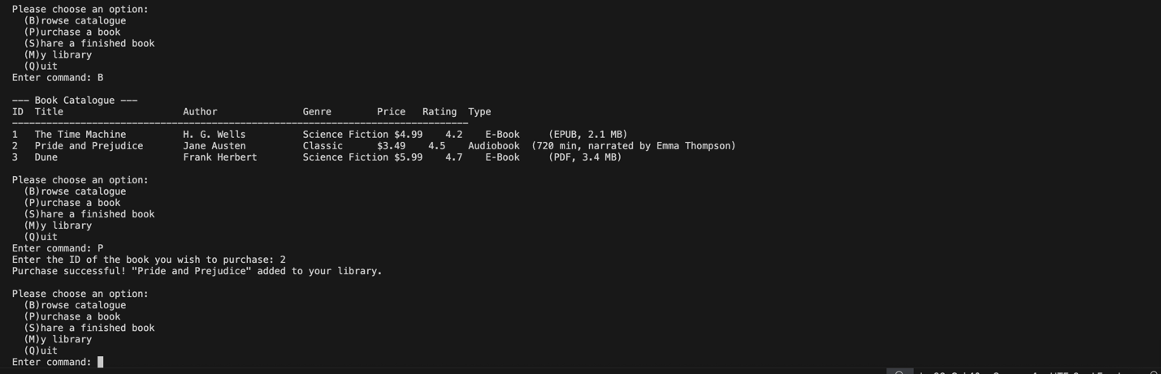
Screenshot showing interaction with menus and brief response messages

