1. Project Overview
This console-based Java application implements an online book-sharing library where users can browse, purchase, borrow, and share books. The system demonstrates core object-oriented principles: inheritance, composition, polymorphism, and interface implementation.
Week 2 Focus: Implementation of the Borrowable interface and demonstration of polymorphism through book-type-specific borrow periods.

2. Class Architecture
Class | Purpose & OO Concept
Borrowable | [Interface] Defines contract for borrowable items. Enables polymorphism.
Book | Base class implementing Borrowable. Common attributes: title, author, price, genre, rating.
EBook | [Inheritance] Extends Book. Adds format, file size. 21-day borrow period.
Audiobook | [Inheritance] Extends Book. Adds duration, narrator. 30-day borrow period.
Library | [Composition] Has-many Books. Manages catalogue, borrow/return operations.
User | [Composition] Has-a Shelf. Manages wallet and book ownership.
Shelf | [Composition] Has-many Books. Collection of user-owned books.
Main | Application entry point. Command loop and polymorphism demo.
MessageBox | Utility class centralizing all UI text.

3. Object-Oriented Design

3.1 Inheritance
Base: Book | Derived: EBook, Audiobook
Shared: ID generation, common attributes (title, author, price), Borrowable interface implementation, toString() formatting
Unique: EBook adds format/fileSize; Audiobook adds duration/narrator; Each has different borrow period

3.2 Composition
- User has-a Shelf: Personal book collection
- Shelf has-many Books: Owned books list
- Library has-many Books: Complete catalogue

3.3 Polymorphism (Week 2)
The Borrowable interface's getBorrowPeriodDays() method demonstrates polymorphism. Each book type returns a different value:
- EBook → 21 days (digital convenience)
- Audiobook → 30 days (longer content)
- Regular Book → 14 days (standard)
The Library class works with any Borrowable without knowing the specific type. Same method call, different behavior based on actual object type.

3.4 Interface Implementation
Borrowable Interface Methods:
- boolean borrow(String userName) - Mark as borrowed
- boolean returnItem() - Return to library
- boolean isBorrowed() - Check status
- String getBorrower() - Get borrower name
- int getBorrowPeriodDays() - Get period (polymorphic)
Why Interface? Enables future extensibility (magazines, DVDs), polymorphic behavior in Library, separation of concerns, and testability.

4. Class Relationships
<<interface>> Borrowable
▲
| implements
▼
Book
(base class)
▲
| extends
▼
EBook Audiobook
───────────────────────
User ◆── Shelf ◆── Book
(composition: has-a / has-many)
Library ◆── Book
(composition: has-many)

5. Implementation Summary & Next Steps

5.1 Week 2 Accomplishments
- Created Borrowable interface with 5 methods
- Implemented interface in Book base class
- Demonstrated polymorphism with book-type-specific borrow periods
- Added borrow/return functionality to Library
- Created explicit polymorphism demonstration at startup
- Maintained inheritance and composition from Week 1

5.2 Week 3 Plans
- Implement constructors with validation
- Apply proper access specifiers (private, protected, public)
- Create abstract base class for media items

5.3 Week 4 Plans
- Integrate SQLite database for persistent storage
- Implement CRUD operations for books and users
- Add transaction history tracking

6. Screenshots

6.1 Startup

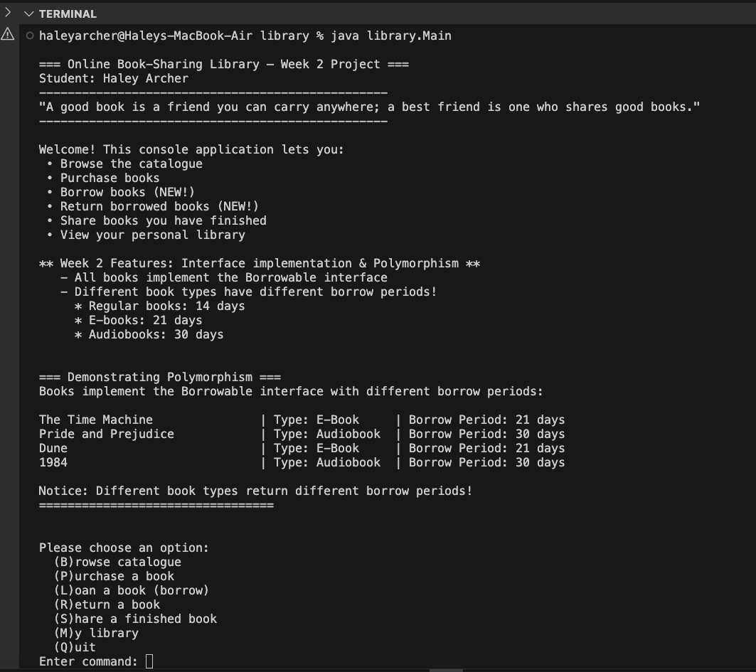

6.2 Browse Catalog

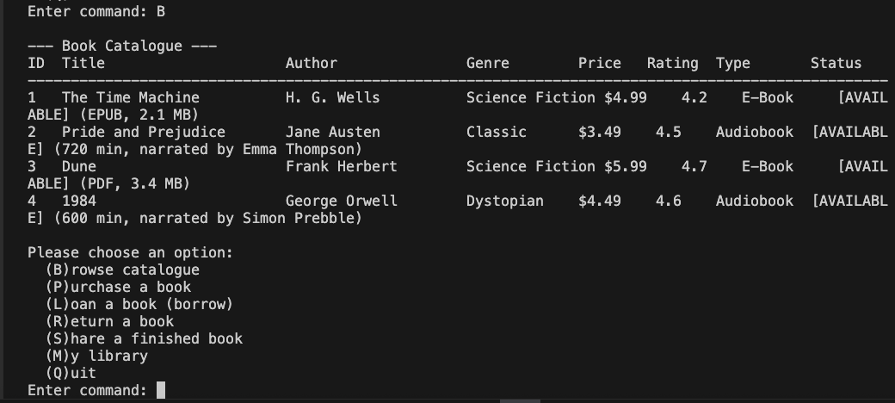

6.3 Borrow Audiobook

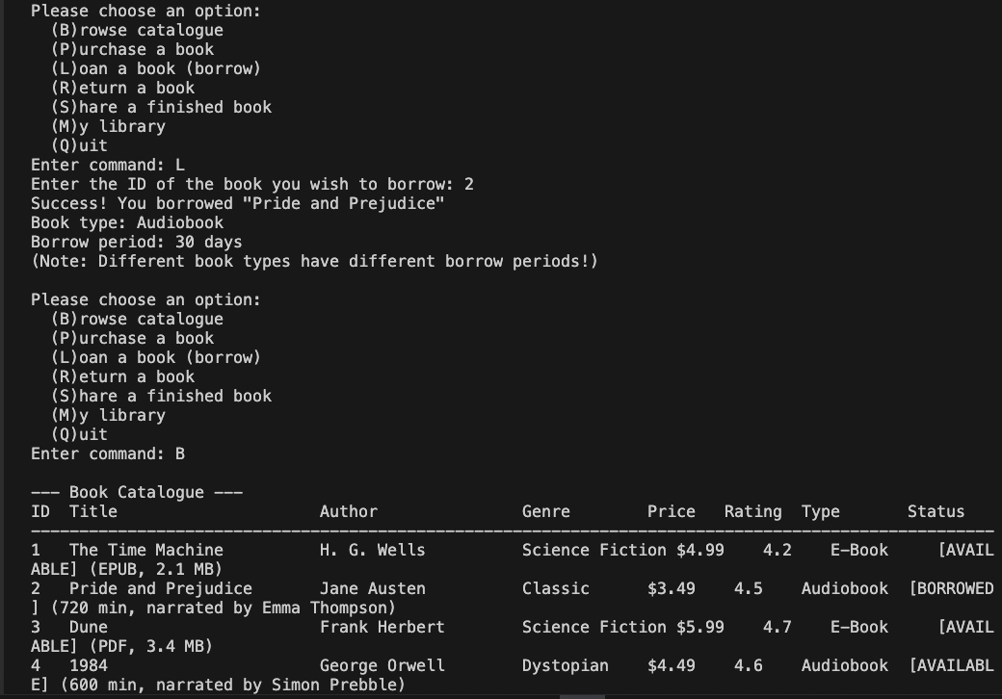

6.4 Borrow E-Book

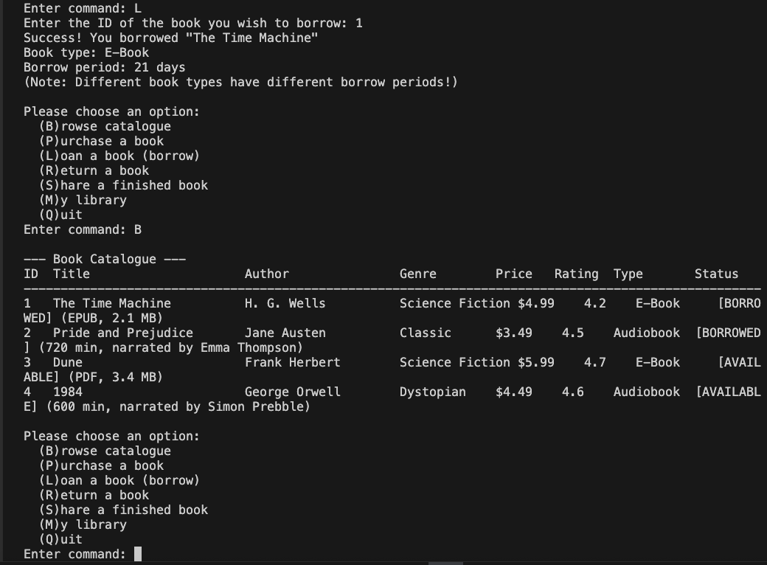

7. Conclusion
This design successfully implements all required Week 2 OOP concepts. The Borrowable interface provides a clean abstraction for borrowable items, while polymorphism is clearly demonstrated through type-specific borrow periods. The architecture builds naturally on Week 1's inheritance and composition, creating a maintainable and extensible system ready for database integration in Week 4.

