1. Project Overview
This console-based Java application implements an online book-sharing library where users can browse, purchase, borrow, and share books. The system demonstrates core object-oriented principles: inheritance, composition, polymorphism, interface implementation, abstraction, constructors, and access specifiers.
Week 2-3 Focus: Implementation of the Borrowable interface, polymorphism through book-type-specific borrow periods, abstract Media class with abstract methods, multiple constructors with chaining, and proper access specifier usage.

2. Class Architecture
Class | Purpose & OO Concept
Borrowable | [Interface] Defines contract for borrowable items. Enables polymorphism.
Media | [Abstract Class - Week 3] Base class for all media types. Defines abstract methods: getMediaType(), getTypeSpecificInfo(), calculateLateFee().
Book | Extends Media. Common book attributes: title, author, price, genre, rating, pageCount. Multiple constructors (Week 3).
EBook | [Inheritance] Extends Book. Adds format, file size. 21-day borrow period, $0.25/day late fee.
Audiobook | [Inheritance] Extends Book. Adds duration, narrator. 30-day borrow period, $0.75/day late fee.
Library | [Composition] Has-many Media items. Manages catalogue, borrow/return operations. Multiple constructors (Week 3).
User | [Composition] Has-a Shelf. Manages wallet and book ownership. Enhanced access specifiers (Week 3).
Shelf | [Composition] Has-many Books. Collection of user-owned books. Package-private methods (Week 3).
Main | Application entry point. Demonstrates all OO concepts.
MessageBox | Utility class centralizing all UI text.

3. Object-Oriented Design

3.1 Abstraction (Week 3)
Abstract Media Class: Serves as the base for all media types. Defines three abstract methods that subclasses must implement:
- getMediaType() - Returns the type (Book, E-Book, Audiobook)
- getTypeSpecificInfo() - Returns formatted details specific to each type
- calculateLateFee(int days) - Calculates late fees (Book: $0.50/day, E-Book: $0.25/day, Audiobook: $0.75/day)
Benefits: Easy to add new media types, eliminates code duplication, enforces consistent structure, enables polymorphic handling.

3.2 Constructors (Week 3)
Multiple constructors with chaining implemented in all classes:
- Full constructors - Accept all parameters with validation
- Partial constructors - Chain to full constructor with defaults
- Minimal constructors - Require only essential fields
All constructors include input validation to prevent invalid states.

3.3 Access Specifiers (Week 3)
- Private: All instance fields (wallet, borrower, genre, etc.)
- Protected: Methods for inheritance (setBorrowPeriod, getId, getTitle)
- Public: External interface methods (borrow, returnItem, listCatalog)
- Package-private: Related class access only (debit, addBook, removeBook)

3.4 Inheritance
Hierarchy: Media → Book → EBook/Audiobook
Shared: ID generation, common attributes, Borrowable implementation, toString() formatting
Unique: EBook adds format/fileSize; Audiobook adds duration/narrator; Each has different borrow period and late fee

3.5 Composition
- User has-a Shelf: Personal book collection
- Shelf has-many Books: Owned books list
- Library has-many Media: Complete catalogue

3.6 Polymorphism
The Borrowable interface's getBorrowPeriodDays() and abstract calculateLateFee() methods demonstrate polymorphism:
- EBook → 21 days, $0.25/day
- Audiobook → 30 days, $0.75/day
- Regular Book → 14 days, $0.50/day

4. Class Relationships
<<interface>> Borrowable
▲
| implements
▼
Media (abstract)
(abstract base class)
▲
| extends
▼
Book
▲
| extends
▼
EBook Audiobook
───────────────────────
User ◆── Shelf ◆── Book
(composition: has-a / has-many)
Library ◆── Media
(composition: has-many)

5. Implementation Summary & Next Steps

5.1 Week 2-3 Accomplishments
- Created Borrowable interface with 5 methods (Week 2)
- Demonstrated polymorphism with book-type-specific borrow periods (Week 2)
- Created abstract Media class with 3 abstract methods (Week 3)
- Refactored Book to extend Media (Week 3)
- Implemented multiple constructors with chaining in all classes (Week 3)
- Applied proper access specifiers throughout codebase (Week 3)
- Added input validation to all constructors (Week 3)
- Improved encapsulation with private fields and controlled access (Week 3)

5.2 Week 4 Plans (Database Integration)
- Integrate SQLite database for persistent storage
- Implement CRUD operations for books and users
- Add transaction history tracking

5.3 Week 5 Plans (Final Integration)
- Complete all remaining features
- Comprehensive testing and bug fixes
- Final documentation and polish

6. Screenshot

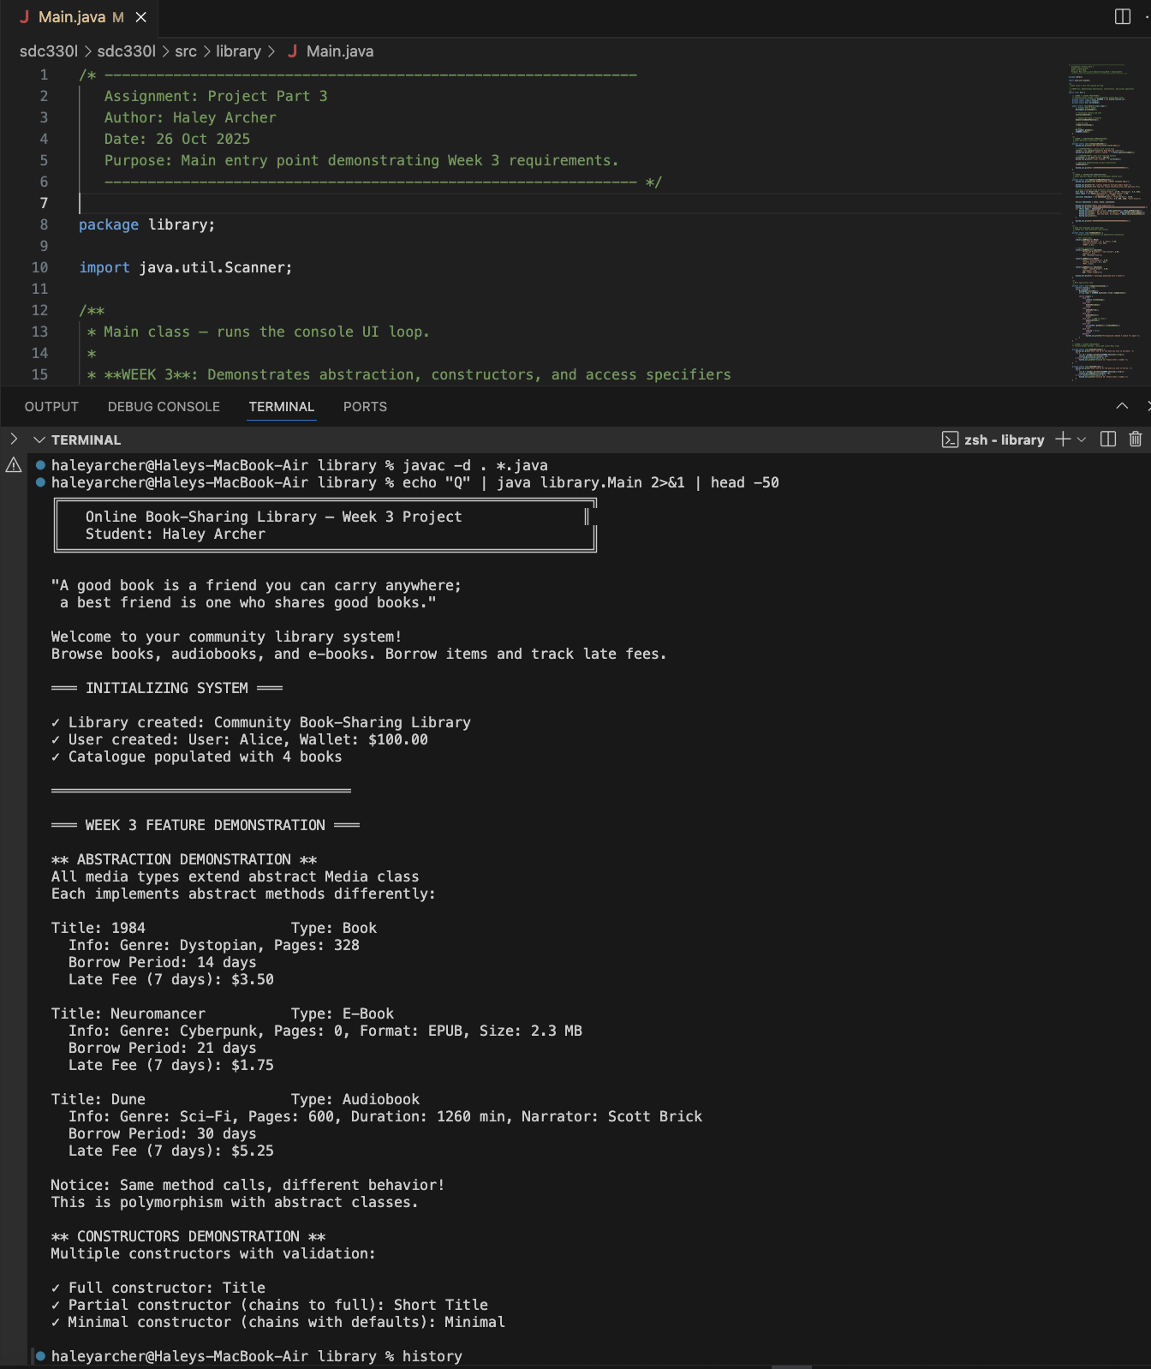

7. Conclusion
This design successfully implements all required Week 2-3 OOP concepts. The abstract Media class provides a clean foundation for all media types, while polymorphism is demonstrated through both the Borrowable interface and abstract methods. Multiple constructors with chaining offer flexibility, and proper access specifiers ensure encapsulation. The architecture is maintainable, extensible, and ready for database integration in Week 4.

