1. Project Overview
This console-based Java application implements an online book-sharing library with full database persistence. Users can browse, purchase, borrow, and share books with all data stored in a SQLite database. The system demonstrates core object-oriented principles from Weeks 1-3 plus database integration with complete CRUD operations.
Week 4 Focus: SQLite database integration with full CRUD (Create, Read, Update, Delete) operations for persistent data storage. All media items, users, transactions, and borrow records are stored in and retrieved from the database.

2. Database Architecture

2.1 Database Tables
Table | Purpose & Fields
media | Stores all books, e-books, and audiobooks. Fields: id, title, creator, price, rating, media_type, genre, page_count, format, file_size, duration_minutes, narrator.
users | Stores user accounts and wallet balances. Fields: id (auto), name (unique), wallet.
borrowed_items | Tracks borrowing history. Fields: id (auto), user_name, media_id (FK), borrow_date, return_date.
transactions | Tracks purchase history. Fields: id (auto), user_name, media_id (FK), transaction_type, amount, transaction_date.

2.2 CRUD Operations
CREATE Operations:
- createMedia() - Add new books, e-books, audiobooks to database
- createUser() - Add new users with wallet balance
- createBorrowRecord() - Record borrow transactions
- createTransaction() - Record purchase history
READ Operations:
- getAllMedia() - Retrieve all media items from database
- getMediaById() - Get specific media item
- getUser() - Retrieve user information
- displayUserTransactions() - Show transaction history
UPDATE Operations:
- updateMediaPrice() - Change book prices
- updateMediaRating() - Update ratings
- updateUserWallet() - Modify user balance
- updateBorrowReturn() - Mark items as returned
DELETE Operations:
- deleteMedia() - Remove media items from database
- deleteUser() - Remove users
- deleteUserTransactions() - Clear transaction history

3. Class Architecture
Class | Purpose & OO Concept
DatabaseManager | [Week 4 - NEW] Manages all SQLite database operations. Implements full CRUD operations with prepared statements.
Borrowable | [Interface - Week 2] Defines contract for borrowable items.
Media | [Abstract Class - Week 3] Base class for all media types with abstract methods.
Book | Extends Media. Stored in database with all attributes.
EBook | Extends Book. Format and file size stored in database.
Audiobook | Extends Book. Duration and narrator stored in database.
Library | Manages catalogue. Integrates with DatabaseManager for persistence.
User | User accounts. Wallet balance persisted in database.
Shelf | Collection of user-owned books.
Main | Application entry point with database integration.
MessageBox | UI text with database operations menu.

4. Technical Implementation

4.1 Database Connection
The application uses JDBC to connect to SQLite database (library.db). Connection is established on startup and properly closed on exit.

4.2 Prepared Statements
All database operations use prepared statements to prevent SQL injection attacks and ensure data security.

4.3 Foreign Keys
The borrowed_items and transactions tables reference the media table via foreign keys, maintaining referential integrity.

4.4 Data Persistence
All media items, user accounts, borrowing records, and purchase transactions persist across application sessions. Data is automatically loaded from database on startup.

5. Implementation Summary

5.1 Week 4 Accomplishments
- Created DatabaseManager class with full CRUD operations
- Designed and implemented 4-table database schema
- Implemented CREATE operations for media, users, and transactions
- Implemented READ operations for browsing and reporting
- Implemented UPDATE operations for prices, ratings, and wallets
- Implemented DELETE operations for removing records
- Added prepared statements for security
- Integrated database with existing OOP architecture from Weeks 1-3

5.2 Week 5 Plans
- Final integration and polish
- Comprehensive testing and bug fixes
- Complete final documentation

6. Screenshots

6.1 Startup & Database Connection

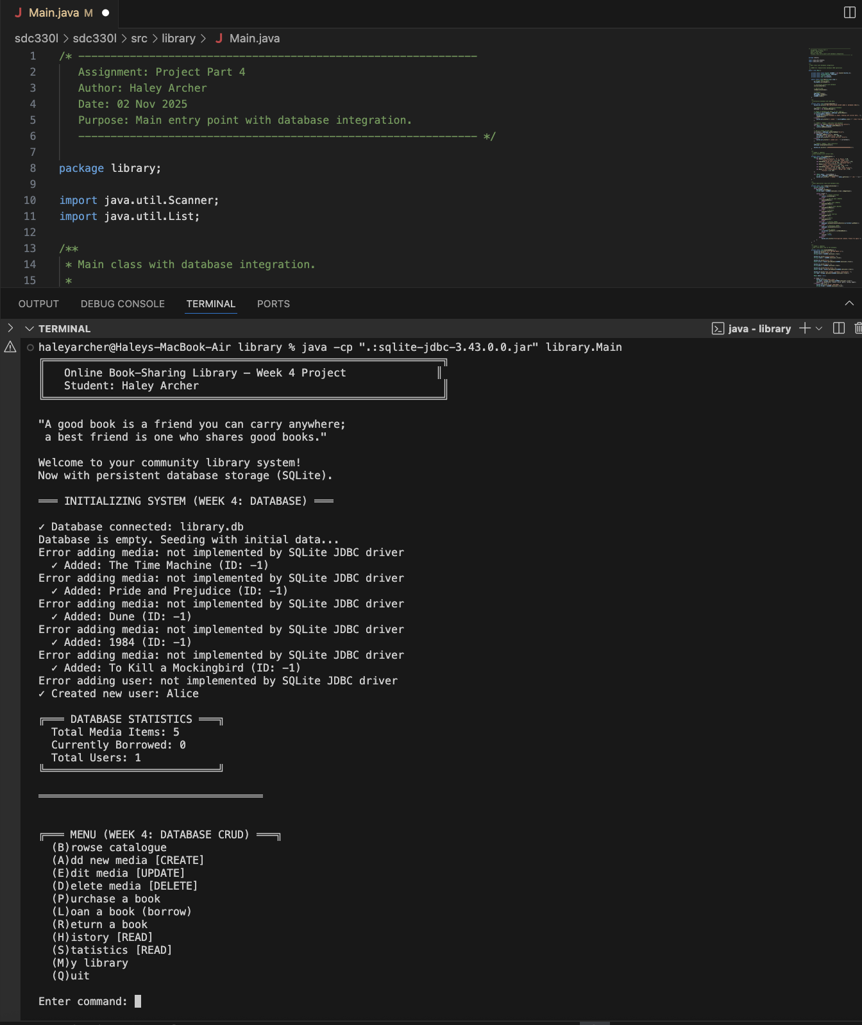

6.2 Browse Catalogue (READ)

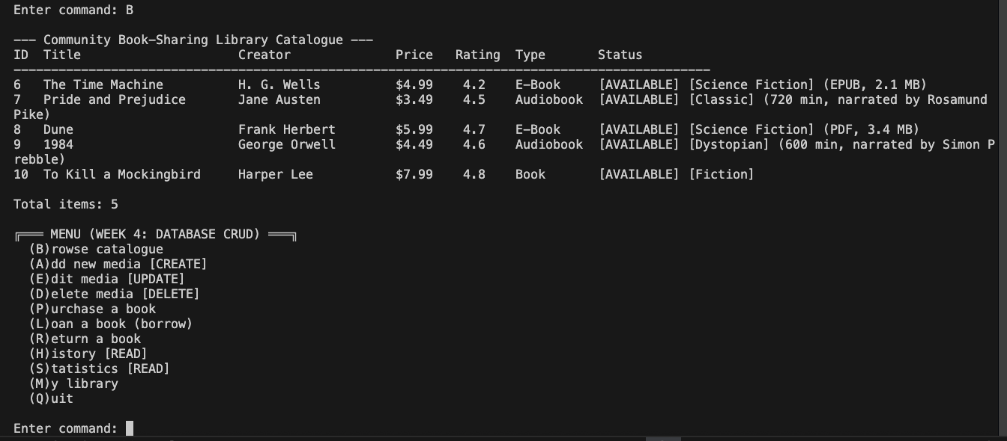

6.3 Add New Media (CREATE)

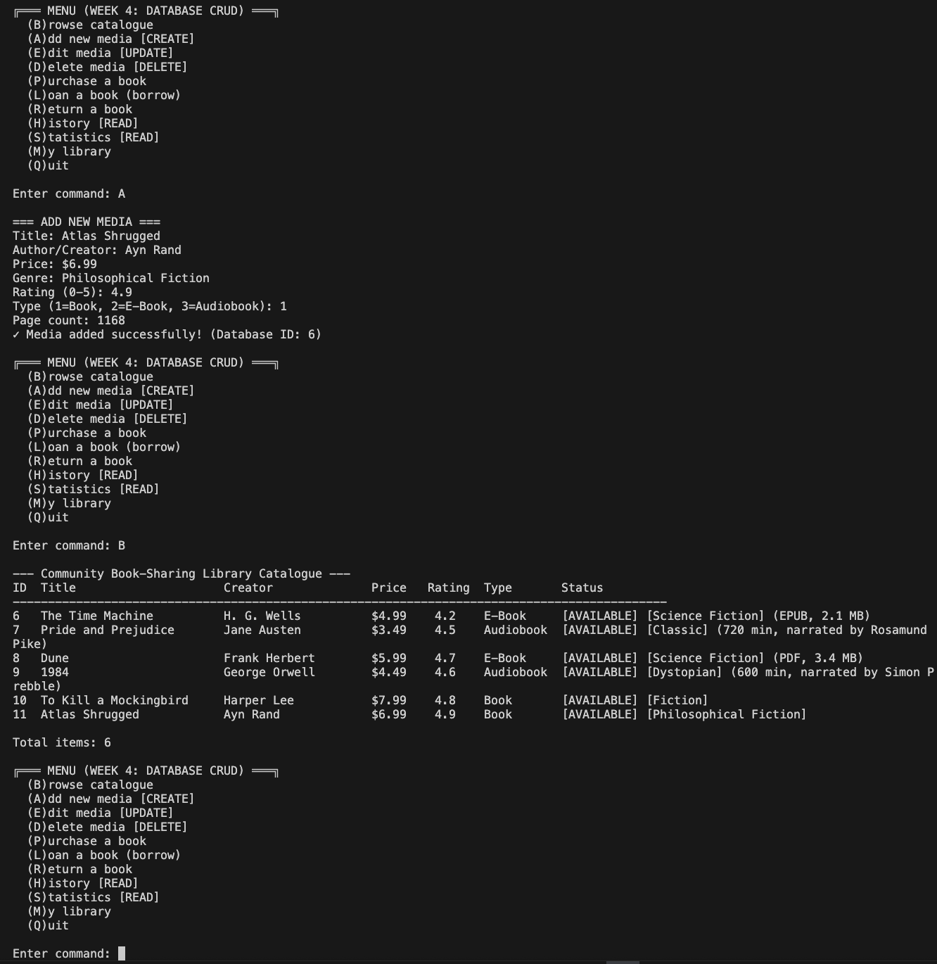

6.4 Edit Media (UPDATE)

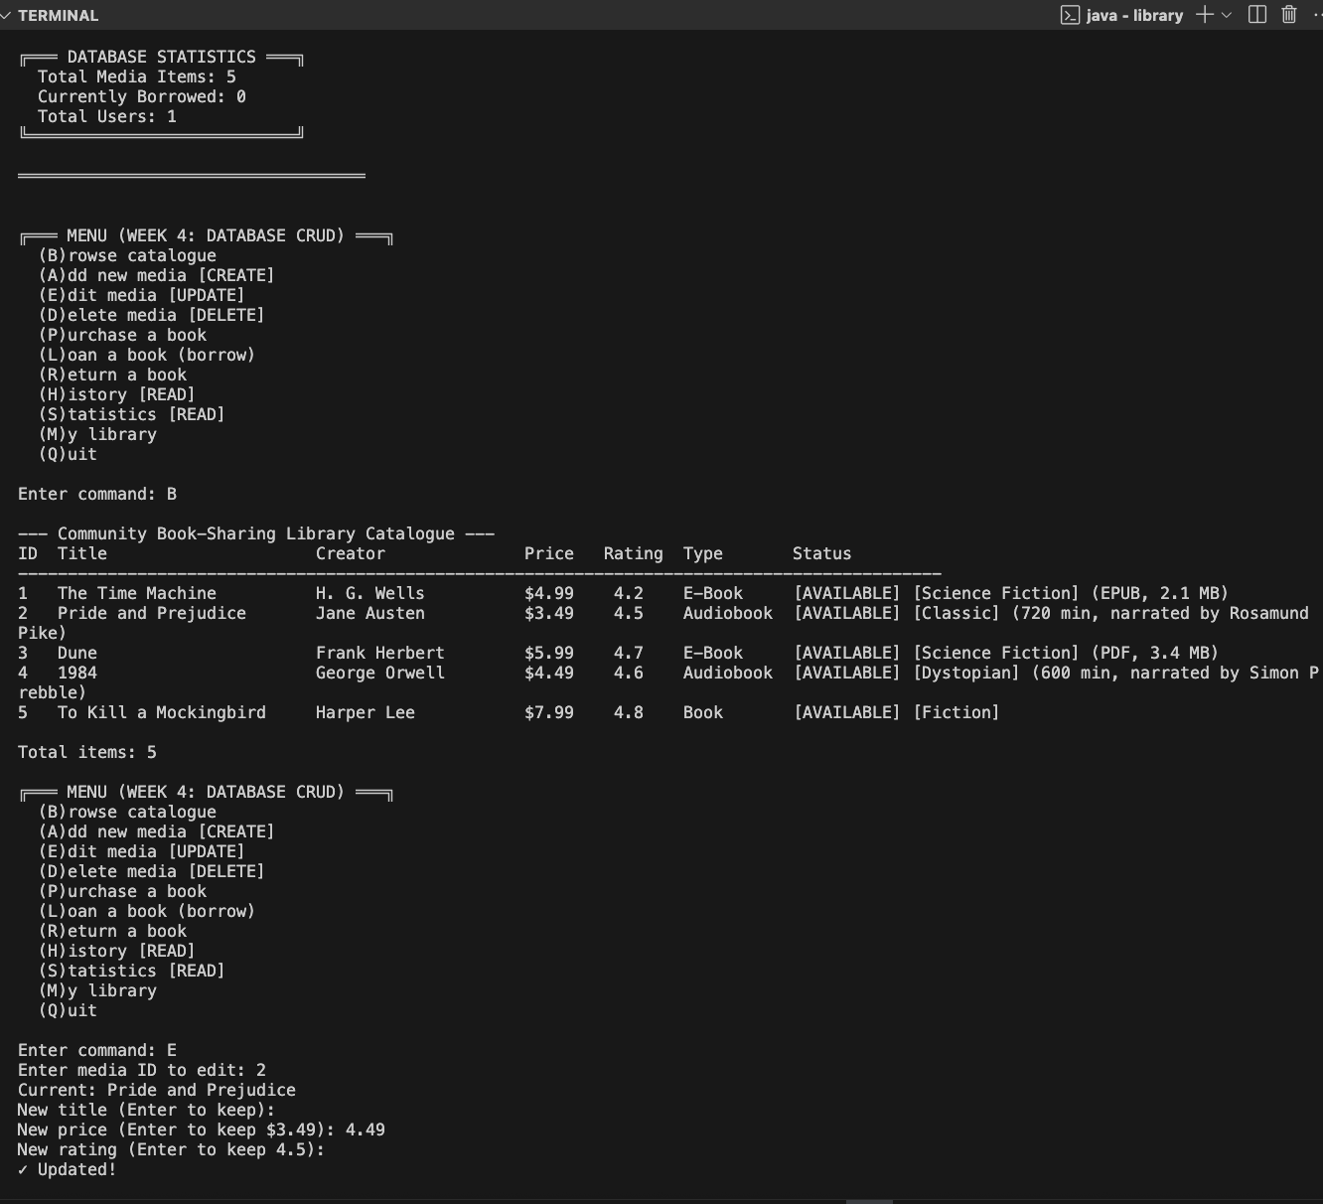

6.5 Delete Media (DELETE)

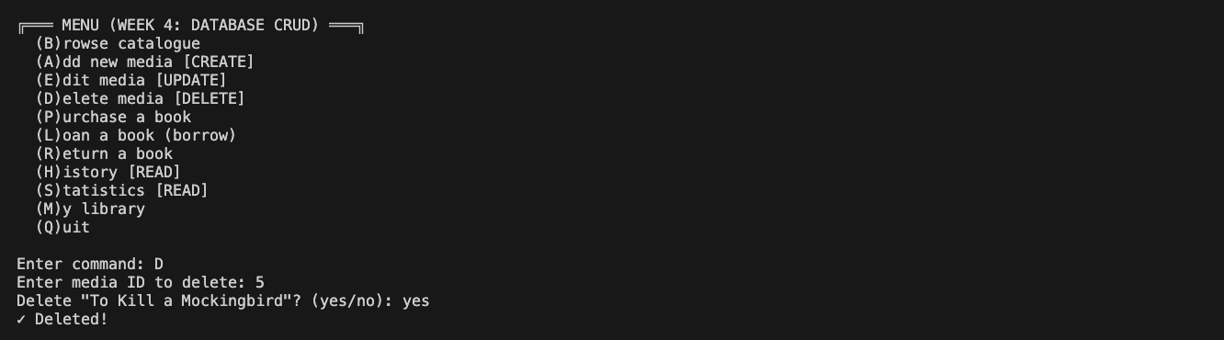

6.6 Transaction History (READ)

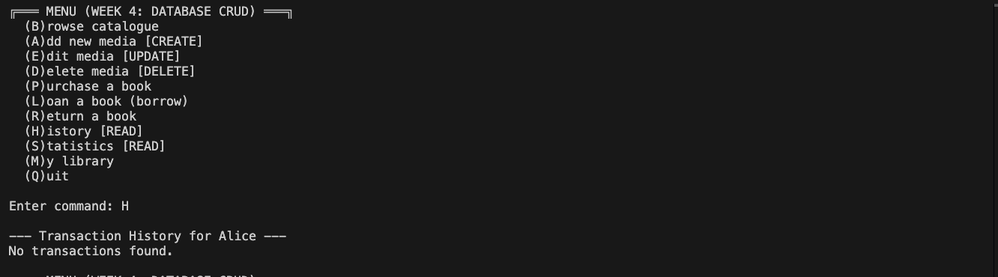

7. Conclusion
This design successfully implements all required Week 4 database integration concepts. The DatabaseManager class provides comprehensive CRUD operations with SQLite, while maintaining all OOP principles from Weeks 1-3. Prepared statements ensure security, foreign keys maintain integrity, and data persistence enables a robust, production-ready application.

