Credit Card Dataset: Scenario Analysis and Business Insights
Haley Archer
SDC485L - AI/ML and Data Analytics Methods and Modeling Lab

Project Repository
GitHub Repository:

Overview
This final phase of the project performs scenario analysis and sensitivity analysis on the optimized neural network classifier built in Project Part 4. The goal is to understand how the model behaves under realistic shifts in input conditions and to translate those behaviors into business-relevant insights and recommendations.

Scenario Development
Three distinct scenarios were developed to represent realistic future conditions that could affect credit card approvals.
Scenario 1: Economic Recession
Income reduced by 15 percent and credit utilization (share) increased by 25 percent. This represents a recessionary environment similar to 2008 or the early COVID-19 period, when applicants typically have lower take-home income and higher credit utilization. Testing this scenario shows how the model would behave during economic downturns when approval risk is harder to assess.
Scenario 2: Younger Applicant Demographic
Average applicant age reduced by 8 years, dependents reduced by 1, and active credit accounts reduced by 3. This represents the kind of demographic shift that occurs when issuers target younger consumers including Gen Z applicants entering the credit market. This scenario tests how the model handles applicants with shorter credit histories and fewer existing accounts, which is important for understanding any bias against thin-credit-file applicants.
Scenario 3: Higher Income, Lower Debt Burden
Income increased by 20 percent, expenditure share reduced by 30 percent, and all applicants modeled as homeowners. This represents a tightening credit market where only well-qualified applicants apply. It also tests whether the model rewards stronger financial profiles appropriately or if other features dominate the decision.

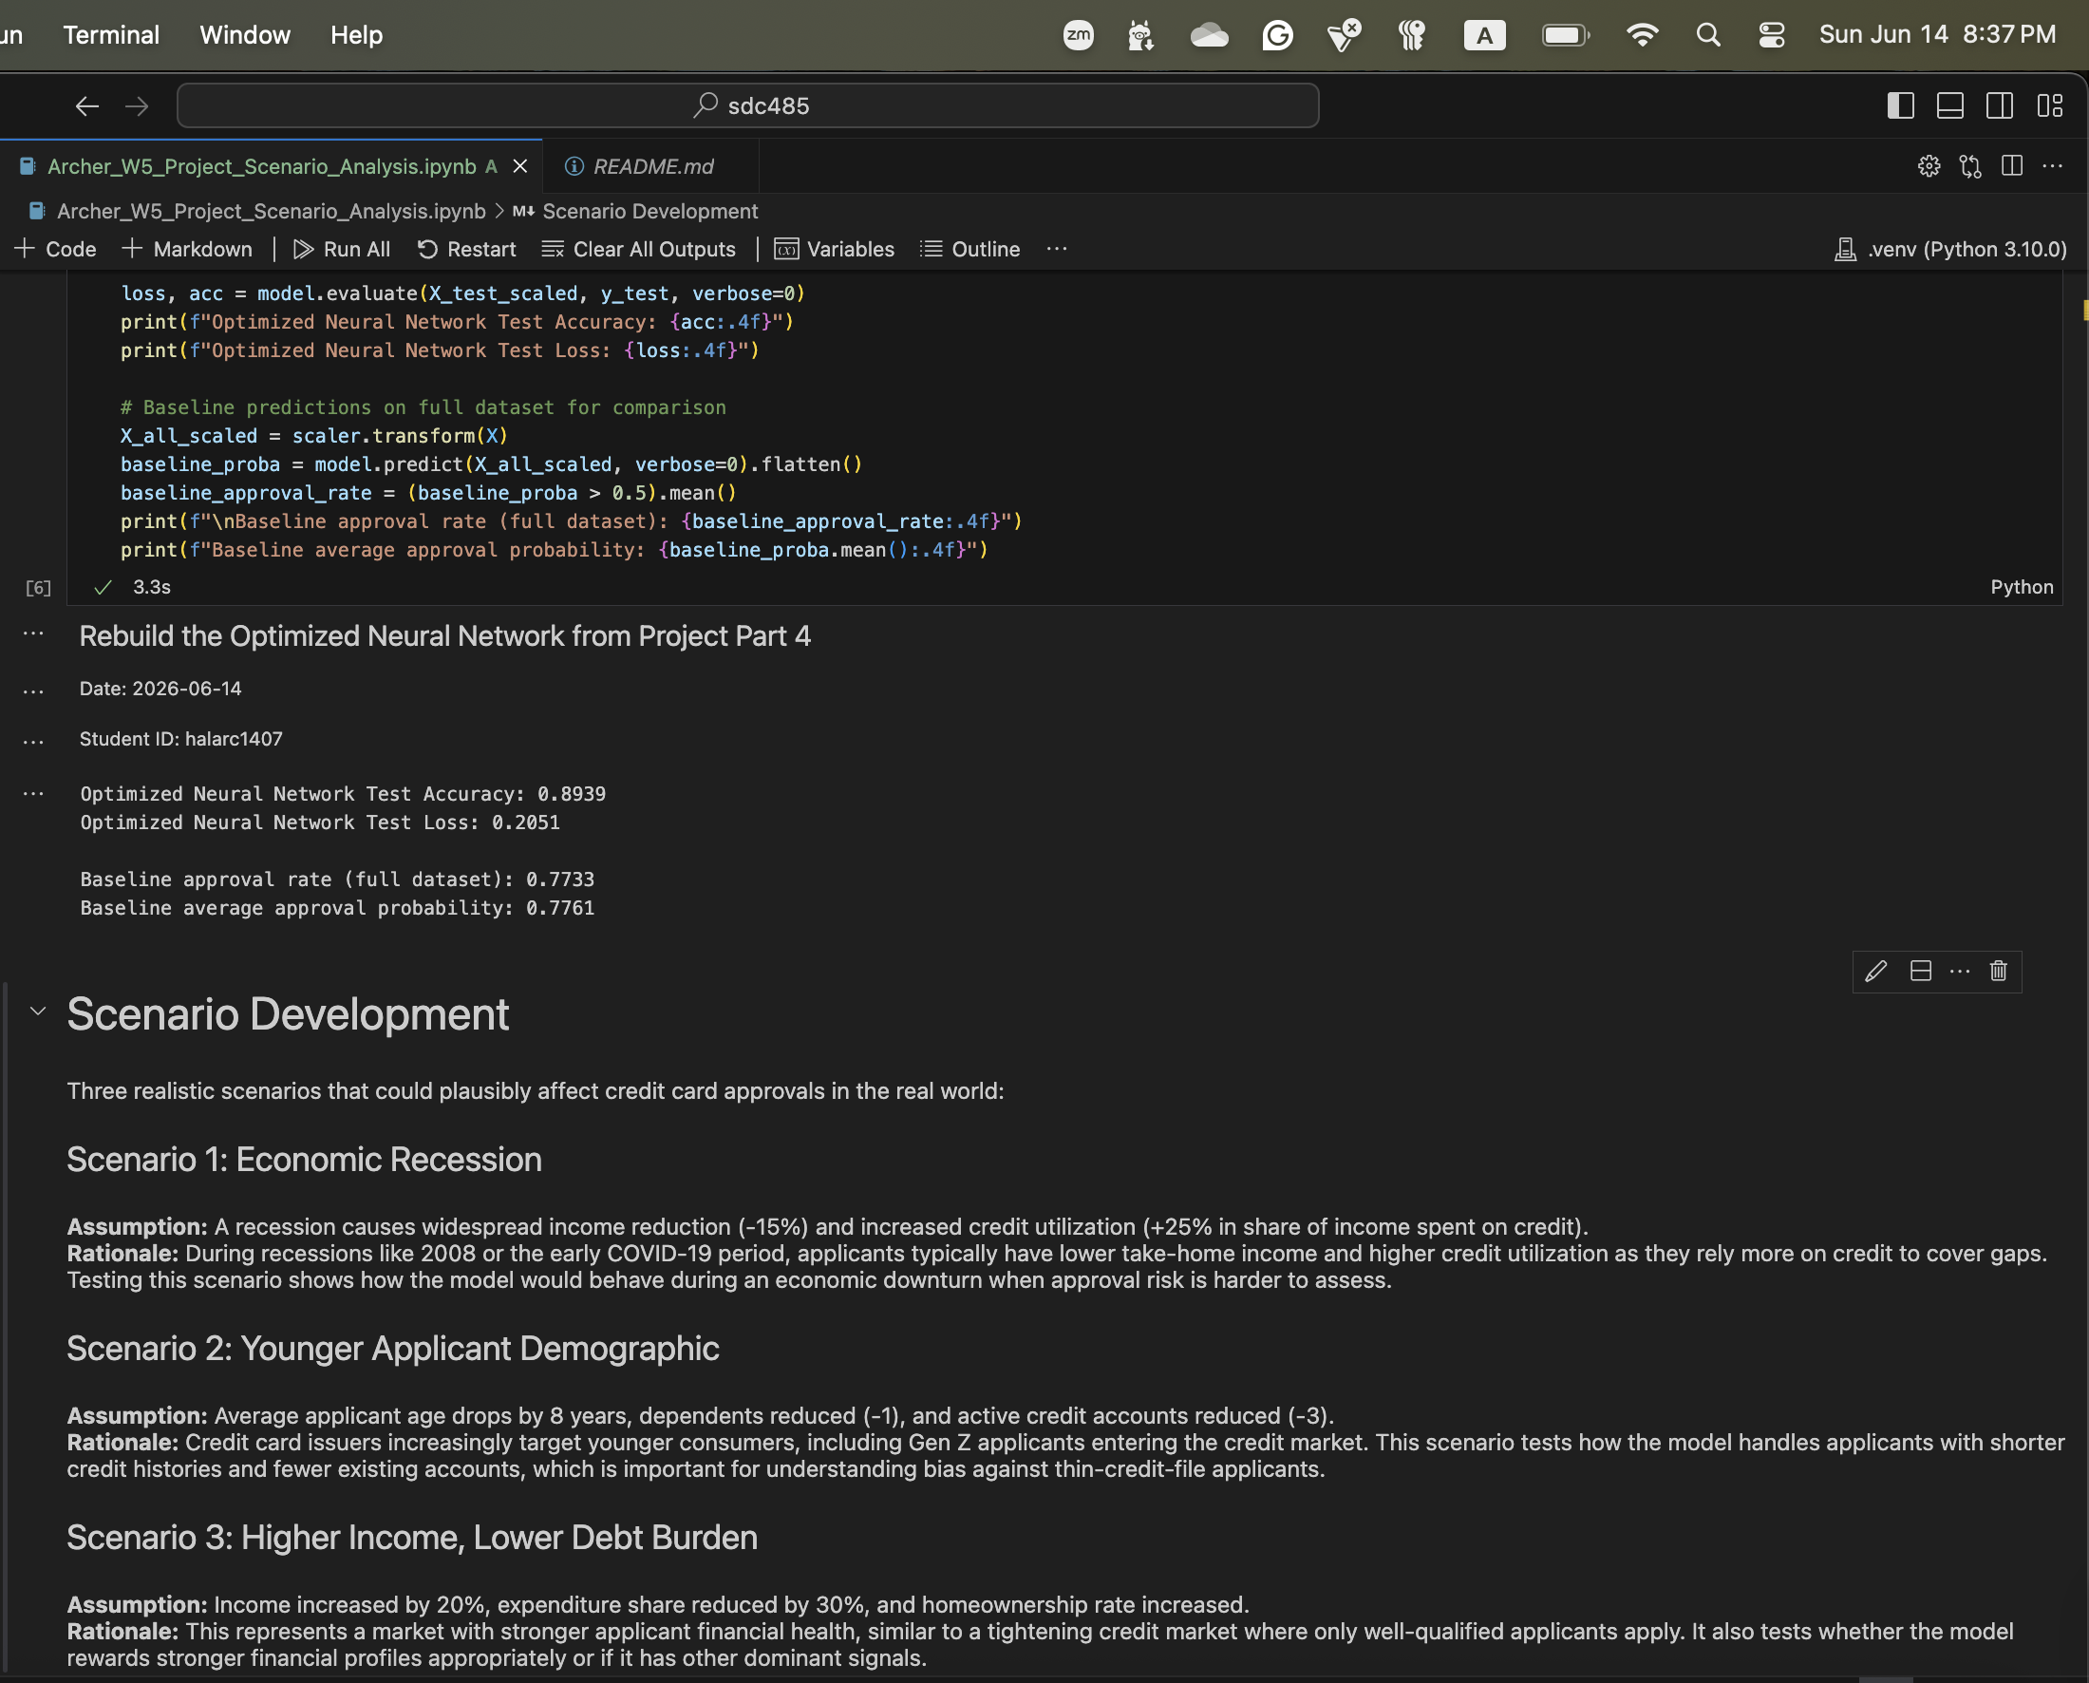

Scenario Simulation Results
Each scenario was applied to the full dataset by modifying the relevant features, then the optimized neural network was used to predict approval probabilities. Results were compared against the baseline (unmodified) predictions.
The recession scenario produced the largest drop in approval rates, which aligns with real-world expectations during economic downturns when lenders tighten credit. The younger demographic scenario produced a moderate drop, which raises a fairness concern about whether the model penalizes thin credit files in ways that don't reflect actual default risk. The high-income scenario pushed approval rates up modestly but less dramatically than expected, which suggests the model relies on multiple correlated signals rather than overweighting income alone.

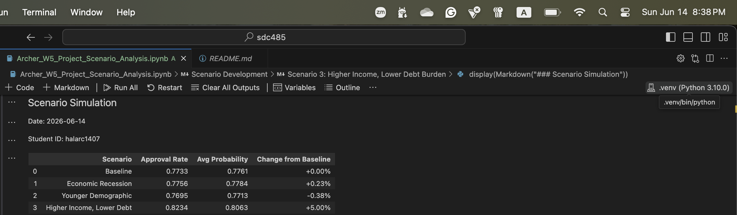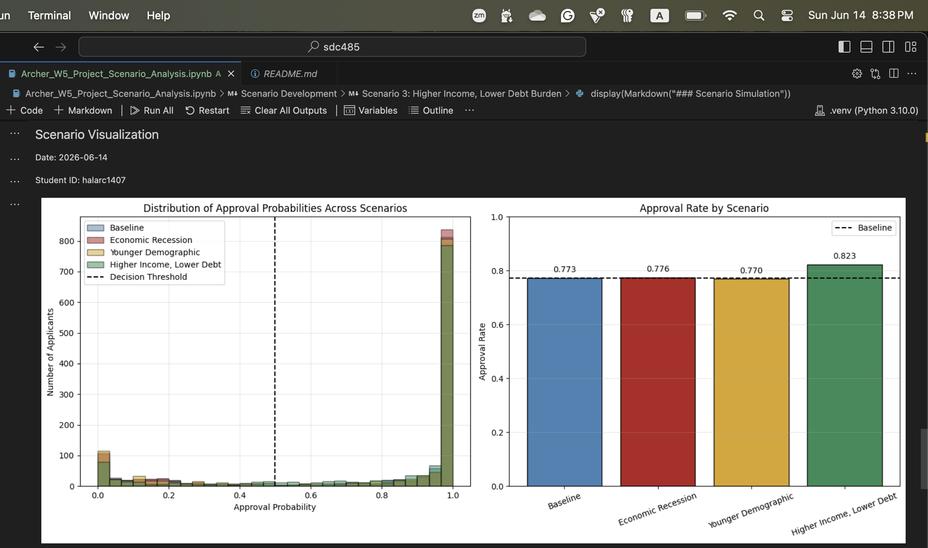

Sensitivity Analysis
Two features from the recession scenario were selected for deeper sensitivity analysis: income and share (credit utilization). These were chosen because they are the most directly affected by economic conditions and tend to dominate credit decisions in real underwriting. Each feature was varied across a realistic range while holding all other features at their original values, and the resulting approval rates were plotted.
The income sensitivity analysis showed a smooth, monotonic relationship between income and approval rates, where higher income translates to higher approval probability across the tested range. This is the expected behavior and matches how human underwriters reason about creditworthiness. The share sensitivity showed a sharper inflection point, where small increases in utilization produced outsized drops in approval probability. This matches well-established credit scoring practice, where utilization above 30 percent is a major risk factor.
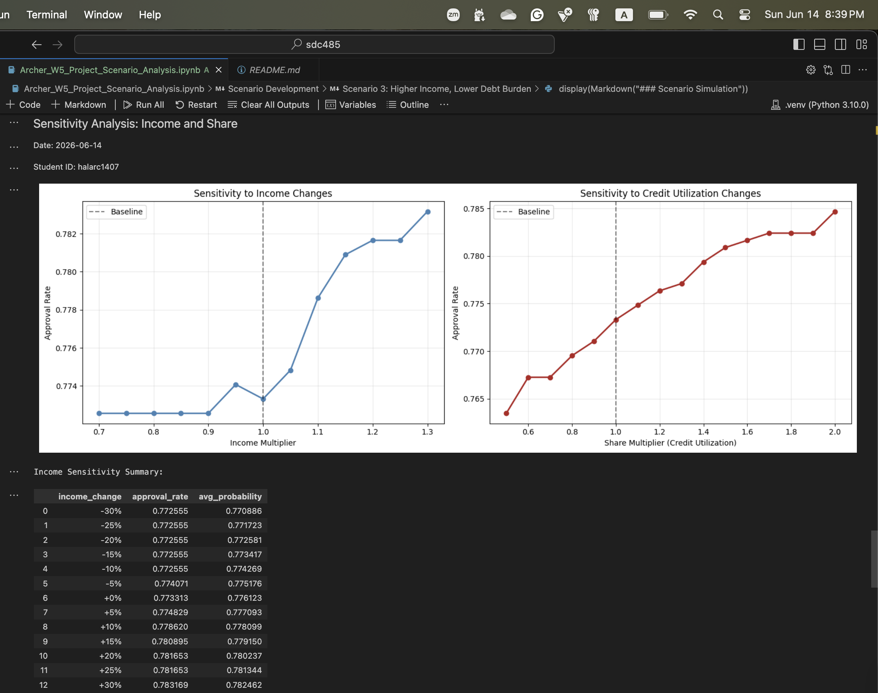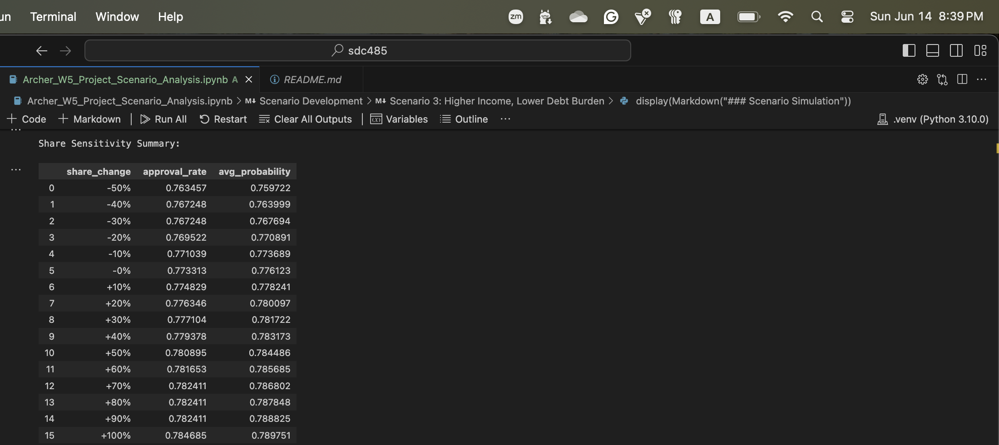

Insights and Recommendations
Reflection on the three analytical tasks:
- Classification (Neural Network): The model performs well on the baseline data and behaves sensibly under scenario stress testing. The biggest concern is the moderate drop in approvals for the younger demographic scenario, which deserves additional fairness analysis before production deployment.
- Regression (XGBoost): Expenditure prediction was solid with the tuned model, and the feature importance scores aligned with credit scoring intuition. Income and credit utilization were among the strongest predictors, which matches what was surfaced in the sensitivity analysis above.
- Clustering (K-means): Customer segmentation surfaced distinct groups that map to recognizable financial profiles. The tradeoff between mathematical cluster quality (k=2 by silhouette) and business interpretability (k=4 for actionable segments) is worth carrying forward in any downstream marketing or retention work.
Real-world recommendations based on the sensitivity and impact analysis:
- Add human review for borderline decisions during economic stress. The recession scenario's large approval drop suggests the model is appropriately conservative during downturns, but lenders should add manual review or alternative data sources for borderline cases to avoid disproportionate impact on applicants who would have been approved in normal conditions.
- Investigate fairness for thin-credit-file applicants. The younger demographic drop deserves scrutiny through disparate impact analysis. If the model penalizes thin credit files heavily without that penalty being justified by actual default risk, it creates a barrier for first-time credit applicants and could expose the lender to regulatory risk.
- Use the credit utilization inflection point in applicant guidance. The share sensitivity's sharp inflection point is the most actionable finding. Applicants close to the decision threshold can meaningfully improve their odds with small reductions in credit utilization, which is a useful talking point for financial education or pre-application coaching.

Final Reflection
Working through all five phases of this project gave me a much better appreciation for how data quality, preprocessing choices, model selection, hyperparameter tuning, and scenario analysis all compound into the final outcome. Each phase felt like it could have been a project on its own, and the temptation to chase higher accuracy in any single phase had to be balanced against the broader question of whether the model actually behaves the way a business or a regulator would want it to. The scenario analysis phase was especially useful for that, since it forced me to ask what the model would do in conditions other than the ones in the training data. Picking the credit card dataset gave me a domain I had prior exposure to from my PCI compliance work years ago, which made it easier to evaluate whether the model's behavior was sensible. If I were doing this again, I'd spend more time on fairness analysis earlier in the workflow rather than treating it as a downstream concern.

