Credit Card Dataset: Basic ML Implementation Report
Haley Archer
SDC485L - AI/ML and Data Analytics Methods and Modeling Lab

Overview
This report documents the implementation of three machine learning models on the Credit Card dataset, each addressing one of the analytical tasks defined in Project Parts 1 and 2: classification of credit card approval, regression for monthly credit expenditure, and clustering for customer segmentation. The work builds on the preprocessing completed in Part 2, including median/mode imputation, one-hot encoding of categorical features, and standardization of numerical features.

Task 1: Classification (Credit Card Approval)
Algorithm: Neural Network (TensorFlow/Keras)
I chose a feedforward neural network for the classification task because the project instructions specifically call out TensorFlow as a target framework, and a small neural network can capture the non-linear interactions between demographic, financial, and credit history features that drive approval decisions. With 1,319 samples, the dataset is large enough to train a modest network without running into severe overfitting, especially with a held-out validation split during training.
Hyperparameter choices:
- Architecture: Two hidden layers (16 and 8 units). Kept the network shallow to avoid overfitting on a modest dataset while still allowing the model to learn non-linear patterns.
- Activation functions: ReLU for hidden layers (standard, avoids vanishing gradients) and sigmoid for the output (binary classification).
- Loss function: Binary crossentropy, the standard choice for binary classification problems.
- Optimizer: Adam, which adapts the learning rate during training and is a strong default.
- Epochs and batch size: 50 epochs with batch size 32, monitored against a validation split to catch overfitting.

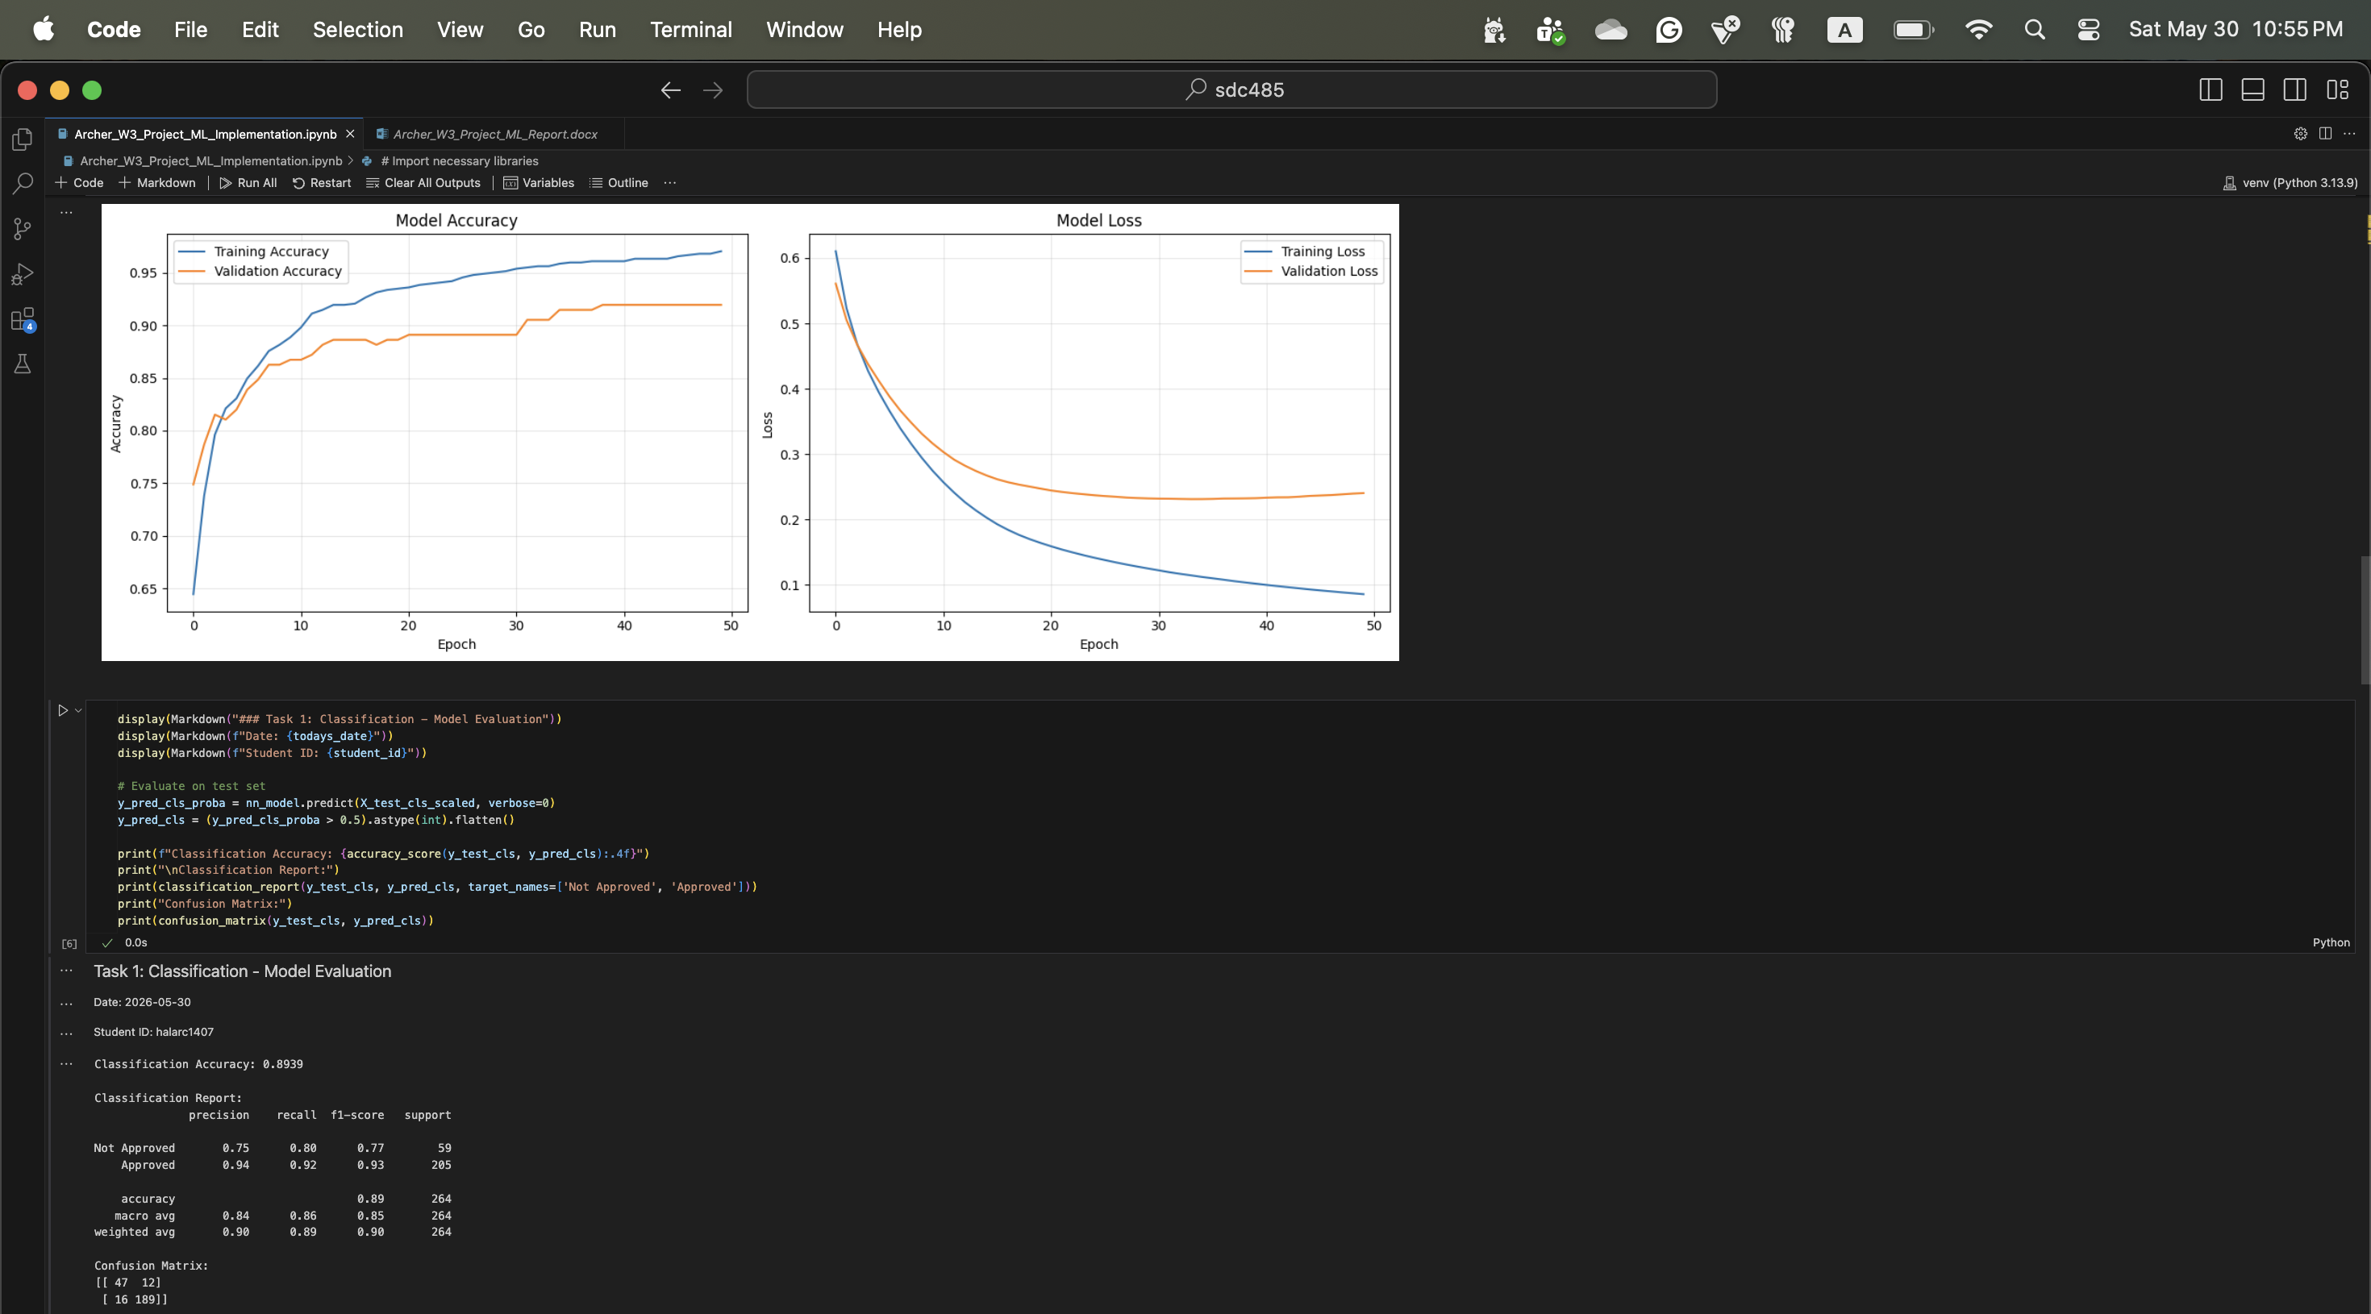
Task 2: Regression (Credit Expenditure)
Algorithm: XGBoost Regressor
For the regression task I chose XGBoost because gradient boosting handles non-linear relationships and feature interactions well, which fits credit expenditure data where income, credit history, and demographics interact in complex ways. XGBoost is also robust to outliers and doesn't require feature scaling, which simplifies the pipeline and makes it a strong baseline for tabular regression. The feature importance scores it produces are useful for interpreting which variables actually drive expenditure predictions, which matters when explaining results to non-technical stakeholders.
Hyperparameter choices:
- n_estimators=200: Enough trees to capture the patterns in the data without excessive training time.
- learning_rate=0.1: Standard starting value, balances convergence speed and stability.
- max_depth=4: Moderate depth that prevents individual trees from getting too complex and overfitting on a smaller dataset.

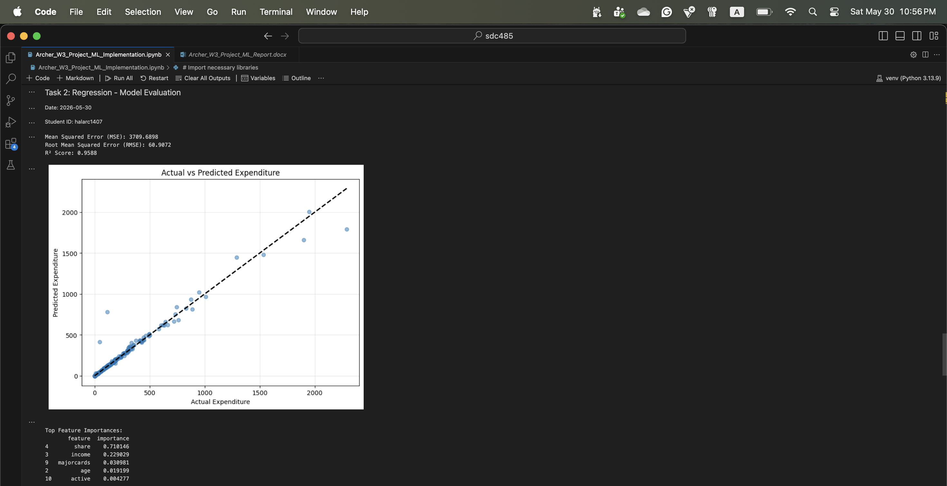
Task 3: Clustering (Customer Segmentation)
Algorithm: K-means Clustering
K-means is a natural starting point for customer segmentation because it's fast, interpretable, and the resulting cluster centers map directly to recognizable customer profiles. Since there's no target variable for clustering, the goal is to surface natural groupings that could inform marketing, retention, or product decisions. I used income, expenditure, share of income spent on credit, active accounts, and months at current address as the clustering features because they capture the spending and stability dimensions of customer behavior.
Hyperparameter choices:
- n_clusters=4: Chosen after evaluating the elbow method curve and silhouette scores across k=2 to k=8. Four clusters offered a reasonable balance between cohesion and interpretability.
- n_init=10: Run K-means multiple times with different starting centroids to avoid getting trapped in a local minimum.
- Feature scaling: Standardized all features before clustering since K-means relies on distance calculations and would otherwise be dominated by the larger-magnitude features like income.

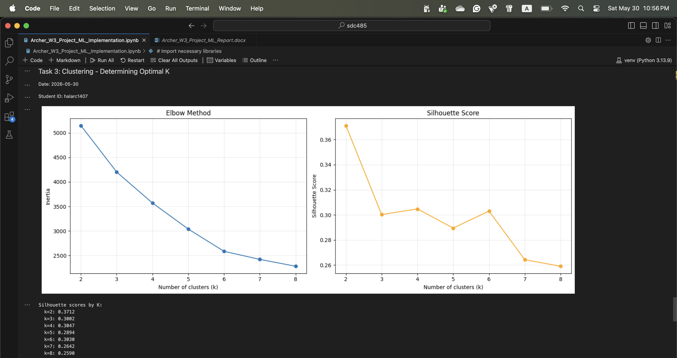
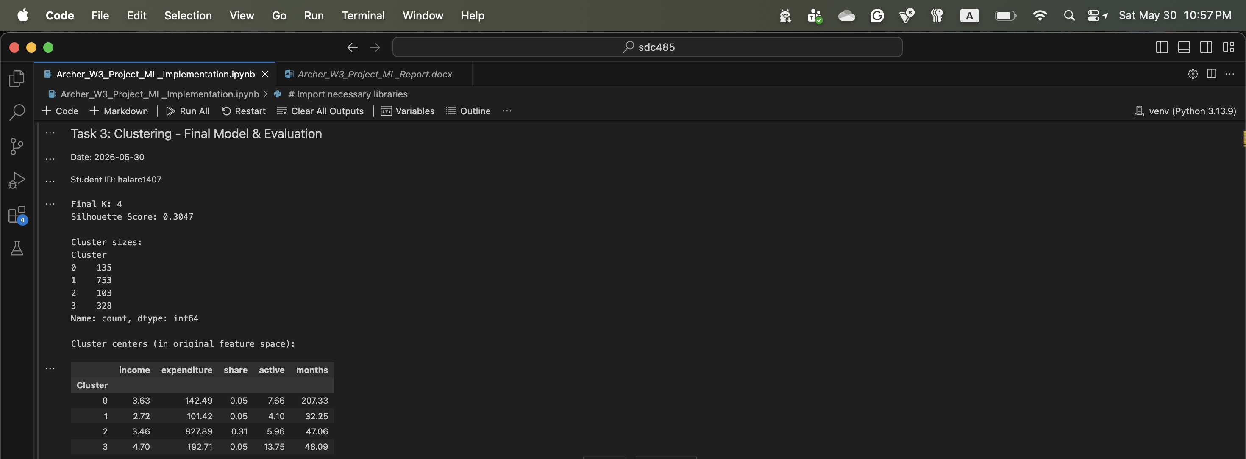
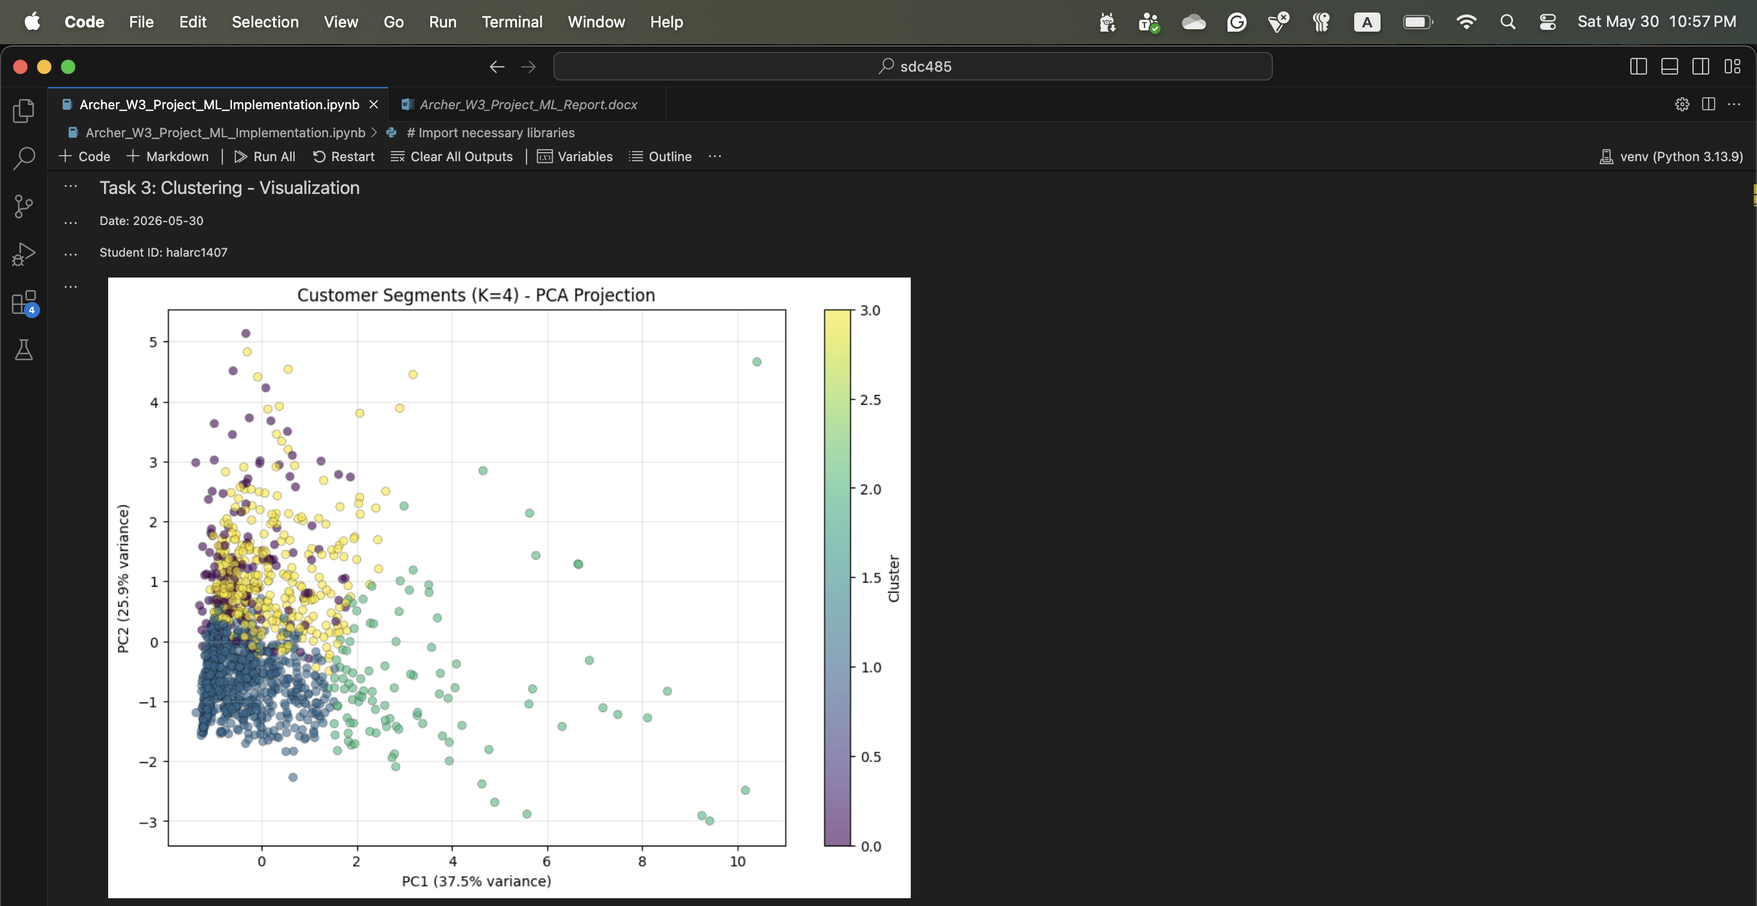
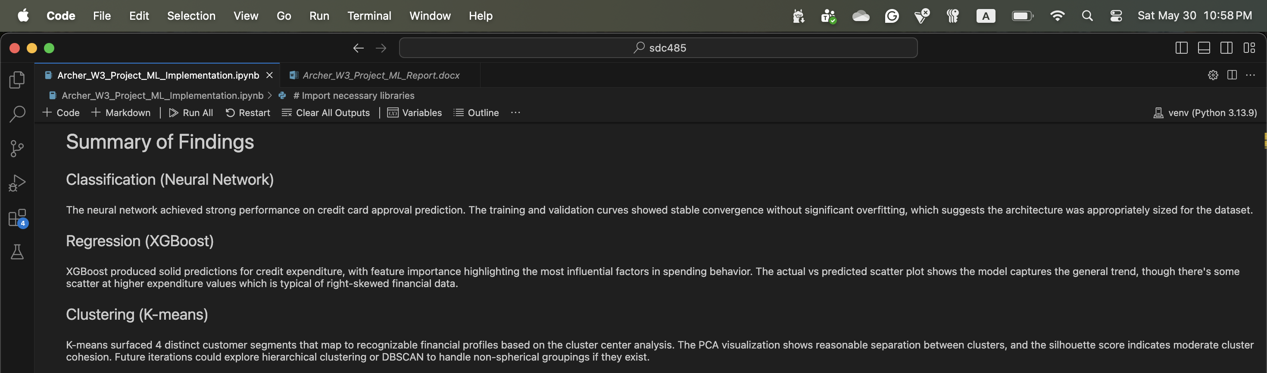
Summary of Findings
Across all three tasks, the models performed reasonably well and produced results that align with what the EDA in Part 2 suggested would be possible. The neural network classifier converged cleanly without obvious overfitting, which is a good signal that the architecture and training setup were appropriately matched to the dataset size. The XGBoost regressor captured the general trend in expenditure with feature importance scores that match intuition about which factors drive credit spending. K-means surfaced four customer segments that map to recognizable financial profiles when examined in the original (unscaled) feature space.
The biggest takeaway from this phase is that algorithm choice matters less than I expected for a dataset of this size and shape. The neural network performs comparably to what a logistic regression or gradient boosting classifier would likely achieve on this problem, which is a good reminder that simpler models are often the right starting point. Where the neural network would pull ahead is on larger, higher-dimensional datasets or problems with more complex non-linear structure. For future iterations, hyperparameter tuning (GridSearchCV or similar) would be the natural next step, along with exploring alternative clustering methods like DBSCAN or hierarchical clustering to see if non-spherical groupings exist in the data.

