Bank Fraud Project Random Forest Modeling Guide
Paige La
SYST/OR 568 – Applied Predictive Analytics
Project Question: Is the transaction fraudulent?
Random Forest model question: How does the device or platform used to initiate transactions relate to fraud occurrence in the bank fraud data?

Method
- I began with a general Random Forest model to show a complete fraud modeling pipeline. The model was trained in caret style with repeated 10-fold cross-validation.
- I preserved categorical variables as factors because Random Forest can use them directly; we did not rely on PCA or scaling for the RF pipeline. I engineered time features from the mixed-format transaction date and HH:MM:SS transaction time fields because fraud behavior can vary by time context. I then examined variable importance to test whether Transaction_Device and Device_Type remain important after accounting for other predictors.
- The code for model training was not generating a model due to such a large dataset. To overcome this I reduced the model training size from the full 200k rows, reduced the repeats from 5 to 2, and reduced the number of ntrees from 1000 to 150.
- For the final, I extended this with the smaller device-focused model and richer interpretation plots to answer the device/platform question more directly.

Modeling Procedure
- Read the raw CSV from disk fresh so the script always starts from the same source data.
- Remove the export index column (Unnamed: 0 or X).
- Remove identifier columns Transaction_ID and Merchant_ID so the model does not learn IDs.
- Convert Is_Fraud from 0/1 into the labeled factor levels NoFraud and Fraud.
- Convert core categorical predictors to factor variables so the Random Forest can properly construct decision tree splits: Gender, Account type, Transaction type, Merchant category, Transaction device, and Device type.
- Parse Transaction_Date using both MM/DD/YYYY and DD-MM-YYYY formats.
- Engineer time features: txn_month, txn_wday, txn_hour, and is_weekend.
- Split Transaction_Location into Txn_City and Txn_State.
- Dropped the raw Transaction_Date, Transaction_Time, Parsed_Date, and Transaction_Location columns after feature engineering.
- Dropped Transaction_Description because it has over 50 unique values which is too many unique values for this RF workflow.
- Dropped high cardinality columns because they are unhelpful for this prediction problem: Bank_Branch, Txn_State, Transaction_Currency.
- Near-zero variance predictors were removed using the caret function nearZeroVar() to prevent unstable splits: txn_month.
- Trained a general Random Forest model using all retained predictors. Random Forest is an ensemble learning algorithm that constructs many decision trees and aggregates their predictions. Each tree was built using the bootstrap sampling of the data and random subsets of predictors at each split. This approach reduces variance and improves generalization performance.
- Evaluate the general model using the out-of-fold predictions saved from repeated cross-validation.
- Train a device-focused Random Forest model with device variables plus a small set of controls.
- Compare the performance and variable importance results of the two models.

Expected Results - General Model
The general model is the model. It answers the overall fraud prediction problem while still checking whether device and platform variables remain important once the model also sees transaction amount, merchant category, transaction type, balance, age, gender, and engineered time variables. If Transaction_Device and Device_Type rank highly in variable importance in the general model, then device/platform is likely an important fraud signal even after accounting for the other predictors.

Expected Results - Device-focused Model
The device-focused model is a cleaner interpretation model. It narrows the predictor set so that the role of Transaction_Device and Device_Type is easier to explain. Its purpose is not necessarily to beat the general model in raw predictive performance. Its purpose is to show whether the device variables still carry meaningful fraud signal in a smaller and more interpretable model.

Index Column
The raw CSV contains an extra first column called Unnamed: 0. That column is usually just a saved row index from a previous export and not a true modeling variable. In some R imports, the same kind of unnamed first column appears as X. It is different from Transaction_ID, which is the actual transaction identifier in the dataset. The new script removes the export index column first and then removes Transaction_ID and Merchant_ID as true identifiers.

Repeated 10-fold Cross Validation (CV)
Repeated 10-fold cross-validation splits the data into 10 folds, trains on 9 folds, validates on the remaining fold, and rotates so that every fold serves as validation once. Repeating that full 10-fold process 5 times produces 50 validation estimates instead of relying on one random split. This gives a more stable measure of model performance and matches the course emphasis on resampling-based evaluation.

Things I changed in the final model:
- The final modeling phase introduced three key improvements: class imbalance handling (down-sampling and up-sampling), hyperparameter tuning (mtry), and evaluation using both cross-validation and a holdout test set.
- Add improved engineering features - initial model results showed that device alone is weak. A better final model should test whether device matters in combination with transaction context. The general model should evaluate whether device remains important after amount, merchant category, transaction type, balance, age, gender, and time are included.
- Upgraded training sections - real tuning procedure, resampling results, comparison of models, explicit handling of class imbalance, which is critical in fraud data and emphasized in Kuhn & Johnson’s discussion of severe class imbalance.
- Model selection step to pick the best model based on ROC
- Expand on evaluation in include CV mean/SD and test-set evaluation

Pilot Model Results
Model | Metric | Result
General RF | Best mtry | 3
General RF | Cross-validated AUC | 0.5106992
General RF | Precision | 0.5
General RF | Recall | 0.001
General RF | F1 | 0.001996008
Device-focused RF | Best mtry | 3
Device-focused RF | Cross-validated AUC | 0.5149485
Device-focused RF | Precision | 0
Device-focused RF | Recall | 0
Device-focused RF | F1 | Na

The general Random Forest model shows weak predictive performance (ROC ~ 0.5), indicating limited ability to distinguish fraud from non-fraud. The model demonstrates extremely high recall but very low specificity, suggesting it predicts most transactions as fraud. This behavior is likely driven by: class imbalance because fraud is rare, reduced training dataset size, and limited signal captured in current predictors. As a result, the general model is not reliable for answering the research question directly. The analysis will instead focus on the device-focused model to better understand how Transaction_Device and Device_Type relate to fraud occurrence.
The device-focused Random Forest model achieved a ROC of approximately 0.515, indicating very limited ability to distinguish between fraudulent and non-fraudulent transactions. The model exhibited near-perfect recall but zero specificity, suggesting it predicted nearly all transactions as fraud. This indicates that device-related variables alone do not provide sufficient predictive signal for fraud detection. Fraud appears to depend on a broader combination of transaction and contextual features. Device or platform alone does not provide sufficient predictive signal to distinguish fraudulent transactions from legitimate ones.
The Random Forest models developed demonstrate that predicting fraud is a challenging classification problem under the current feature set and pilot configuration. While device-related variables contribute some signal, they are not sufficient on their own to effectively distinguish fraudulent transactions. These findings suggest that fraud detection requires a more comprehensive modeling approach that integrates device information with transaction-level and behavioral features.
Final Model results:
General Model:
- Cross-Validation AUC: ~0.505
- Test AUC: ~0.502
- Recall (Sensitivity): ~0.001
- Precision: ~0.10–0.18
- F1 Score: ~0.002
- Balanced Accuracy: ~0.50
The general Random Forest model demonstrates no meaningful separation capability (AUC ~0.5), extremely high bias (very high specificity and near zero recall), misleading overall accuracy, no improvement from pilot. The model does not successfully learn a decision boundary for fraud detection under the current feature set and class distribution. Even after tuning and resampling, performance remains equivalent to random classification.

Device Model:
Best model: Device_Down (down-sampling). Best ROC: 0.508
- Cross-Validation:
  - AUC: ~0.508
  - Recall: ~0.644
  - Specificity: ~0.372
  - Precision: ~0.17
  - F1: ~0.27
- Test Set:
  - AUC: ~0.498
  - Recall: ~0.627
  - Specificity: ~0.366
  - Precision: ~0.05
  - F1: ~0.09
- Improved class detection behavior. The model flags many transactions as fraud, but most are false positives. The model still lacks true predictive discrimination. The model is no longer defaulting to the majority class. It is actually attempting classification
- The device-focused model improves fraud detection behavior by identifying a larger proportion of fraudulent transactions but still fails to meaningfully distinguish fraud from non-fraud at a predictive level.
Variable Importance:
- General Model (Top predictors)
  - Account_Balance
  - amount_to_balance_ratio
  - Transaction_Amount
  - is_high_amount
  - Device_Type (moderate importance)
  - Transaction_Device (lower importance)
- Device Model (Top predictor)
  - Device_Type = strongest predictor
- Interpretation: device is not the primary driver. Device gains importance only in isolation because the device type is the top variable but overall model performance is weak. Device or platform contributes to fraud prediction, but it is not a strong standalone predictor and does not provide sufficient signal to accurately distinguish fraudulent transactions without additional contextual features.
Conclusions:
The RF analysis demonstrates that fraud detection in this dataset is a challenging classification problem. While device-related variables show some relative importance, especially in the device-focused model, they do not provide sufficient predictive power on their own. The general model fails to detect fraud due to class imbalance and weak signal separation, while the device-focused model improves recall but at the cost of very low precision. Overall, device/platform plays a secondary role in fraud occurrence and must be considered alongside financial and behavioral transaction features.

Result Plots:
From ROC plots, all curves lie very close to the diagonal line. Final models do not visibly separate above the baseline. Device-final curve is slightly more “active” (less flat), but still near random. None of the models achieve meaningful class separation. Device/platform contributes signal, but it is not the primary driver of fraud behavior. Plots show that different device types have slightly different average predicted fraud probabilities, but the differences are small and overlapping. No device stands out as a clear high-risk category. The partial dependence plots show that the model does not learn a strong functional relationship between device variables and fraud likelihood.
- ROC curve
  - General – pilot
    - 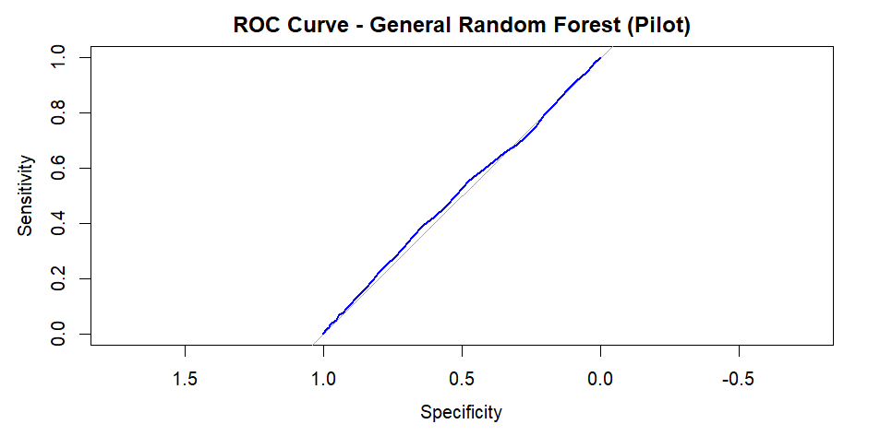
  - General – final
    - 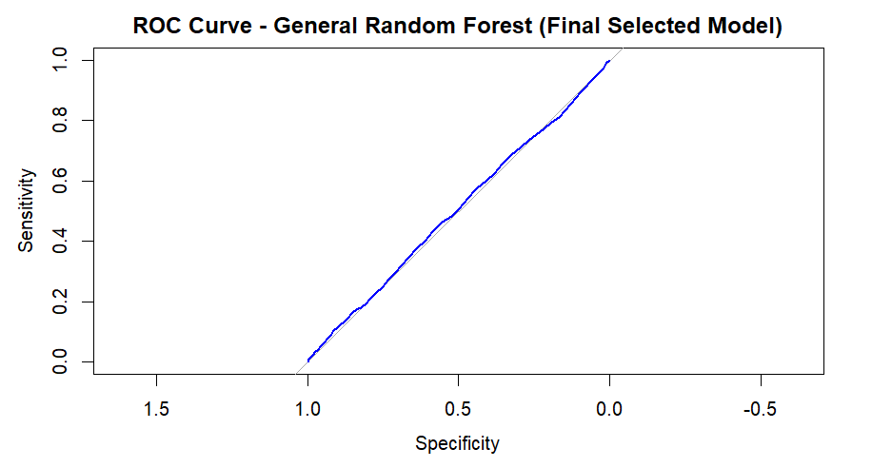
  - Device – pilot
    - 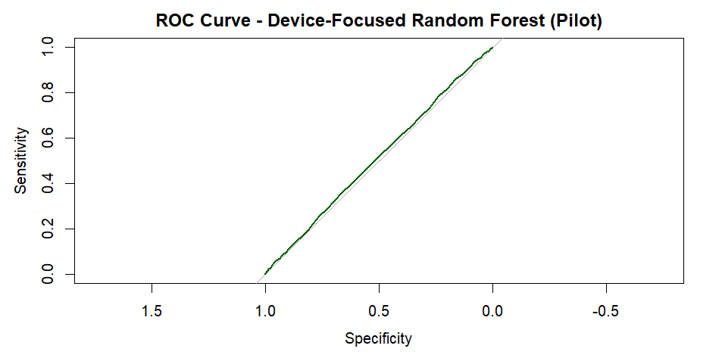
  - Device – final
    - 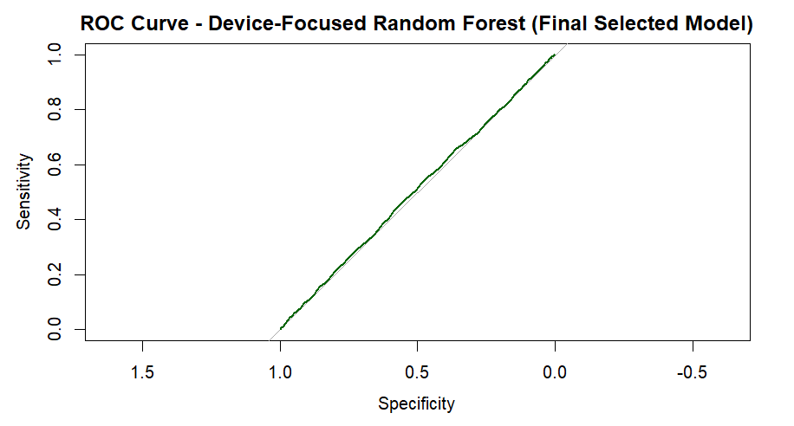
- Top Predictors
  - General – pilot
    - 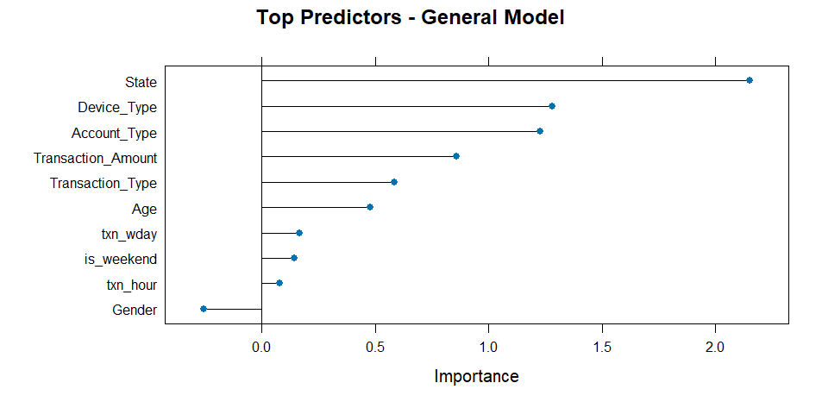
  - General – final
    - 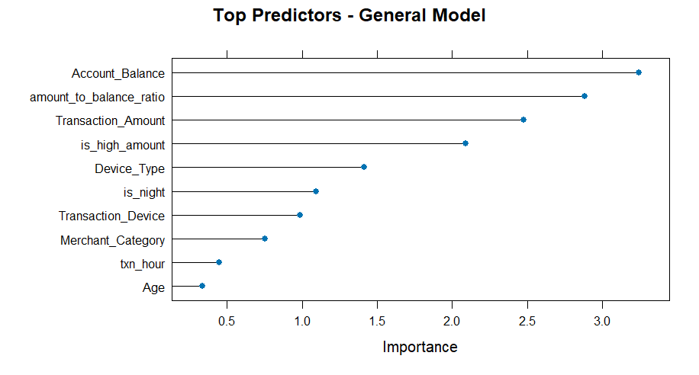
  - Device – pilot
    - 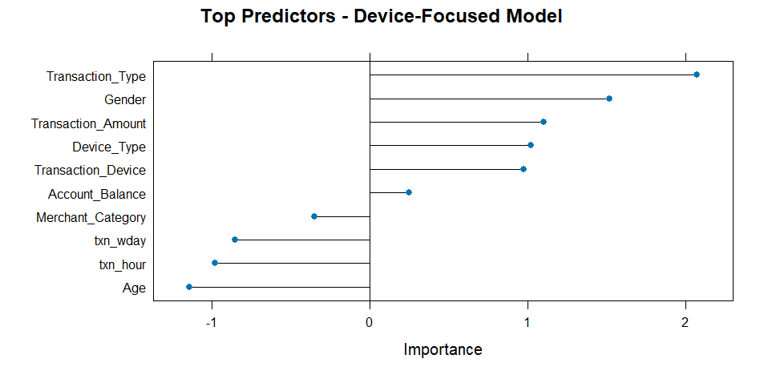
  - Device – final
    - 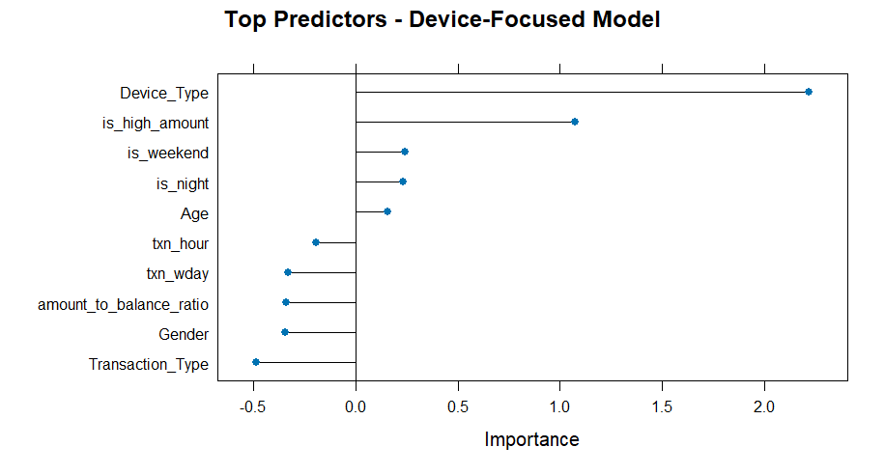
- Predicted Fraud Probability by Device Type
  - General – pilot
    - 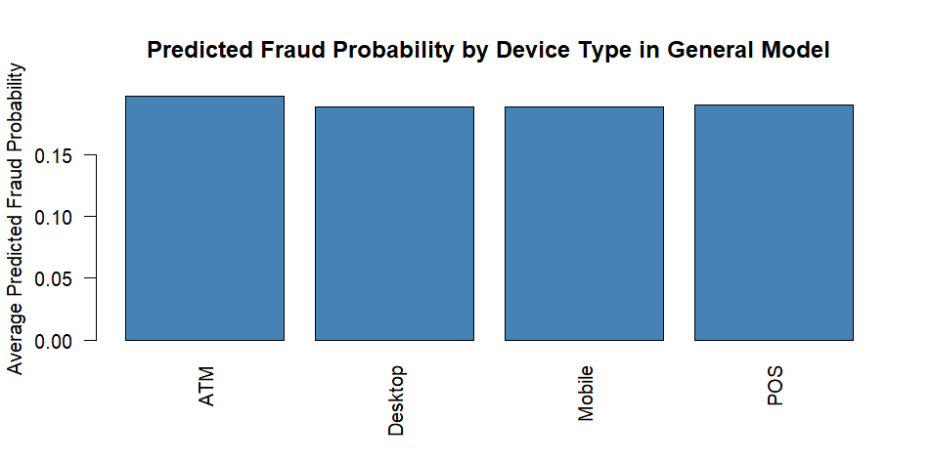
  - General – final
    - 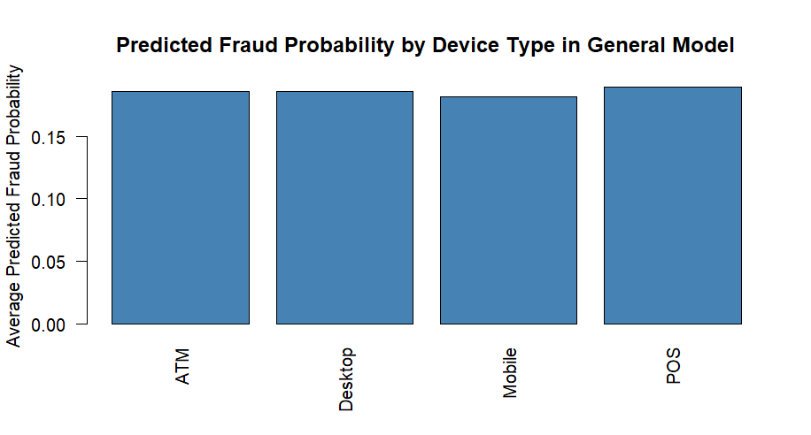
  - Device – pilot
    - 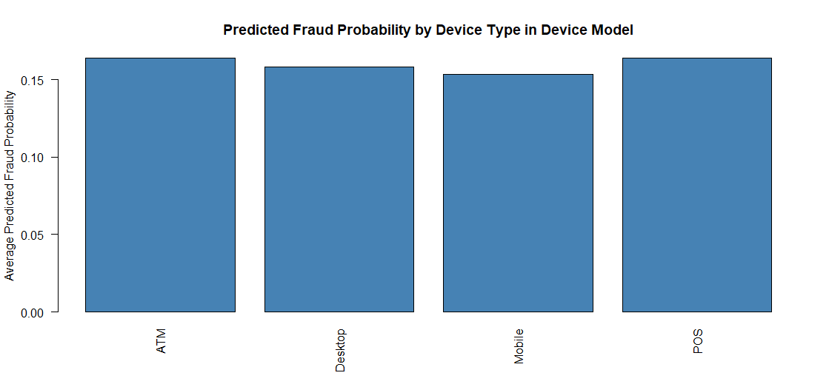
  - Device – final
    - 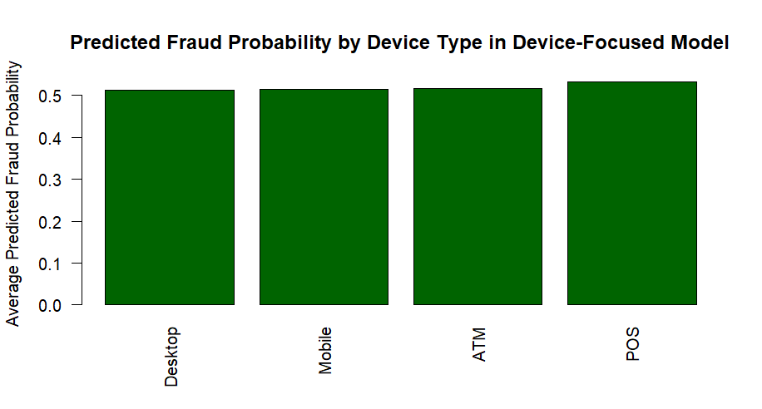
- Partial Dependence
  - Transaction Device
    - 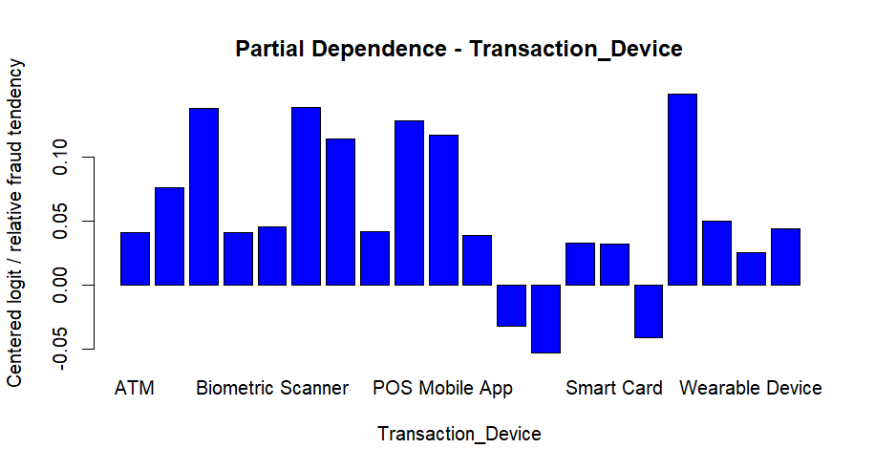
  - Device Type
    - 