Fraud probability vs device type plot
This chart summarizes the model-predicted fraud probability by device type. It gives a direct presentation answer to the question: which device types are associated with higher predicted fraud risk? If one or two device types show noticeably higher average predicted fraud probability, that gives you a concrete visual link between device/platform and fraud occurrence.

Partial dependence plots for Transaction_Device and Device_Type
These plots isolate the model effect of each device variable while averaging over the rest of the predictors. They are useful because variable importance alone tells you what mattered, but not the directional relationship. Partial dependence helps show whether certain device categories push the model toward higher or lower fraud tendency.

- ROC curve
  - General – pilot
    - 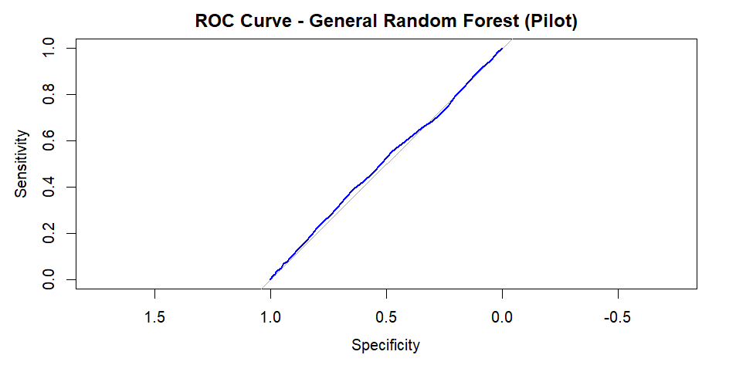
  - General – final
    - 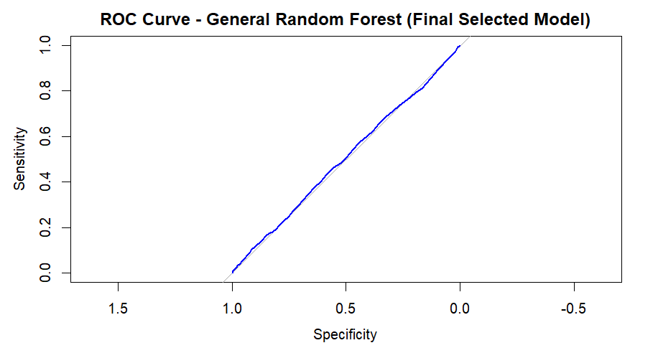
  - Device – pilot
    - 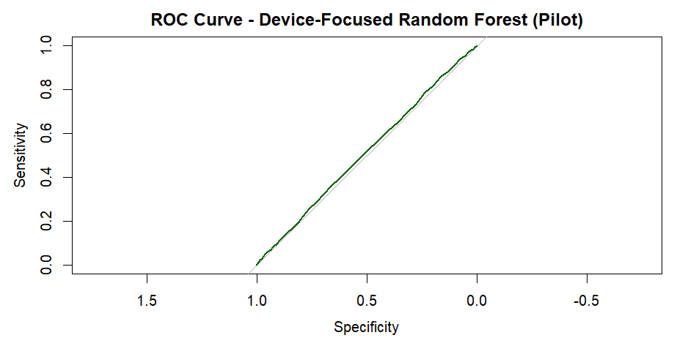
  - Device – final
    - 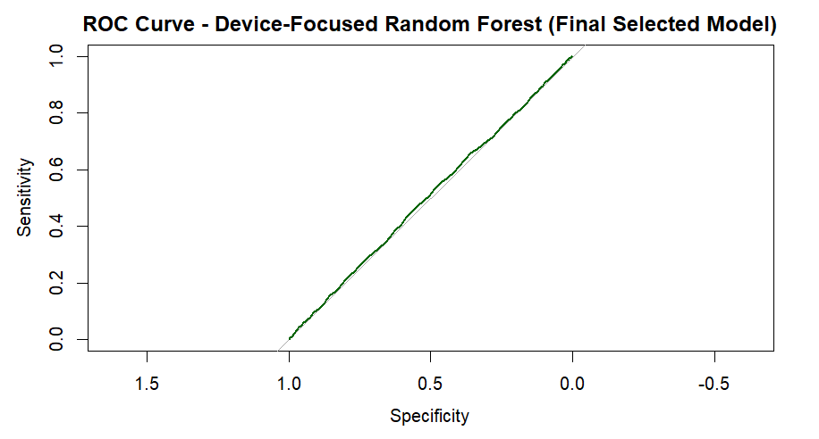
- Top Predictors
  - General – pilot
    - 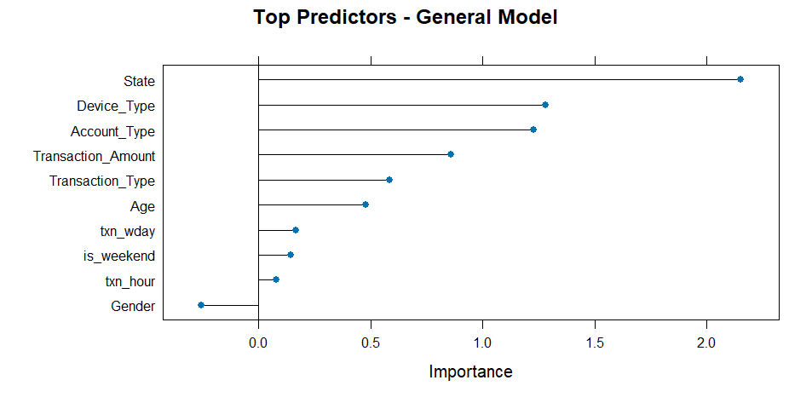
  - General – final
    - 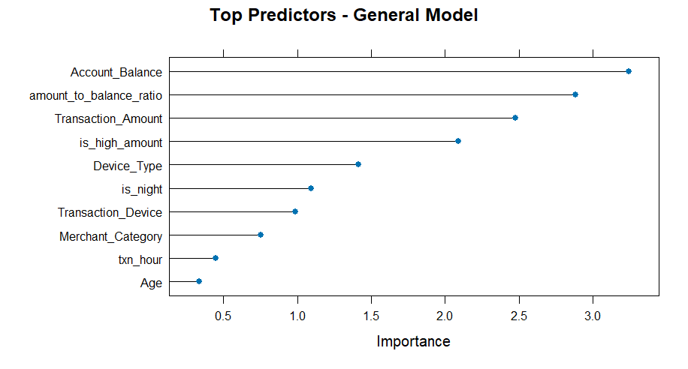
  - Device – pilot
    - 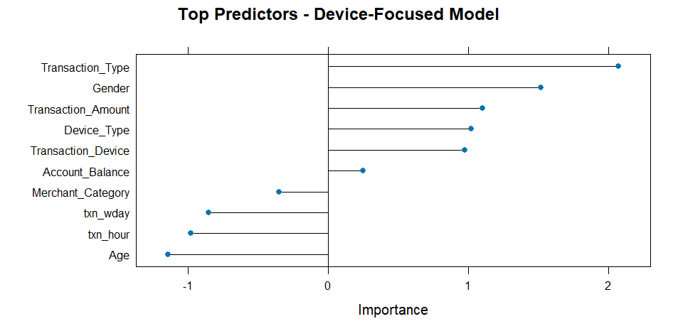
  - Device – final
    - 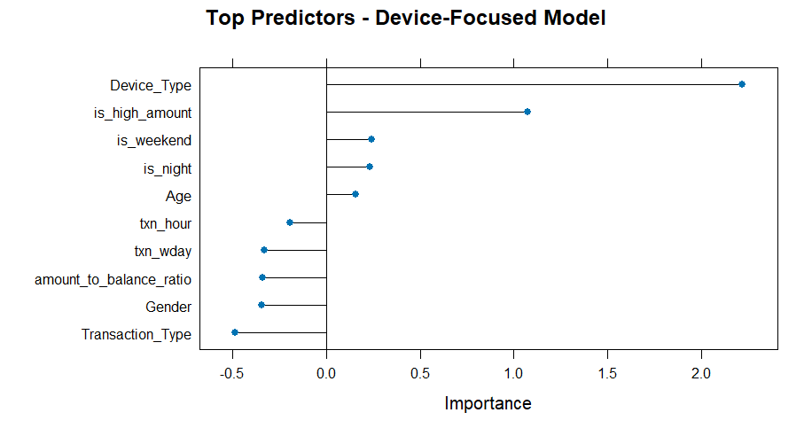
- Predicted Fraud Probability by Device Type
  - General – pilot
    - 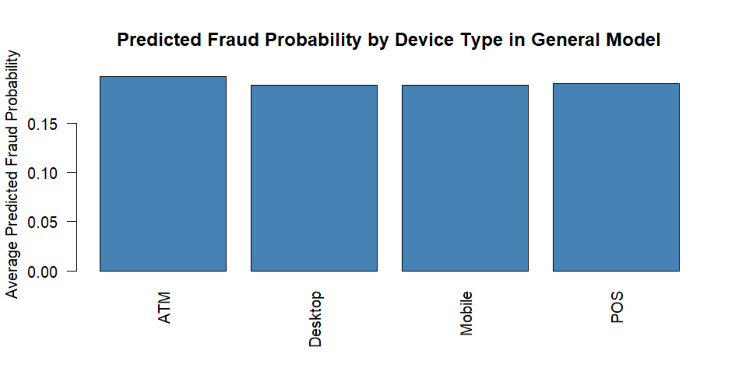
  - General – final
    - 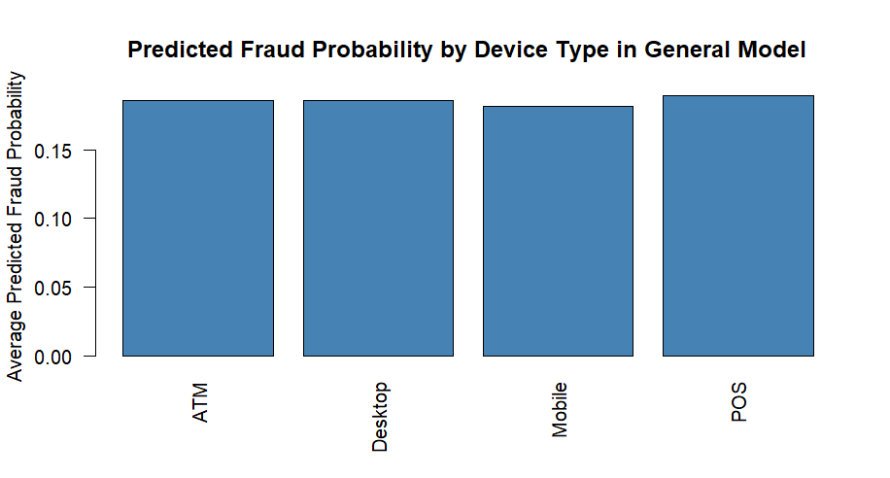
  - Device – pilot
    - 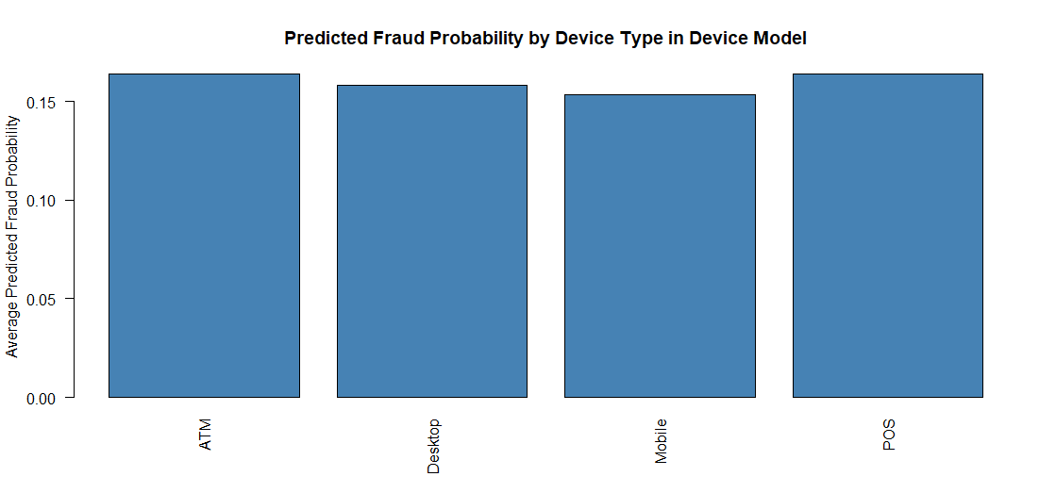
  - Device – final
    - 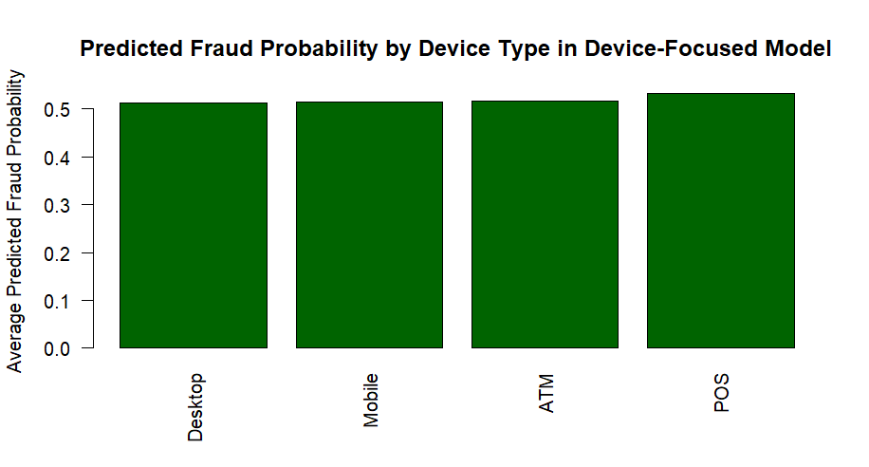
- Partial Dependence
  - Transaction Device
    - 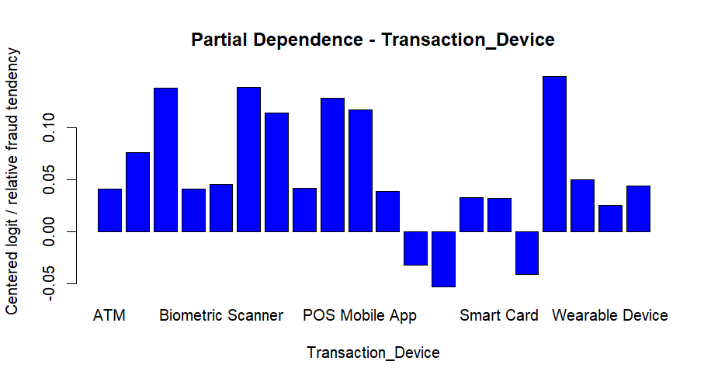
  - Device Type
    - 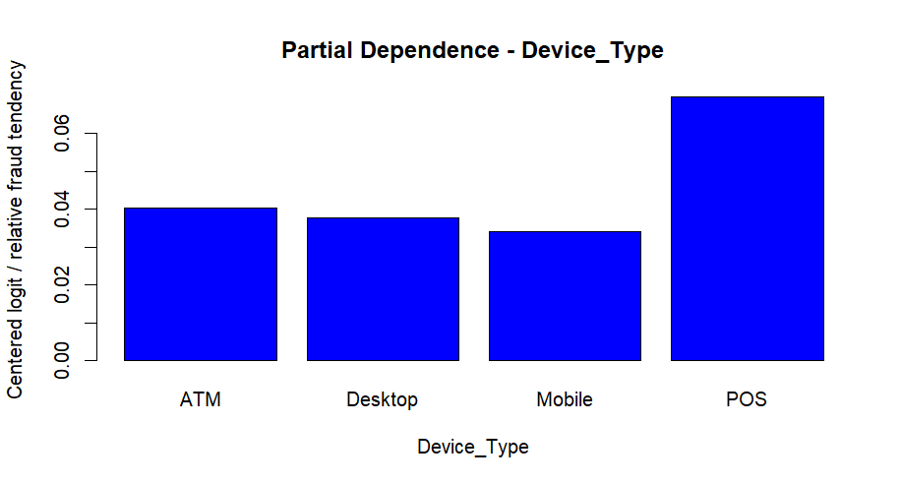
- Variable Importance
  - General
    - 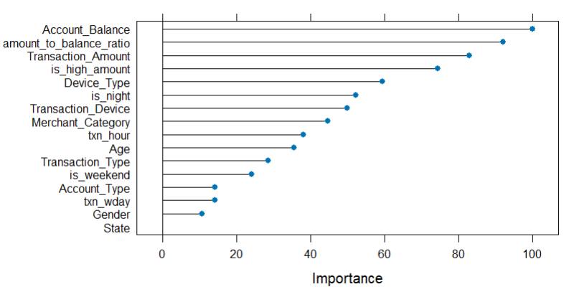
  - Device
    - 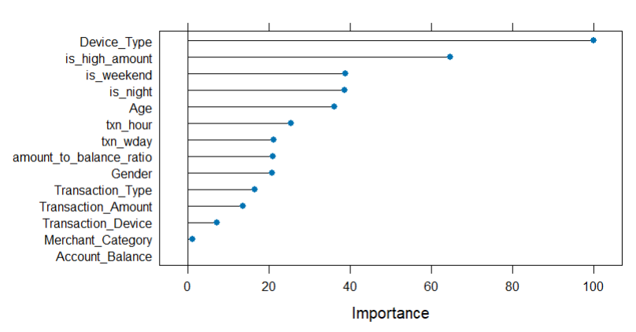
- Predicted Fraud Probabilities (Histogram)
  - General
    - 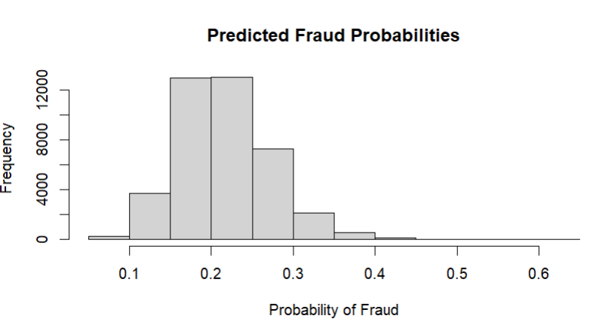
  - Device
    - 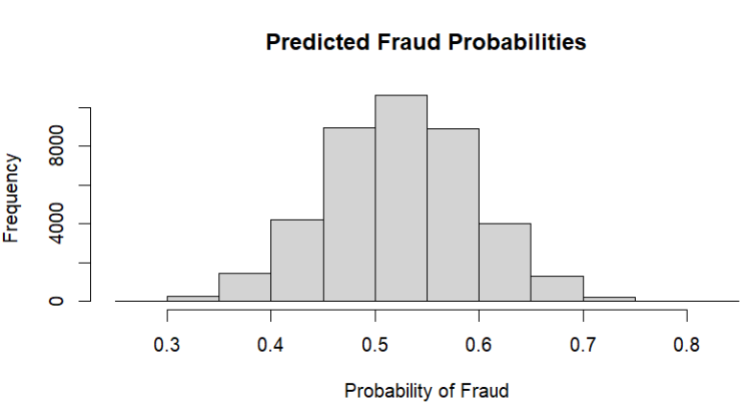
- Predicted Fraud Probabilities by Actual Class (Box Plot)
  - General
    - 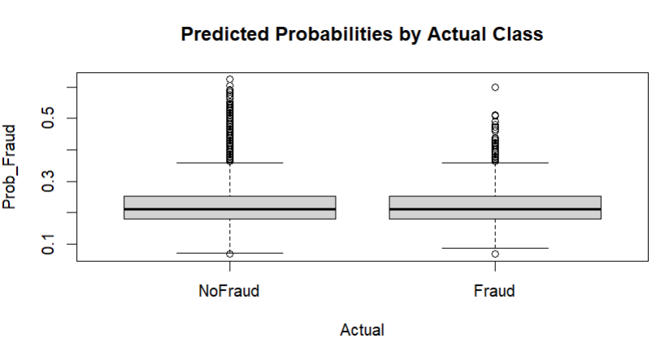
  - Device
    - 