GYM MANAGEMENT SYSTEM
Entity-Relationship Model
Objective. Design a database model that manages gym locations, members, sports sessions, coaches and member registrations, replacing the paper-based registration process.
1. Entities and attributes
ENTITY | ATTRIBUTES
GYMNASIUM | gym_id (PK), name, address, phone_number
MEMBER | member_id (PK), last_name, first_name, address, date_of_birth, gender
SESSION | session_id (PK)*, sport_type, schedule
COACH | coach_id (PK)*, last_name, first_name, age, specialty
PK = Primary Key. * session_id and coach_id are technical identifiers added because the brief does not provide unique identifiers for sessions or coaches.
2. Main associations
The ER diagram on the next page shows the four entities, their associations and the minimum–maximum cardinalities at both ends of each association.
How to read a cardinality: 0..N means optional participation in zero or many instances; 1..1 means exactly one; 1..N means at least one and possibly many. The value N is used in the diagram; exact limits (20 members and 2 coaches) are business rules, not cardinality notation.
Modeling assumptions
- Each session is hosted by exactly one gymnasium. This is a reasonable assumption for a gym chain, although the brief does not state it explicitly.
- Each session has at least one coach because the brief says sessions are led by coaches. The maximum of two is enforced separately.
- The brief specifies a unique identifier only for members. gym_id, session_id and coach_id are added as technical primary keys. A minimum of 0 is used where the brief does not require participation.

3. ENTITY-RELATIONSHIP DIAGRAM
Rectangles = entities | Diamonds = relationships | Red labels = cardinalities
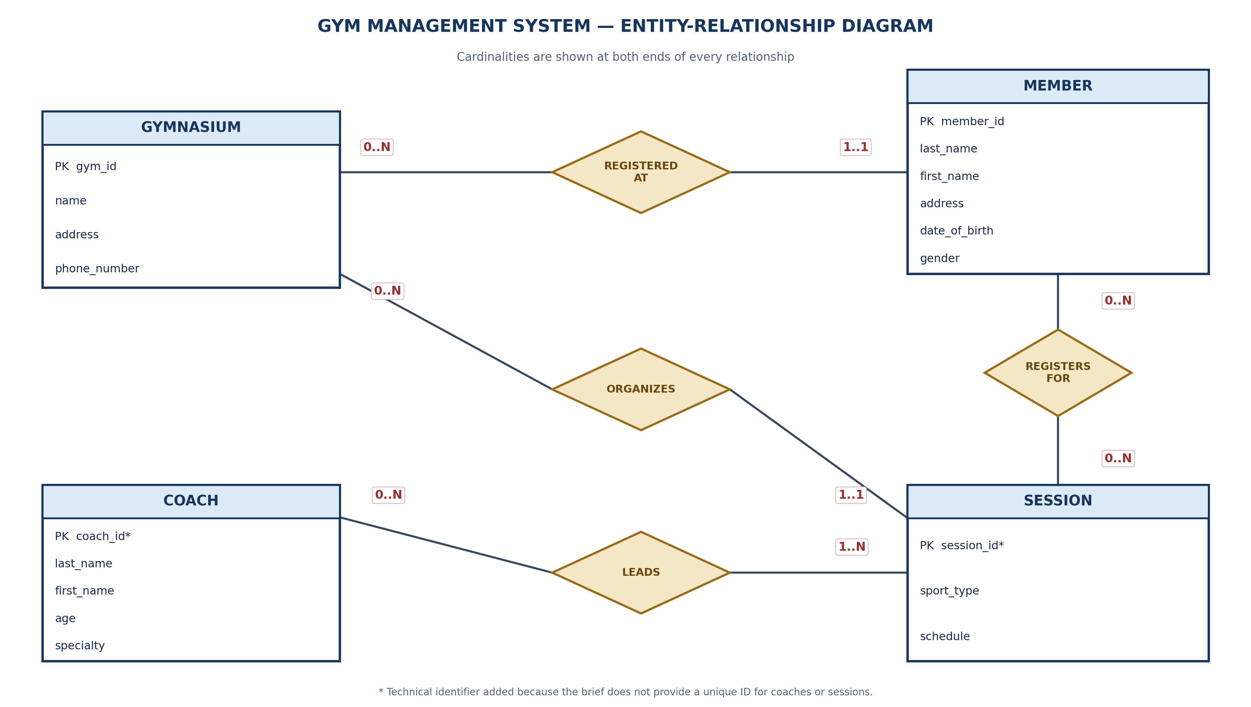
The diagram uses N for a general “many” cardinality. The exact capacity limits are listed separately as business rules.

4. Relationship types and cardinalities
ASSOCIATION | CARDINALITIES | TYPE | INTERPRETATION
GYMNASIUM – MEMBER | GYMNASIUM: 0..N  MEMBER: 1..1 | One-to-Many | A gym can have many members; each member is registered at exactly one gym.
GYMNASIUM – SESSION | GYMNASIUM: 0..N  SESSION: 1..1 | One-to-Many | A gym can host many sessions; each session takes place at one gym.
MEMBER – SESSION | MEMBER: 0..N  SESSION: 0..N | Many-to-Many | A member may register for many sessions; a session may have many registered members.
COACH – SESSION | COACH: 0..N  SESSION: 1..N | Many-to-Many | A coach may lead many sessions; each session is led by one or more coaches.
Classification rule. The relationship type depends on the maximum cardinality on each side: one-to-many when one side is “one” and the other is “many”; many-to-many when both sides are “many”. A minimum of 0 means participation is optional and does not change the relationship type.
5. Relational database implementation
The two many-to-many associations are implemented with junction tables in a relational database: REGISTRATION and SESSION_COACH.
TABLE | COLUMNS
GYMNASIUM | gym_id (PK), name, address, phone_number
MEMBER | member_id (PK), last_name, first_name, address, date_of_birth, gender, gym_id (FK)
SESSION | session_id (PK), sport_type, schedule, gym_id (FK)
COACH | coach_id (PK), last_name, first_name, age, specialty
REGISTRATION | member_id (PK, FK), session_id (PK, FK) — composite primary key
SESSION_COACH | session_id (PK, FK), coach_id (PK, FK) — composite primary key
6. Business rules (exact limits)
- A session can accommodate a maximum of 20 registered members. This is a capacity constraint, not a cardinality label in the ER diagram.
- A session can be led by a maximum of 2 coaches. This is also a business constraint; the ER diagram uses N to represent “many”.
- A member must not be registered twice for the same session. The composite primary key of REGISTRATION prevents duplicate member–session pairs.
PK = Primary Key; FK = Foreign Key. The foreign keys in the relational schema implement the conceptual associations shown in the ER diagram.

