

ASSINGMENT:-1

Name :- Abhishek Pandey

Roll no.:-1/21/FET/BCS/025

Section:-5CSA

GITHUB

## **[Part 1: Configuring your GitHub account](https://docs.github.com/en/get-started/onboarding/getting-started-with-your-github-account" \l "part-1-configuring-your-github-account)**

The first steps in starting with GitHub are to create an account, choose a product that fits your needs best, verify your email, set up two-factor authentication, and view your profile.

There are several types of accounts on GitHub. Every person who uses GitHub has their own personal account, which can be part of multiple organizations and teams. Your personal account is your identity on GitHub.com and represents you as an individual.

### [1. Creating an account](https://docs.github.com/en/get-started/onboarding/getting-started-with-your-github-account" \l "1-creating-an-account)

To sign up for an account on GitHub.com, navigate to <https://github.com/> and follow the prompts.

To keep your GitHub account secure you should use a strong and unique password. For more information, see "[Creating a strong password](https://docs.github.com/en/authentication/keeping-your-account-and-data-secure/creating-a-strong-password)."

### [2. Choosing your GitHub product](https://docs.github.com/en/get-started/onboarding/getting-started-with-your-github-account" \l "2-choosing-your-github-product)

You can choose GitHub Free or GitHub Pro to get access to different features for your personal account. You can upgrade at any time if you are unsure at first which product you want.

For more information on all of GitHub's plans, see "[GitHub’s products](https://docs.github.com/en/get-started/learning-about-github/githubs-products)."

### [3. Verifying your email address](https://docs.github.com/en/get-started/onboarding/getting-started-with-your-github-account" \l "3-verifying-your-email-address)

To ensure you can use all the features in your GitHub plan, verify your email address after signing up for a new account. For more information, see "[Verifying your email address](https://docs.github.com/en/get-started/signing-up-for-github/verifying-your-email-address)."

### [4. Configuring two-factor authentication](https://docs.github.com/en/get-started/onboarding/getting-started-with-your-github-account" \l "4-configuring-two-factor-authentication)

Two-factor authentication, or 2FA, is an extra layer of security used when logging into websites or apps. We strongly urge you to configure 2FA for the safety of your account. For more information, see "[About two-factor authentication](https://docs.github.com/en/authentication/securing-your-account-with-two-factor-authentication-2fa/about-two-factor-authentication)."

Optionally, after you have configured 2FA, add a passkey to your account to enable a secure, passwordless login. For more information, see "[About passkeys](https://docs.github.com/en/authentication/authenticating-with-a-passkey/about-passkeys)" and "[Managing your passkeys](https://docs.github.com/en/authentication/authenticating-with-a-passkey/managing-your-passkeys)."

### [5. Viewing your GitHub profile and contribution](https://docs.github.com/en/get-started/onboarding/getting-started-with-your-github-account" \l "5-viewing-your-github-profile-and-contribution-graph) graph

Your GitHub profile tells people the story of your work through the repositories and gists you've pinned, the organization memberships you've chosen to publicize, the contributions you've made, and the projects you've created. For more information, see "[About your profile](https://docs.github.com/en/account-and-profile/setting-up-and-managing-your-github-profile/customizing-your-profile/about-your-profile)" and "[Viewing contributions on your profile](https://docs.github.com/en/account-and-profile/setting-up-and-managing-your-github-profile/managing-contribution-settings-on-your-profile/viewing-contributions-on-your-profile)."

## [Part 2: Using GitHub's tools and processes](https://docs.github.com/en/get-started/onboarding/getting-started-with-your-github-account" \l "part-2-using-githubs-tools-and-processes)

To best use GitHub, you'll need to set up Git. Git is responsible for everything GitHub-related that happens locally on your computer. To effectively collaborate on GitHub, you'll write in issues and pull requests using GitHub Flavored Markdown.

### [1. Learning Git](https://docs.github.com/en/get-started/onboarding/getting-started-with-your-github-account" \l "1-learning-git)

GitHub's collaborative approach to development depends on publishing commits from your local repository to GitHub for other people to view, fetch, and update using Git. For more information about Git, see the "[Git Handbook](https://guides.github.com/introduction/git-handbook/)" guide. For more information about how Git is used on GitHub, see "[GitHub flow](https://docs.github.com/en/get-started/quickstart/github-flow)."

### [2. Setting up Git](https://docs.github.com/en/get-started/onboarding/getting-started-with-your-github-account" \l "2-setting-up-git)

If you plan to use Git locally on your computer, whether through the command line, an IDE or text editor, you will need to install and set up Git. For more information, see "[Set up Git](https://docs.github.com/en/get-started/quickstart/set-up-git)."

If you prefer to use a visual interface, you can download and use GitHub Desktop. GitHub Desktop comes packaged with Git, so there is no need to install Git separately. For more information, see "[Getting started with GitHub Desktop](https://docs.github.com/en/desktop/installing-and-configuring-github-desktop/overview/getting-started-with-github-desktop)."

Once you install Git, you can connect to GitHub repositories from your local computer, whether your own repository or another user's fork. When you connect to a repository on GitHub.com from Git, you'll need to authenticate with GitHub using either HTTPS or SSH. For more information, see "[About remote repositories](https://docs.github.com/en/get-started/getting-started-with-git/about-remote-repositories)."

### [3. Choosing how to interact with GitHub](https://docs.github.com/en/get-started/onboarding/getting-started-with-your-github-account" \l "3-choosing-how-to-interact-with-github)

Everyone has their own unique workflow for interacting with GitHub; the interfaces and methods you use depend on your preference and what works best for your needs

**GIT INSTALLATION**

Step 1:

Download the [latest version of Git](https://git-scm.com/downloads) and choose the 64/32 bit version. After the file is downloaded, install it in the system. Once installed, select Launch the Git Bash, then click on finish. The Git Bash is now launched.

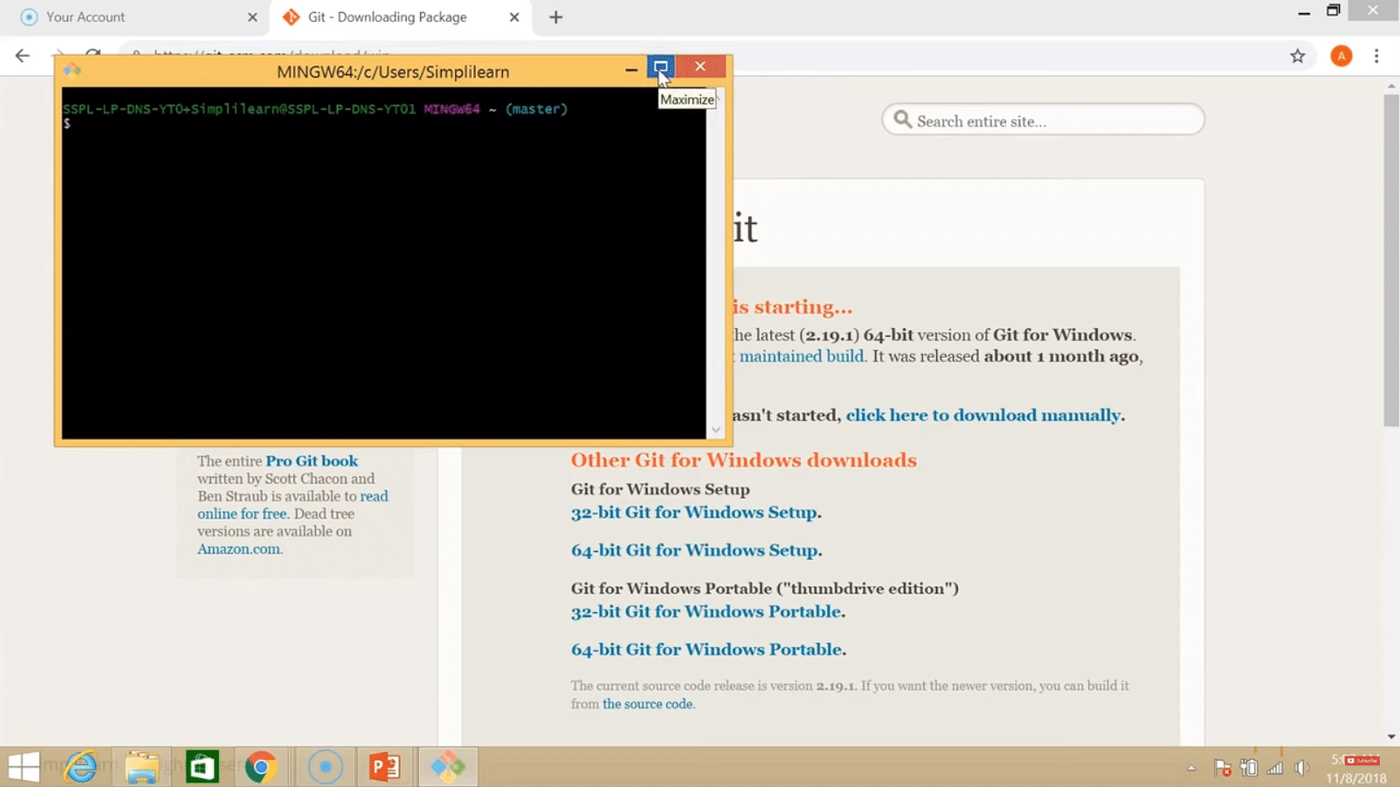

Step 2:

Check the Git version:

|  |
| --- |
| $ git --version |

Step 3:

For any help, use the following command:

|  |
| --- |
| $ git help config |

This command will lead you to a browser of [config commands](https://www.simplilearn.com/tutorials/git-tutorial/git-commands). Basically, the help the command provides a manual from the help page for the command just following it (here, it's config).

Another way to use the same command is as follows:

|  |
| --- |
| $ git config --help |

Step 4:

Create a local directory using the following command:

|  |
| --- |
| $ mkdir test  $ cd test |

Step 5:

The next step is to initialize the directory:

|  |
| --- |
| $ git init |

Step 6:

Go to the folder where "test" is created and create a text document named "demo." Open "demo" and put any content, like "Hello Simplilearn." Save and close the file.

Step 7:

Enter the Git bash interface and type in the following command to check the status:

|  |
| --- |
| $ git status |

Step 8:

Add the "demo" to the current directory using the following command:

|  |
| --- |
| $ git add demo.txt |

Step 9:

Next, make a commit using the following command:

|  |
| --- |
| $ git commit -m "committing a text file" |

Step 10:

Link the Git to a [Github](https://www.simplilearn.com/tutorials/git-tutorial/what-is-github) Account:

|  |
| --- |
| $ git config --global user.username |

Note: simplilearn-github is the username on the Github account.

Step 11:

Open your Github account and create a new repository with the name "test_demo" and click on "Create repository." This is the remote repository. Next, copy the link of "test_demo."

Step 12:

Go back to Git bash and link the remote and local repository using the following command:

|  |
| --- |
| $ git remote add origin <link> |

Here, <link> is the link copied in the previous step.

Earn the Most Coveted DevOps Certification!



Step 13:

Push the local file onto the remote repository using the following command:

|  |
| --- |
| $ git push origin master |

Step 14:

Move back to Github and click on "test_demo" and check if the local file "demo.txt" is pushed to this repository.

Additional Customization Options

1. This option enables users to add extra elements such as symbolic links for command lines. Nevertheless, one should always prefer default options for shortcuts or more.
2. There are some experimental options available such as pseudo control Support or Built in file system monitor concerning your installed Git version.

Configure GitHub Credentials

You can configure your local GitHub installation with credentials by using the following commands. Also, don't forget to add your own GitHub credentials for username and email address.

1. git config –global user.n  
   ame "github_username"
2. git config –global user.e  
   mail "email_address"

Clone a GitHub Repository

1. Initially you need to click the options repository on GitHub.
2. Then in the top right corner, click the option clone or download where a small drop-down box will appear having a URL for cloning over HTTPS.
3. Then enter into your Powershell windows and write clone URL as:  
   git clone repository_url
4. On the other hand, you can clone a github repository with SSH URLs where first you need to generate an SSH key pair on your windows workstation as well as need to assign a public key to your GitHub account.

List Remote Repositories

1. Make a copy of the repository from GitHub for your working directory.
2. Ensure that the working directory should have the project name as  
   "cd git_project" and replace the project name from the downloaded repository.
3. If the above option doesn't work, you can list the content using "ls command" for the current directory, especially to check your exact number of spellings.
4. Besides, you can list the remote repository in the sub-directory as "git remote -v".

Learn Concepts - Basics to Advanced!



Summary: Steps For Git Installation on Windows 10

1. Download and install Git
2. Git bash interface
3. Basic Git commands
4. Create a local repository
5. Connect to the remote repository
6. Push the file to GitHub