**Department of Computer Science & Engineering**

**Mini-Project Synopsis - Academic Year 2023-24**

|  |  |  |
| --- | --- | --- |
| **1** | **Title of the Project** | Network Port Scanner |
| **2** | **Team No** | 60 |
| **3** | **Department** | Department of Computer Science & Engineering |
| **4** | **Project Area/Domain** | Networking and Cyber security |
| **5** | **Project Type** | Software |
| **6** | **Name of the Students with USN** | 1. Prateek Satyavan Naik 4SF21CS110  2. Adithya Nayak K 4SF21CS007  3.Puneeth Kumar 4SF21CS117 |
| **7** | **Name of Guide** | Mr. Kishore Kumar K |

**Abstract**

In the context of this network-based project, our primary goal is to develop a robust and efficient tool for examining open ports on a target system. Utilizing the principles of socket programming, our approach will emphasize port scanning—a technique used to identify accessible entry points on a network. Port scanning involves systematically probing a range of ports on a host to discover which ones are open, closed, or filtered. By leveraging an API, our aim is to create a versatile and potent scanning tool, specifically focusing on TCP port scanning.

Central to our efforts is the identification and analysis of vulnerabilities within the network. This entails a thorough exploration of potential weaknesses that could be exploited by malicious actors. Our tool's comprehensive capabilities extend beyond TCP ports, incorporating an investigation into potential vulnerabilities within UDP ports. This holistic approach enhances the tool's effectiveness in network security assessment, ensuring a thorough examination of potential risks and weaknesses, including those unveiled through the intricacies of port scanning.

**Introduction**

**Overview:** The Network Port Scanner project is rooted in the foundational principles of network security, aiming to address the growing need for accessible yet robust tools that enable the identification of potential vulnerabilities within computer networks. At its core, the project revolves around the development of a Python-based tool that leverages socket programming, multithreading, and user interface design to provide an efficient and user-friendly solution for port scanning.

**Scope:** The scope of the project extends from fundamental aspects, such as user-input handling and specifying port ranges, to advanced features, including multithreading for optimized performance and the potential for scanning UDP ports. Additionally, the project encompasses the design of an intuitive user interface and robust error-handling mechanisms, ensuring a comprehensive and adaptable tool for users with varying levels of technical expertise.

**Literature Survey:**

**Base Papers:**

|  |  |  |  |  |
| --- | --- | --- | --- | --- |
| **Name of Paper** | **Publisher** | **Date of Publish** | **Source of paper** | **Author** |
| Port scan detection | IEEE | 2nd Feb 2009 | IEEE website | Jayanth Gadge  Anish Anand Paatil |
| Port Scanning Techniques | Research gate | 2010 | DBLP | Germinal Isren |
| Port Scanning Utility | IIT Kanpur | 2015 | IIT Kanpur | Sourav Khandelwal  Anurag Awasthi  Vismay Chintan |

**Problem Statement and Description**

**Problem Statement**

The Network Port Scanner project addresses a common problem in computer security. We're creating a user-friendly tool in Python to help people easily check if any doors (or "ports") on their computer are open and potentially vulnerable. It's like a simple check to see if your house doors are left open. This tool is designed to be accessible to everyone, making computer security easy without needing advanced technical skills

**Explanation**

The Network Port Scanner project tackles a common issue in computer security. Imagine your computer as a house with doors. We want to make sure those doors are closed to keep it safe. Existing tools are either too complicated or not user-friendly. So, we're creating a simple tool to easily check if any doors are open, making computer security straightforward for everyone

**Objectives:**

**Develop a User-Friendly Interface**: Create an intuitive and accessible user interface for the Network Port Scanner, allowing users of varying technical backgrounds to input target IP addresses and port ranges effortlessly.

**Implement Efficient Port Scanning:** Utilize socket programming and multithreading to design a scanning mechanism that ensures efficient examination of open ports, providing timely and accurate results without compromising performance.

**Explore Advanced Features**: Investigate the feasibility of extending the tool's capabilities to include the scanning of UDP ports, offering users a more comprehensive analysis of network services.

**Promote Ethical Use:** Emphasize responsible and ethical use of the Network Port Scanner by incorporating features and guidelines that encourage obtaining proper authorization before initiating scans, reinforcing a commitment to legal and ethical boundaries in cybersecurity practices.

**Proposed Methodology:**

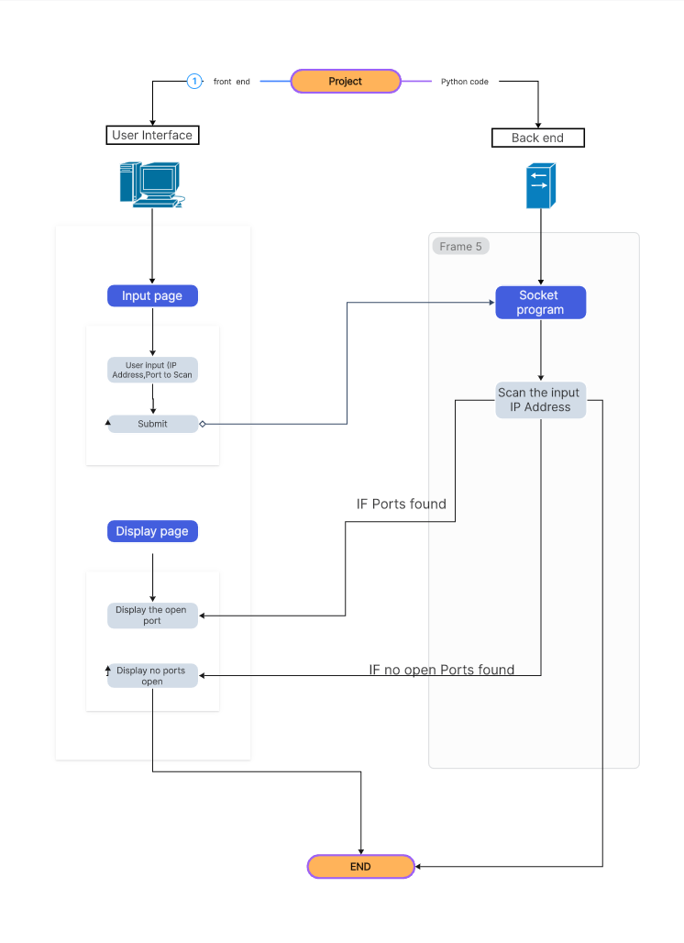

**Outcome of the work**

**Functional Tool:** Develop a practical Network Port Scanner that efficiently checks open ports on a computer.

**User-Friendly Interface:** Create an easy-to-use interface, making it simple for everyone to understand and operate.

**Efficient Scanning:** Ensure quick and accurate results with a scanning mechanism that doesn't slow down the computer.

**Advanced Capabilities:** Explore additional features like scanning UDP ports for a more thorough analysis of network services.

**Ethical Use:** Promote responsible hacking practices by emphasizing proper authorization before using the tool.

**Educational Impact:** Provide users with insights into network security, ethical hacking, and Python programming.

**Continuous Improvement**: Plan for regular updates to address user feedback and emerging security considerations.

**Empower Users:** Enable users to assess and fortify their computer's security without needing advanced technical knowledge.

**Conclusion**

In conclusion, the Network Port Scanner project has successfully crafted a user-friendly tool to check computer security. By creating an easy-to-use interface, ensuring efficient scanning without slowing down, and exploring advanced features, the tool empowers users to understand and enhance their network security. Emphasizing ethical use and continuous improvement, the project not only offers practical utility but also serves as an educational resource for those interested in cybersecurity.

|  |  |  |
| --- | --- | --- |
| **16.** | **Signature of Students** |  |
| **17.** | **Signature of Guide** |  |
| **18.** | **Signature of the Project Coordinator** |  |