| **EXP:9**  **17/04/2025** | **Develop neural network-based time series forecasting model** |
| --- | --- |

**AIM:**

To develop a neural network-based model for forecasting car sales using historical time series data and evaluate its performance using prediction accuracy metrics.

**PROCEDURE:**

**1) Import Necessary Libraries**

import pandas as pd

import numpy as np

import matplotlib.pyplot as plt

from sklearn.preprocessing import MinMaxScaler

from tensorflow.keras.models import Sequential

from tensorflow.keras.layers import Dense

from sklearn.metrics import mean_squared_error

**2)** **Load and Prepare Time Series**

**df = pd.read_csv("Car_sales.csv")**

**df['Latest_Launch'] = pd.to_datetime(df['Latest_Launch'], errors='coerce')**

**df = df.dropna(subset=['Latest_Launch', 'Sales_in_thousands'])**

**ts = df.groupby('Latest_Launch')['Sales_in_thousands'].sum().sort_index()**

**scaler = MinMaxScaler()**

**scaled_ts = scaler.fit_transform(ts.values.reshape(-1, 1))**

**3) Convert Time Series to Supervised Learning Format**

def create_dataset(data, look_back=5):

X, y = [], []

for i in range(len(data) - look_back):

X.append(data[i:i + look_back, 0])

y.append(data[i + look_back, 0])

return np.array(X), np.array(y)

look_back = 5

X, y = create_dataset(scaled_ts, look_back)

**4)Split Dataset into Train and Test Sets**

train_size = int(len(X) * 0.8)

X_train, X_test = X[:train_size], X[train_size:]

y_train, y_test = y[:train_size], y[train_size:]

**5)Build and Train the Neural Network**

model = Sequential()

model.add(Dense(64, input_dim=look_back, activation='relu'))

model.add(Dense(32, activation='relu'))

model.add(Dense(1))

model.compile(optimizer='adam', loss='mean_squared_error')

model.fit(X_train, y_train, epochs=100, verbose=0)

**6) Evaluate and Predict**

train_pred = model.predict(X_train)

test_pred = model.predict(X_test)

train_pred_rescaled = scaler.inverse_transform(train_pred)

test_pred_rescaled = scaler.inverse_transform(test_pred)

y_train_rescaled = scaler.inverse_transform(y_train.reshape(-1, 1))

y_test_rescaled = scaler.inverse_transform(y_test.reshape(-1, 1))

train_rmse = np.sqrt(mean_squared_error(y_train_rescaled, train_pred_rescaled))

test_rmse = np.sqrt(mean_squared_error(y_test_rescaled, test_pred_rescaled))

print(f"Train RMSE: {train_rmse:.2f}")

print(f"Test RMSE: {test_rmse:.2f}")

### **7) Plot Predictions**

plt.figure(figsize=(12, 5))

plt.plot(ts.index[look_back:train_size+look_back], y_train_rescaled, label='Train Actual')

plt.plot(ts.index[look_back:train_size+look_back], train_pred_rescaled, label='Train Predicted')

plt.plot(ts.index[train_size+look_back:], y_test_rescaled, label='Test Actual')

plt.plot(ts.index[train_size+look_back:], test_pred_rescaled, label='Test Predicted', linestyle='--')

plt.title('Neural Network Forecasting on Car Sales')

plt.xlabel('Date')

plt.ylabel('Sales in Thousands')

plt.legend()

plt.grid(True)

plt.tight_layout()

plt.show()

**OUTPUT:**

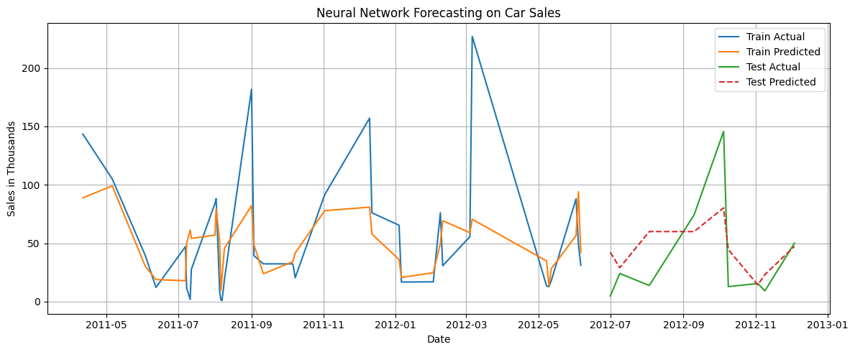

**RESULT:**

Thus the program has been executed successfully