**4. Implement programs to check stationary of a time series data**

**AIM:**

To Implement programs to check stationary of a time series data

**PROCEDURE:**

**1.Import the necessary libraries:** 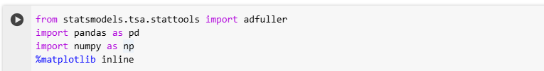

**2. Load the dataset :**



**3.Check for the missing values.**



**4.Explore the correlation between the numeric column.**

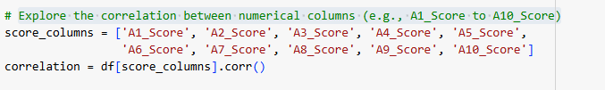

**5.Select the numeric column for the ADT test and perform the test.**

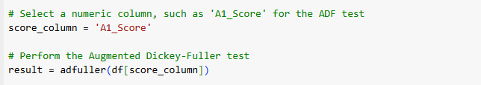

**OUTPUT**

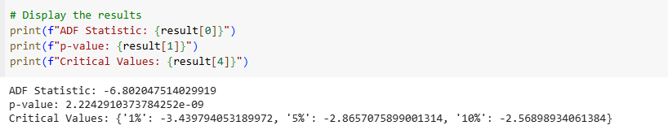

**Interpret the final result and check for the stationary**

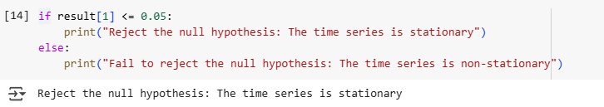

**RESULT:**

The program to check stationary on the autism screening dataset has been implemented successfully.