WEEK 2 Assignment

1.

Select a.account_number,a.customer_number,c.FIRSTNAME,c.lastname,a.account_opening_date from customer_master c inner join account_master a on a.customer_number=c.CUSTOMER_NUMBER order by a.account_opening_date;

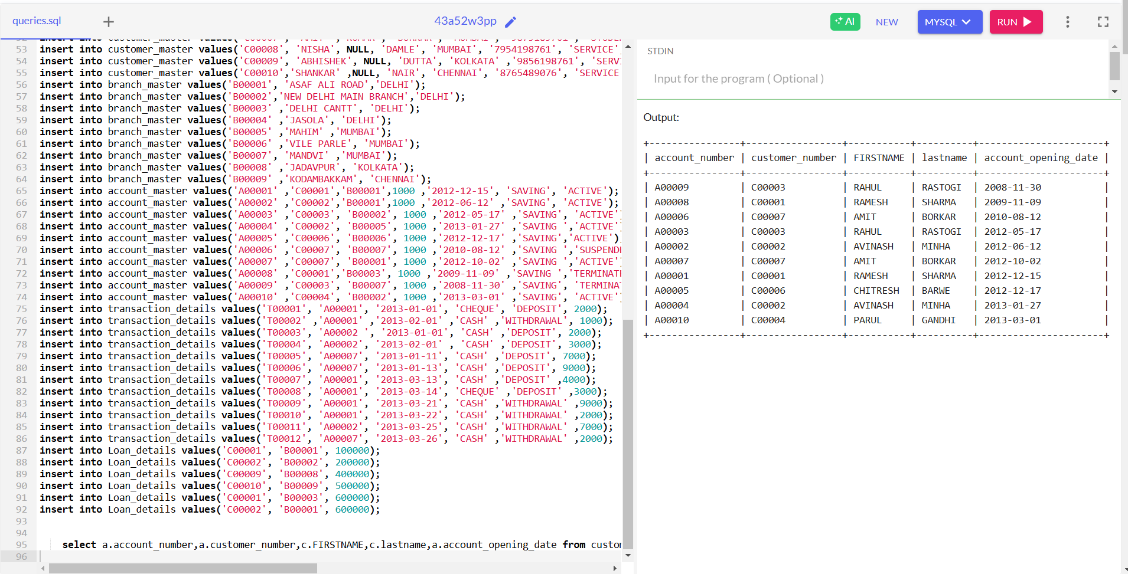

2.

select count(CUSTOMER_CITY) as Cust_Count from customer_master

Where CUSTOMER_CITY="Delhi";

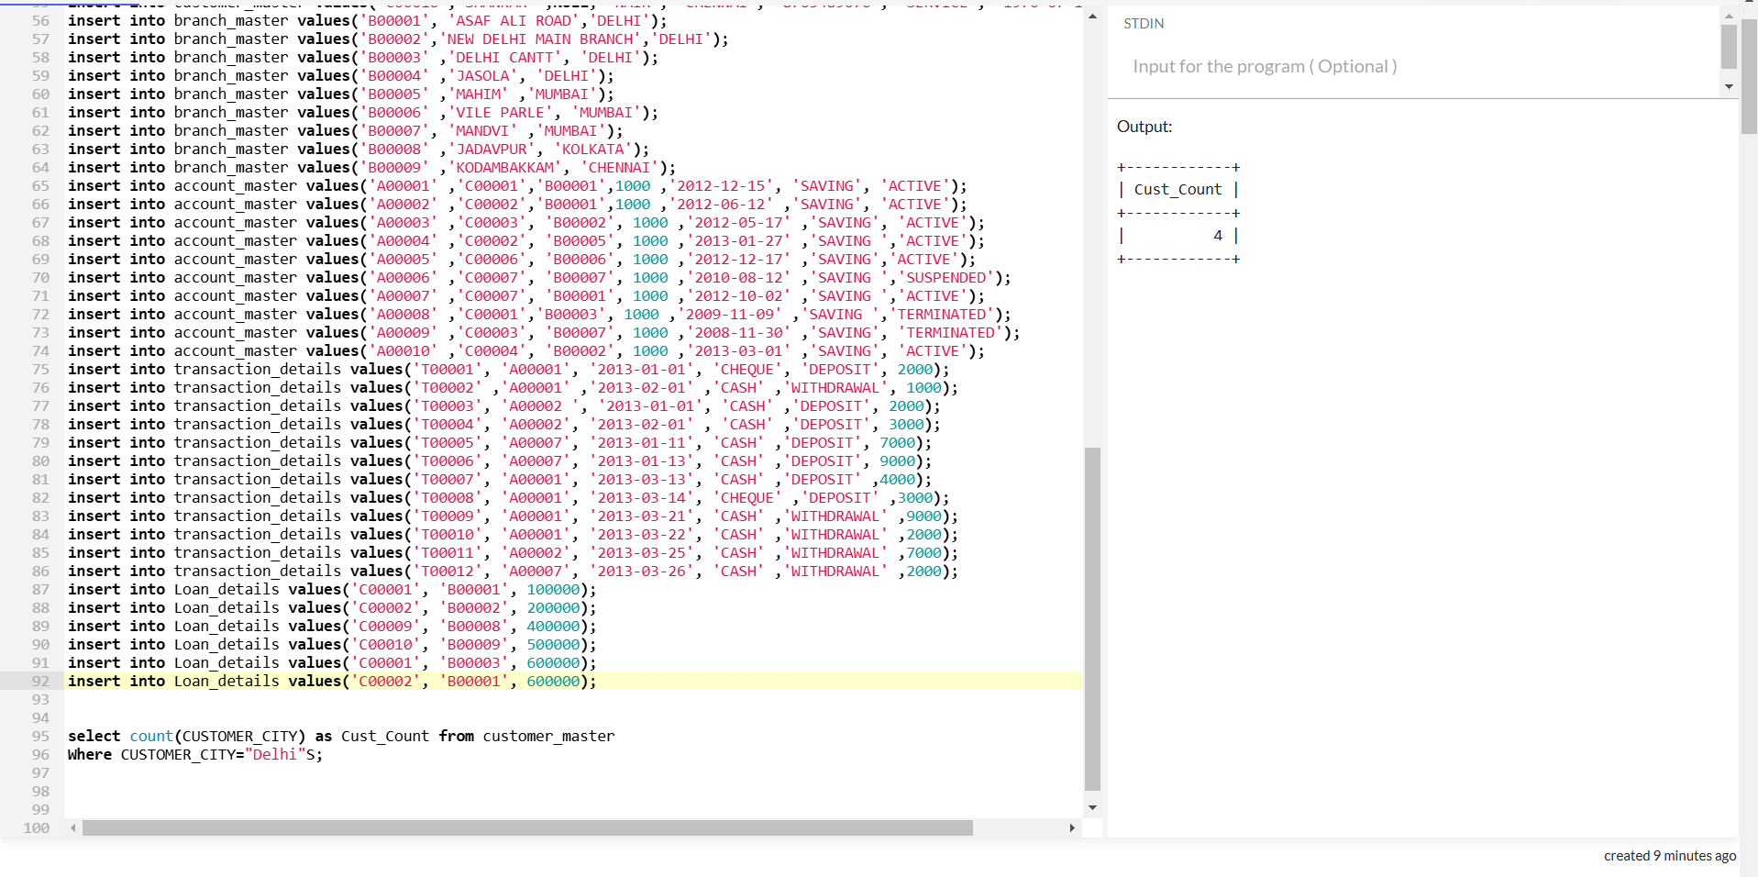

3.

select a.customer_number, c.FIRSTNAME, a.account_number

from account_master a

inner join customer_master c on a.customer_number=c.customer_number

where DAY(a.account_opening_date) >15

order by a.customer_number asc,a.account_number;

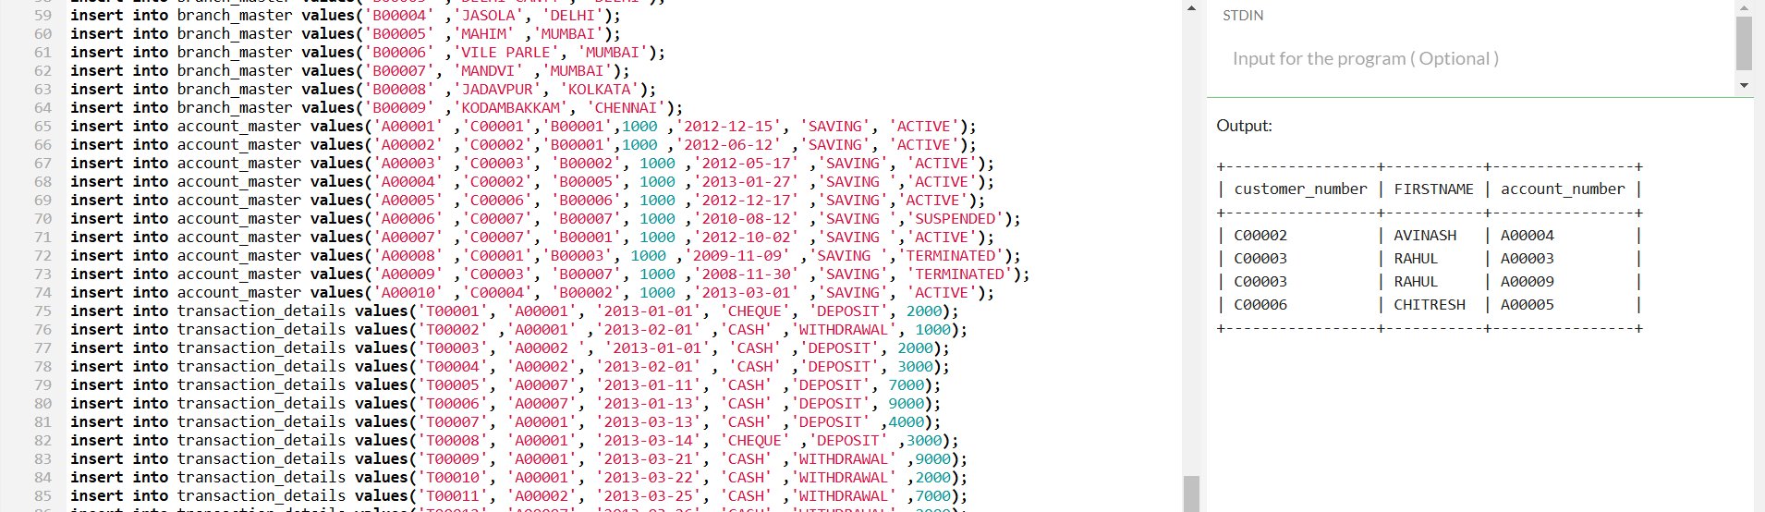

4.

select count(customer_number) as Count_Customer from customer_master

where customer_number not in (select customer_number from account_master);

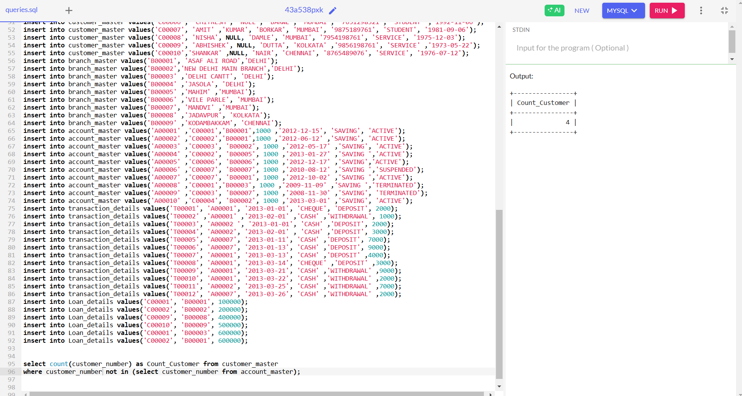

5. select t.transaction_type ,COUNT(*) as Trans_Count

from transaction_details t

inner join account_master a on a.account_number = t.account_number

where a.customer_number like "%001"

group by t.transaction_type

order by t.transaction_type;

