

975G5: Engineering Scalable and Reliable Software Project

|  |  |
| --- | --- |
| **Title** | Technical Documentation by Group 6 |
| **Candidate Numbers** | 276280, 277822, 276267, 277822, 284318, 260029, 284496 |
| **Module Leader** | Prof. Hsi-Ming Ho |
| **Course Title** | MSc ESRS |
| **Date Submitted** | 14/05/2024 |

**Abstract**

This report presents the study, design and analysis of a software project targeted at creating a Book Lending application. This project is developed as a part of the course module – ESRS as a tool to learn software development to enable deploying software systems which are scalable and dependable. The project has been created by the collaborative and determined efforts of the team members of Group-9.

**Acknowledgement**

The team members of Group – 9 express sincere gratitude to our teacher and module convenor Prof. Hsi-Ming Ho for his constant support and invaluable insights throughout the course of this project. His expertise and guidance have been crucial in achieving success through the journey of the project development.

Furthermore, a heartfelt thank you to all the members of Project Group 9. The dedicated hard work, sheer determination, and collective effort of all the team members have played an important role in achieving the goals of developing this project. The commitment to excellence and working together has made this journey fulfilling and has provided a rewarding experience to all. Thank you all for your valuable contributions.

1. INTRODUCTION 1
   1. Overview 1
   2. Project Tasks 2
      1. N-Queens Problem 2
      2. Polysphere Problem - 2 Dimension 2
      3. Polysphere Problem - 3 Dimension 2
2. DEVELOPMENT 3
   1. Development Methodology 3
   2. Software Tools 3
   3. Implementation 4
      1. Task 1: Create GitHub account and repository 4
      2. Task 2: Develop N-Queens Puzzle Solver 4
      3. Task 3: Develop Polysphere Puzzle Solver 4
      4. Task 4: Develop Polysphere Pyramid Puzzle Solver 4
      5. Task 5: Additional Features and Free Exploration 5
3. TESTING 6
   1. N-Queens Problem 6
   2. Polysphere Puzzle-2D 11
   3. Polysphere Extreme 17
4. CONCLUSION 24
   1. Limitations 24
      1. N-Queens Puzzle 24
      2. Polysphere Pro 24
      3. Polysphere Extreme 24
   2. Future Improvements 25

# INTRODUCTION

## Overview

This comprehensive report unfolds an in-depth study and analysis, delving into a purposeful software initiative aimed at the development of book lending application. The primary objective of this application is to create a multi-user style application which enables like-minded persons to connect with each other and share their common love for books. This application allows them to request & share books with each other building towards a sense of community for book lovers. The application is robust enough to handle server failures and scalable whenever required.

The development approach for this application involved the adoption of the agile methodology where the project was being continuously made deployable with small incremental features and the developers kept adding various functionality. One real-life scenario of changing requirement was simulated as well when the team decided the UI-UX needs to be changed and be made much more sophisticated. This strategic choice allowed team to proactively respond to the evolving needs and made them feel the importance of strictly following software development techniques learned in the past module. Only because of such techniques, it was possible to accommodate changes in the project even in the later stages. The application is hosted on AWS cloud

# DEVELOPMENT

## Development Methodology

To replicate the authentic experience of a rigorous software development project, the development approach involved the adoption of the Agile methodology. This strategic choice allowed all parties to build features incrementally. GitHub & JIRA will be the platforms for all aspects of development tracking in collaboration with the client. GitHub provides an efficient environment that can be used to maintain version control, and project management was handled with the help of JIRA throughout the development process. By using GitHub, it is possible to maintain transparency and collaboration.

## Software Tools

The project utilized following set of tools to support various aspects of development:

* **Django:** The project was implemented using the Django framework.
* **HTML, CSS, and JavaScript:** These web technologies were utilized for frontend development.
* **MySQL:** The MySQL database management system was chosen to store and manage puzzle solutions efficiently.
* **Ubuntu Minimal Linux OS:** The project was hosted on the Ubuntu Minimal Linux operating system, providing a robust and secure environment for the application.

## Implementation

The project's implementation unfolded through a series of structured tasks, each contributing to the overall development and refinement of the application. Here's an elaboration on each task:

### Task 1: Create GitHub account and repository

In this phase, the project plan was devised to create a primary structure of the project.

### Task 2: Design & Plan architecture

### Task 3: Dividing tasks as per talent available

### Task 4: Incremental development of features

### Task 5: Deployment as per architecture

# TESTING

Following sections lists the test cases and results for each game to evaluate the software functionality is as expected and meets the specified functional requirements. The goal of this phase is to ensure the functionality and reliability of the implemented code and algorithm fulfilling its intended purpose.

## N-Queens Problem

|  |  |  |  |
| --- | --- | --- | --- |
| S.No. | Test Case | Expected Result | Results |
| 1 | To test the deployment of Bingle app | Successful launch of application hosted on url – ‘ENTER URL HERE’ | Server launched. |
| 2 | To test adding of new book into your account |  |  |

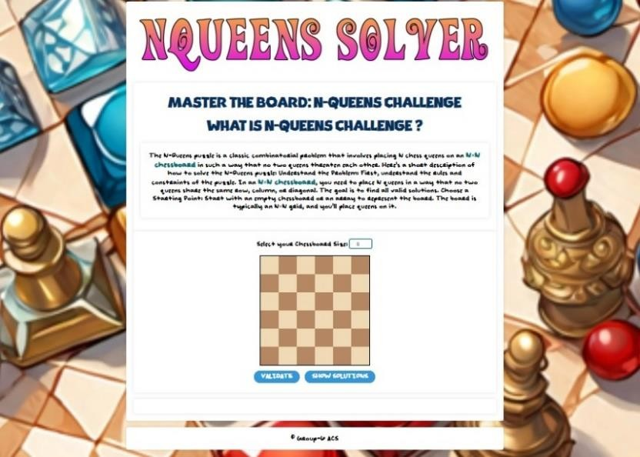

***Figure 1***

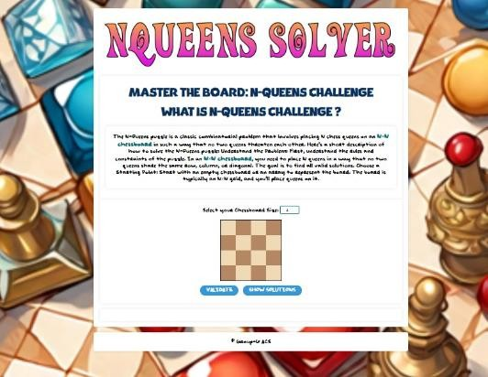

***Figure 2***

|  |  |  |  |
| --- | --- | --- | --- |
| S.No. | Test Case | Expected Result | Results |
| 3 | To remove an existing book from your account |  |  |
| 4 | To test viewing the entire library |  |  |

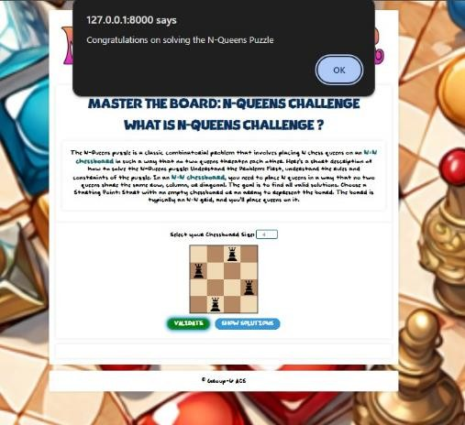

*Figure 3*

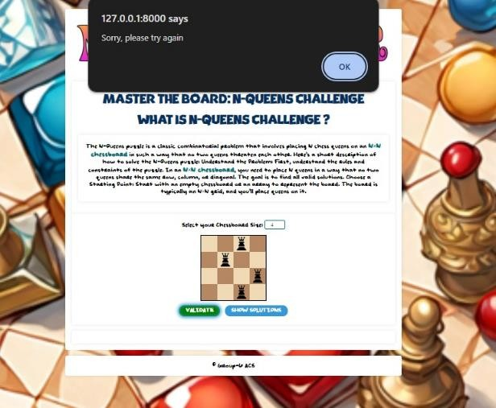

***Figure 4***

|  |  |  |  |
| --- | --- | --- | --- |
| S.No. | Test Case | Expected Result | Results |
| 5 | To test requesting a particular book |  |  |

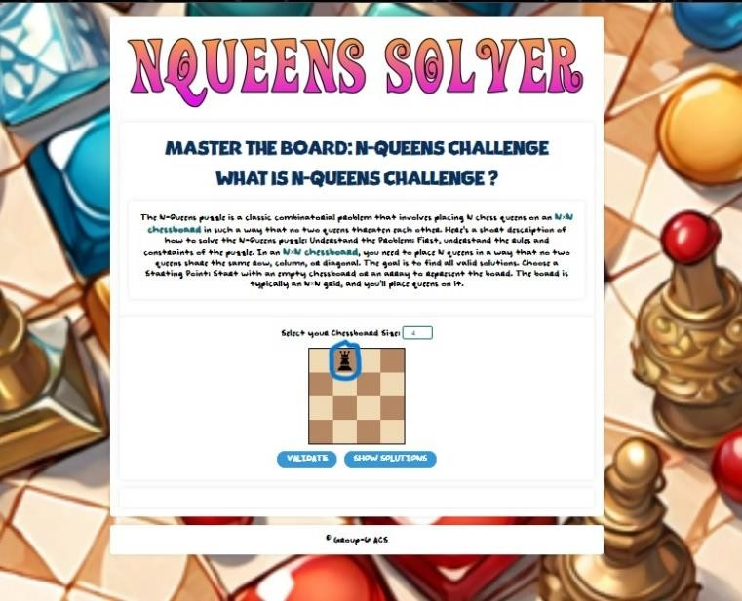

***Figure 5***

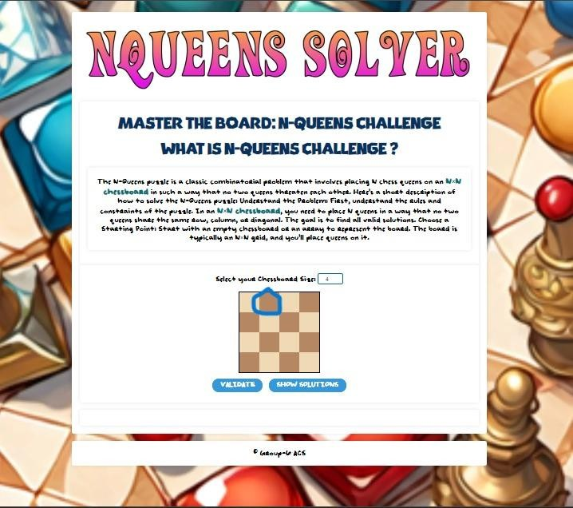

***Figure 6***

|  |  |  |  |
| --- | --- | --- | --- |
| S.No. | Test Case | Expected Result | Results |
| 6 | To accept a book borrow request from a fellow user |  |  |

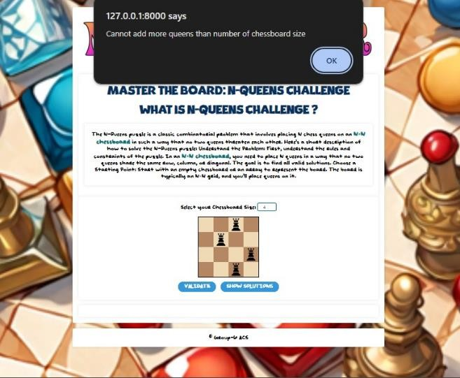

***Figure 7***

|  |  |  |  |
| --- | --- | --- | --- |
| S.No. | Test Case | Expected Result | Results |
| 7 | To reject a book borrow request from a fellow user |  |  |
| 8 | To chat with a particular user |  |  |
| 9 | To view Booking history |  |  |
| 10 | To change personal information in profile page |  |  |
| 11 | Search for User in search page |  |  |
| 12 | Search for Book in search page |  |  |
| 13 | To view pending notifications |  |  |

# CONCLUSION

In conclusion, this comprehensive report outlines a purposeful software initiative focused on the development of a web-based game application, emphasizing interactive puzzle resolution. The project's central objective is to empower users to independently engage with and solve intricate puzzles, including the N-Queens puzzle and the Polysphere Puzzles in both 2D and 3D dimensions. The web application is designed to facilitate active user participation in the puzzle-solving process, allowing navigation through chessboard scenarios, strategic queen placements, and the placement of various shapes on grids for Polysphere Puzzles. The is project is implemented through agile methodology to provide requested features and feedback from the client. Utilized GitHub as the central platform for tracking all development activities in collaboration with the customer. The project also underwent thorough testing to verify reliability and functionality of the web-based game application.

## Limitations

### N-Queens Puzzle

* The Chessboard size is limited to 10 Queen pieces due to computation complexities emerging with higher size boards as heavy resources are consumed when computing the solutions.

### Polysphere Pro

* While dragging of the shapes, image of the shape while being dragged cannot change according to rotations and flips performed by the user. Although the placement of the shape remains accurate.

### Polysphere Extreme

* Placement of the shapes can only be done unidirectional relative to the initial placement of the first sphere.
* Users cannot place the pieces diagonally as the shape of pieces cannot be skewed from its original shape.
* The user cannot drag and drop the pieces on the pyramid. The game relies on the User’s understanding of the 3-d structures and visual knowledge of the shapes. The limitation is caused due to heavy reliance on libraries such as Three.js and Orbit Controls that are used to generate the 3-D elements of the Game.

## Future Improvements

To improve the puzzle-solving capabilities, the optimization of time complexity and the enhancement of algorithmic efficiency in the computation of solutions for each puzzle will be required in the project. The primary goal is to guarantee the time required for solving puzzles is minimized, and the implemented algorithms show efficiency in delivering accurate solutions. By improving the time complexity, the overall performance of the puzzle-solving mechanisms will be enhanced, providing users with a smoother experience in navigating through complex problems. Furthermore, enhancement in both the user experience and the visual features of the system can also be implemented. This improvement can elevate the overall usability and aesthetics of the application. Enhancing the user experience requires improving the interface, navigation flow, and overall interaction design for a more intuitive, efficient, and satisfying engagement for the users.