1. Starting with the values 1, 2, 4, 4, 5, 6, 9, 11, 12, 12, 17, do the following:
   1. Create a heap H in which these values are the keys.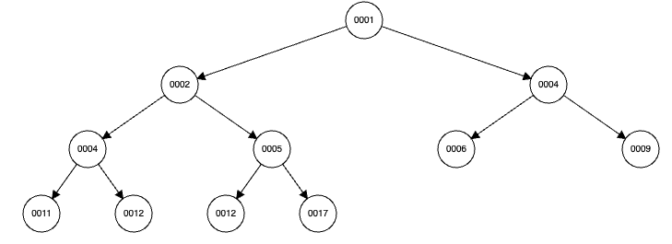
   2. Perform the insertItem algorithm to insert the value 7 into H. Show all steps.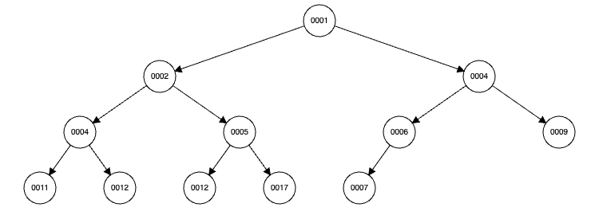
   3. Perform the removeMin algorithm on H and show all steps.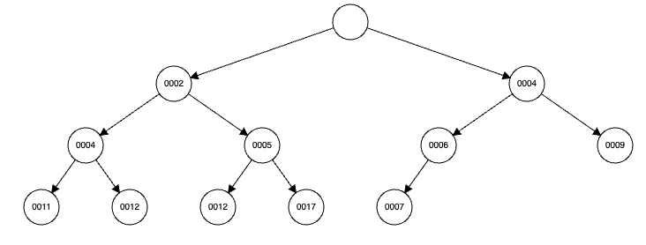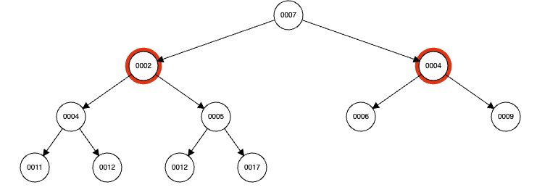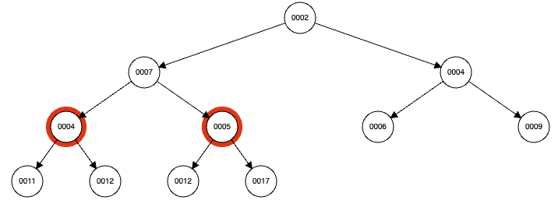

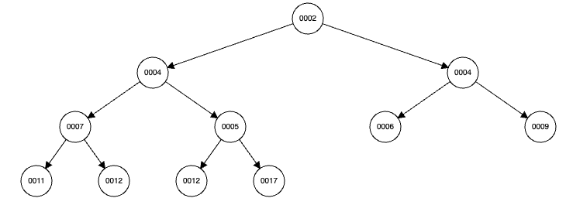

* 1. Represent H in the form of an array A.

[2, 4, 4, 7, 5, 6, 9, 11, 12, 12, 17]

* 1. Perform the array-based insertItem algorithm to insert 14 into A – show all steps.

newIndex = 2i + 1 -> i = (newIndex - 1) / 2 = (11 - 1) / 2 = 5

arr[5] = 6, 11 > 6 —> no need rotation

[2, 4, 4, 7, 5, 6, 9, 11, 12, 12, 17]

* 1. Perform the array-based removeMin algorithm on A – show all steps.

[2, 4, 4, 7, 5, 6, 9, 11, 12, 12, 17, 14]

-> [14, 4, 4, 7, 5, 6, 9, 11, 12, 12, 17]

-> [4, 14, 4, 7, 5, 6, 9, 11, 12, 12, 17]

-> [4, 5, 4, 7, 14, 6, 9, 11, 12, 12, 17]

-> [4, 5, 4, 7, 12, 6, 9, 11, 12, 14, 17]

1. Carry out the array-based version of HeapSort on the input array [1, 4, 3, 9, 12, 2, 4] Show steps and outputs along the way. Make sure to distinguish between Phase I and Phase II of the algorithm.

Phase 1:

1 | 4 3 9 12 2 4

1 4 | 3 9 12 2 4

upheap 4 1 | 3 9 12 2 4

4 1 3 | 9 12 2 4

4 1 3 9 | 12 2 4

upheap 4 9 3 1 | 12 2 4

upheap 9 4 3 1 | 12 2 4

9 4 3 1 12 | 2 4

upheap 9 12 3 1 4 | 2 4

upheap 12 9 3 1 4 | 2 4

12 9 3 1 4 2 | 4

12 9 3 1 4 2 4

upheap 12 9 4 1 4 2 3

Phase 2:

3 9 4 1 4 2 | 12

9 3 4 1 4 2 | 12

9 4 4 1 3 2 | 12

2 4 4 1 3 | 9 12

4 2 4 1 3 | 9 12

4 3 4 1 2 | 9 12

2 3 4 1 | 4 9 12

4 3 2 1 | 4 9 12

1 3 2 | 4 4 9 12

3 1 2 | 4 4 9 12

2 1 | 3 4 4 9 12

1 2 3 4 4 9 12

1. Draw an example of a MaxHeap whose keys are all the odd numbers lie in [1, 21] (with no repeats), such that the insertion of an item with key 14 would cause up-heap to proceed all the way up to a child of the root (replacing that child’s key with 14).

[1, 3, 5, 7, 9, 11, 13, 15, 17, 19, 21]

21

19 11

13 17 3 9

1 7 5 15

->

21

19 11

13 17 14 9

1 7 5 15