**Call-Center on Mobile for Clinics**

**Nguyen The Phuong – Phan Thanh Thuan – Nguyen Cao Duy – Nguyen Luong Tuan Kiet – Kieu Trong Khanh**

FPT University, Software Engineering, Ho Chi Minh City, Vietnam

Nguyễn Thế Phương - phuongntse62087@fpt.edu.vn

Phan Thành Thuận - thuanptse62063@fpt.edu.vn

Nguyễn Lương Tuấn Kiệt- kietnltse61696@fpt.edu.vn

Nguyễn Cao Duy - duyncse@61032@fpt.edu.vn

Kiều Trọng Khánh, M.E (Advisor) - khanhkt@fe.edu.vn

*Abstract*

At the present, the clinic usually uses traditional ways to receive the call, that is hiring a switchboard operator. But, that solution has a few problems such as missed call or receive the wrong information. So, the use of switchboard operator to received call do not high efficiency.

Another way to solve this problem for the clinic is Call-Center, the clinic will rent the traditional Call-Center to receive the call from patients. In this method, Call-Center will provide more professional service for the clinic, but the cost is quite expensive and it is hard to exchange appointment information for the clinic.

That is the reason why we decided to build an automatically Call-Center system to save time and cost for the clinic. When there is a call from the patient, the system will pick up the call automatically, receive information and schedule appointment for the patient. And then, the system will send SMS about appointment information for the patient. The clinic just accesses the system to view all schedule appointment. Our system also allows patient book appointment via SMS like the way above.

Keywords

Automatically Call-Center, Schedule appointment, Speech To Text, Text To Speech.

# **Introduction**

Call-Center on mobile for clinic is the system we build to provide booking appointment services for the patient by hotline phone number. Our approach contains a main problem is booking appointment service by the call.

Booking appointment service by the call is the way we allow patient call to clinic phone number and interactive with the system to make appointment. To do that we need to control a clinic’s phone number, that is mean when clinic’s phone number have any incoming call, our system will pick up a call automatically, answer to the patient by a voice and also receive information when patient talk.

In the detail, we build booking appointment service with flowing flow:

* When a patient call to clinic’s phone number, we pick up a call automatically.
* Then answer to the patient by hello message and guiding patient how to book appointment.
* Next step is listen patient’s information
* Once the patient’s information is available, the system will analyze that data and make appointment.
* The last thing is the system will announce appointment’s information to patient.

# **PROBLEM and Solution plan**

When we start to identify problems and find the way to resolve them, we found many difficult things. We decide to use smartphone as a switchboard to receive and answer a call. We try on both Android and IOS but as we know that, take the privilege of system phone is really hard things. We try to root Android system and jailbreak IOS to take that privilege but it still not worked correctly. And event after many hours research we find the way to done the first step is auto pick up phone call (only working on Samsung’s device). We instantly face with another problem, we cannot send voice answer when we are receiving the call. So, we fail on that way.

After that, we change the way to looking for this problem, that is using third-party framework to control the clinic’s phone number. We research about some frameworks suck as Twilio, Nexmo, Bitrix24, etc. Finally, we choose Twilio to solve our problem because Twilio provide rich of document about their framework and they get better support from the StackOverFlow community, the most important thing is that they provide some features that fit our system.

# **plan implementation**

1. **Schedule appointment**

After the system analyzed information received from patient via SMS or the call, we need to estimate a time for appointment. To implement this algorithm, we use information about working hours of the clinic which is configured yet.

The appointment time is calculated based on formula:

**Estimate_Time = Base_Time + Examination_Duration**

Detail description:

* Estimate_Time: The time estimated for new appointment
* Examination_Duration: The duration for one examination which configured by clinic
* Start_Working: The start working time which configured by the clinic
* End_Working: The end working time which configured by the clinic
* Last_Appointment: The time of last appointment on the day of clinic
* Delay_Duration: The duration of epsilon time for working hours
* Base_Time:
  + If no appointment made on that day, Base_Time is Start_Working and set Examination_Duration = 0
  + If clinic has any appointment on that day, Base_Time is the time of Last_Appointment
* If Base_Time is early than current time, Base_Time is the current time

If estimate time of new appointment is later than (End_Working + Delay_Duration), that appointment cannot creating.

1. **Book appointment by the call**

When our system receives the call from patient, who want to book appointment. We must to guide patient how to book appointment and collect information patient was response, bases on that information we make appointment for patient.

The processing model of booking appointment following these steps:

1. Guiding the patient book appointment when system receive a call
   * Check a call is valid or not
     + If the patient’s phone number is blocked by the clinic, our system finishes a call and notify to patient the reason
     + If this is the time clinic does not workings, our system finishes a call and announce the non-working time of clinic to patient
   * After condition checking done, the system find and play greeting audio file of clinic which contain hello message and guiding message of clinic
   * After play greeting audio file, the system plays beep sound and start recording a call.
2. Analyzing patient’s information which input on the call
   * When the patient ends a call, our system stops recording and save recorded file.
   * Next step, we get patient’s name from recorded file by the way translate voice to text.
   * If that patient already booked appointment on this day, our system will send error message to the patient and finish this algorithm
3. Estimation time for appointment using “Schedule Appointment” algorithm
   * Get estimation time for appointment using “Schedule Appointment” algorithm
   * If estimation time is valid we continue step 4)
   * If estimation time is invalid, our system will send error message to the patient and finish this algorithm
4. Announcement about appointment’s information for patient and clinic. Base on estimation time, our system will announce appointment information to patient and clinic

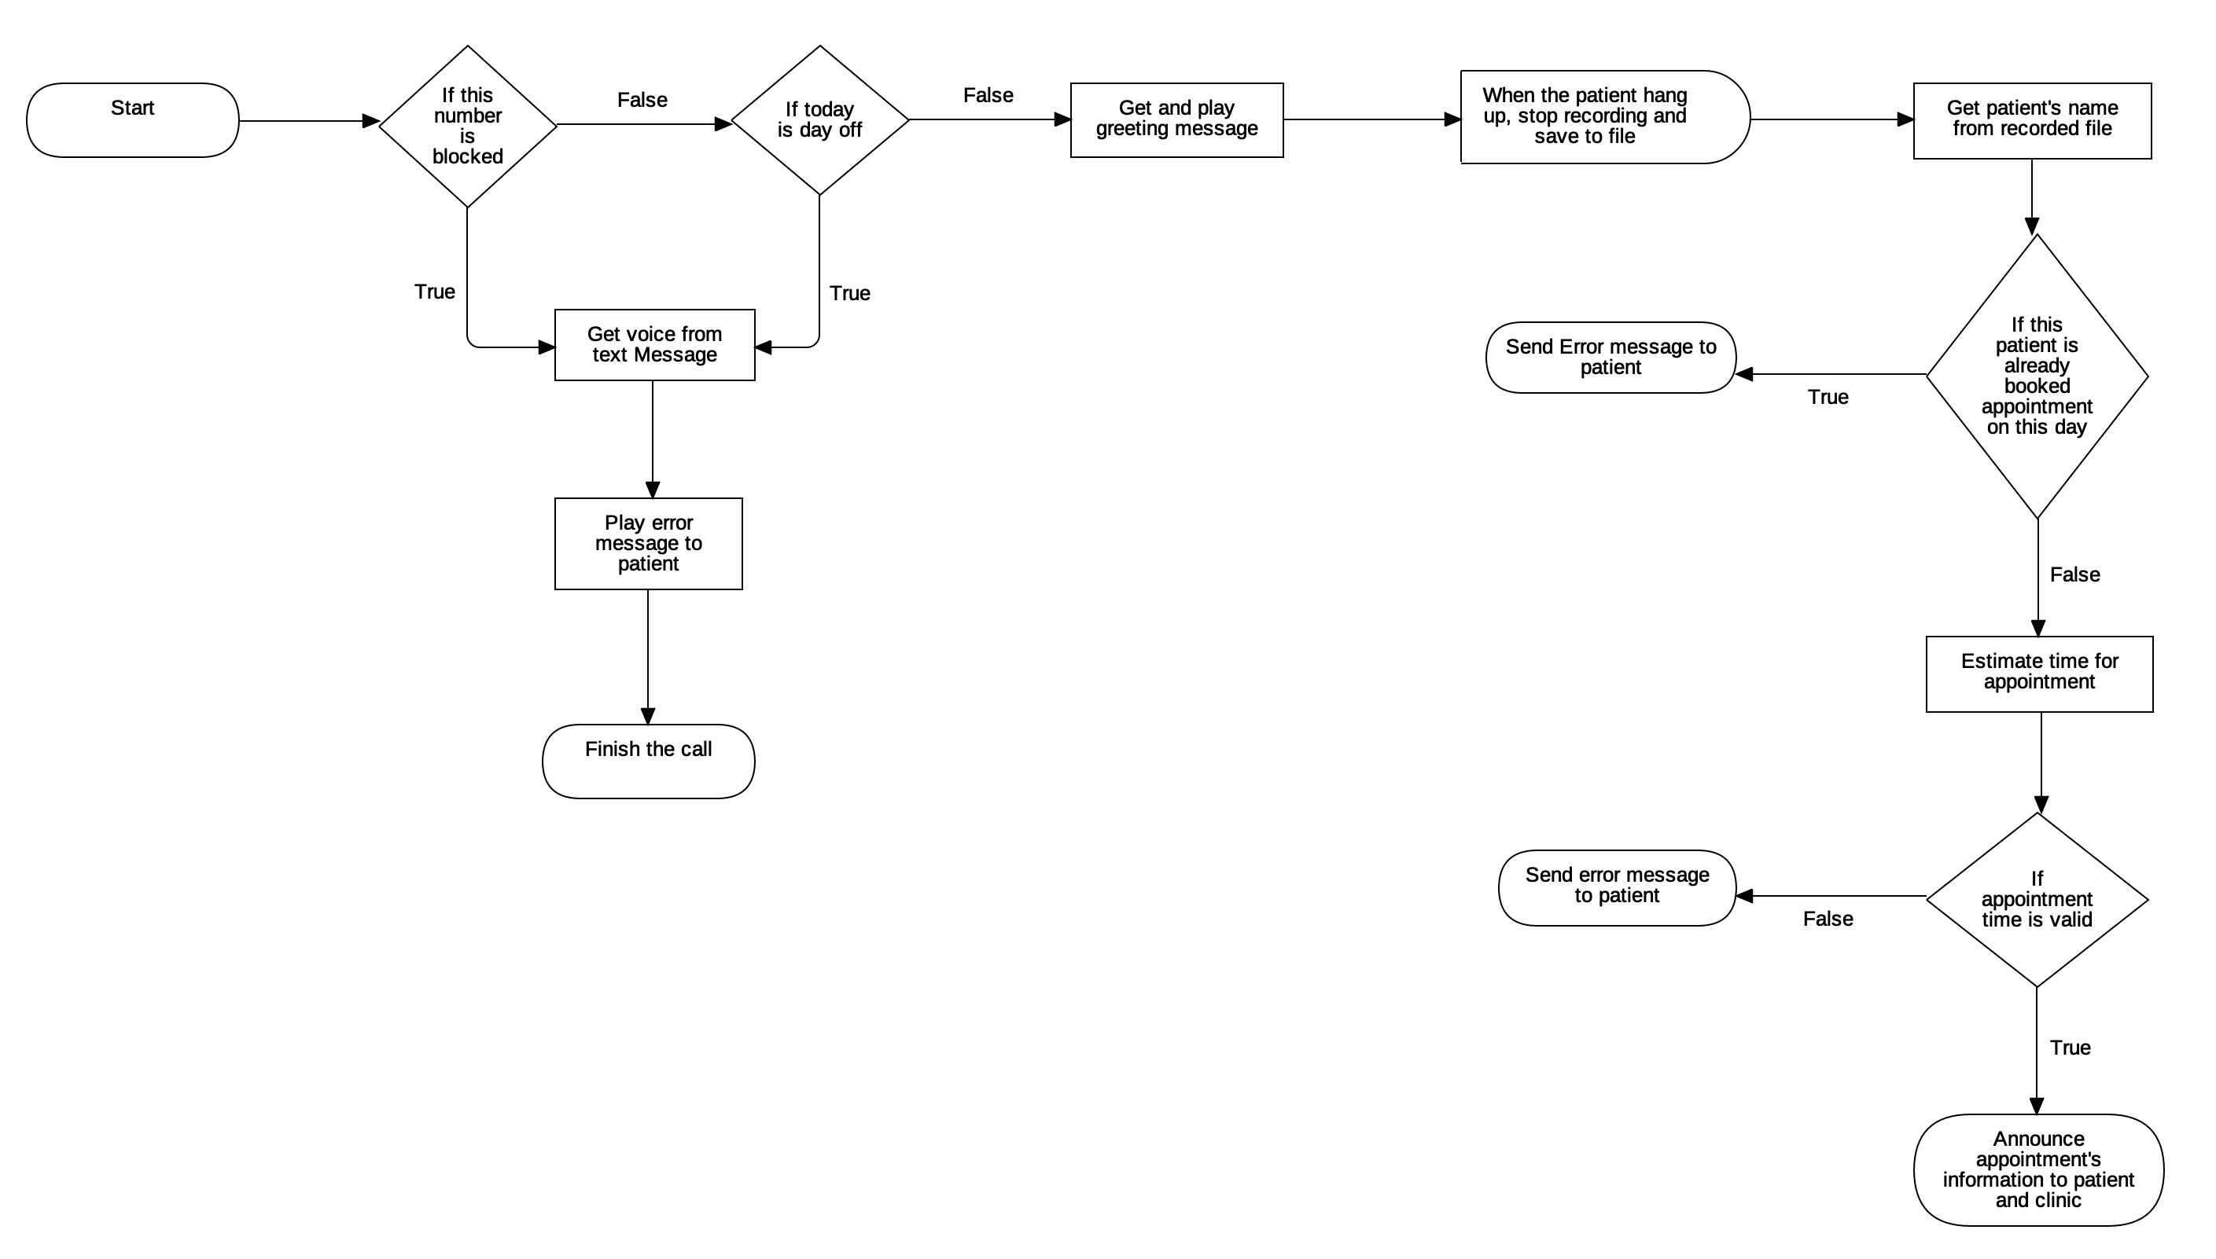

1. **Book appointment by SMS**

When our system receives the SMS from patient, who want to book appointment. We must to analyze information on a SMS and try to make appointment base on that information, and then announce the result to patient.

The processing model of booking appointment following these steps:

1. Check appointment booking

* If SMS booking appointment is wrong format, our system will send guiding message to the patient and finish this algorithm
* If the patient’s phone number is blocked by the clinic, our system will notify to patient the reason and finish this algorithm
* If this is the time clinic does not workings, our system announce the non-working time of clinic to patient and finish this algorithm
* If the patient already booked appointment on this day, our system will send error message to the patient and finish this algorithm

1. Estimation time for appointment using “Schedule Appointment” algorithm

* Get estimation time for appointment using “Schedule Appointment” algorithm
* If estimation time is valid we continue step 3
* If estimation time is invalid, our system will send error message to the patient and finish this algorithm.

1. Announcement about appointment’s information for patient and clinic: base on estimation time, our system will announce appointment information to patient and clinic.

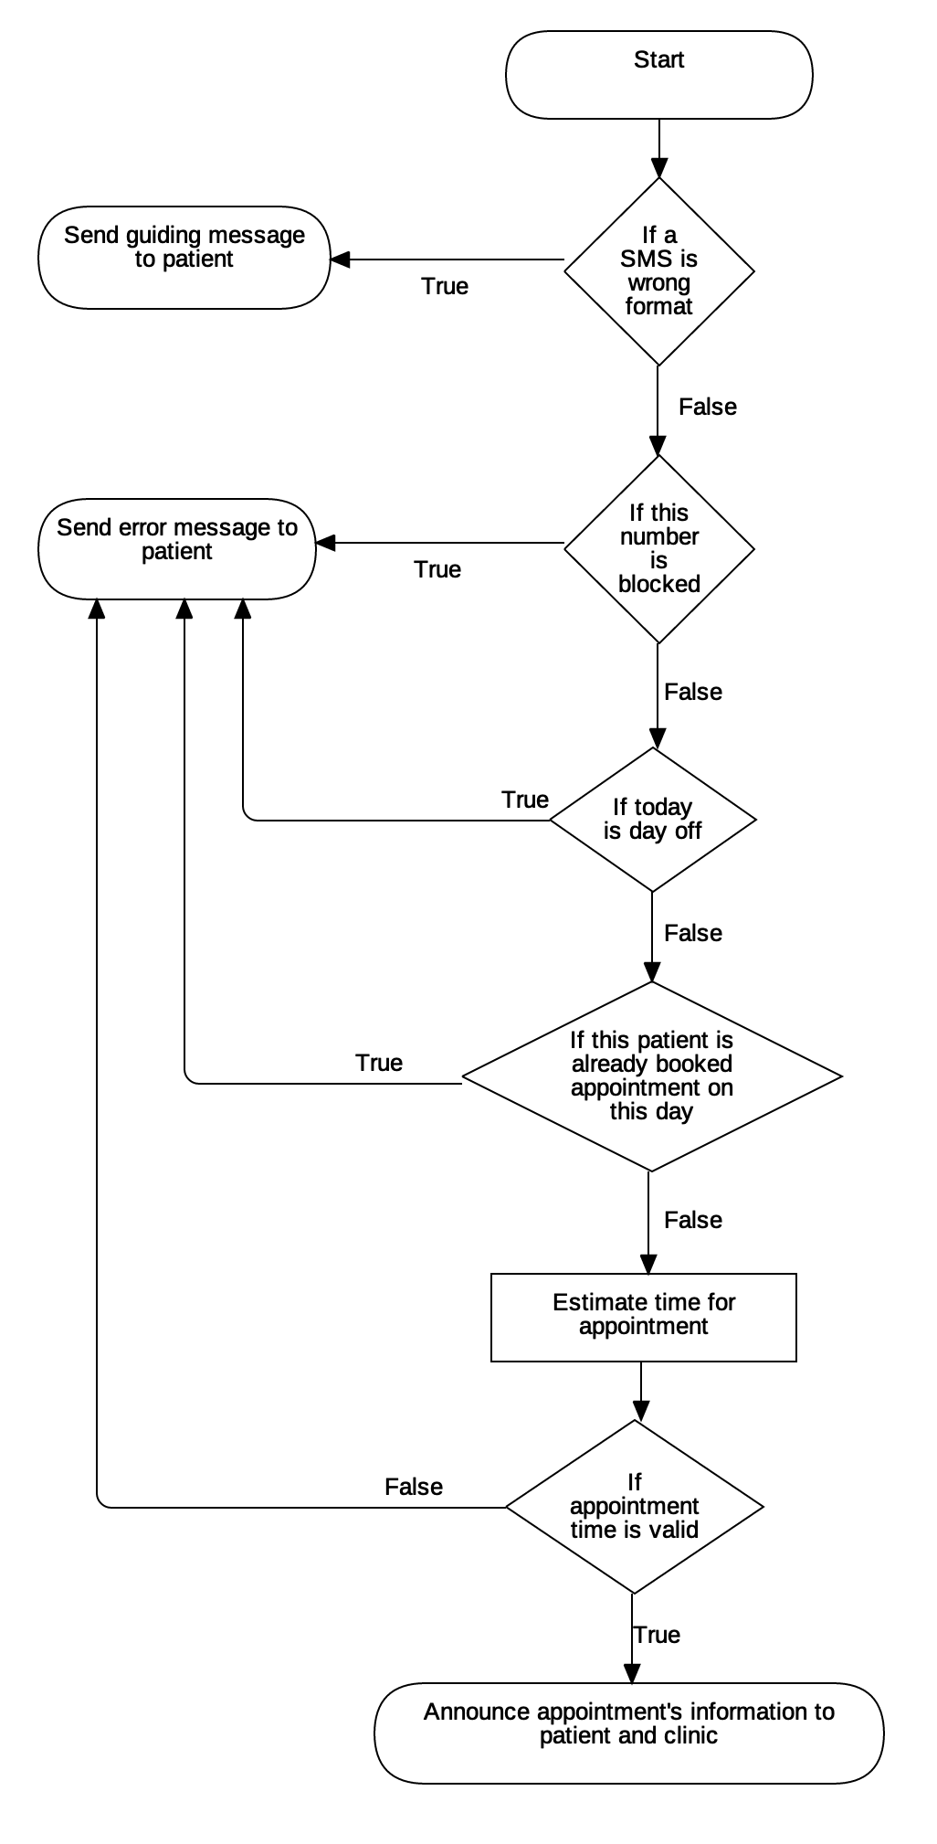

# **ANalysis**

Analysis the methods that are presented in III sections, are affected by Proofing or result of testing

# **EXPERIMENTAL RESults and conclusion**

Describe how to simulator the solutions and results of system testing

##### Acknowledgment *(Heading 5)*

Expression the supporting from some one ….

##### References

The template will number citations consecutively within brackets [1]. The sentence punctuation follows the bracket [2]. Refer simply to the reference number, as in [3]—do not use “Ref. [3]” or “reference [3]” except at the beginning of a sentence: “Reference [3] was the first ...”

Number footnotes separately in superscripts. Place the actual footnote at the bottom of the column in which it was cited. Do not put footnotes in the reference list. Use letters for table footnotes.

Unless there are six authors or more give all authors’ names; do not use “et al.”. Papers that have not been published, even if they have been submitted for publication, should be cited as “unpublished” [4]. Papers that have been accepted for publication should be cited as “in press” [5]. Capitalize only the first word in a paper title, except for proper nouns and element symbols.

For papers published in translation journals, please give the English citation first, followed by the original foreign-language citation [6].

1. G. Eason, B. Noble, and I.N. Sneddon, “On certain integrals of Lipschitz-Hankel type involving products of Bessel functions,” Phil. Trans. Roy. Soc. London, vol. A247, pp. 529-551, April 1955. (*references*)
2. J. Clerk Maxwell, A Treatise on Electricity and Magnetism, 3rd ed., vol.