Module 6 — Routing Algorithms & Protocols
  - Computer Networks Mastery: SEBI IT / RBI / NABARD / GATE / C-DAC / Interview / Backend — In-Depth Notes (with visuals)
Prepared for nidhi.sharma@forensiccybertech.com
2026
Table of Contents

Module 6 — Routing Algorithms & Protocols
Where this module sits. Module 5 gave each host an IP address. But how does a packet actually find its way across dozens of routers from source to destination? That is routing — the Network layer’s second big job. This module covers the two core algorithm families (distance-vector with Bellman-Ford, and link-state with Dijkstra), the real protocols that run the Internet (RIP, OSPF, BGP), and the ideas that make routing scale (autonomous systems, hierarchy, longest-prefix match). Dijkstra/Bellman-Ford tracing and DV-vs-LS comparisons are frequent exam questions.
Importance ratings (out of 5):
Exam / Use | SEBI IT | RBI IT | GATE CS | Interview | Backend
This module | ★★★ | ★★★ | ★★★★★ | ★★★ | ★★★
Most-asked PYQ concepts (SEBI / RBI / GATE / C-DAC): distance-vector vs link-state; Bellman-Ford vs Dijkstra (and tracing shortest paths); RIP (hop count, max 15, count-to-infinity, split horizon); OSPF (link-state, areas, cost); BGP (path-vector, inter-AS); IGP vs EGP; longest-prefix match; hierarchical routing / autonomous systems.

6.1 Routing vs Forwarding (get this distinction right)
- Routing — the control plane: routers exchange information and build the routing table (which path to use for each destination). Runs in the background.
- Forwarding — the data plane: for each arriving packet, look up the table and send it out the right interface. Happens per-packet, at line speed.
Memory hook: routing = drawing the map (slow, occasional); forwarding = following the map for each car (fast, constant).
A routing table maps a destination prefix → next hop / outgoing interface. When several entries match, the router uses longest-prefix match (the most specific prefix wins); a default route 0.0.0.0/0 catches everything else.

MCQs
- Building the routing table is? → routing (control plane).
- Sending each packet using the table is? → forwarding (data plane).
- Two entries match a destination — which wins? → the longest prefix (most specific).

6.2 Static vs Dynamic Routing
- Static routing: admin manually configures routes. Simple, secure, no overhead — but doesn’t adapt to failures; fine for tiny/stub networks.
- Dynamic routing: routers learn and adapt automatically via a routing protocol (RIP/OSPF/BGP). Scales and self-heals, at the cost of protocol overhead.
Routing protocols pick paths by a metric: hop count (RIP), link cost/bandwidth (OSPF), or policy + AS-path length (BGP).

MCQs
- Which routing adapts to link failures automatically? → dynamic.
- RIP’s metric? → hop count. OSPF’s? → cost (bandwidth-based).

6.3 Distance-Vector Routing (Bellman-Ford, RIP)
Each router keeps a vector of distances to every destination and tells its neighbours its whole table. It updates using Bellman-Ford:
D_x(dest) = min over neighbours n of [ cost(x,n) + D_n(dest) ]
"my distance = cheapest (link to a neighbour + that neighbour's distance)"
Routers exchange tables periodically; distances converge to the shortest paths.
- RIP (Routing Information Protocol): classic DV; metric = hop count, max = 15 (16 = unreachable → limits network size); updates every 30 s.
- Problem — count-to-infinity: when a link fails, bad news spreads slowly and routers can bounce increasing distances back and forth.
- Fixes: split horizon (don’t advertise a route back to the neighbour you learned it from), poison reverse (advertise it back with distance ∞), hold-down timers.
Memory hook: DV = “routing by rumour” — you only hear distances from neighbours, so bad news travels slowly (count-to-infinity).

MCQs
- DV algorithm? → Bellman-Ford.
- RIP metric and max hops? → hop count, 15 (16 = unreachable).
- Count-to-infinity fix that won’t re-advertise a route to its source? → split horizon.

6.4 Link-State Routing (Dijkstra, OSPF)
Each router learns the entire topology (a map), then computes shortest paths itself with Dijkstra.
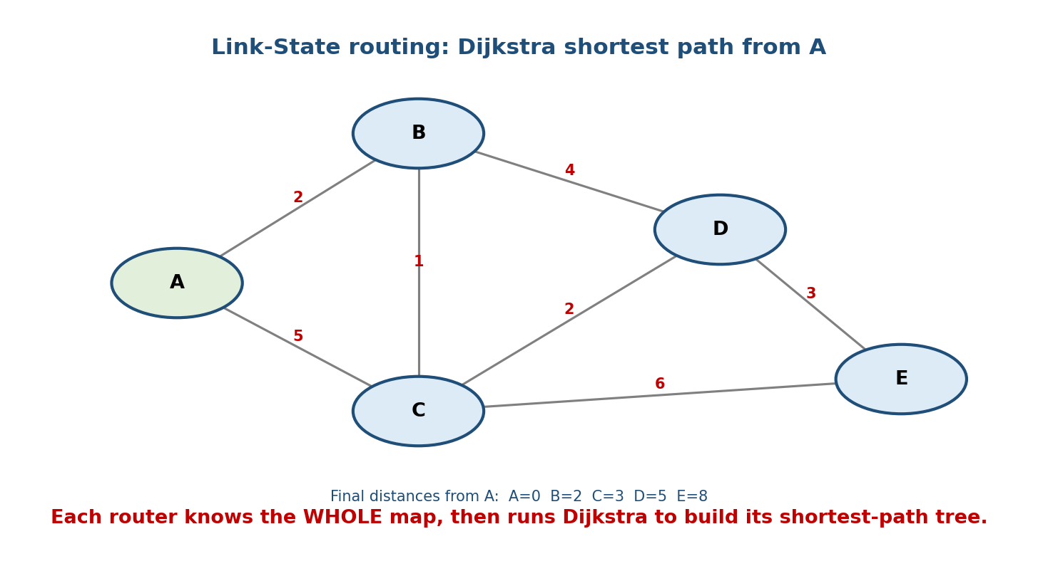
Every router floods its links to all others, builds the full map, and runs Dijkstra to find shortest paths (here A=0, B=2, C=3, D=5, E=8).
How it works:
- Discover neighbours and measure link costs.
- Flood a Link-State Advertisement (LSA) to every router (so all share the same map / link-state database).
- Each router runs Dijkstra (SPF) to build its shortest-path tree and fill its routing table.
- OSPF (Open Shortest Path First): the dominant IGP; link-state; metric = cost (inversely proportional to bandwidth); groups routers into areas (hierarchy) with a backbone area 0; fast convergence, no routing loops.
Memory hook: LS = “everyone gets the same map, then each finds its own shortest path.” Floods link states, not distances.

Distance-Vector vs Link-State (the guaranteed comparison)
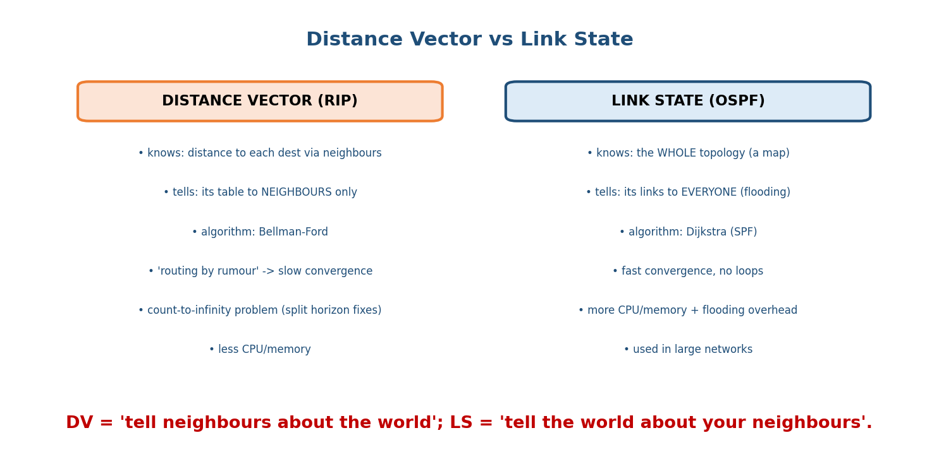
Distance vector tells neighbours about all destinations (Bellman-Ford, slow convergence); link state floods its links to everyone (Dijkstra, fast convergence).
 | Distance-Vector (RIP) | Link-State (OSPF)
Knows | distances via neighbours | the whole topology
Tells | its table to neighbours | its links to everyone (flood)
Algorithm | Bellman-Ford | Dijkstra
Convergence | slow (count-to-infinity) | fast, loop-free
Resources | low CPU/memory | more CPU/memory + flooding
Memory hook: DV = “tell your neighbours about the whole world”; LS = “tell the whole world about your neighbours.”

MCQs
- LS algorithm and a real protocol? → Dijkstra, OSPF.
- What does a router flood in link-state? → its LSA (link states).
- OSPF’s metric? → cost (∝ 1/bandwidth). Backbone area? → area 0.
- Which converges faster, DV or LS? → link-state.

6.5 Path-Vector Routing & BGP (the Internet’s glue)
The Internet is a network of Autonomous Systems (AS) — networks under one administration (an ISP, a company). Routing has two levels:
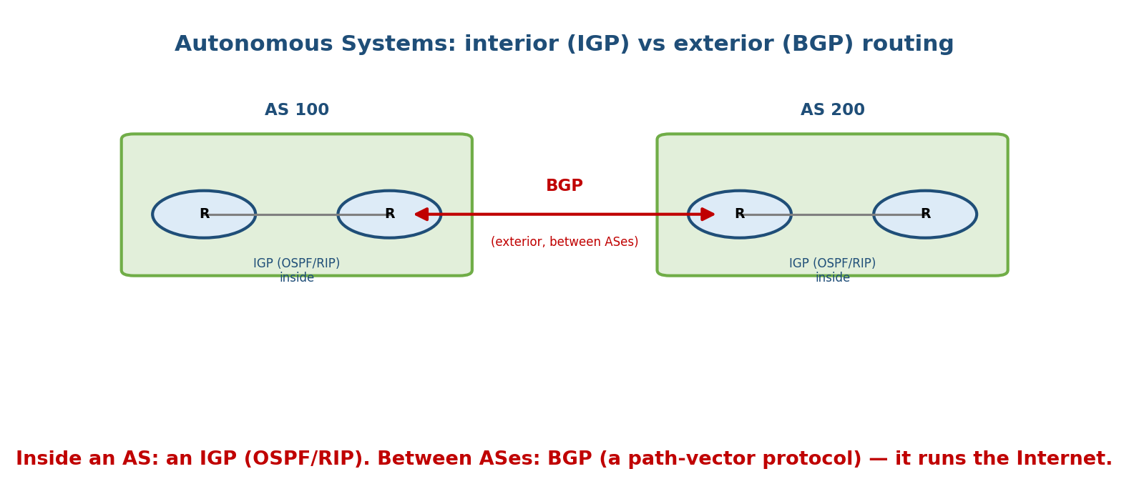
Inside an AS an interior protocol (OSPF/RIP) runs; between ASes, BGP — a path-vector protocol — exchanges reachability and enforces policy.
- IGP (Interior Gateway Protocol) — routing inside one AS: OSPF, RIP, EIGRP.
- EGP (Exterior Gateway Protocol) — routing between ASes: BGP (the only one in use).
BGP (Border Gateway Protocol) is a path-vector protocol: it advertises the full AS-path to each destination (so loops are detected by seeing your own AS in the path), and chooses routes by policy (business relationships), not just shortest distance. BGP is what makes the global Internet route.
Memory hook: inside an AS = IGP (OSPF/RIP); between ASes = BGP. BGP carries the AS-path and is policy-driven, not shortest-hop.

MCQs
- Routing between autonomous systems uses? → BGP (path-vector, EGP).
- How does BGP detect loops? → sees its own AS in the AS-path.
- OSPF and RIP are which category? → IGP (interior).

6.6 Other Routing Ideas (quick but tested)
- Flooding: send an incoming packet out every link except the one it came on; guaranteed delivery but wasteful — controlled by TTL/sequence numbers (used by LS to distribute LSAs).
- Hierarchical routing: group routers into regions/areas so tables stay small (OSPF areas; the Internet’s AS structure) — essential for scale.
- Broadcast/Multicast routing: deliver to all / a group (spanning trees, reverse- path forwarding; protocols like IGMP/PIM).
- Anycast: route to the nearest of several identical servers (how DNS root servers and CDNs work).

MCQs
- Sending a packet out every link but the source is? → flooding.
- What keeps routing tables small as the Internet grows? → hierarchy (areas/ASes).
- Routing to the nearest of many identical servers? → anycast.

6.7 Real-World & Backend Perspectives
- BGP runs the Internet — and BGP misconfigurations cause real global outages (route leaks/hijacks that redirect traffic). Backend/SRE on-call knows BGP.
- OSPF/link-state inside data centers (and modern designs like BGP-in-the-DC) keep large fabrics converging fast.
- Anycast + longest-prefix match is how CDNs and DNS send you to the nearest edge — the routing concepts here directly power low-latency delivery (M12).

6.8 Tradeoffs, Common Mistakes, Edge Cases
- Mistake: swapping algorithms — DV = Bellman-Ford, LS = Dijkstra (not the reverse).
- Mistake: thinking RIP scales — max 15 hops deliberately limits it to small networks.
- Trap: BGP is not shortest-path; it is policy/AS-path based.
- Edge case: DV’s count-to-infinity needs split horizon / poison reverse; LS avoids it but pays with flooding + CPU.

6.9 Exam, Interview & Coding Perspectives
- SEBI / RBI / NABARD: DV vs LS, which protocol is which (RIP/OSPF/BGP), IGP vs EGP, RIP hop limit, what BGP does.
- GATE / C-DAC: trace Dijkstra/Bellman-Ford on a given graph; count-to-infinity; longest-prefix match; metric definitions.
- Interview: “how does the Internet route between networks?” → AS + BGP; “OSPF vs RIP?” → link-state/Dijkstra/fast vs distance-vector/hop-count/slow.

6.10 Concept Checks & MCQs (test yourself)
- Routing vs forwarding? → build table (control) vs use table per packet (data).
- DV and LS algorithms? → Bellman-Ford and Dijkstra.
- RIP metric & hop limit? → hop count, 15.
- OSPF type & metric? → link-state, cost (∝1/bandwidth).
- Inter-AS protocol & type? → BGP, path-vector.
- Two count-to-infinity fixes? → split horizon, poison reverse.
- Multiple matching routes — selection rule? → longest-prefix match.
- What does LS flood? → LSAs (link states).
- IGP examples? → OSPF, RIP (, EIGRP).
- Which converges faster? → link-state (OSPF).

6.11 One-Page Revision Sheet
ROUTING (control plane) = build table. FORWARDING (data plane) = use table per packet.
table: dest prefix -> next hop. LONGEST-PREFIX MATCH wins. default = 0.0.0.0/0.
STATIC (manual) vs DYNAMIC (protocol; adapts). metric: hop(RIP)/cost(OSPF)/policy(BGP).
DISTANCE VECTOR (RIP): Bellman-Ford Dx(d)=min_n[cost(x,n)+Dn(d)].
tell NEIGHBOURS your table. "routing by rumour" -> slow, COUNT-TO-INFINITY.
fixes: split horizon, poison reverse, hold-down. RIP hop metric, MAX 15 (16=unreachable), 30s.
LINK STATE (OSPF): learn WHOLE map -> flood LSAs -> Dijkstra (SPF) -> shortest-path tree.
fast convergence, loop-free, more CPU/mem. cost ~ 1/bandwidth. areas + backbone AREA 0.
DV vs LS: "tell neighbours about the world" vs "tell the world about your neighbours".
PATH VECTOR (BGP): between AUTONOMOUS SYSTEMS. carries AS-PATH (loop detect = own AS in path),
POLICY-based (not shortest). IGP=inside AS (OSPF/RIP/EIGRP) | EGP=between AS (BGP).
OTHER: flooding(all links but source) | hierarchy(areas/AS -> scale) | anycast(nearest server).

Flash cards
Front | Back
DV algorithm / protocol | Bellman-Ford / RIP
LS algorithm / protocol | Dijkstra / OSPF
RIP metric & max hops | hop count; 15
OSPF metric & backbone | cost (∝1/BW); area 0
Inter-AS protocol & type | BGP; path-vector
Count-to-infinity fixes | split horizon, poison reverse
Multiple route match rule | longest-prefix match
IGP vs EGP | inside AS vs between ASes
Routing vs forwarding | build table vs use table
BGP route selection basis | policy + AS-path (not shortest)

Spaced repetition
- 24-hour: trace Dijkstra and Bellman-Ford on a small weighted graph.
- 7-day: DV vs LS table; RIP limits & count-to-infinity fixes; IGP vs EGP.
- 30-day: explain end-to-end how a packet is routed across two ASes (IGP + BGP) — without notes.

6.12 Summary
Routing (control plane) builds the table; forwarding (data plane) uses it per packet, choosing the longest-prefix match. Routes are static or dynamic. Distance-vector protocols (RIP) run Bellman-Ford, telling neighbours their distance vectors — simple but slow, with count-to-infinity (fixed by split horizon / poison reverse) and a 15-hop limit. Link-state protocols (OSPF) flood LSAs so every router has the full map, then run Dijkstra for fast, loop-free paths, organised into areas. Between autonomous systems, BGP (a path-vector, policy-driven protocol carrying the AS-path) routes the global Internet — an IGP runs inside an AS, BGP (EGP) between them. Hierarchy, flooding, and anycast round out how routing scales.
Next, Module 7 — The Transport Layer (TCP & UDP) climbs to Layer 4: ports and sockets, UDP vs TCP, the three-way handshake, connection teardown, and reliable delivery.
You have mastered this module when you can: separate routing from forwarding and apply longest-prefix match; trace Dijkstra and Bellman-Ford; contrast DV vs LS and name their algorithms/protocols; state RIP’s limits and count-to-infinity fixes; and explain IGP vs EGP and BGP’s path-vector, policy-based role — all without notes.

